**U4 Software Development Project**

**Postmortem**



**Henry Manning 02/04/2014**



**HE ASSIGNMENT FRONT SHEET**

|  |  |  |  |  |  |  |  |  |  |  |  |  |  |  |  |  |  |  |  |  |  |  |  |  |
| --- | --- | --- | --- | --- | --- | --- | --- | --- | --- | --- | --- | --- | --- | --- | --- | --- | --- | --- | --- | --- | --- | --- | --- | --- |
| **Programme Title**: | | | | | | | | | Higher National Diploma in Computing & Systems Development | | | | | | | | | | | | | | | |
| **Unit Number/Title**: | | | | | | | | | Unit 4: **Project Design, Implementation and Evaluation** | | | | | | | | | | | | | | | |
| **Title of Assignment**: | | | | | | | | | Assignment 1: **Second Year Project** | | | | | | | | | | | | | | | |
| **Assignment Internally Verified by**: | | | | | | | | | Matt Lyons | | | | | | | | | **Date**: 30/09/2013 | | | | | | |
| **Tutor Name**: | | | | | | | | | Chris Sharkey | | | | | | | | | | | | | | | |
| **Issue Date**: | | 07/10/2013 | | | | | | | **Submission Date**: | | | | | | | | | 04/04/2014 | | | | | | |
| Unit 4 Targeted Criteria within Milestone 1 | | | | | | | | | | | | | | | | | | | | | | | | |
| Submission Date: | | | 25/10/2013 | | | | | | | Re-Submission Date: | | | | |  | | | | | | | | | |
| **Criteria.** |  | | |  |  |  | |  | |  |  | |  |  | |  |  |  |  |  |  |  | |  |
| **Task No.** |  | | |  |  |  | |  | |  |  | |  |  | |  |  |  |  |  |  |  | |  |
| **Met** |  | | |  |  |  | |  | |  |  | |  |  | |  |  |  |  |  |  |  | |  |
|  | | | | | | | | | | | | | | | | | | | | | | | | |
| **Unit 4 Targeted Criteria within Final Submission** | | | | | | | | | | | | | | | | | | | | | | | | |
| **Submission Date:** | | | 04/04/2014 | | | | | | | | | | | | | | | | | | | | | |
| **Criteria.** | P1.1 | | | P1.2 | P1.3 | P1.4 | | P2.1 | | P2.2 | P2.3 | | P3.1 | P3.2 | | P3.3 | P4.1 | P4.2 |  |  |  |  | |  |
| **Task No.** |  | | |  |  |  | |  | |  |  | |  |  | |  |  |  |  |  |  |  | |  |
| **Met** |  | | |  |  |  | |  | |  |  | |  |  | |  |  |  |  |  |  |  | |  |
| **Criteria.** | M1.1 | | | M1.3 | M2.1 | M2.3 | | M3.1 | | M3.3 | D1.2 | | D1.4 | D2.2 | | D3.2 | D3.4 |  |  |  |  |  | |  |
| **Task No.** |  | | |  |  |  | |  | |  |  | |  |  | |  |  |  |  |  |  |  | |  |
| **Met** |  | | |  |  |  | |  | |  |  | |  |  | |  |  |  |  |  |  |  | |  |
|  |  | | |  |  |  | |  | |  |  | |  |  | |  |  |  |  |  |  |  | |  |
| You must fill in your name in lieu of a signature on the project front sheet to attest that the work is entirely your own unless otherwise stated in the body of the project. Failure to do this will invalidate your submission.  You are required to have two copies of the project printed and bound. One will be marked and returned to you, the other will be added to the college’s LRC. Both copies should be submitted to Room 121 in the Derek Gibson wing, no later than 4:00PM on the day of the project deadline. | | | | | | | | | | | | | | | | | | | | | | | | |
| **Statement of Authentication:**  **I declare all work within the submitted project to be entirely my own unless otherwise stated and that I fully understand the college disciplinary process for plagiarism.** | | | | | | | | | | | | | | | | | | | | | | | | |
| **Print Student Name**: | | | | | | | |  | | | | | | | | | | | | |  | | | |
|  | | | | | | | | | | | | | | | | | | | | | | | | |
| **M1 Submitted Date*:*** | | | | | | |  | | | | | **M1 Re-Submitted Date:** | | | | | | |  | | | |  | |
|  | | | | | | | | | | | | | | | | | | | | | | | | |
| **Final Submitted Date:** | | | | | | | 04/04/14 | | | | |  | | | | | | |  | | | |  | |
|  | | | | | | | | | | | | | | | | | | | | | | | | |

**QCF Grading & Feedback Sheet**

**Milestone 1**

|  |  |  |
| --- | --- | --- |
| **Proposal Number** | **Approved (Yes/No)** | **Comments** |
| 1 |  |  |
| 2 |  |  |
| 3 |  |  |
| **General Comments** | |  |

**QCF Grading & Feedback Sheet**

**Milestone 2**

|  |  |  |  |  |
| --- | --- | --- | --- | --- |
| Unit 35 Grading within this assignment | | | | |
| **Task** | **Targeted Criteria** | | **Met** | **Comment** |
| **2** | P1.1 Formulate and record possible outline project specifications | |  |  |
| **2** | P1.2 Identify the factors that contribute to the process of project selection | |  |  |
| **2** | P1.3 Produce a specification for the agreed project | |  |  |
| **2** | P1.4 Produce an appropriate project plan for the agreed project | |  |  |
| **2** | P2.1 Match resources efficiently to the project | |  |  |
| **2** | P2.2 Undertake the proposed project in accordance with the agreed specification | |  |  |
| **2** | P2.3 Organise, analyse and interpret relevant outcomes | |  |  |
| **2** | P3.1 Use appropriate project evaluation techniques | |  |  |
| **2** | P3.2 Interpret and analyse the results in terms of the original project specification | |  |  |
| **2** | P3.3 Make recommendations and justify areas for further consideration | |  |  |
| **2** | P4.1 Produce a record of all project procedures used | |  |  |
| **2** | P4.2 Use an agreed format and appropriate media to present the outcomes of the project to an audience. | |  |  |
| **2** | M1.1 Effective judgements have been made | |  |  |
| **2** | M1.3 An effective approach to study and research has been applied | |  |  |
| **2** | M2.1 Relevant theories and techniques have been applied | |  |  |
| **2** | M2.3 A range of sources of information has been used. | |  |  |
| **2** | M3.1 The appropriate structure and approach has been used | |  |  |
| **2** | M3.3 A range of methods of presentation have been used and technical language has been accurately used | |  |  |
| **2** | D1.2 The validity of results has been evaluated using defined criteria. | |  |  |
| **2** | D1.4 Realistic improvements have been proposed against defined characteristics for success | |  |  |
| **2** | D2.2 Substantial activities, projects or investigations have been planned, managed and organised | |  |  |
| **2** | D3.2 Self-evaluation has taken place | |  |  |
| **2** | D3.4 Problems have been solved | |  |  |
| **General comments** | |  | | |

**Task 1**

**Initial Proposal/Feasibility Document**

You are required prepare a written project proposal and this forms milestone 1 of this unit. The project must involve programming in a language of your choice – those available to you would include C++, Visual Basic, Java and HTML/PHP, as you will have studied all of these by the end of the course. However, although it is expected that the project is to be of an industrial standard of presentation, you are not expected to implement a proposal that is too ambitious or beyond what is reasonable given the limited time at your disposal. The proposal should be set out as a formal report in the following format:

For two preferably three ideas for projects that you have:

**1. Background** - The organisation or person who is “the customer”

A statement of the reason for the project

What you hope to gain or achieve by doing the project

**2. A brief description of the current system**

**3. Outline requirements and objectives of your “customer”, including any specific objectives**

**4. Possible solutions (including techniques to be used, knowledge to be applied, products to be produced)**

**5. Costs/benefits to customer**

**6. A conclusion and your own assessment of the project’s feasibility**

**7. Outline plan (as an appendix)**

**Milestone 1**

You are required to submit your complete project proposal document for approval, on or before 11:59pm on the 25th October 2013.

**Task 2**

**HND Computing Project**

You are required to select one of your approved project proposals to design, implement and then evaluate. The project should ideally relate to a real situation with a real user, whose needs can be met. It should be of HND standard, conforming to the syllabus requirements below. In addition, it should not exceed 60 sides of A4, excluding listings and evidence of test runs (appendices). The report is to be formally structured and include a contents page, bibliography etc.

**Be able to formulate a project**

* Formulate and record possible outline project specifications **(P1.1)**
* Identify the factors that contribute to the process of project selection **(P1.2)**
* Produce a specification for the agreed project **(P1.3)**
* Produce an appropriate project plan for the agreed project **(P1.4)**

**Be able to implement the project agreed procedures and to specification**

* Match resources efficiently to the project **(P2.1)**
* Undertake the proposed project in accordance with the agreed specification **(P2.2)**
* Organise, analyse and interpret relevant outcomes **(P2.3)**

**Be able to evaluate the project outcomes**

* Use appropriate project evaluation techniques **(P3.1)**
* Interpret and analyse the results in terms of the original project specification **(P3.2)**
* Make recommendations and justify areas for further consideration **(P3.3)**

**Be able to present the project outcomes**

* Produce a record of all project procedures used **(P4.1)**
* Use an agreed format and appropriate media to present the outcomes of the project to an audience. **(P4.2)**

**All the research and analysis tasks should make reference to accepted\published expert opinions and procedures. All work should be referenced and cited appropriately using the Harvard referencing system.**

**Criteria covered in this assignment are shaded**

|  |  |
| --- | --- |
| Pass Grade Descriptors | |
| **In order to achieve a PASS the learner must:** | The learner’s evidence shows: |
| **Unit 4: Project Design, Implementation and Evaluation** | |
| 1 **Be able to formulate a project** | 1.1 Formulate and record possible outline project specifications  1.2 Identify the factors that contribute to the process of project selection  1.3 Produce a specification for the agreed project  1.4 Produce an appropriate project plan for the agreed project |
| 2 **Be able to implement the project within agreed procedures and to specification** | 2.1 match resources efficiently to the project  2.2 undertake the proposed project in accordance with the agreed specification  2.3 organise, analyse and interpret relevant outcomes |
| 3 **Be able to evaluate the project outcomes** | 3.1 use appropriate project evaluation techniques  3.2 interpret and analyse the results in terms of the original project specification  3.3 make recommendations and justify areas for further consideration |
| 4 **Be able to present the project outcomes** | 4.1 produce a record of all project procedures used  4.2 use an agreed format and appropriate media to present the outcomes of the project to an audience. |

|  |  |  |
| --- | --- | --- |
| **Merit Grade Descriptors** | | |
| **In order to achieve a MERIT the learner must:** | The learner’s evidence shows: | Evidence in context |
| **M1**. Identify and apply strategies to find appropriate solutions | 1. Effective judgements have been made | The critical assessments and evaluations throughout the analysis, design, implementation, testing and evaluation of the project are sound, with valid conclusions reached. |
| 3. An effective approach to study and research has been applied | There is evidence of clear and valid discussion of appropriate research and the project has been well planned, with any deviations being managed accordingly. |
| **M2** Select/design and apply appropriate methods/techniques | 1.Relevant theories and techniques have been applied | Appropriate and industry standard techniques have been applied throughout the analysis, design, implementation, testing and evaluation of the project. |
| 3. A range of sources of information has been used. | Multiple sources of information have been used (e.g. books, magazines, journals and the Internet), all research is valid and referenced using the Harvard format. |
| **M3** Present and communicate appropriate findings | 1. The appropriate structure and approach has been used | The project is formally structured and includes a table of contents, with correct referencing and citation. |
| 3. A range of methods of presentation have been used and technical language has been accurately used | The project report uses a range of presentation methods e.g. bullets, tables, graphics. Appropriate technical language is used throughout the analysis, design, implementation, testing and evaluation of the project. |

|  |  |  |
| --- | --- | --- |
| **Distinction Grade Descriptors** | | |
| **In order to achieve a DISTINCTION the learner must:** | The learner’s evidence shows: | Evidence in context |
| **D1**. Use critical reflection to evaluate own work and justify valid conclusions | 2. The validity of results has been evaluated using defined criteria. | There is comprehensive evidence of testing the artefact, which follows a well prepared test plan. The reason(s) for any discrepancies have been clearly identified with appropriate corrective action taken. |
| 4. Realistic improvements have been proposed against defined characteristics for success | Following in-depth analysis of the feedback received from the client, a variety of improvements have been discussed which makes reference to the original analysis and specification. |
| **D2** Take responsibility for managing and organising activities | 2. Substantial activities, projects or investigations have been planned, managed and organised | There is clear evidence of planning throughout the project lifecycle; all risks have been fully assessed and any issues encountered have been appropriately managed. Any action points identified during the formal reviews were completed as scheduled. |
| **D3** Demonstrate convergent/lateral/creative thinking | 2. Self-evaluation has taken place | There is a comprehensive critical review, which evaluates both the software artefact and the conduct of the project. From this review, a sound judgement as to the suitability of the software artefact has been made. |
| 4. Problems have been solved | The developed artefact fully meets the requirements of the original specification; the analysis, design, implementation, testing and evaluation documentation is comprehensive, complete and well-presented. |

**U4 Software Development Project**

**Postmortem**

**31/3/2014**

**Henry Manning**

**Table of Contents**

Computer Forensics – Proposal 1 …………………………………………….……12

Yeo Valley – Proposal 2 …………………………………………………….……….13

Introduction ………………………………………………………………….………...14

Problem Analysis ………………………………………………………….………….15

Feasibility Study ………………………………………………………………………16

Requirements ………………………………………………………………………….17

Specification ……………………………………………………………………………29

Quality Assurance ……………………………………………………………………..38

Proposed Solutions ……………………………………………………………………39

Chosen Solution ……………………………………………………………………….40

The Project Plan ……………………………………………………………………….41

Designs ………………………………………………………………………………….42

Postmortem code and Pseudo Code ………………………………………………..43

User Manual ……………………………………………………………………………44

Testing …………………………………………………………………………………..45

Deployment ……………………………………………………………………………..46

Maintenance …………………………………………………………………………….47

Specification Analysis ………………………………………………………………….48

Requirements Analysis ………………………………………………………………..49

Quality Assurance ………………………………………..…………………………….50

Evaluation ……………………………………………………………………………….62

Presentation …………………………………………………………………………….67

Bibliography …………………………………………………………………………….68

Appendix 1 ………………………………………………………………..…………….70

Appendix 2 ………………………………………………………………………………76

Appendix 3 ………………………………………………………………………...…….81

Appendix 4 ………………………………………………………………………………87

Appendix 5 ………………………………………………………………………..……. 89

Appendix 6 …………………………………………………………………..….……….92

Appendix 7 …………………………………………………………………………..….101

Appendix 8 ……………………………………………………………….……………..102

Appendix 9 ………………………………………………………..…………………….107

Appendix 10 ………………………………………………………..………………….. 143

Appendix 11 ……………………………………………………………………………..183

Appendix 12 ………………………………………………………..………………….. 198

Appendix 13 ………………………………………………………….…………….……229

Appendix 14 ……………………………………………………….……………….……231

Appendix 15 ……………………………………………………………………………..234

Appendix 16 ……………………………………………………………..………………238

Appendix 17 …………………………………………………………………………..…245

Review Forms …………………………………………………………………………...264

**Computer Forensics – Proposal One**

**See Appendix 1**

**Yeo Valley – Proposal Two**

**See Appendix 2**

**Introduction**

When personal computers became more accessible to the general public, the computer crime rate increased which led to many pieces of legislation being passed by the United Kingdom Parliament. Legislation made new crimes recognised by courts such as computer hacking and to prove that unlawful activity has taken place, computer forensics was introduced.

There are many types of computer forensics, they can be:

* Computer Forensics
* Forensic Data Analysis
* Database Forensics
* Mobile Device Forensics
* Network Forensics
* Forensic Video
* Forensic Audio

Each sub category of the Computer Forensic topic includes different forensic activity as well as retrieving the data wanted for proving crimes such as hacking or electrical fraud. There are also many other crimes which are solved via the use of computer forensics, they can be espionage, child pornography, cyber stalking, rape and murder.

An example of computer forensics is an operating internet browser. An internet browser stores information about search entries and other information but even if the internet search is deleted via the browser, this can still be found in the memory of the computer system which can lead to convictions.

However, sometimes forensic analysts can achieve bad results via mismanaging their process, a famous case in the USA proved that. In 2011 Casey Anthony was found not guilty of murdering her daughter. The Sheriff’s office at the time overlooked the internet browser called Mozilla Firefox which if discovered would of shown that the search terms used by Casey Anthony was; “fool-proof suffocation”. (AP, 2012)

When computer evidence is collected and processed by an investigator at a crime scene it is sent to a computer forensics lab. The evidence being processed needs to be lawfully secured as in the evidence need to be protected from tampering and destruction. The aim of the Postmortem program is to protect evidence from tampering. The Postmortem program will hash files when retrieved and will then verify the hash to confirm it has not been tampered with. If a file has been tampered, the hash value will change confirming evidence tampering.

The Postmortem program will help forensic analysts in certifying evidence when needed which is very important for court cases criminal or civil.

**Problem Analysis**

**See Appendix 3**

**Feasibility Study**

**See Appendix 4**

**Requirements**

The first set of requirements for the client is legal requirements. Legal requirements are very important to companies and clients included. The companies, clients and developers of the program or application must abide by the legal requirements or they can face punishments set by courts and other government agencies. Here are a few of case law examples of why it is very important to follow laws set by the parliament of the United Kingdom.

There are many laws in which software development has to adhere to, those laws are:

1. Police and Criminal Evidence Act 1984
2. Computer Misuse Act 1990
3. The Copyright (Computer Programs) Regulations 1992
4. Data Protection Act 1998.

There are also two guides which help public servants such as police officers when dealing with crime scenes and evidence. Those are:

1. Police and Criminal Act 1984 CODE B
2. Good Practice Guide for Computer-based Electronic Evidence Official Release Version

The premise of the Police and Criminal Evidence Act 1984 is:

“*An Act to make further provision in relation to the powers and duties of the police, persons in police detention, criminal evidence, police discipline and complaints against the police; to provide for arrangements for obtaining the views of the community on policing and for a rank of deputy chief constable; to amend the law relating to the Police Federations and Police Forces and Police Cadets in Scotland; and for connected purposes.”* 31st October 1984. Police and Criminal Evidence Act 1984.London.HMSO.

Within the Police and Criminal Evidence Act 1984, there are specific laws regarding seizure of items. When a constable executes a warrant for search and seizure, they have the power to detain and keep articles which are at a place of a crime or could be used in a crime. However, the right to detain items come with certain responsibilities when securing said items. Section 19 of the PACE 1984 Act applies to electronic evidence states;

“*Section 19, Paragraph 4: The constable may require any information which is stored in any electronic form and is accessible from the premises to be produced in a form in which it can be taken away and in which it is visible and legible or from which it can readily be produced in a visible and legible form if he has reasonable grounds for believing—*

*(A) That—*

*(i) it is evidence in relation to an offence which he is investigating or any other offence; or*

*(ii) It has been obtained in consequence of the commission of an offence; and*

*(B) That it is necessary to do so in order to prevent it being concealed, lost, tampered with or destroyed.*”

This law relates to the Postmortem program due to the electronic evidence of securing it forensically sound for prosecution cases.

Another part of the PACE 1984 Act is again for computerised information. Section 21 of the PACE 1984 Act allows a constable to copy and access information in regard to evidence. Section 21, Paragraph 5 states:

“*Section 21, Paragraph 5: A constable may also photograph or copy, or have photographed or copied, anything which he has power to seize, without a request being made under subsection (4) above.”*

Section 21, Paragraph 4 allows the constable to copy computerised information if they have reasonable suspicion that it is used in a crime or going to be used in a crime. This relates to the Postmortem program because the information seized by a police constable needs to be hashed in relating to evidence reliability in a court of law. Without hashing the computerised evidence, the evidence can be subject to scrutiny by the lawyers and prosecution.

Another law which relates to the Postmortem program is the Computer Misuse Act 1990. The premise to the Computer Misuse Act 1990 is:

“*An Act to make provision for securing computer material against unauthorised access or modification; and for connected purposes.”* 29th June 1990. Computer Misuse Act.London.HMSO.

In the Computer Misuse Act of 1990, there are many sections of the law which applies to the Postmortem project. Within the Computer Misuse Act 1990, the aim of the law is to deter people gaining access to systems illegally. The Act defines many ways to illegally gaining access to a system and sets out the punishment if found guilty of this offence. Section 1 of the Computer Misuse Act 1990 states:

“*Section 1: A person is guilty of an offence if—*

*(A) He causes a computer to perform any function with intent to secure access to any program or data held in any computer [F1, or to enable any such access to be secured] F1;*

*(B) The access he intends to secure [F2, or to enable to be secured,] F2 is unauthorised; and*

*(C) He knows at the time when he causes the computer to perform the function that that is the case.*

*(2)The intent a person has to have to commit an offence under this section need not be directed at—*

*(A) Any particular program or data;*

*(B) A program or data of any particular kind; or*

*(C) A program or data held in any particular computer*.”

The first part of Section 1 of the Computer Misuse Act 1990 defines what an illegal breach of a system is. 1a of Section 1 states that if a person causes a computer to perform any function with intent to secure access to any program or data held in any computer. This affects the Postmortem program due to the code because the code needs to be sufficiently reviewed to check if there are any security concerns using it.

Another part of this law which applies to the Postmortem program is Section 14 of the Computer Misuse Act 1990. A computer forensic constable is allowed to accompany a constable when there is electronic evidence to be seized or may be seized. Section 14 Paragraph 3, Part A states:

“A warrant under this section—

(A) May authorise persons to accompany any constable executing the warrant;”

When securing information which is being seized it has to follow forensic protocol to make sure the evidence is kept safe, secure and is not tampered with.

Furthermore another law which affects the Postmortem project is the Copyright (Computer Programs) Regulations 1992. The premise of the Copyright (Computer Programs) Regulations 1992 is the following statement:

“*Now, therefore, the Secretary of State, being a Minister designated (1) for the purposes of section 2(2) of the European Communities Act 1972(2) in relation to measures relating to the protection by copyright of computer programs, in exercise of the powers conferred by section 2(2) and (4) of the said Act of 1972, hereby makes the following Regulations:* “16th December 1992. The Copyright (Computer Programs Regulations 1992.1992.London.HMSO

The Copyright Computer Programs Regulations 1992 isn’t as big as other laws however it still is a law which have to be followed. The main objective of the Copyright Computer Programs Regulations 1992 is to stop developers and programmers using and copying code from decompiled programs.

Section 5 of the Copyright Computer Programs Regulations 1992 states:

“*In section 21 (infringement by making adaptation), in subsection (3) (meaning of “adaptation”) in paragraph (a) after “literary” insert “work, other than a computer program,”*

*(2) After that paragraph of that subsection insert—*

*“(ab) in relation to a computer program, means an arrangement or altered version of the program or a translation of it;”*

*(3) In subsection (4) of that section (meaning of “translation” in relation to computer programs), omit the words “, otherwise than incidentally in the course of running the program*”. Copyright Computer Programs Regulations 1992.London.HMSO.

The Copyright Computer Programs Regulations 1992 affects the Postmortem project by not allowing the creator of the program to use code from other programs unless permission has been granted to him. Otherwise the developer of the Postmortem program will be breaking this regulation.

Lastly, another law which applies to the Postmortem program is the Data Protection Act 1998. The premise of the Data Protection Act 1998 is:

“*An Act to make new provision for the regulation of the processing of information relating to individuals, including the obtaining, holding, use or disclosure of such information*.”

The Data Protection Act 1998 is a very important law as it relates to colleagues data information including other data which relates to people. Within the Data Protection Act defines sensitive personal data. Those are:

1. Racial or ethnic origin of person
2. Political persons of person
3. Religious persons of person
4. Member of trade unions
5. Physical or mental health of a person
6. Sexual life of a person
7. Commission or alleged commission by him of any offence
8. Any proceedings for any offence committed or alleged to have been committed by him, the disposal of such proceedings or the sentence of any court in such proceedings

The above definitions are not allowed to be seen or sent to other companies except with the proper permission from the data owner. However, the most important definition relating to the Postmortem program is the last two definitions. Because of the information gained by having seized items, the information relating to them such as who the owner is and because it’s a criminal investigation must be kept secret except for the lawyers and the Criminal Prosecution Service.

There are safeguards in the Data Protection 1998 Act for employees of people who break the law which effects the person of interest whom the information relates too. Section 13 of the Act states:

*“(1) An individual who suffers damage by reason of any contravention by a data controller of any of the requirements of this Act is entitled to compensation from the data controller for that damage.*

*(2) An individual who suffers distress by reason of any contravention by a data controller of any of the requirements of this Act is entitled to compensation from the data controller for that distress if—*

*(a) The individual also suffers damage by reason of the contravention, or*

*(b) The contravention relates to the processing of personal data for the special purposes.*

*(3)In proceedings brought against a person by virtue of this section it is a defence to prove that he had taken such care as in all the circumstances was reasonably required to comply with the requirement concerned.”* Data Protection Act 1998.London.HMSO

Section 13 states that a person is allowed compensation if certain conditions are met such as if the person has suffered damage or if the data relating to the person has a negative effect upon them. In the Postmortem project, this law is very easily to work with due to the information collected in the database. In the database, it will not have any information relating to the person in question. A case number, serial ID and a hash value has no direct effect on the person as it has no specific information relating to said person.

As well as laws, there are guides which have been released by the Metropolitan police pertaining to the use of computer forensics. The guides includes methods on how to keep information secured and how to keep the forensic integrity value of the information.

The first guide is the Police and Criminal Evidence Act 1984 (PACE) Code B Guide. The title of the guide is the code of practice for searches of premises by police officers and the seizure of property found by police officers.

Paragraph 7.14 states:

“*Subject to paragraph 7.15, anything seized in accordance with the above provisions*

*may be retained only for as long as is necessary. It may be retained, among other*

*purposes:*

*(i) For use as evidence at a trial for an offence;*

*(ii) To facilitate the use in any investigation or proceedings of anything to which it is inextricably linked, see Note 7H;*

*(iii) For forensic examination or other investigation in connection with an offence;*

*(iv) In order to establish its lawful owner when there are reasonable grounds for believing it has been stolen or obtained by the commission of an offence.”*

The above section of the PACE Act is very important as stated before as it gives the officer the right to seize evidences if they reasonably believe if it’s related to the investigation. Also, in paragraph 7H it states:

“*Paragraph 7.14 (ii) applies if inextricably linked material is seized under the Criminal*

*Justice and Police Act 2001, sections 50 or 51. Inextricably linked material is material it is not reasonably practicable to separate from other linked material without prejudicing the use of that other material in any investigation or proceedings. For example, it may not be possible to separate items of data held on computer disk without damaging their evidential integrity. Inextricably linked material must not be examined, imaged, copied or used for any purpose other than for proving the source and/or integrity of the linked material.”*

The above statement from the guidebook says that evidence which is very difficult to separate such as information on a computer hard drive must not be examined until it can be seen at a forensic lab because if a regular officer does it, they can affect the integrity of the material.

The second guide relating to the Postmortem program is the good practice guide for computer based electronic evidence. The commander Sue Wilkinson who released the guide says;

“*With ever-increasing numbers of digital seizures and constantly developing technology, these guidelines are essential to informing the collection and preservation of this most fragile form of evidence. Previous versions of this document have set vital standards for law enforcement and corporate investigators alike, a position I would like to see continue with this and future revisions of the document. The continuing fast paced evolution of both hardware and software makes it essential to develop best practice in line with the technical challenges which we face when capturing digital evidence, in order to prevent its contamination or loss. This latest revision has been not only timely, but also essential, in order that our practices are fit for purpose when considering recent and upcoming advances in every day technology.*

*Historically, the impact of e-crime or computer related crime has involved only a small proportion of victims and investigators. However, this position is changing and the impact of digital evidence within ‘conventional’ investigations is already widespread. Indeed, any investigation within the public or private arena is likely to involve the seizure, preservation and examination of electronic evidence, therefore a digital evidence strategy must form an integral part of the wider investigative process. I commend this guide and recommend the application of its principles to both managers and practitioners alike.”* Sue Wilkinson, Commander, Metropolitan Police Service, Chair of the ACPO E-Crime Working Group.

On Page 24 of the guide which is the Evidence Recovery page. The guide states that:

*“The nature of computer-based electronic evidence is such that it poses unique challenges to ensure its admissibility in court. It is imperative that established forensic procedures are followed. These procedures include, but are not limited to, four phases: collection, examination, analysis, and reporting.”* (Metropolitan Police Service, 2013)

The key to admissibility in the court room is evidence integrity, keeping the hash value of the data drive being kept the same to avoid an issue with evidence tampering or evidence deletion. This is a very big part of the Postmortem program which this relates to. The way which the Police and other entities keep evidence integrity is to hash the drive or file to confirm its size and it gets changed the slightest, the hash changes, thus confirming evidence tampering. If this happens, the judge and defence of the suspect will say that this evidence is not admissible due to their being hash value conflicts. The Postmortem program confirms the size of the MD5 hash value by calculating the results of the process and then comparing them to the original value given when the evidence was first hashed.

The legal requirements of the program have been met, the laws which have been stated are very important to the company involved with the program as well as the suspects whom are being accused of crimes which involve the use of computer forensics. However the Postmortem program will have safeguards to protect the integrity of the evidence, as well as keep the suspects information safe from breaches of the Data Protection Act. The code of the program will also be monitored and peer reviewed to make sure it does not conflict the Computer Misuse Act.

The client requirements are just as important as legal requirements. The clients requirements of the customer for which the program is being created for are the following:

1. Connects to a database file or SQL server
2. Simple to use
3. Multiple Text Fields
   1. Case Number
   2. Chain of Custody
   3. Date of Hash
   4. Serial ID
   5. Hash Algorithm
   6. Hash Value
   7. Hash Verified Value
   8. Hash Verified (Y/N)
4. Able to hash the file within the program
5. Search features
   1. Search Hash
   2. Search Case Number
6. Load and save features
7. Easy to use the hashing process

From the requirements set by the client, they are must have components of the Postmortem program. The Postmortem program must have the features set out in the proposal and feasibility study because they are the main aspects of the reason to create the program. The client requirements are a very important reason for why the client wishes for this program to be created.

Just like must have requirements, there should also be requirements which are beneficial to the Postmortem program but are not mandatory per the proposal requirement list. The Postmortem program will include the following “Should Have” features:

1. Delete Record Button
2. Two extra hashing algorithms (SHA256 and SHA384)
3. Refresh Hashing function button
4. Browse database features i.e. First record, Previous and Next record functions
5. Security Login Page

The Postmortem program also must not have some features due to many factors. The only function it must not have is more than 3 forms on the project. The reason for this is complexity. Too many forms create a much more complex environment for the client when using it.

The first requirement of the clients request is to have the program connect to an access database or a local SQL database. The program can either use a Microsoft Access Database or an SQL file but this requirement can be decided by the developer at their discretion. The Postmortem program will be created in VB.net and this programming language has a database connect function implemented into the language already. By the developer using the following functions:

**Dim dbProvider As String**

**Dim dbSource As String**

**dbProvider = "PROVIDER=Microsoft.Jet.OLEDB.4.0;"**

**dbSource = "Data Source = C:/DATABASEADDRESS"**

**con.ConnectionString = dbProvider & dbSource**

The above code snippet allows the VB.net developer to connect to a database file which the client has requested. The other database option specified by the client is a SQL database. To connect the VB.net application to SQL database, the following code would be used:

**Imports System.Data.SqlClient  
Dim con As New SqlClient.SqlConnection("data source=DATASOURCE;initial catalog=NAME OF DATABASE;Integrated Security=True")  
Dim cmd As New SqlCommand()  
cmd.Connection = con  
con.Open()  
con.Close()**

The above code snippet allows the VB.net developer to connect to a SQL database. The client has requested either a Microsoft Access database or a SQL database. The SQL database can be local to a computer network or it can become a WAN so that the computer forensic expert has the ability to connect to the database while at a crime scene or away at formal conferences.

The second requirement set by the client is for the program to be simple to use. With the program being created in VB.net it allows the developer to create programs with a GUI (Graphical User Interface). A GUI allows the person using it to easily choose buttons and textboxes without the need to type in commands in the console. Postmortem will not be using console commands on the main GUI however it will be using command prompt to compare hashes against a file. On the GUI form of Postmortem, there will be easily accessed buttons, text boxes and text fields which show the command to use to achieve a MD5 hash of the file in question. This allows the user of the program to complete easily.

The third requirement set by the client is for the program to have multiple text fields in the form. Within the text fields there are sub requirements for what they have to include. Those include:

* Case number
* Chain of custody
* Date of Hash
* Serial ID
* Hash Algorithm
* Hash Value
* Hash Verified Value
* Hash Verified (Y/N)

The case number is required by the client for legal reasons stated in the legal requirements section. The case number relates to other text fields and is used to complete forensic legal integrity. This is also a safeguard against accidently doing the hash verification against a different hard drive media.

The chain of custody text field is also required by the client for again, legal reasons. The legal reasons of having a chain of custody is to make sure that the hard drive or evidence required by the analyst is certified, has the authority to do so and proves that it was never in the wrong hands.

The date of hash text field isn’t a legal requirement however it makes the analyst’s job much easier to say when the original hash was created. It is important to have an original hash because then the analyst can then make sure that the hash was taken at an earlier date than the current one. This is to remove the doubt of evidence tampering.

The serial ID text field is a legal requirement because it directly relates to the evidence in question. The serial ID of the piece of hardware or software is connected to the hash also. So for example, the client has search the serial ID and the relevant information will generate along with the hash. The serial ID is also needed for evidence integrity because the analysts will be able to link the serial ID of the evidence to the hash key and date.

The hash algorithm isn’t a legal requirement but for client reasons it has been included. The reasons for it being included are to tell the analyst what hash algorithm it was hashed in. The main two hash algorithms being used to hash the media are MD5 and SHA-1.

The hash value text field is the most important of all the required fields. This field shows the original hash value of the media when it was examined and taken into evidence. This field takes the hash value in the database and displays it to the analyst using Postmortem. The analyst is then able to hash the file and then check with the original version to make sure there is no data change or hash value change. If the hash value has changed from its original value, then these points towards evidence tamper and evidence integrity being reduced.

The hash verified value text field is a useful text box for the analyst. Once the hash checker has completed its hashing process, it will then display the hash. This allows easy checking for the analyst between the two hashes.

The hash verified image is again a useful tool for the analyst and it is not a legal requirement for this to be included. If the hashes are the same then there will be a green tick image shown to the analyst however if the hashes are not the same, then there will be a red warning sign shown to the analyst.

The fourth requirement set by the client is to have the program hash the files. This can be done using the program or have the program launch an external resource such as CMD to allow this to happen. Within the VB.net programming language, there are many methods and functions which allow the developer to check the hashes of strings and files alike. The following table shows what possibly will be used in the program:

|  |  |
| --- | --- |
| **Keyword:** | **Definition:** |
| MD5 | The MD5 keyword initialises a new instance of MD5 |
| HashSize | The HashSize keyword retrieves the size in bits of the computed hash code. This is inherited from HashAlgorithm. |
| HashSizeValue | The HashSizeValue keyword represents the size in bits of the computed hash code. This is also inherited from HashAlgorithm. |
| State | The state keyword shows the state of the hash computation and is inherited from HashAlgorithm. |
| HashValue | The HashValue keyword represents the value of the computed hash code. |
| Clear | The Clear keyword releases all resources used by the HashAlgorithm which is again inherited from HashAlgorithm. |

(Microsoft, 2011)

The fifth requirement set by the client, is to have the ability to search hashes or a case number. This is a very easy requirement for the developer to implement, it only requires a search function which is related to the database. This will be done in VB.net and will allow easy search procedures for the forensic analyst. The reason why it is a requirement is to make it easier for the user of the program.

When there is a massive database of hashes and related case numbers, it will become more difficult to find the correct hash. By having a search function in the program, it will be easier for users to find the correct hash for the correct case.

There will be two search functions. One search function for hash number (value) and another search function for the case number. This again increases the simple usage of the program which also relates to the second requirement.

The sixth requirement set by the client is for the program to have load and save features in the Postmortem program.

The ability to load databases is a pretty important feature. There can be multiple databases which can be loaded and those databases might have different information on them. The ability to save databases from the VB.net application is also very important to the client’s requirements. The forensic analyst needs to the ability to save the hash verified values to confirm that it is correct. There is multiple ways for the developer to load databases. Including ways to save the database from VB.net.

The developer can use the TableAdapter.Update method which a code example includes:

Try

Me.Validate()

Me.CustomersBindingSource.EndEdit()

Me.CustomersTableAdapter.Update(Me.NorthwindDataSet.Customers)

MsgBox("Update successful")

Catch ex As Exception

MsgBox("Update failed")

End Try

The developer can also use the DataAdapter.Update method, a code example of this is:

Try

SqlDataAdapter1.Update(Dataset1.Tables("Table1"))

Catch x As Exception

' Error during Update, add code to locate error, reconcile

' and try to update again.

End Try

(Microsoft, 2013)

The seventh and last requirement set by the client is to have an easy to use hashing procedure. There are two ways to make it easy for the client to use, have a well written document of the program, or have an onscreen tutorial.

The written document will be in a PDF format and will accompany the Postmortem program file location. In the PDF file, it will include:

1. Title of the program
2. Synopsis of the program
3. Table of contents
4. How to use program
5. Solutions to Problems
6. Contact information

To access the onscreen tutorial of the program, there will be a menu which allows the client or the user to select the onscreen tutorial. In this tutorial there will also be:

1. Synopsis of the program
2. How to use the program with appropriate diagrams
3. Solution to Problems
4. Contact information

The contact information of the documentation or onscreen help with be the telephone number and email address of the developer. They will be able to gain updates and be able to contact the person back regarding their problem.

The client requirements have been met and fully discussed. The client requirements set by the client are very important to the program’s success when it is fully finished and transferred to the client themselves. It is very important for all the requirements to be fulfilled to appropriate and satisfactory levels. If all the requirements are not fulfilled by the developer, the reputation of the developer will decrease and thus, no more projects will be wanted by the developer.

**Specification**

* Project Statement
* Project Purpose
* Project Scope
* Project’s Most Technical Components
  + Algorithms
    - MD5
    - SHA
    - AES
    - More hashing algorithms explored
  + Database
    - Microsoft Access
    - Connecting Code Snippets
    - Table Search
  + Message Box Overloading
    - Overloading
  + Variables
    - Strings
    - Integers
  + Imports
    - System.Cryptography
    - System.Text
    - System.IO
    - System.Environment

**Project Statement:** The Metropolitan Police Service requested a program for use in computer forensics. The details of the software was for it to verify hashes and hash evidence files for court cases and lawful reasons. The expectations of the police service is to create a program with a verification system with on screen prompts along with the program being able to connect to a database which full search functionality. The program which will be created for the replacement on that particular feature of hashing instead of applications which cost a lot of money.

**Project Purpose:** When the program is created for the Metropolitan Police Service, its purpose it to make analysts jobs easier. Another purpose to this program is that it is a free alternative to the current system. The overall purpose of the Postmortem program is to provide an easy simple solution to hashing evidence files without the need to buy expensive software to do the task.

**Project Scope:** The Postmortem is a much needed program because of a couple aspects:

1. Simplicity
2. Cost
3. Functionality

The creation of Postmortem is justified via the above points. The Postmortem is easier to use than the current system as they require months of training. The Postmortem program is free to use and lastly, the functionality of the program does what the client requires it to do.

The Postmortem program will deliver on two aspects, database and the hash verification. The program will be able to export the hashing mechanism result to a database where analysts and higher ranking officers are able to view it to see if it is indeed verified. The database functionally is also very key to the scope of the project as it is a requirement but also a feature in the program. The analyst will be able to view the database coinciding with the hash tool on the other side of the program.

Before the Postmortem program can be fully finished, it has to meet the requirements of the client. Those requirements are:

1. Connects to a database file or SQL server
2. Simple to use
3. Multiple Text Fields
   1. Case Number
   2. Chain of Custody
   3. Date of Hash
   4. Serial ID
   5. Hash Algorithm
   6. Hash Value
   7. Hash Verified Value
   8. Hash Verified (Y/N)
4. Able to hash the file within the program
5. Search features
   1. Search Hash
   2. Search Case Number
6. Load and save features
7. Easy to use the hashing process

If one of the requirements are not met, thus the program will not meet the standards set by the client which in the end means failure.

**Projects Most Technical Components:**

Within this section of the specification, it will detail the most technical components of the program. This will include algorithms, overloading, variables, database and imports.

**Algorithms –**

The first technical component of the Postmortem program is the algorithms which will be implemented.

There are two main algorithms which will be implemented which are:

1. MD5
2. SHA

The reason for having MD5 is due to its ability of having low impact MD5 collisions in evidence for the use of computer forensics. The same principle of hash collisions is also the same for SHA however, it is only used as a backup hash function.

There are three properties of hashes which are fundamental:

1. The hash function must be able to convert digital information easily
2. The hash must be computationally infeasible to receive any information in relation of the input from the hash
3. The hash must be computationally infeasible to find other files which have the same hash (Thompson, 2005)

In the Visual Basic .net namespace, there is a cryptography library called System.Security.Cryptography which has all the necessary tools for implement an algorithm in a VB.net application. The VB.net namespace includes classes which represent the framework security system of .NET as well as the permissions. There are also child namespaces within the framework which provide access to auditing objects, authentication, cryptographic services, control of operations and resources.

To implement an instance of MD5 in an application, the developer would use the following code snippet:

Dim MD5 As MD5CryptoServiceProvider = New MD5CryptoServiceProvider

The “Dim MD5” aspect of the above code declares MD5 as a new instance of a MD5 and the “= New MD5…” fully initialises the MD5 class into the application.

When the MD5 has been declared as a new instance, it also requires functions when the developer calls it to hash a file, to hash a file with the MD5 declared, it requires the “hash” method. The hash method can be achieved via Visual Studio application:

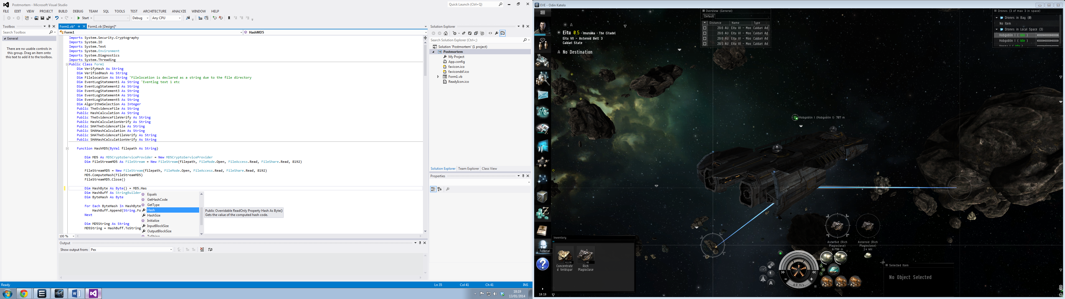

There is also many requirements to fully implement an algorithm into a Visual Basic application. Those requirements are:

1. Several variables
2. Imports
3. File Location

Several variables are needed to fully implement the hash algorithm by handling as events. The variables which are needed is stringbuilder, bytes and strings. The variables can be declared via the Dim function in the VB.net application, an example of what is required is the following code snippet:

Dim HashByte As Byte() = MD5.Hash

Dim HashBuff As StringBuilder = New StringBuilder

Dim ByteHash As Byte

Dim MD5String As String

Dim TheEvidenceFile As String = Filelocation

Dim HashCalculation As String = HashMD5(Filelocation)

These variables are needed due to the method of creating an algorithm in the Visual Basic program. The string data type holds characters or a text, which in the Postmortem program, it will hold the hash value i.e 4FSDEW4FW4W465346233G3 and the file location, i.e. C://User/MAN10158150/Evidence/Evidencefile.jpg.

The stringbuilder data type holds a value in the memory of the computer system. This is where the value is stored of an object, this allows the client or the developer of the program to perform repeated modifications to the string. When the stringbuilder function is used in the VB.net application, this improves performance to the program by devolving the strings into a loop.

The byte data type holds a value ranging from 0 to 255 and that value is unsigned. In the algorithm, it uses two byte variables in according to the hash protocol of the program. One will convert the value of bytes into a hash byte function where it can they be displayed.

Imports is very important function in algorithm creation, however this will be talked more thoroughly later in the specification.

The last important part of the algorithm is the file location of the file the user wishes to hash. The location of the file can be declared as a String data type because it will hold the text of where the file is. To declare where a location is, the user can do it in multiple way. They can hard code it into the VB.net application which is very inflexible and it will look like the following code snippet:

Dim TheFile As String = "C://user/test/test/evidence.jpg"

When the above code is implemented, this makes the application only hash one file location which is very bad if the user wishes to hash multiple files. To implement a flexible hashing system, a new system has to be implemented. For a flexible hashing system to be implemented, instead of a hardcoded location, the developer would use a string variable to hold the text value. An example of this, it would look like the following code snippet:

Filelocation = txtboxFileLocation.Text 'Text input declares the FileLocation variable

Dim TheEvidenceFile As String = Filelocation

What the above code snippet does it two things; one it stores the inputted text values as a string, then it declares the evidence file as a String to fully implement it into the memory. By using this system, the above code would be inputted into a textbox and finally a button to click to implement the string values to the text.

**Database –**

The second most technical component of the Postmortem program is Microsoft Access database connectivity. In the VB.net programming language, there is another library called ADO.net. The ADO.net library provides several classes to allow the developer data access protocols. ADO.net allows the developer functionality in creating code similar to COM which provides access to data sources such as Microsoft Access and SQL databases.

To connect to a Microsoft Access database, the developer needs to use the System.Data.OleDB class. The System.Data.OleDB class provides 4 libraries to the developer, Constructor, Methods, Properties and Events. The following code snippet starts the process of implementing a database into the VB.net application:

Dim con As New OledbConnection("Provider=microsoft.Jet.oledb.4.0DataSource=C:\Evidence\EvidenceLog.mdb;")

The above code snippet declares “con” as an OledbConnection which provides the connectivity to the Microsoft Access database. After the declaration, the location of the database is put into the parameters.

The OledbConnection type is not all that is needed to implement the database functionality into the application, the following code snippet will show what else is needed:

Dim cmd As New OleDbCommand

Dim da As New OleDbDataAdapter

The above code snippet declares CMD as a new OleDbCommand function and the da as a new OleDbDataAdapter. The OleDbCommand function is needed as a SQL procedure which is used to execute against the Access database. The OleDbDataAdapter function is needed because it holds many methods which are used to fill the database and to update the data sources records.

The requirements set by the client requires that the program Postmortem must have a search function via the interactive database of Microsoft Access. For this to be fully implemented, there needs to be a dataset. The dataset is not visible to the client and is stored in the memory. The dataset represents a row of information from a database which in this situation is Microsoft Access. The following code snippet is what will be used to declare a dataset in the Postmortem program:

Dim DataSetEvidence As New DataSet

The above code declares “DataSetEvidence” a new instance of a dataset which mentioned before allows access to a Microsoft Access database. The next part is showing the information from the database into a textbox where the information will be viewed; the code snippet to do this is the following:

txtHashNumber.Text = ds.Tables("EvidenceLog").Rows(1).Item(1)

The above code snippet allows a textbox which will hold the value of the first row and the first item from the EvidenceLog database.

To search the database via the Postmortem program, it will be using an If statement with an Else statement included. An example of an If statement is the following code snippet:

If txtboxTest.text = 100 Then

MsgBox("Correct")

Else

MsgBox("False")

End If

This allows the program to instead of crash or hang, to provide an output to the user to show if one statement is wrong, then it will instead give out another statement to confirm it’s wrong.

To search the next record, the following code snippet would be used:

If inc <> MaxRows - 1 Then

inc = inc + 1

NavigateRecords()

Else

MsgBox("No More Rows")

End If

The inc variable is equal to positive one so if the maximum amount of rows are detected then it will go provide a message box of “no more rows” however if there are more rows to navigate then the NavigateRecords() function will search the next row and show the information.

To search the previous record of the Postmortem program and the Microsoft database, the following code snippet will be used:

If inc > 0 Then

inc = inc - 1

NavigateRecords()

Else

MsgBox("First Record")

End If

The inc variable is equal to negative one so once it reaches the first record and the user presses the go back button again, they will receive a message box saying “First Record”.

The Microsoft Access database will already have many hash records accompanied with many other aspects such as date, time, chain of custody and the hash value. When the hash process has been completed, the hash verification allows the analyst to export the result to the database. To add a record to the Microsoft Access database, the following code snippet example will be used:

ds.Tables("AddressBook").Rows(2).Item(1)

ds.Tables("AddressBook").Rows(2).Item(1) = "Hash Value"

ds.Tables("AddressBook").Rows(inc).Item(1) = txtboxHashVerification.Text

ds.Tables("AddressBook").Rows(inc).Item(2) = txtboxHashVerified.Text

MsgBox("Hash Verification Added To Database")

The first two lines of the above code snippet finds the Microsoft Access database rows and the designated Hash Value row. The two procedures of adding the values is done by the third and fourth line. This adds the text in the text boxes to the database. To fully implement the new values into the database, a button is used such as “btnAdd”. Once pressed, the database will be updated with the new values.

**Message Box Overloading –**

The third most technical component of the Postmortem program is message box overloading. Conventional message boxes do not provide support for extra parameters. An example of a conventional message box looks like the following code and image:

MessageBox.Show("Example of a Conventional MsgBox")

=

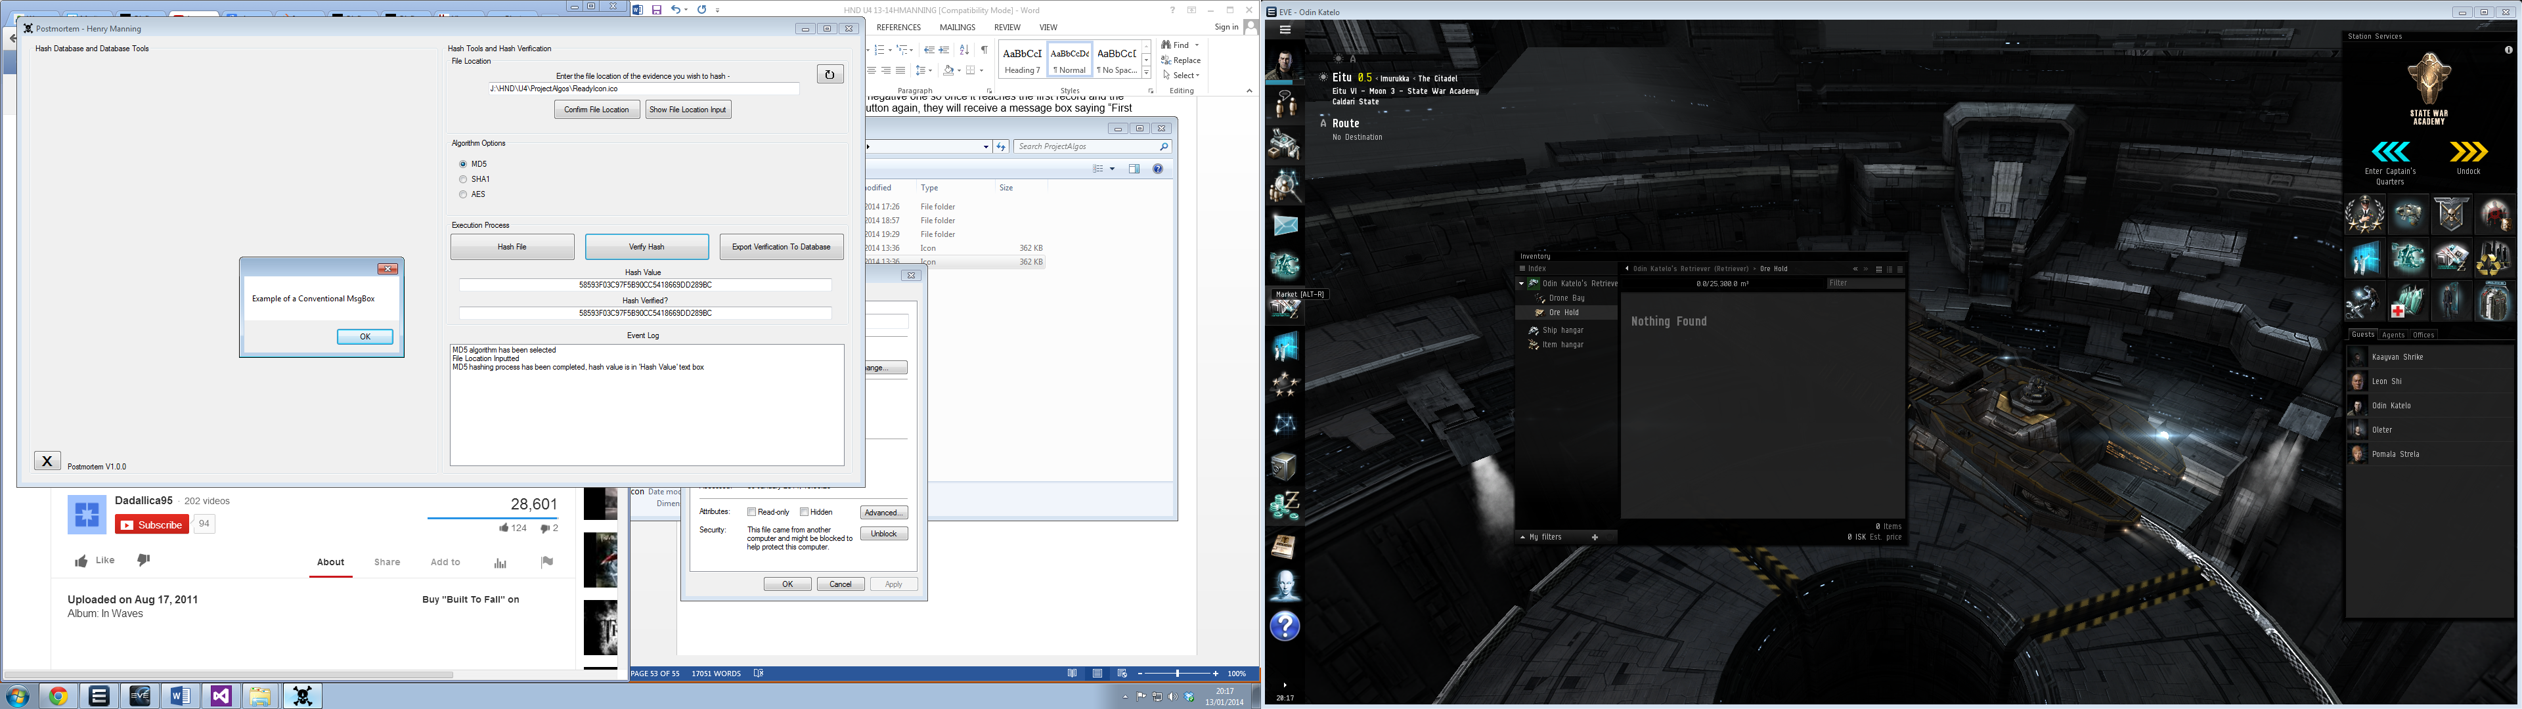

With conventional message boxes, they do not provide a message box title and do not offer any support with parameters. Instead of using the “MessageBox.Show” function, the developer will be using the “MsgBox” function.

They both have a similar name but both offer different methods of completing a task. With the MsgBox function, the developer can add a title with a caption. The overloading method bypasses restrictions with the MessageBox function. The code snippet to this example is the following:

Dim BoxMsg As DialogResult

Dim Message1 As String = "HASHES ARE VERIFIED"

Dim MsgBoxTitle2 = "Successful Hash Verification"

BoxMsg = MessageBox.Show(Message1, MsgBoxTitle2)

The first variable declares BoxMsg as a DialogResult which allows the BoxMsg to be a visual representation. The second variable is a string as it holds a text value which in this instance is “Hashes are verified” and the third variable is a string as it holds the text of “Successful Hash Verification”). The declared variable of BoxMsg is now equal to the MessageBox. When this event happens, the messagebox shows with two parameters. The first parameters is the text inside the messagebox which is Message1 and the second parameter is the title of the messagebox which is MsgBoxTitle2.

**Variables –**

The fourth most technical component of the Postmortem program are the variables. In the Postmortem program, variables are needed to hold values so that they can complete tasks. There are many types of variables but in the Postmortem program, the main variables are:

1. String
2. Byte
3. Integer

The String data type variable holds text values which are limited to alphanumeric characters. To declare a string in a VB.net application, the code snippet would look like the following:

Dim EventLogStatement1 As String

The Byte data type variable holds an unsigned 8bit integer which ranges from 0 to 255. The Byte variable holds only binary data and the default value of a Byte is 0. To declare a Byte variable in a VB.net application, the code snippet would look like the following:

Dim ByteTest As Byte

The integer data type variable holds a numeric value which ranges from -2,147,483,648 to 2,147,483,647 and is a signed 32bit integer. The integer data type variable is the most optimal on 32bit system as other types are slower to load from the memory of the computer system. To declare an integer variable in a VB.net application, the code snippet would look like the following:

Dim IntegerValue As Integer = 100

The variables used in the Postmortem program are mainly used by the String data type method. This is due to many text values such as the file location and the hash value.

**Imports –**

The import function is a statement which allows the developer to import a namespace directly to the vb.net application. An example of importing namespaces to the VB.net application is the following image:

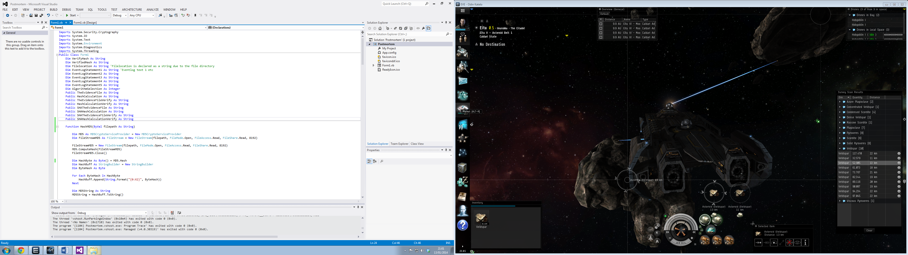

The import function must be placed above all over private subs and stubs of the application otherwise they will be highlighted in blue. For example, if the Import System.Security.Cryptography library is imported then it offers many other libraries to the developer’s creation.

When the developer has imported a namespace then it offers many functions, so when they have properly imported a namespace such as Cryptography then it offers the following classes:

|  |  |
| --- | --- |
| **Class** | **Description** |
| AES | AES Encryption class for AES implementations |
| DSA | DSA Encryption Class for DSA implementations |
| CipherMode | Specifies block ciphers for use in encryption |
| Many others… (MSDN, 2013) |  |

If the developer has created AES or MD5 algorithm functions in the application and the import namespace hasn’t been implemented, then the algorithm functions will not work.

**Quality Assurance**

**See Appendix 5**

**Proposed Solutions**

**See Appendix 6**

**Chosen Solution**

**See Appendix 7**

**The Project Plan**

**See Appendix 8**

**Designs**

**See Appendix 9**

**Pseudo Code and Postmortem Code**

**See Appendix 10**

**User Manual**

**See Appendix 11**

**Testing**

**See Appendix 12**

**Deployment**

**See Appendix 13**

**Maintenance**

**See Appendix 14**

**Specification Analysis**

**See Appendix 15**

**User Requirements Analysis**

**See Appendix 16**

**Quality Assurance**

To fulfil quality assurance in the Postmortem program, there must be checks made to the progress of the development of the program and after the program has been created. There will be many tools used to control the quality assurance of the program, these will be risk assessments, auditing, testing and program monitoring for each user of the Postmortem program.

**Risk Assessment:**

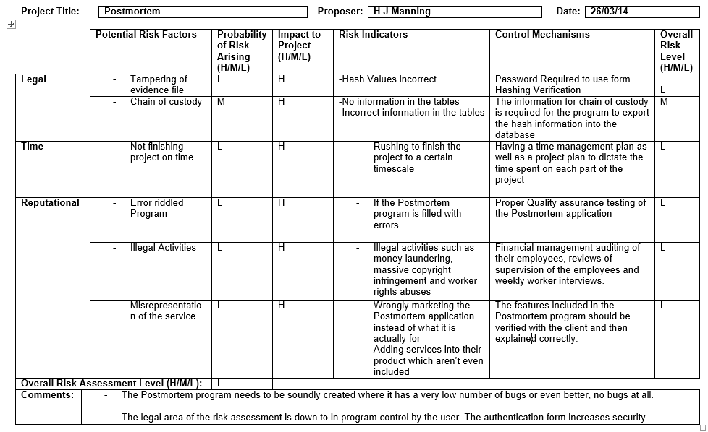

The purpose of the Postmortem program risk assessment is to protect the users and the business of whom deploys it. The risk assessment focuses on risks which would take place if anything goes wrong. If there is a possibility of a risk, the risk assessment also proposes solutions to the problem to try and rectify it.

**Software Audit:**

|  |  |  |
| --- | --- | --- |
| **Auditor Form** | | |
| **Auditor:** Henry Manning | **Date Audited:** 01/05/14 | **Program Name:** Postmortem |
|  |  |  |
| **Location:** London MPS | **Number of Units:** 15 | **Signed by Auditor:** |
|  |  |
| **Unit 1** | **Henry Manning** |
| **Unit 2** | **Henry Manning** |
| **Unit 3** | **Henry Manning** |
| **Unit 4** | **Henry Manning** |
| **Unit 5** | **Henry Manning** |
| **Unit 6** | **Henry Manning** |
| **Unit 7** | **Henry Manning** |
| **Unit 8** | **Henry Manning** |
| **Unit 9** | **Henry Manning** |
| **Unit 10** | **Henry Manning** |
| **Unit 11** | **Henry Manning** |
| **Unit 12** | **Henry Manning** |
| **Unit 13** | **Henry Manning** |
| **Unit 14** | **Henry Manning** |
| **Unit 15** | **Henry Manning** |
|  |  |  |
| **All Units Pass? Yes [ X ] No [ ] – If No, Take Unit Number(s):** | | |
|  |  |  |
| **Location:** A & S HTU | **Number of Units:** 10 | **Signed By Auditor:** |
|  |  |
| **Unit 1** | **Henry Manning** |
| **Unit 2** | **Henry Manning** |
| **Unit 3** | **Henry Manning** |
| **Unit 4** | **Henry Manning** |
| **Unit 5** | **Henry Manning** |
| **Unit 6** | **Henry Manning** |
| **Unit 7** | **Henry Manning** |
| **Unit 8** | **Henry Manning** |
| **Unit 9** | **Henry Manning** |
| **Unit 10** | **Henry Manning** |
|  |  |  |
| **All Units Pass? Yes [ X ] No [ ] – If No, Take Unit Number(s):** | | |
|  | | |
| **Client Signed: John Doe Client Date:** 01/05/14 **Auditor Signed: Henry Manning** | | |

The purpose of a software audit is to make sure that the version being used on all the designated computer systems are the correct version and are not illegal downloads or potential Trojans from fake websites. The software audit will check each system, the version and the code behind the program to make sure it is legit and not fake which can lead to attacks.

**Testing:** Testing of the Postmortem program is very important to the assurance of quality of the application. Each part of the testing process, tests each component of the application, this is to make sure that it is functioning correctly. It is also important in testing the program because the files being hashed are important and are to do with court cases or legal documents.

The testing of the Postmortem application was completed at an earlier stage. The test table used is the following:

|  |  |  |  |  |
| --- | --- | --- | --- | --- |
| **No.** | **Type** | **What** | **Expectations** | **What Happened?** |
| 1 | Blackbox | Does frmLogon load first? | The form 2 should load first before anything else. | The frmLogon loaded which allowed the user to launch the Postmortem application |
| 2 | “ | If there is a successful password input, does the frmLogon hide? | The frmLogon should hide when the correct password is inputted | The frmLogon did hide in the background when the password was successful. |
| 3 | “ | If there is a successful password input, does the frmHashDatabase show? | The frmHashDatabase should show onto the screen of the clients system | The frmHashDatabase showed when the password input was successful |
| 4 | “ | When the database browse button is pressed, does it load the dialog? | The dialog should load when the button is pressed | The dialog was generated and allowed the user to use it |
| 5 | “ | When the dialog is shown, does it show the default C: drive? | The C drive should load into the dialog result | The C drive was the only drive visible to the user at the start, but they are able to change drive if they wish |
| 6 | “ | When selecting the database file, does the location load into the database textbox? | The database location should be loaded into the textbox | The database location was loaded into the textbox |
| 7 | “ | When the database browse button is pressed, does the Load button become enabled? | The Load button should become re enabled through the Postmortem application | The Load button became enabled |
| 8 | “ | When the load button is pressed, does a messagebox show that a connection has been established to the database? | The messagebox should pop up onto the clients system showing that there has been a successful connection | When the Postmortem application connected to the database, the messagebox popped up when it was successful. |
| 9 | “ | When the database has been connected, does 11 buttons become enabled on the Postmortem application? | When the database connects, 11 buttons should become enabled | When the Postmortem application connected to the database, all 11 buttons enabled on the form. |
| 10 | “ | When the database has been connected does the 17 textboxes become enabled in the Postmortem application? | When the database connects, 17 textbox should become enabled | When the Postmortem application connected to the database, all 17 textboxes became enabled on the form. |
| 11 | “ | When searching a hash value, does the database textboxes update with the correct information? | The correct information should populate the textboxes in the database section | When the button was searched, it correctly inputted the information required into the textboxes |
| 12 | “ | When searching a case number value, does the database textboxes update with the correct information? | The correct information should populate the textboxes in the database section | When the button was searched, it correctly inputted the information required into the textboxes |
| 13 | “ | When a case number has been searched, does the event log update? | The event log should update with what action the user has taken | The event log was updated with the correct action |
| 14 | “ | When a hash value has been searched, does the event log update? | The event log should update with what action the user has taken | The event log was updated with the correct action |
| 15 | “ | When the First Record button is pressed, does it go to the first record of the database? | The first record in the database should be shown when the button is pressed | When the button was pressed, the first record on the database was shown |
| 16 | “ | When the Next Record button is pressed, does it go to the next record? | The next record should populate the database textboxes | When the button was pressed, it populated the textboxes of the next record |
| 17 | “ | When the Previous Record button is pressed, does it go to the previous record in the database? | The previous record should populate the database textboxes | When the button was pressed, it populated the textboxes of the previous record |
| 18 | “ | When the Delete Record button is pressed, does it show a messagebox with Yes and No options? | The messagebox with the Yes or No option should load into the clients view on the application | The messagebox showed the two Yes or No options on the form |
| 19 | “ | When the Delete Record message box is shown, when the Yes button is pressed does the event log update with the action of the client? | The event log should update with the action of the client. | The event log was updated with the action wanted by the client |
| 20 | “ | When the Delete Record message box is shown, when the No button is pressed does a message box pop up with a message stating about the cancelation of the delete operation? | The message box should load to the user and say that the delete operation has been aborted | When the no button was pressed on the message box, another messagebox was generated to state that the function has been aborted |
| 21 | “ | When the evidence file location browse button is pressed, does it load the dialog? | The dialog should load onto the clients application | The browse evidence file dialog was loaded into the clients application |
| 22 | “ | When the dialog loads, does it automatically go to the C: drive? | The dialog should automatically go the clients C: drive | The dialog was automatically on the C: drive |
| 23 | “ | When selecting the evidence file, does the Select button put the file location in the evidence file location textbox? | The evidence file location textbox should be populated by the dialogs select file button | The evidence file textbox was filled with the file location of the selected file |
| 24 | “ | When the evidence file load button is pressed, does the event log update with the action of loading the file? | The event log should update with the client loading the file into the program | The event log was updated with the action done by the client of the Postmortem application |
| 25 | “ | When selecting MD5 radio button, does the event log update with the selection? | The event log should update with the action chosen by the client | The event log was updated with the action done by the client of the Postmortem application |
| 26 | “ | When selecting SHA radio button, does the event log update with the selection? | The event log should update with the action chosen by the client | The event log was updated with the action done by the client of the Postmortem application |
| 27 | “ | When selecting SHA256 radio button, does the event log update with the selection? | The event log should update with the action chosen by the client | The event log was updated with the action done by the client of the Postmortem application |
| 28 | “ | When selecting SHA384 radio button, does the event log update with the selection? | The event log should update with the action chosen by the client | The event log was updated with the action done by the client of the Postmortem application |
| 29 | “ | When the Hash File button is pressed, does the Hash File button become disabled? | The Hash File button should become disabled when pressed | When the button was pressed, it became disabled |
| 30 | “ | When the Hash File Again button is pressed, does the Hash File Again button become disabled? | The Hash File Again button should become disabled when pressed | When the button was pressed, it became disabled |
| 31 | “ | When the Verify Hash Values button is pressed, does the Verify Hash Values button become disabled? | The Verify Hash Values button should become disabled when pressed | When the button was pressed, it became disabled |
| 32 | “ | When the Verify Hash Values button has been pressed, does the messagebox show up with either a Failed Verification message or a Successful Verification message? | The message box should show with either a failed message or a successful message | The messagebox was generated and provided a successful message |
| 33 | “ | When the Input Information button has been pressed, does the Input Information button become disabled? | The button should become disabled when pressed | When the button was pressed, it became disabled |
| 34 | “ | When the Export To Database button is pressed, does the button become disabled when pressed? | The button should become disabled when it has been pressed | When the button was pressed, it became disabled |
| 35 | “ | When the Export To Database button is pressed, does the messagebox show that it has been exported to the database? | The messagebox should show with a conformation message when the export has been completed | When the Export To Database button was pressed, it generated a messagebox which confirmed that the record has been exported |
| 36 | “ | When the Reset button is pressed, does the event log update with its purpose? | The event log should update with a statement of what it has done | When the reset button was pressed, the event log was updated with the reset statement |
| 37 | “ | When the Reset button is pressed, does it clear the hash values textboxes? | The Hash Values textboxes should be cleared of both values | When the reset button was pressed, both of the hash value textboxes were cleared |
| 38 | “ | When the Reset button is pressed, does it clear the hash algorithm radio buttons? | The radio buttons should become unchecked which will allow a new hash to take place | When the reset button was pressed, all four of the hash algorithm radio buttons were cleared to unchecked |
| 39 | “ | When the Reset button is pressed, does it clear the Evidence File Location textbox? | The textbox should be cleared where another location can be declared | When the reset button was pressed the evidence file location textbox was cleared |
| 40 | “ | When the Exit button is pressed, does it exit the application? | The application should exit when the button has been pressed | When the Exit button was pressed, the application exited |
| 41 | Whitebox | Does the textboxes within the database section of the program correspond with the tables in the database file? | The textboxes should be populated with the correct information from the database | The database columns matched the Postmortem insert SQL statements. |
| 42 | “ | When selecting a database file, the application should only accept aacdb files and no other types of files. | The application should bring up an error message stating that the file is unrecognised | The Postmortem application did not crash when selecting a unrecognised format and the Postmortem application generated a messagebox to state it’s the wrong format |
| 43 | “ | When searching a hash number, does the SQL statement within the program take it from the hash value textbox? | The textbox value should be used and then populate the database textboxes | The value inputted into the textbox allowed a successful population of the correct data |
| 44 | “ | When searching a case number, does the SQL statement within the program take it from the case number textbox? | The textbox value should be used and then populate the database textboxes | The value inputted into the textbox allowed a successful population of the correct data |
| 45 | “ | When a record has been deleted from the database, does the SQL statement in the application actually delete a record from the database file? | The record should be deleted from the database file | The Postmortem application deleted the record when the SQL statement was invoked |
| 46 | “ | When selecting the MD5 algorithm, does it equal HashAlgorithm 1? | The HashAlgorithm variable should equal 1 | The variable HashAlgorithm was equalled to 1 |
| 47 | “ | When selecting the SHA algorithm, does it equal HashAlgorithm 2? | The HashAlgorithm variable should equal 2 | The variable HashAlgorithm was equalled to 2 |
| 48 | “ | When selecting the SHA256 algorithm, does it equal HashAlgorithm 3? | The HashAlgorithm variable should equal 3 | The variable HashAlgorithm was equalled to 3 |
| 49 | “ | When selecting the SHA384 algorithm, does it equal HashAlgorithm 4? | The HashAlgorithm variable should equal 4 | The variable HashAlgorithm was equalled to 4 |
| 50 | “ | When pressing the Hash File button, if the algorithm selection is 1 does it start the MD5 hashing function? | If the algorithm selection is 1 then it should start the background worker regarding MD5 | When the HashAlgorithm was 1 it started the MD5 hashing process |
| 51 | “ | When pressing the Hash File button, if the algorithm selection is 2 does it start the SHA1 hashing function? | If the algorithm selection is 2 then it should start the background worker regarding SHA1 | When the HashAlgorithm was 2 it started the SHA hashing process |
| 52 | “ | When pressing the Hash File button, if the algorithm selection is 3 does it start the SHA256 hashing function? | If the algorithm selection is 3 then it should start the background worker regarding SHA256 | When the HashAlgorithm was 3 it started the SHA256 hashing process |
| 53 | “ | When pressing the Hash File button, if the algorithm selection is 4 does it start the SHA384 hashing function? | If the algorithm selection is 4 then it should start the background worker regarding SHA384 | When the HashAlgorithm was 4 it started the SHA384 hashing process |
| 54 | “ | When pressing the Hash File Again button, if the algorithm selection is 1 does it start the MD5 Verification hashing function? | If the algorithm selection is 1 then it should start the background worker regarding MD5 verification | When the AlgorithmSelection was 1 it started the MD5 verification hashing process |
| 55 | “ | When pressing the Hash File Again button, if the algorithm selection is 2 does it start the SHA1 Verification hashing function? | If the algorithm selection is 2 then it should start the background worker regarding SHA1 verification | When the AlgorithmSelection was 2 it started the SHA verification hashing process |
| 56 | “ | When pressing the Hash File Again button, if the algorithm selection is 3 does it start the SHA256 Verification hashing function? | If the algorithm selection is 3 then it should start the background worker regarding SHA3256 verification | When the AlgorithmSelection was 3 it started the SHA256 verification hashing process |
| 57 | “ | When pressing the Hash File Again button, if the algorithm selection is 4 does it start the SHA384 Verification hashing function? | If the algorithm selection is 4 then it should start the background worker regarding SHA384 verification | When the AlgorithmSelection was 4 it started the SHA384 verification hashing process |
| 58 | “ | When pressing the Verify Hash Values, does the compare function work correctly? | The function should compare the two values and display a message. | When the function compared two sets of values, it successfully compared the two to decide if it was verified or not. |
| 59 | “ | When logging into the Postmortem application, if the password is not correct, does the program exit? | The Postmortem password submit form should close and then exit the whole application. | When entering the wrong password into the textbox, when the submit button was pressed, a messagebox appeared stating that it was shutting down the program |

The evidence of the testing can be found at Appendix 12.

**Postmortem Monitoring:**

|  |  |  |  |  |
| --- | --- | --- | --- | --- |
| **Postmortem Monitoring Form** | | | | |
| **Monitor:** Henry Manning | | **Date Monitored:** 01/05/14 | | |
|  | | | | |
| **Location:** London MPS | | **Number of Units:** 15 | | |
|  | | | | |
| **Unit 1 -** | **MD5 [ ]** | **SHA1 [ ]** | **SHA256 [ ]** | **SHA384 [ ]** |
| **Unit 2 -** | **MD5 [ ]** | **SHA1 [ ]** | **SHA256 [ ]** | **SHA384 [ ]** |
| **Unit 3 -** | **MD5 [ ]** | **SHA1 [ ]** | **SHA256 [ ]** | **SHA384 [ ]** |
| **Unit 4 -** | **MD5 [ ]** | **SHA1 [ ]** | **SHA256 [ ]** | **SHA384 [ ]** |
| **Unit 5 -** | **MD5 [ ]** | **SHA1 [ ]** | **SHA256 [ ]** | **SHA384 [ ]** |
| **Unit 6 -** | **MD5 [ ]** | **SHA1 [ ]** | **SHA256 [ ]** | **SHA384 [ ]** |
| **Unit 7 -** | **MD5 [ ]** | **SHA1 [ ]** | **SHA256 [ ]** | **SHA384 [ ]** |
| **Unit 8 -** | **MD5 [ ]** | **SHA1 [ ]** | **SHA256 [ ]** | **SHA384 [ ]** |
| **Unit 9 -** | **MD5 [ ]** | **SHA1 [ ]** | **SHA256 [ ]** | **SHA384 [ ]** |
| **Unit 10 -** | **MD5 [ ]** | **SHA1 [ ]** | **SHA256 [ ]** | **SHA384 [ ]** |
| **Unit 11 -** | **MD5 [ ]** | **SHA1 [ ]** | **SHA256 [ ]** | **SHA384 [ ]** |
| **Unit 12 -** | **MD5 [ ]** | **SHA1 [ ]** | **SHA256 [ ]** | **SHA384 [ ]** |
| **Unit 13 -** | **MD5 [ ]** | **SHA1 [ ]** | **SHA256 [ ]** | **SHA384 [ ]** |
| **Unit 14 -** | **MD5 [ ]** | **SHA1 [ ]** | **SHA256 [ ]** | **SHA384 [ ]** |
| **Unit 15 -** | **MD5 [ ]** | **SHA1 [ ]** | **SHA256 [ ]** | **SHA384 [ ]** |
|  | | | | |
| **All Units Pass? Yes [ ] No [ ] If No, Take Unit Numbers:** | | | | |
|  | | | | |
| **Location:** A&S HTU | | **Number of Units:** 10 | | |
|  | | | | |
| **Unit 1 -** | **MD5 [ ]** | **SHA1 [ ]** | **SHA256 [ ]** | **SHA384 [ ]** |
| **Unit 2 -** | **MD5 [ ]** | **SHA1 [ ]** | **SHA256 [ ]** | **SHA384 [ ]** |
| **Unit 3 -** | **MD5 [ ]** | **SHA1 [ ]** | **SHA256 [ ]** | **SHA384 [ ]** |
| **Unit 4 -** | **MD5 [ ]** | **SHA1 [ ]** | **SHA256 [ ]** | **SHA384 [ ]** |
| **Unit 5 -** | **MD5 [ ]** | **SHA1 [ ]** | **SHA256 [ ]** | **SHA384 [ ]** |
| **Unit 6 -** | **MD5 [ ]** | **SHA1 [ ]** | **SHA256 [ ]** | **SHA384 [ ]** |
| **Unit 7 -** | **MD5 [ ]** | **SHA1 [ ]** | **SHA256 [ ]** | **SHA384 [ ]** |
| **Unit 8 -** | **MD5 [ ]** | **SHA1 [ ]** | **SHA256 [ ]** | **SHA384 [ ]** |
| **Unit 9 -** | **MD5 [ ]** | **SHA1 [ ]** | **SHA256 [ ]** | **SHA384 [ ]** |
| **Unit 10 -** | **MD5 [ ]** | **SHA1 [ ]** | **SHA256 [ ]** | **SHA384 [ ]** |
|  |  |  |  |  |
| **All Units Pass? Yes [ ] No [ ] If No, Take Unit Numbers:** | | | | |
|  |  |  |  |  |
| **Client Signed: John Doe Client Date:** 01/05/14 **Auditor Signed: Henry Manning** | | | | |

The role of the Postmortem Monitoring Form is to make sure that the hashing algorithms used create the correct hash value. Each machine will have four tests:

1. MD5 Hash Check
2. SHA1 Hash Check
3. SHA256 Hash Check
4. SHA384 Hash Check

The process which will be used to test each hashing function is to use an online hash file generator. The website which will be used is OnlineMD5.com. This website will be used for three hashing algorithms; MD5, SHA1 and SHA256. For the SHA384 algorithm, the website which will be used is Hash.Online-convert.com. The process of testing each hash function will be the following:

**Step 1:** Locate the “HashingCheck” text file within the Postmortem directory. Hash the file within the Postmortem program.

**Step 2:** The result of the hash value will be shown in the program:

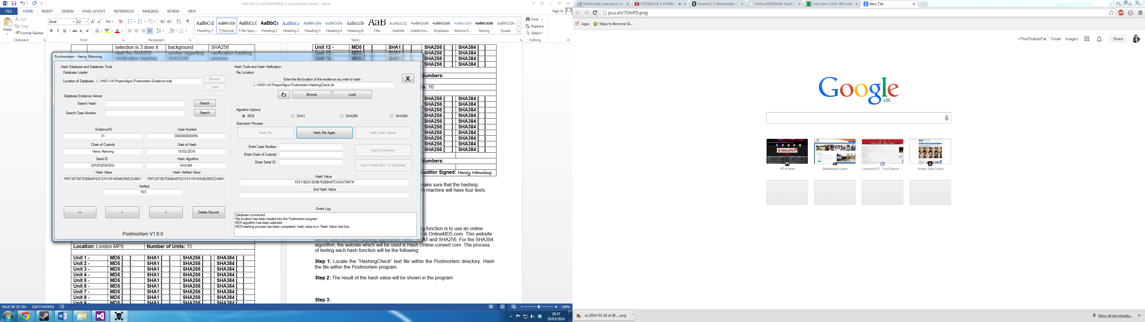

**Step 3:** Go into either online hash generator website and also hash the text file.

**Step 4:** Once the hashing has taken place on the online generator, compare both values. If they match, they will pass the test and then can be checked on the Postmortem Monitoring Form.

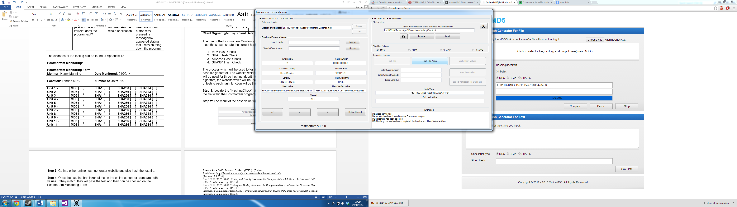



(OnlineMD5, 2014), (hash.online-convert, 2014)

**Evaluation**

The Postmortem program has been a success. There are many variables contributing to the program’s success. These variables which are related to the success of the Postmortem project are:

1. Requirements
2. Project Time Planning

The requirements set by the client are very important to what the Postmortem program looks and functions. The requirements have been met by the Postmortem application, they are all functioning and have been implemented with success.

There was an extra effort made to implement more algorithms which were first wanted by the client. The original hashing algorithms which were going to be implemented into the Postmortem application were MD5, SHA1 and AES. Instead of those three algorithms, there was four hashing algorithms included; MD5, SHA1, SHA256 and SHA384, this is a successful implementation which exceeded the expectations of the client.

However, there was a problem with the development of the Postmortem application. There was a certain part of the Postmortem application which kept on crashing and hanging. This was a very big problem for the user of the Postmortem application. The crashing or hanging would derive from the user pressing the hash file button, this would cause the program to crash because it was on one thread. When one thread is in use, the program crashes until the process on that one thread finishes which un-crashes the application.

The crashing program was a very hard problem to fix as there was knowledge on how to change the amount of threads or add new threads to the program. This was problem was fixed however with external help to the developer of the Postmortem application. The hashing function was correctly working however it kept crashing while creating the hash value, this was an important aspect needing to be fixed but came down to an external entity required to help fix that error. The method of fixing that error was down to a Visual Studio method called a back ground worker. This made the hashing function generate in the background on a different thread instead of one thread, this fixed the hashing error.

The database section of the of the Postmortem application looks like the following image:

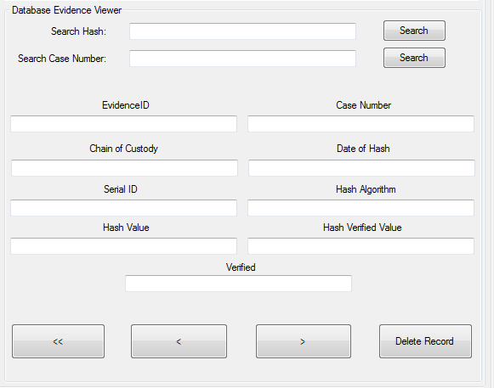

The database section of the Postmortem program looks unclean because of the layout. The database columns which contain the hashing information such as Serial ID, Hash Value etc… populate those textboxes and are viewed by the client. Instead of having multiple textboxes, another possibility which could replace them is a data grid.

A data grid could replace the whole navigation system such as the first record button, previous and next buttons. Also the data grid can replace the textboxes because it holds the same information but wastes less space and includes all of the database columns. A data grid would look like the following image:

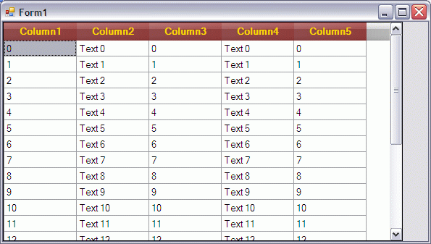

A data grid would look very more professional also than multiple textboxes. In a later update of the Postmortem program, there could be a change of textboxes to a data grid.

Furthermore, there is also another success aspect of the Postmortem project which was the Project plan. The project plan consists of many time management variables.

The project plan sets out the time management of each section of the project and allows the developer of the project to set amounts of time to each aspect. The time management of the project was very important in completing the project successfully.

If a project plan was not in place, the Project would not be a success. This is because the developer has poor time management with long and extensive projects. It is very important to have a project plan with big or small projects because it is the reputation of the developer which is on the line.

When the new hashing function was implemented, it is important to test the functions but also important to see how long it takes for a particular file to hash. The test conditions of the time test are the following:

1. A Game of Thrones S01E01 720p, 1.5GB



1. The Lord of the Rings The Fellowship of the Ring 720p, 7.8GB

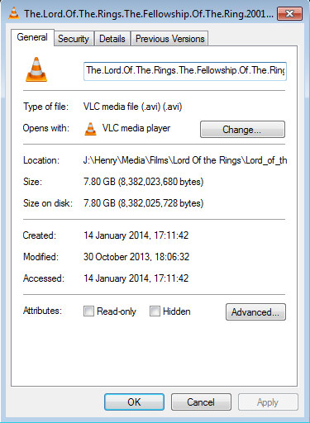

1. Gladiator 10th Anniversary Edition 1080p, 14.4GB

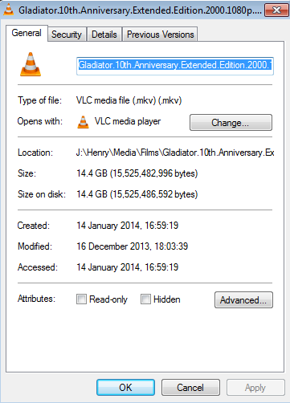

The time test will consist of three tests for each file and their retrospective hashing algorithms.

It is important to know the times it takes for each sized file because it is time consuming if files hashed are a big size. This is a rough estimate for each file which could contain sensitive information such as terrorist activity or child related abuse. Files such as computer system images could take a very long time to hash because they can be sizes ranging from 10GB up to 1TB in size. The hashing of a typical file is a success in the Postmortem application, however sizes above 14.4GB have not been tested, but since the hashing values are correct, they should also be correct when big files are hashed.

The reason for creating the Postmortem program was to save the companies which are going to use it, a lot of money. A professional program includes hashing files however they come at a very high price:

|  |  |  |
| --- | --- | --- |
| **FTK** | **Subscription Length** | **Price** |
| 1 Year | £730.59 |
| 2 Year | £1,2229.03 |
| 3 Year | £1,636.02 |
| **Encase** | 1 Year | £364.80 |
| 2 Year | £656.58 |
| 3 Year | £875.52 |

The program itself has been successful and replaces the need for a costly program which in turn saves a lot of money.

Finally, the project of Postmortem has been success. The requirements have all been met which is a positive point with the client, the amount of algorithms which were first in the specification have been exceeded which is a good addition. In addition to the extra algorithms, the quality of the program is excellent due to three factors:

1. Simple
2. Well laid out
3. Different sections for different uses

It is simple because that is also a requirement of the client. The easy to use hashing function follows a process where the buttons are disabled so the user is about to use a logical route of hashing.

The program is well laid out and not messy. The buttons and multiple textboxes are all put in a particular order and again follow a logical typical order.

The last factor is due to two different sections. The first section is the database section of the Postmortem application. This area doesn’t have the most technical components of the program as it only relates to the database. The hashing section of the Postmortem program is the most technical as it uses the Cryptography library from VB.net.

Overall, the Postmortem program could be improved on the database section such as a data grid but since it does what it is supposed to do, there is no urgent requirement to change it. The hashing of the program works flawlessly however, there needs to be an added try catch error method to stop one particular error happening. The error is caused by entering a string not related to a file location thus crashing. Lastly, the testing provided showed that it was a well-made program will zero to one error created.

**Presentation**

**See Appendix 17**

# Bibliography

AccessData, 2013. *Certifications.* [Online]   
Available at: http://www.accessdata.com/training/certifications  
[Accessed 07 10 2013].

AccessData, 2013. *FTK.* [Online]   
Available at: http://www.accessdata.com/products/digital-forensics/ftk  
[Accessed 7 10 2013].

AccessData, 2013. *FTK features.* [Online]   
Available at: http://www.accessdata.com/products/digital-forensics/ftk  
[Accessed 7 10 2013].

AccessData, 2013. *FTK Volatile VAD.* [Online]   
Available at: http://www.accessdata.com/assets/img/FTK/FTK_Volatile_VAD.png  
[Accessed 07 10 2013].

AP, 2012. *Casey Anthony detectives overlooked Google search.* [Online]   
Available at: http://news.yahoo.com/casey-anthony-detectives-overlooked-google-search-153900682.html  
[Accessed 15 1 14].

Arora, M., 2012. *How secure is AES against brute force attacks?.* [Online]   
Available at: http://www.eetimes.com/document.asp?doc_id=1279619  
[Accessed 4 1 2014].

Bunting, S., 2012. EnCase Computer Forensics -- The official EnCE: Encase Certified Examiner Study Guide. In: Official Edition ed. Unknown: John Wiley & Sons, p. 179.

Carvell, A., 2010. *Researcher cracks SHA-1 hashes for $2.10 with Amazon’s cloud service.* [Online]   
Available at: http://www.geek.com/news/researcher-cracks-sha-1-hashes-for-2-10-with-amazons-cloud-service-1295926/  
[Accessed 4 1 2014].

Data, A., 2013. *PRTK The Key To Cracking It.* [Online]   
Available at: http://www.accessdata.com/products/digital-forensics/decryption  
[Accessed 7 10 2013].

Encase, 2013. *Encase v7.* [Online]   
Available at: https://www.encase.com/products/Pages/encase-forensic/overview.aspx  
[Accessed 3 10 2013].

Encase, 2013. *EnCE Certification Program.* [Online]   
Available at: http://www.encase.com/training/Pages/ence-certification-program.aspx  
[Accessed 7 10 2013].

ForensicFocus, 2014. *Digital Evidence Recovery Officer - South Yorkshire Police.* [Online]   
Available at: http://www.forensicfocus.com/Forums/viewtopic/t=11304/  
[Accessed 10 1 14].

ForensicStore, 2013. *Forensic Toolkit 5 (FTK 5).* [Online]   
Available at: http://forensicstore.com/product/access-data/forensic-toolkit-5/  
[Accessed 8 1 2014].

Gao, J. T. H. W. Y., 2003 . Testing and Quality Assurance for Component-Based Software. In: Norwood, MA, USA : Artech House , pp. 141-154.

Gao, J. T. H. W. Y., 2003. Testing and Quality Assurance for Component-Based Software. In: Norwood, MA, USA : Artech House , pp. 119 - 137.

hash.online-convert, 2014. *Generate a SHA hash with 384 Bits.* [Online]   
Available at: http://hash.online-convert.com/sha384-generator  
[Accessed 29 03 2014].

Information Commisioner Report, 2007. *Orange and Littlewoods in breach of the Data Protection Act,* London: Information Commisioner Report.

Metropolitan Police Service, 2013. *Good Practice Guide for Computer-Based Electronic Evidence.* [Online]   
Available at: http://www.7safe.com/electronic_evidence/ACPO_guidelines_computer_evidence.pdf  
[Accessed 21 11 2013].

Microsoft, 2011. *System Security Cryptography.* [Online]   
Available at: http://msdn.microsoft.com/en-us/library/system.security.cryptography.md5.aspx?cs-save-lang=1&cs-lang=vb#code-snippet-1  
[Accessed 27 11 2013].

Microsoft, 2013. *How to: save a Dataset Changes to a Database.* [Online]   
Available at: http://msdn.microsoft.com/en-us/library/xzb1zw3x.aspx  
[Accessed 02 12 2013].

MSDN Microsoft, 2013. *System.Security.Cryptography.MD5.* [Online]   
Available at: http://msdn.microsoft.com/en-us/library/System.Security.Cryptography.MD5(v=vs.110).aspx  
[Accessed 4 1 2014].

MSDN, 2013. *System.Security.Cryptography Namespace.* [Online]   
Available at: http://msdn.microsoft.com/en-us/library/system.security.cryptography(v=vs.110).aspx  
[Accessed 13 1 14].

OnlineMD5, 2014. *MD5 & SHA1 Hash Generator For File.* [Online]   
Available at: http://onlinemd5.com/  
[Accessed 29 03 2014].

PACE, 1984. *Police and Criminal Evidence Act 1984.* [Online]   
Available at: http://www.legislation.gov.uk/ukpga/1984/60/section/22  
[Accessed 09 10 2013].

Ravis, 2012. *AutoUpdater.NET Autoupdate library for VB.net and C# Developer.* [Online]   
Available at: http://autoupdaterdotnet.codeplex.com/  
[Accessed 10 10 2013].

Thompson, E., 2005. *MD5 collisions and the impact on computer,* Lindon, UT: Elsevier.

Wilkinson, S., 2013. Good Practice Guide for Computer based Electronic Evidence. In: Wales: Association of Chief Police Officers, p. 12.

Wilkinson, S., 2013. *Good Practice Guide for Computer-Based Electronic Evidence,* London: Metropolitan Police Service .

**Appendix 1 –**

**Computer Forensics – Proposal One**

**Name of Program:** Postmortem

**Postmortem Programming Language:** VB.net and Command Prompt Commands

**Background:**

The project called Postmortem is a program for the computer forensics community. Computer forensics is used by private, public and government departments. Computer forensics is where an analyst would forensically get data from hard drives, CD’s and other forms of media. This extracted data would then be shown to a court of law or can be used by CEO’s of companies to see who is doing what. The customer for this project will be the Metropolitan Police Service and any private entity wishing to expand their computer forensic tool set. The reason this project is being created is to expand the amount of freeware tools in the computer forensic community because there is two notably big companies which provide their service for a nominal fee. By doing this project, it will hope to bring more free tools to businesses and government agencies to save them spending large amounts of money for something that should be either free or a small fee. This project will also help experience of the programmer in programming for such an aspect of the computing science world including dealing with chain of custody when evidence is involved. Furthermore, by having this project made, it can make job opportunities much easier to gain because some rival applicants might not have this type of project on their portfolio.

**Description of Current System:**

There are two main systems at this moment which acts like my proposal. There is the Encase system and the FTK system. Both Encase and FTK are computer forensics software and are usually the most required to know software when applying for a job and if the application has a certificate in either EnCE (Encase, 2013) or ACE (AccessData, 2013) that will increase their job opportunities greatly. Encase has many features within its software regarding forensics. The latest version of Encase which is Encase Forensic v7.08 has the following features:

1. Tablet and Smartphone Investigation Tools – This allows the analyst to get data off the mobile devices and use that as evidence.
2. Removable Media Tools – This allows the analyst to also gain data while making sure that no data is being written to that particular removable media.
3. Hard Drive Tools – This allows the user via the GUI to view the contents of the hard drive in full detail.
4. Reports – This is a tool which sets out evidence in a report style so it can be presented to the consultant’s superiors as well as in a court of law.
5. Evidence Exports (Encase, 2013)

The rival to Encase is FTK. FTK was created by AccessData and is the global forensic software standard (AccessData, 2013). Just like Encase, the latest version of FTK is FTK 5 and has the same tools as Encase with added features such as:

1. Unique FTK architecture – The software is database driven thus if there is a UI crash then the processes behind the scene will still be in effect.
2. Encryption Support – FTK is now able to send encrypted files straight to PRTK (FTK Decryption Software (Data, 2013)) on the fly. PRTK is used by law enforcement and security professionals.
3. Faster Index and Binary Searching – FTK uses a full featured engine which allows the analyst to search and analyse data all at once.
4. Advanced Volatile/Memory Analysis – FTK supports Windows 32bit and 64bit. It also included UNIX and Linux. It can run Static RAM analysis against live systems. The software is able to dump processes and the appropriate DLL’s using third party plugins or tools. Memory string and memory mapped automatically to corresponding DLL’s or another corresponding item.
5. Internet and Chat Analysis – Over 50 internet chat, P2P and online game carvers which will automatically show evidence during processing.
6. Large Apple OS Analysis Support – FTK provides Process B attributes for metadata, PLIST support, SQLite database support, Apple DMG and DD_DMG disk image support and lastly JSON file support. (AccessData, 2013).

Another part of the current system is evidence integrity. When there is a crime scene, the first step of acquiring evidence is to record it and to put it into evidence bags so it can be examined. That evidence needs to be booked into the evidence safe or room and have witnesses to make sure that it’s being handled properly i.e. Latex gloves (Wilkinson, 2013). The main law regarding evidence retention is PACE 1984 Section 22 (See Bibliography). This law provides the computer forensic analyst to seize any appropriate items which can be used for: Evidence at a trial or for forensic examination in relation to an offence. Secondly another part of evidence integrity is hashing images and virtual evidence. Hashing is a technique used by computer forensic analysts to prove that the data has not been tampered or altered. The typical algorithm used for hashing computer evidence is MD5. Encase uses MD5 for hashing evidence (Bunting, 2012). When an analyst hashes the evidence it creates a MD5 number which is then used to show that the evidence has not been tampered with. How they do this is to verify the hash number against the original hash when investigating that first piece of evidence. If the evidence has the same MD5 hash as before then the integrity of that evidence is admissible if it isn’t, then the defence legal team can call for a mistrial due to tampered evidence.

**Requirements and Objectives Set By Customer:**

The Metropolitan Police Service have set out many requirements for the project. These requirements relate to chain of custody, databases and much more. The list of requirements are the following:

1. Connects to a database file or SQL server
2. Simple to use
3. Multiple Text Fields
   1. Case Number
   2. Chain of Custody
   3. Date of Hash
   4. Serial ID
   5. Hash Algorithm
   6. Hash Value
   7. Hash Verified Value
   8. Hash Verified (Y/N)
4. Able to hash the file within the program
5. Search features
   1. Search Hash
   2. Search Case Number
6. Load and save features
7. Easy to use the hashing process

Furthermore the Metropolitan Police Service have set out numerous objectives for the computer forensic project. These objectives are:

1. To finish the proposal of the program by 20th October 2013
2. To finish the requirements of the program by 1st November 2013
3. To finish the designs of the program by 30th November 2013
4. To finish the programming of the project by 1st January 2014
5. To finish the documentation of the program by 1st March 2014
6. To finish the operating and maintaining of the program by 2nd April 2014

**Possible Solutions, Techniques and Specific Knowledge to be used:**

The solution to the programme will be using VB.net.

For creating and implementing the program, it will be used from an approach called the Systems Development Life Cycle. There are 5 stages to this model it starts with:

1. Planning
2. Analysis
3. Design
4. Implementation
5. Maintenance

The first stage of planning starts with this proposal. Planning is very important because if the developer of the program doesn’t, they will not where to start, what laws to follow and the requirements needed for said program.

The second stage of the systems development life cycle is analysis. This the part where the developer would analyse their proposal, go into more detail about it as well generate more research about each point or recommendation they make.

The third stage of the systems development life cycle is design. At this stage, the developer would create multiple designs for their program. Once they have the designs they would show the client and ask them which one they like the most and if they need any modifications to it.

The fourth stage of the systems development life cycle is the implementation of the program. At this stage, this is where the developer will create the program via the chosen programming language. After they have finished implementing the program, they would then fix bugs.

The last and fifth stage of the life cycle model is the Maintenance aspect. This last stage is geared towards testing the program, how to update the program, how to maintain the program and finally how to use the program via documents or on screen help with the program.

Regarding specific knowledge, VB.net and command prompt commands will be the most main part of knowledge to be implemented into the program. Another specific aspect of knowledge which the program will be using is the File Checksum Integrity Windows tool which is free to download from the Microsoft website. The knowledge of VB.net will be used to have a coordinated program with the FCIW tool which will allow the user to verify the MD5 checksum of the file.

**Costs and Benefits to the User:**

For this project, there will no costs for the client and it will be an open source program as well as being freeware. To the client there is multiple benefits from this program including benefits from the cost. The cost benefits are:

1. It is free – Computer Forensic software costs vast amounts of money to buy.

The benefits of the program for the client are:

1. Alternative easy to use program compared to complicated detailed programs such as Encase and FTK.
2. Regular bug fixes
3. Updateable database on the fly while using the program
4. Very quick hash verification tool

**Project Conclusion:**

The feasibility of the program is very important to the project. If the program is too hard to make then it will be very hard for the developer to create the program on the objective target dates or to even finish the program.

There are many feasibility issues for a project. These are:

1. Competitor’s
2. Cost at the market
3. Will it be finished on time?
4. Functioning as planned?
5. Maintained as planned?

The project which is especially for computer forensics, has a few competitors which are Encase and FTK. Those two companies have a very big foothold in the forensic market. Since the program is an open source software, which means it can be modified for any ones uses whereas the Encase and FTK software isn’t, that is an advantage to the Postmortem program which creates a positive for the feasibility in the developer’s court.

The second issue for feasibility is the cost at the market if the developer wishes to sell it and at what cost. The Postmortem project is free and will not cost any money to download and install as well as having free regular updates to the code including adding more algorithms. The feasibility is again good and can be done and so far in this project conclusion, two out of two feasibility issues are covered.

The third issue is the biggest issue and that is if the program Postmortem will be finished on time. With what the proposal has set, it will be completed on time, if the developer does the stages on time. If the stages are done on time, therefore it will be done on time so the feasibility will be fine.

The fourth issue is having the program function as it is designed and planned to do. The function of the program is to check the MD5 file and run it against the original hash of the evidence file which will be able to be done with the knowledge known. The feasibility of this issue is again, no problem.

The last and fifth issue is having the program being maintained and updated. The updating could be troubling regarding the feasibility as I do not currently know how to do it via the update, I would presumed using the AutoUpdater.NET library (Ravis, 2012). The second part of this issue is the maintenance planning, this will be covered by the updating as per bug fixing as well as making the GUI look better and extra features included said update.

Overall, the program is very feasible for the project and this report recommends it.

**Appendix 2 –**

**Yoghurt Tester – Proposal Two**

**Name of Program:** Yoghurt Tester

**Yoghurt Tester Programming Language:** VB.net

**Background:**

The program is called Yoghurt Tester and is being created for Yeo Valley in Cannington, Somerset. Within the Yoghurt Testing program, there is a key component to it which relates to the yoghurts properties. The main component of the yoghurt is the viscosity of the yoghurt. The viscosity is a name for the thickness of the yoghurt and it has to be in a certain area of viscos to be approved. As well as viscosity, there are two other main tests; those are the culture tests and the taste tests. The culture tests consist of taking a sample of the yoghurt, putting it in a petri dish and then putting it in an incubator for 24 hours. This will show the supervisor of germs and bacteria. If there are bad bacteria then the batch will be tested further and then thrown out. The other main test is the taste test, this is simply a test of tasting the yoghurt to check if it has the proper flavour and isn’t bad. The program is being made to replace the current system at Yeo Valley. The program being made is to help Yeo Valley in creating a database of their made yoghurts and to help them avoid sending out bad batches of yoghurts. If they do send out bad batches of yoghurts and other products they will tarnish their name and in turn they will lose profit.

**Description of Current System:**

The current system of the Yeo Valley yoghurt testing is a paper based system. Within the paper based system there are many options inside of that system which evaluate the yoghurt to see if it’s applicable to be sold or refused, those options or factors are:

1. Fat Count
2. Petri Dish Results
3. Viscosity Test
4. Excess Whey
5. Sugar Amount
6. Correct labelling
7. Yoghurt Acidic Test
8. Correct Yoghurt Flavour

When the person checking the yoghurts, they have to watch for certain factors in the product. The first factor is the fat count. The fat count is designated by the ingredients so low fat yoghurt would be created with low fat ingredients and full fat products will be created with full fat ingredients. If the low fat yoghurt is tested and found to have full fat content, then it will be rejected. The results will be written down on a sheet and then sent to the higher management for them to see the results and then go from there.

The petri dish results are the most important factor in creating yoghurt and selling it. When testing the yoghurt, the analyst will take a sample of the yoghurt, smear it into the petri dish and then leave it in the incubator for 24 hours, once those hours are up, the scientific analysis will then test it to see if its bad bacteria or good bacteria, if it’s bad bacteria then the batch will be thrown out.

The third aspect of the current system is the viscosity test. The key to yoghurt is having a certain thickness because it’s too runny, it’s not a yoghurt it’s actually a drink. This test is also recorded on a spreadsheet and then sent to the higher management to affirm that the results are correct and from there, the go ahead is given to send the yoghurt to their distributors.

The fourth aspect of the current system is the whey test. After a certain amount of time, whey is created by the yoghurt and sits on the top of the yoghurt. If the whey has been created too much it can make the batch look very unappetising thus returns of the product will happen. This will also create a backlash and bad reputation against the company.

The fifth aspect of the current system is the sugar amount of the product. The sugar amount of the ingredients should reflect on the label of the product. This again is record on the spreadsheet via hand and then sent to the higher management.

The sixth and second biggest aspect of the current system is the labelling. In the UK, Yeo Valley has to adhere to; The Food Labelling Regulations 1996. Within that law, Yeo Valley has to use the standards set so they do not fall foul of the law. This acts states that all food must be labelled correctly, including the ingredients, how it should be stored, use by date and trademarks. Each label would be checked to make sure it matches the serial ID of the product.

The seventh aspect of the current system is recording the acidic test of the yoghurt. If it’s not the correct level of acidity then the product will be breaking down too fast. If it has broken down too fast, it will then it will be visible to the tester which will then be recorded onto the hand written spreadsheet and then again sent to the higher management.

The last aspect of the current system is checking the yoghurt flavour matches the label. This is simply done by tasting the yoghurt, if its confirmed that it’s the correct flavour it will be recorded on a hand written spreadsheet and as well if it’s not the correct one, there will be an urgent alert sent to the higher management to stop production of that product and to stop it from being sent to the supermarkets.

**Requirements and Objectives Set By Customer:**

Yeo Valley has requested that the program must have the following requirements and objectives, the requirements are:

1. Connects to a database
   1. SQL or Access database
2. Easy to use
   1. Clear Buttons
   2. Boxes to show information
   3. Help Documents
3. Multiple text boxes of yoghurt data
   1. Yoghurt Brand Name
   2. Yoghurt ID Number
   3. Frozen/Stirred/Drinking/Set/Concentrated Yoghurt
   4. Yoghurt Batch Number
   5. Yoghurt Flavour
   6. Yoghurt Taste Test
   7. Yoghurt Acidic Test
   8. Yoghurt Viscosity Test
   9. Yoghurt Fat % Content
   10. Alert Box
   11. Warning Box
   12. Acceptable Box
   13. Yoghurt Cultures
   14. Label Correct (Y/N)
4. Search Batch Number
5. Search Yoghurt ID Number
6. Send Alerts to Departments regarding Yoghurt Testing

Furthermore, the objectives set by Yeo Valley are the following:

1. Finish the proposal by 20th October 2013.
2. To finish the requirements of the program by 1st November 2013.
3. To finish the designs of the program by 30th November 2013.
4. To finish the programming of the project by 1st January 2014.
5. To finish the documentation of the program by 1st March 2014.
6. To finish the operating and maintaining of the program by 2nd April 2014.

**Possible Solutions, Techniques and Specific Knowledge to be used:**

The solution to the programme will be using VB.net.

For creating and implementing the program, it will be used from an approach called the Systems Development Life Cycle. There are 5 stages to this model it starts with:

1. Planning
2. Analysis
3. Design
4. Implementation
5. Maintenance

The first stage of planning starts with this proposal. Planning is very important because if the developer of the program doesn’t, they will not where to start, what laws to follow and the requirements needed for said program.

The second stage of the systems development life cycle is analysis. This the part where the developer would analyse their proposal, go into more detail about it as well generate more research about each point or recommendation they make.

The third stage of the systems development life cycle is design. At this stage, the developer would create multiple designs for their program. Once they have the designs they would show the client and ask them which one they like the most and if they need any modifications to it.

The fourth stage of the systems development life cycle is the implementation of the program. At this stage, this is where the developer will create the program via the chosen programming language. After they have finished implementing the program, they would then fix bugs.

The last and fifth stage of the life cycle model is the Maintenance aspect. This last stage is geared towards testing the program, how to update the program, how to maintain the program and finally how to use the program via documents or on screen help with the program.

Regarding specific knowledge, VB.net will be the most main part of knowledge to be implemented into the program.

**Costs and Benefits to the User:**

For this project, there will no costs for the client and it will be an open source program as well as being freeware. To the client there is multiple benefits from this program including benefits from the cost. The cost benefits are:

1. It is free

The benefits of the program for the client are:

1. Provides a database which can be connected to at all times
2. Regular updates

**Project Conclusion:**

The feasibility of the program is very important to the project. If the program is too hard to make then it will be very hard for the developer to create the program on the objective target dates or to even finish the program.

There are many feasibility issues for a project. These are:

1. Competitor’s
2. Cost at the market
3. Will it be finished on time?
4. Functioning as planned?
5. Maintained as planned?

The first feasibility issue is competing with competitors. When creating a database with a form to perform actions, there are always going to be competition from some business as this is what they do as a profession, however there are keys factors in which the competitors might not want to get involved, the main factor being cost which is be discussed at a later stage.

The cost factor will be very feasible as the price is free for the company it is being made for. The updates to the program will be free as well as the maintenance being free so for this aspect of the feasibility is very good.

The third feasibility issue is that will it be completed on time. This feasibility is important as without the guidelines and objectives set for each development of the program is very important. Each of the objectives is set with enough time for the developer to create that part or design of the program and thus if the objectives are met then the project will be feasibility.

The fourth feasibility issue is that will the program will function as planned. This is a very important feasibility issue as if the program does not function as properly, then the company who has already implemented it, will lose money when its being used due to the fact that it won’t work. However with the skills already learnt, the function as planned aspect will be feasibility viable.

The fifth and last feasibility issue is will it be maintained as planned. As the program is being used, there will be a report menu as the user of the program can report bugs and issues so they can be fixed in updates. As there will be a report menu, there will be regular updates as well as maintenance so the feasibility issue has been met.

Overall, the program is very feasible for the project and this report also recommends it.

**Appendix 3 –**

**Problem Analysis**

In the problem analysis stage of this software development project, the aim is to analyse the constraints of the current software in use and then develop a program to counter act those constraints.

There can also be problems encountered while creating Postmortem. The problems created will be discussed after the problems with the current system.

The Postmortem program offers an alternative solution to certain problems to the current system in use. There are many problems with the current application for file hashing. Those problems are:

1. Cost
2. Complex

There are two main competitors in the forensic market, FTK and Encase. Below is a table covering the costs and price of both of the applications.

|  |  |  |  |
| --- | --- | --- | --- |
| **Creator** | **Price** | **Subscription (Y/N)** | **Extras (Y/N)** |
| Guidance Software / Encase v7 | £1,823.30 | N | Y |
| Access Data / FTK 5 | £2,432.08 | N | Y |

However, there are also added costs to the current applications such as SMS. SMS is Software Maintenance Service and is mandatory when buying such software. There are typically three options when buying SMS; one year, two year and a three year plan. SMS allows the company which the software is bought from to do regular fixes of the program on the client’s whim and corrects issues with the client. The costs of the plans are:

|  |  |  |
| --- | --- | --- |
| **FTK** | **Subscription Length** | **Price** |
| 1 Year | £730.59 |
| 2 Year | £1,2229.03 |
| 3 Year | £1,636.02 |
| **Encase** | 1 Year | £364.80 |
| 2 Year | £656.58 |
| 3 Year | £875.52 |

(ForensicStore, 2013), (Encase, 2013)

Both of the rival and main competitors in the market provide a service for a very large price. The large price is a very big problem due to the amount of licenses issued to companies and government agencies.

There are forty eight police forces in their separate jurisdictions in the United Kingdom. There are also at least twenty five police stations in each jurisdiction thus creating one thousand two hundred police stations in the United Kingdom alone. Each police constabulary has a forensic division with at least two computers for forensic use. By using Encase v7 with a one year SMS subscription plan as a pretext, for a one year license, the whole of the UK’s police service forensic software costs come to:

**£5,251,440**

By using FTK 5 with a one year SMS subscription plan as a pretext, for a one year license, the whole of the UK’s police service forensic software comes to:

**£7,590,408**

If the police service in the UK used the above software which they would do, this would come to the above amount. The amount shown is a lot of money just put towards a computer forensic program, let alone the costs for forensic lab or the equipment used in collection of evidence.

This first problem is solved by the Postmortem program in a single way, it is free. However, the two applications of Encase and FTK do provide other features towards computer forensics which can compensate the costs of the above price. But, the sole purpose of Postmortem is to hash files and then verify the hashes which the Encase and FTK programs also provide.

The second problem of the current system is the complexity of them both. Both of the programs are very popular among employers, for example;

|  |  |  |
| --- | --- | --- |
| **Job Title** | **Required Quals** | **Salary/Wage** |
| Advanced Associate, Evidence Processing Unit | EnCE / CFCE | Not Given |
| Digital Evidence Recovery Officer | EnCE | £32k - £36k |

(ForensicFocus, 2014)

The EnCE is the important aspect of the employers request information because it is very hard to achieve unless the analyst has had lots of experience using Encase software.

The EnCE is a certification program which lets public and private sector workers achieve certification in using Encase Forensic software. From opening the program, the application is very daunting for new users;

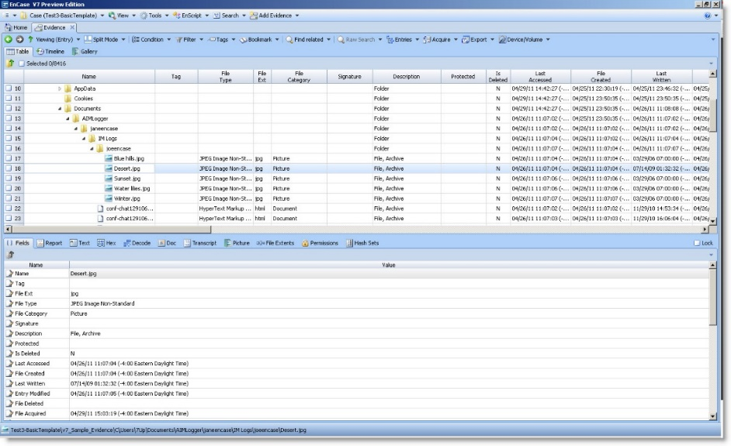

# The reason employers would not accept someone without either a FTK certification or an EnCE certification is due to liability and mistakes.

The Postmortem fixes the problem of complexity of Encase and FTK software applications. The Postmortem problem fixes the complexity by having a well laid out written documentation for the user of the program. Another fix of complexity for the Postmortem program is the layout of the application. The layout of the application would be far easier to navigate than Encase of FTK. The layout will again be accompanied by a well written documentation on how to use the program.

When creating the Postmortem application, there can be many problems encountered while developing the software. The problems can be created via developing the software where a bug can arise or an obstacle can happen if there is something which the programmer does not know how to handle it.

One problem which can arrive is bugs. In the VB.NET framework, Microsoft have included functions which can control bugs which throw out exceptions, this is called Exception Handling.

Exception handling is a function in vb.net which can control errors without the program hanging or crashing. An example of error catching in the VB.net language is the following code snippet:

Dim ErrorHandling As Integer = 10

Try

If ErrorHandling = 10 Then

MsgBox("True")

End If

Catch

MsgBox("Error")

Finally

Application.Exit()

End Try

The first line declares that “ErrorHandling” is an integer and has a value of 10. If the integer holds the value of 10 then a message box will appear saying “True”. However, if the value is not 10 then the program will throw an error which will cause the program to hang but the Catch function is used where the program will catch the error not causing the program to hang.

Another problem which the developer can face is obstacles when creating a program. The obstacles can range from not knowing how to accomplish a specific function, access issues such as not having Visual Studio or Microsoft Access.

The first obstacle which can be a problem is not knowing how to accomplish a certain method or function and class. The developer which is using VB.net gains an extra feature when using Visual Studio which is a help feature when programming.

For example, the developer work space is the following image:

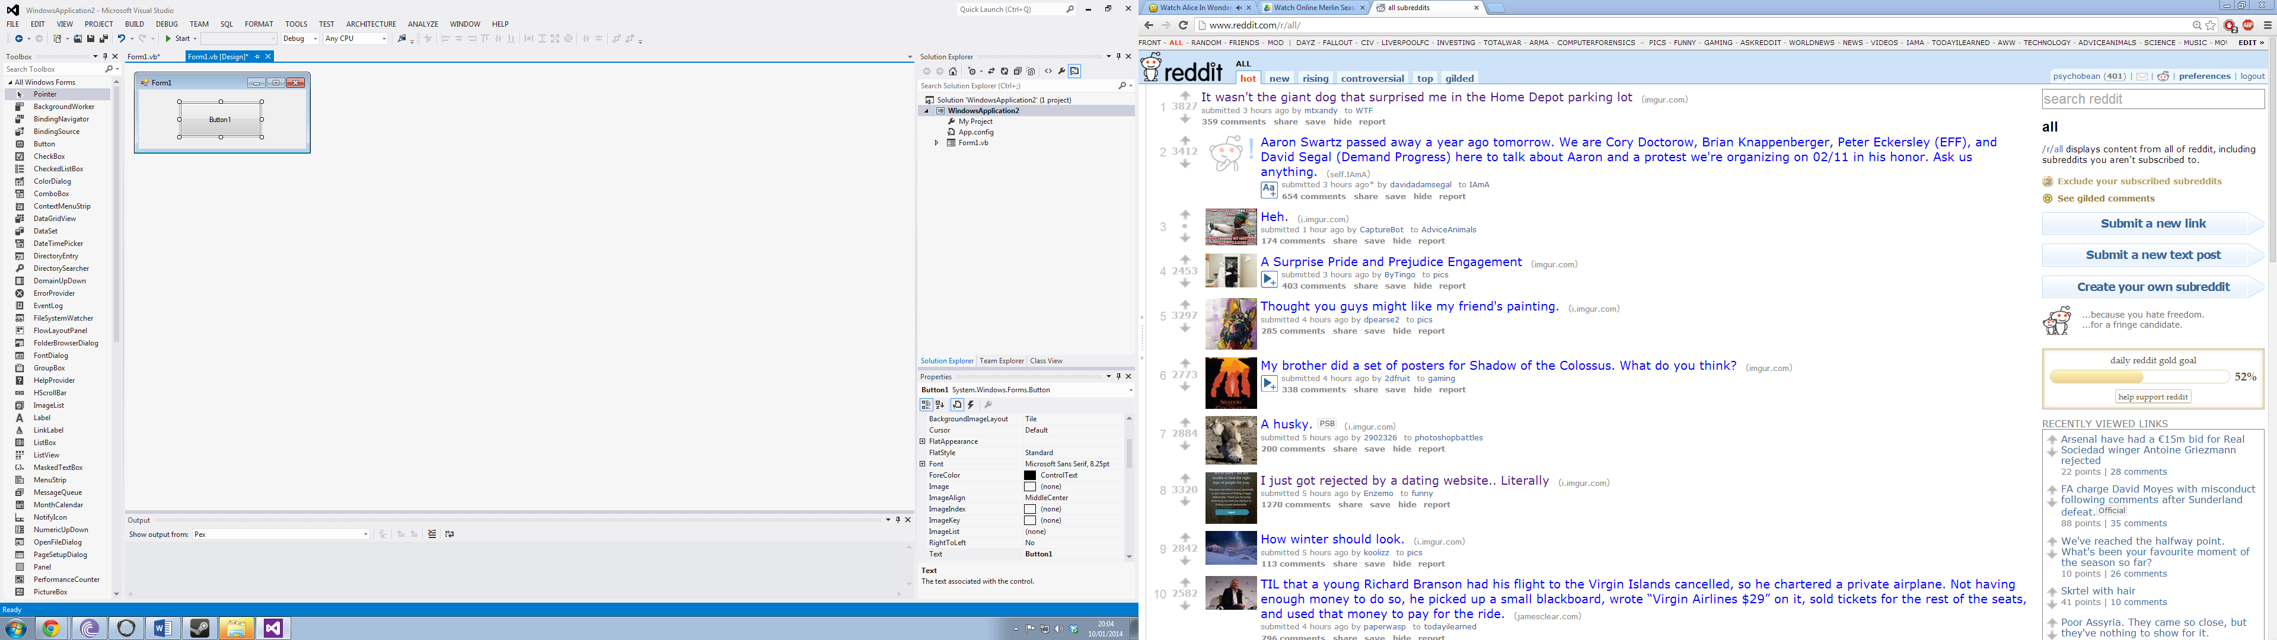

When the developer is programming certain features into the form, Microsoft Visual Studio shows functions and methods when a certain keyword is entered. For example, the source code also shows help when creating the application:

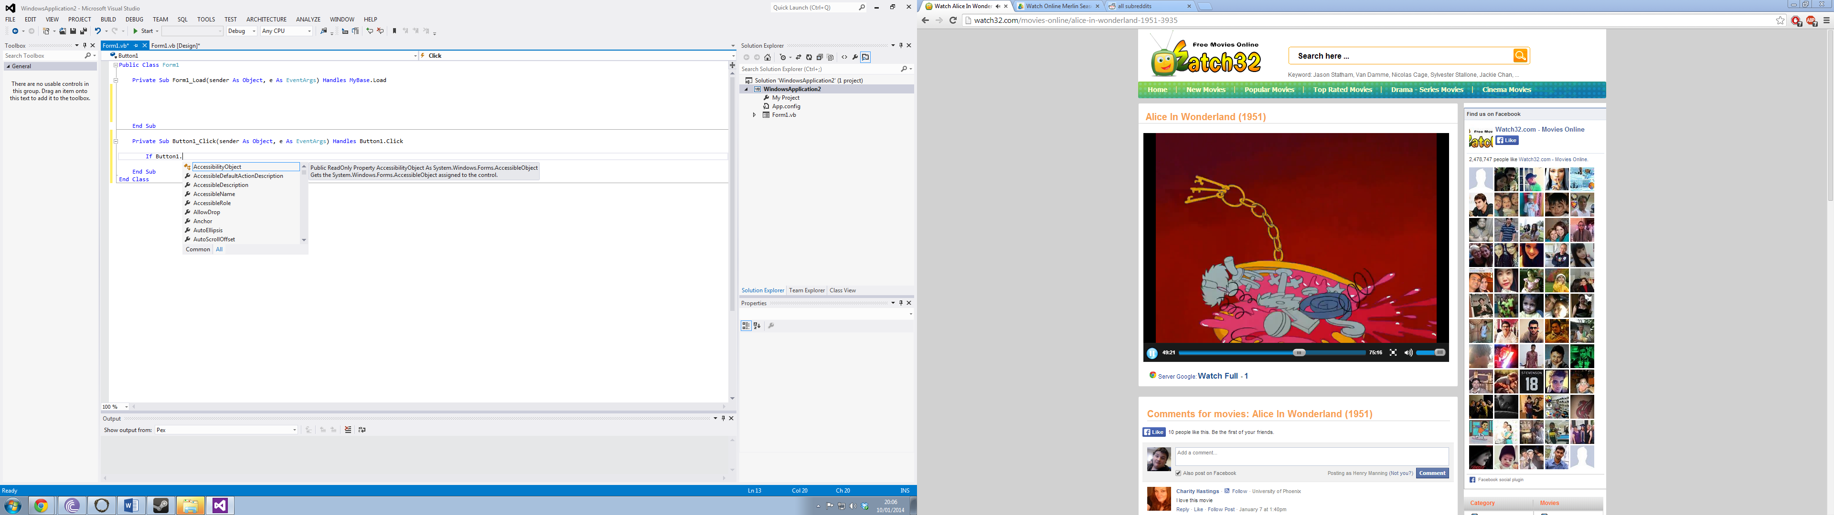

This gives the developer more knowledge on how to complete code actions and allows the developer more choices on how to accomplish their code goal. Another example of this is that there is more than one way to create a message box. The first way is by using the “Messagebox” function which can be achieved via the following code snippet:

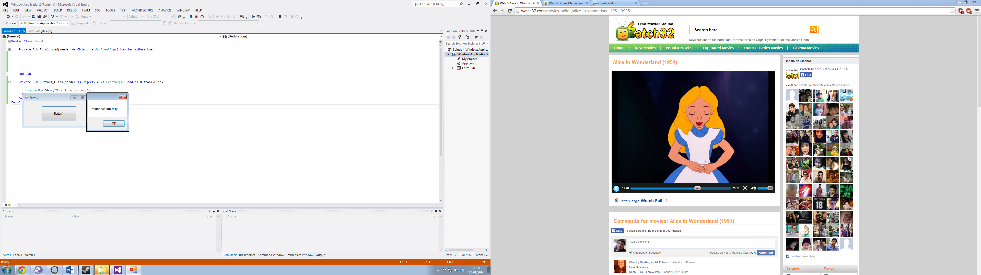

The second way of using a message box is done via the following code snippet accompanied by an image:

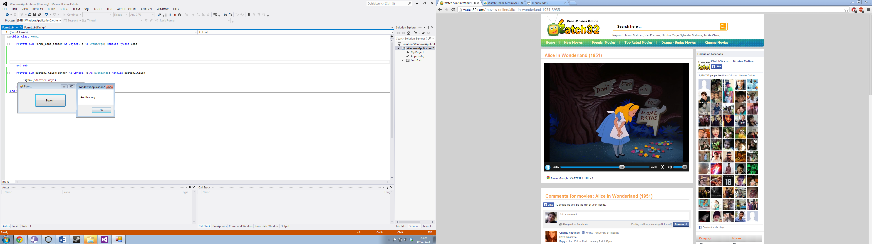

This shows that there are more ways than one to accomplish the code the developer wishes to create. There is no right way to accomplish a task and there is no wrong way to accomplish a task as long as it is the one they wish to do.

VB.net also provides on screen help when there is code written but not to the proper VB.net language. For example the VB.Net Visual Studio programs shows the developer how to do a certain code snippet:

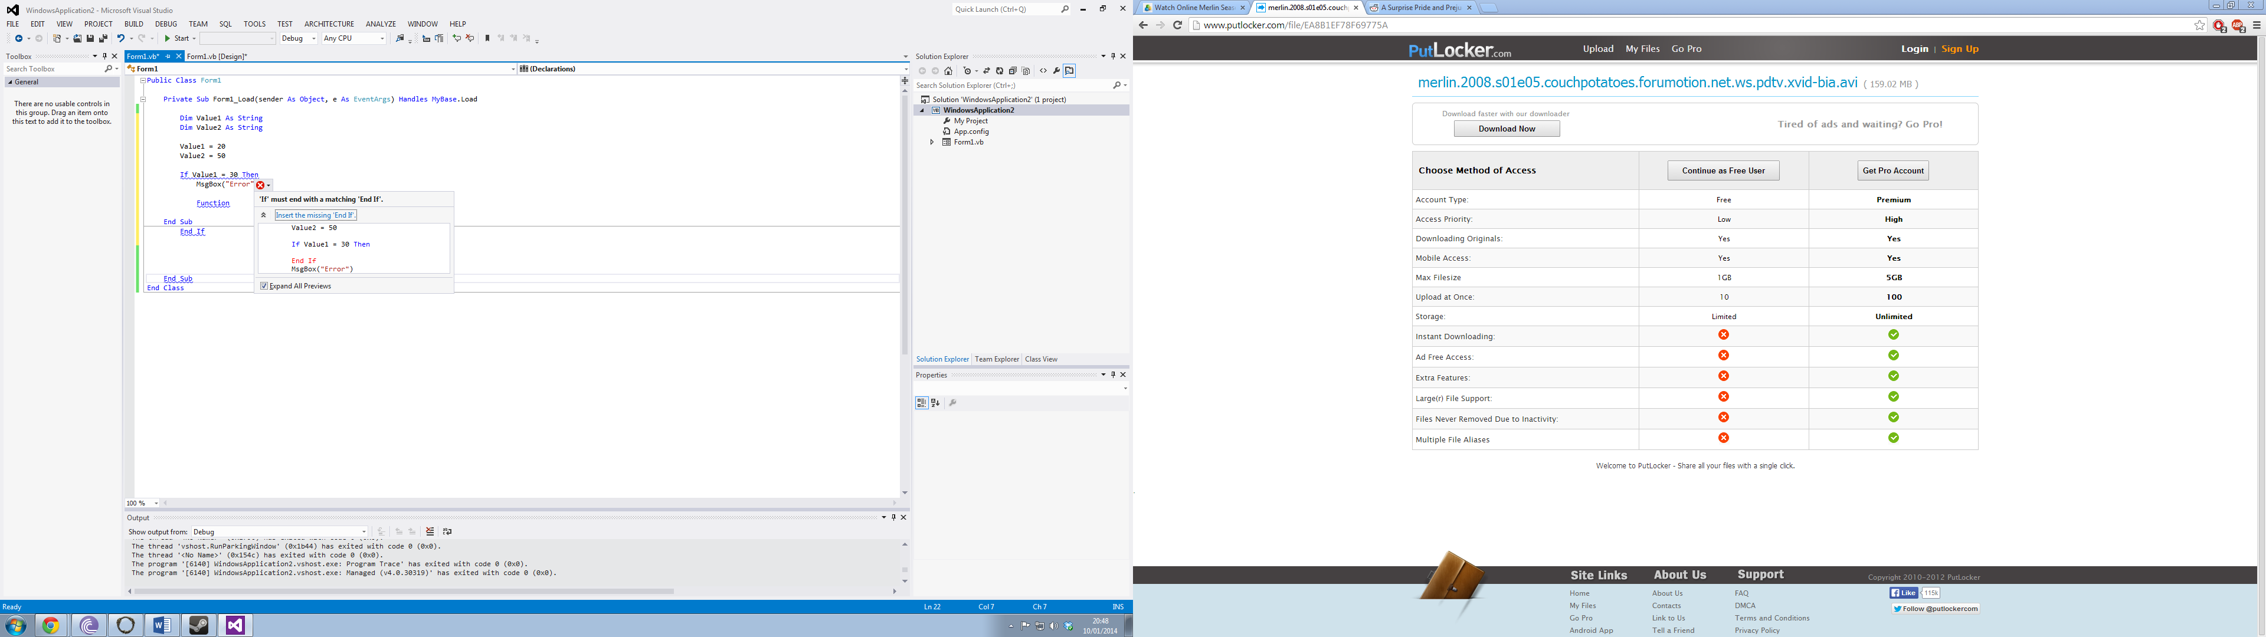

Visual Studio shows the developer how to complete a code snippet with the help of a visual representation as shown above.

In Conclusion, the current system problems gives enough support to create a new program which is a free alternative. The first problem is the cost of the two software applications. They both cost in excess of £2500 each with SMS included which is a lot of money however they do provide other tools such as imaging and file analysis. The problem of cost is fixed via the Postmortem program due to it being free and would save a lot of money in the area of hashing evidence files which included the standard formats.

The second problem which has been discussed is the complexity of the two programs Encase and FTK. Both of the programs require a large amount of training for them to be properly and procedurally correct for clients including lawful situations. The Postmortem program has a solution to that particular problem with it being laid out in an easily navigable layout.

The two problems which can arise from developing the Postmortem program can easily be avoided by using the VB.net frameworks tools and features. Lastly, the developer can append the problems created while developing the application via the Visual Studio help feature.

**Appendix 4 –**

**Feasibility Study**

**Project Title:** Postmortem

**Project Version:** V1.0.0

**Date:** 02/12/2013

**Author:** Henry Manning

**Client/Owner/Sponsor:** Metropolitan Police Service

**The Aim of the Program -**

The aim of the Postmortem program is to provide a free tool to the computer forensic community. The role of the Postmortem program is to allow a computer forensic analyst to hash a file so that the analyst can compare hashes to provide evidence integrity.

**The Programs Scope -**

The scope of the Postmortem program is the current systems which the agency has already installed. The program will correspond with current systems, and the servers which the SQL server of the Microsoft Access. There scope of the program relies on software for it to work on the systems such as the latest .NET Framework and the correct Microsoft Access Database versions because some are not compatible.

**Current Constraints of the Project Program -**

Within the program, there are a few constraints to the functionality of the program. The first constraint of the project is the hash algorithms due to the complexity of the required hash algorithms. The hash algorithms will be the most difficult to implement in the program and they will require the most amount of time to develop. The second constraint of the project is program permissions. The project is only for the use of computer forensics for the Metropolitan Police Service. The program has yet to have any login permissions or HWID to control the use of the program. The HWID function allows the developer of the project to control the distribution of the program.

**The Clients Requirements -**

The requirements set by the client are the following:

1. Connects to a database file or SQL server
2. Simple to use
3. Multiple Text Fields
   1. Case Number
   2. Chain of Custody
   3. Date of Hash
   4. Serial ID
   5. Hash Algorithm
   6. Hash Value
   7. Hash Verified Value
   8. Hash Verified (Y/N)
4. Able to hash the file within the program
5. Search features
   1. Search Hash
   2. Search Case Number
6. Load and save features
7. Easy to use the hashing process

The client requirements are very important to the project because they are what the client actually wants in the program. If any of the requirements are not met, this will cause the client to refuse the program.

**Cost Benefit Analysis -**

The cost of creating the program Postmortem will be zero. The creation of the program will be free to the Metropolitan Police Service for the initial service. However, the agreement of the transfer of program will be free when the project has been completed. Once the program has been transferred to the client, it will then cost the developer to add updates to the programs through an update server which requires the internet.

**Conclusion to the Feasibility Report -**

The project itself is very feasible. The requirements set by the client can be met, if the developer puts his time to do it properly and succeeds, and then the feasibility of the program would be fine. However, there are many aspects of the program which are bordering the feasibility issue. However, one of the requirements isn’t a stone requirement as it relies on the person’s knowledge of the program that is the second requirement which requires the program to be simple to use. Overall, the requirements and the aim of the project are feasible.

**Appendix 5 –**

**Quality Assurance**

When the Postmortem program has been created, it needs to meet certain standards for it being used in a Computer Forensic environment. The first area of quality assurance is in making sure it meets the legal requirements for its use in a court of law. The main UK law which governs the computer forensic side of evidence is based in the Police and Criminal Act 1984. This law has already been discussed and analysed in the requirements section of this project document.

An International organisation called International Organisation on Computer Forensics also provides and works with national police service units on establishing compatible international standards covering seizure of evidence.

In the United Kingdom there is one main procedure with dealing with computer forensics which is called “Good Practice Guide for Computer Based Electronic Evidence”. There are four main principles which gives Postmortem more quality assurance and is dependent on the forensic analyst:

1. No action taken by law enforcement agencies or their agents should change data held on a computer or storage media which may subsequently be relied upon in court.
2. In circumstances where a person finds it necessary to access original data held on a computer or on storage media, that person must be competent to do so and be able to give evidence explaining the relevance and the implications of their actions.
3. An audit trail or other record of all processes applied to computer-based electronic evidence should be created and preserved. An independent third party should be able to examine those processes and achieve the same result.
4. The person in charge of the investigation (the case officer) has overall responsibility for ensuring that the law and these principles are adhered to.

(Wilkinson, 2013)

From these four principles, the actions of the forensic analyst make the program quality assured or if they don’t follow the principles, they will make the program unassured due to their misconduct.

The third principle is directly connected to the program via a chain of custody. Chain of custody is a procedure where if evidence is taken from the crime scene, it must be recorded who has taken it, labelled the evidence and present it to an evidence lockup where the evidence is again, checked that it matches the original description. A chain of custody is used to have no evidence tampering or any discrepancies to the evidence integrity. In the Postmortem program, one of the requirements was to have a chain of custody layout. The chain of custody layout would provide the analyst areas to enter their name, officer number, date and time. A full chain of custody paper trail is very important in keeping a case water tight. A further quality assurance aspect on this is that when there is evidence, another officer or superior has to be with the analyst at all times in case there is very explicit images such as Level 1, 2, 3, 4 or 5 child abuse images, the higher the level being the more graphic. When there is another officer or superior with the forensic analyst, they also have to report what they see and pull from the data which creates for assurance of the quality of data being used for prosecution or defence purposes.

The second area which needs to have quality assurance is the hashing process. The hashing algorithms can be done in two parts. When the analyst selects the file location of the evidence file, they will select the algorithm they wish to choose such as MD5 or SHA1. When they click on the hash process, the program will then hash the file which in turn gives out a MD5 or SHA1 hash value into a textbox or a message box. This creates a hash value but this still needs to be quality assured to see if it’s correct. To confirm that it is the same value, the program Postmortem will hash the same file again which just like the first time, will provide a hash value. The key to making sure they are both the same is to compare both of the values. This can be done by using code such as the following code snippet:

If txtboxHashVerified.Text = txtboxHashValue.Text Then

Dim BoxMsg As DialogResult

Dim Message1 As String = "HASHES ARE VERIFIED"

Dim MsgBoxTitle2 = "Successfull Hash Verification"

BoxMsg = MessageBox.Show(Message1, MsgBoxTitle2)

txtboxHashVerified.ForeColor = Color.Green

ListBoxEvent.Items.Add("MD5 hash verification process has been completed - VERIFIED")

Else

What the above code snippet does for quality assurance is three aspects. The first is making sure the values equals each other, this can be done by using the “=” method by comparing the two textboxes, if they do equal each other in values then it will begin the verify process. The second aspect is if it is verified, it will show a message box with overloading features, saying it is confirmed and verified. The last and third aspect is providing a visual to the analyst by turning the hash colour in the textbox green. This increases the quality assurance by allowing the analyst to verify the hash by hashing it again with complementary features such as a green colour and a messagebox plus an event log saying that is has been verified.

The program Postmortem needs to be created in a way which guarantees quality in the information it provides to the forensic analyst. A method which can be used is Code Signing. Code signing is where there is signed executables and scripts which are used to confirm the creator of the software. This provides proof to the user of the program that the code has not been altered with or changed since being released.

If the Postmortem has been code signed then it provides many features to the program. The first feature of code signing is to provide security when deploying the software to the clients. The second feature it brings to the Postmortem program is to help avoid namespace conflicts in the VB application. The third feature of code signing is that it brings a signature mechanism which verifies the identity of the build or creator of the program. The last feature of code signing is a checksum tool which verifies the build of the Postmortem program. If the program has been modified, then the checksum will not match with the build which will show the analyst that the build has been tampered with and is not safe to use for forensic uses. By having the Postmortem code signed, this makes the program more quality assured due to the security of having a protected program which can’t be tampered with. If the program has been tampered, it can be directed to alter files and destroy evidence.

**Appendix 6 –**

**Proposed Solutions**

There are many ways to create the Postmortem application. Each solution will be discussed and analysed to see if it is suitable and if the developer can add features gained from each solution to the final version. The two solutions will first be briefly discussed and then will be analysed thoroughly.

**First Solution:**

The first solution of the Postmortem program is VB.net. Visual Basic is a programming language in the .NET framework and allows users to have visual applications based on it. Within VB.net, the developer is able to have their own cryptography libraries varying from MD5, SHA and AES encryption and algorithm technology.

**Second Solution:**

The second solution of the Postmortem program is C++. C++ is another programming language within the .net framework however compared to VB.net it is not a visual language but visual C++ is. A C++ console program looks like a DOS program in the command prompt.

**First Solution Analysed:**

The first solution which has been provided is VB.net. Within VB.net there are many MD5 and SHA1 libraries which give the developer the opportunity to have algorithms in the application.

The main library which the developer will be using is System.Security.Cryptography. This library provides support for encoding of data, decoding of data and many cryptographic services.

The library offers a large amount of support for cryptography uses, this opens up a large amount of algorithms which the software developer is able to use. The three main security algorithms which can be implemented into the Postmortem program are:

1. AES
2. MD5
3. SHA1

Within the Security library, there is the AES class. Within the AES Class, the developer is able to implement AES hashing. There are many different AES sizes which range from: 1bit, 2bit, 4bit, 8bit, 16bit, 32bit, 64bit, 128 bit and 256bit with 256 being the most secure. From different block sizes of AES, this becomes an issue with security and relevant data protection laws. A 16bit AES encryption key allows a possible 65536 combinations and a 256bit encryption provides 1.1 x 10^77 possible combinations. However, AES 128bit or AES 256bit have never been cracked because it would take quantum computing for that to be possible. (Arora, 2012) Furthermore, the AES class in the VB.net library allows the developer to choose their block size thus making it readily available for 256bit or 128bit hashing.

The most important hashing algorithm for forensic computing is MD5. Just like AES, the VB.net programming language has a MD5 library available to the developer. The libraries provided by Microsoft make it much easier to implement cryptography into applications through those libraries.

To implement an instance of MD5 into a VB.net application, the developer would use the MD5 class. An example of how it is implemented into a VB application:

'Declaration

Public Shared Function Create As MD5

The features of the MD5 class is very big and provides many tools for the developer to use to fully implement the class. VB.net is a very good provider of such methods and functions. A table showing the methods, properties, fields and functions is provided below.

|  |  |
| --- | --- |
| **Name** | **Description** |
| Initialize | Initializes an implementation of the HashAlgorithm class. |
| ComputeHash(Byte()) | Computes the hash value for the specified byte array. |
| ComputeHash(Stream) | Computes the hash value for the specified Stream object. |
| ComputeHash(Byte(), Int32, Int32) | Computes the hash value for the specified region of the specified byte array. |
| Hash | Gets the value of the computed hash code. |
| HashSize | Gets the size, in bits, of the computed hash code. |
| Equals(Object) | Determines whether the specified object is equal to the current object. |
| HashSizeValue | Represents the size, in bits, of the computed hash code. |
| HashValue | Represents the value of the computed hash code. |

(MSDN Microsoft, 2013)

The above table shows that the VB.net has large support for cryptography as it is a very important issue in software programs and development.

The third and last algorithm which will be implemented into the Postmortem application is SHA1. The SHA1 algorithm is implemented the same way as MD5 and AES, through initialising it in the applications source code:

Public MustInherit Class SHA1 _

Inherits HashAlgorithm

The same methods, functions, fields and properties are available to the developer as well as MD5. SHA1 is a less secure hash against MD5 and AES being AES the most secure, as long as it is 128bit or more. Below is a table of how fast it is to brute force a SHA1 hash.

|  |  |  |
| --- | --- | --- |
| **Algorithm** | **Character Size** | **Time Taken To Decrypt** |
| SHA1 | 1-6 | 41 Minutes |

(Carvell, 2010)

However, the same context applies to all hashing techniques, if the evidence is tampered, the hash value is different from the original one. Thus making it still relevant to the forensic tools.

The VB.net solution for the Postmortem application will be done in VB.net thus making use of the visual properties of the VB.net application. The base visual application looks like the following image:

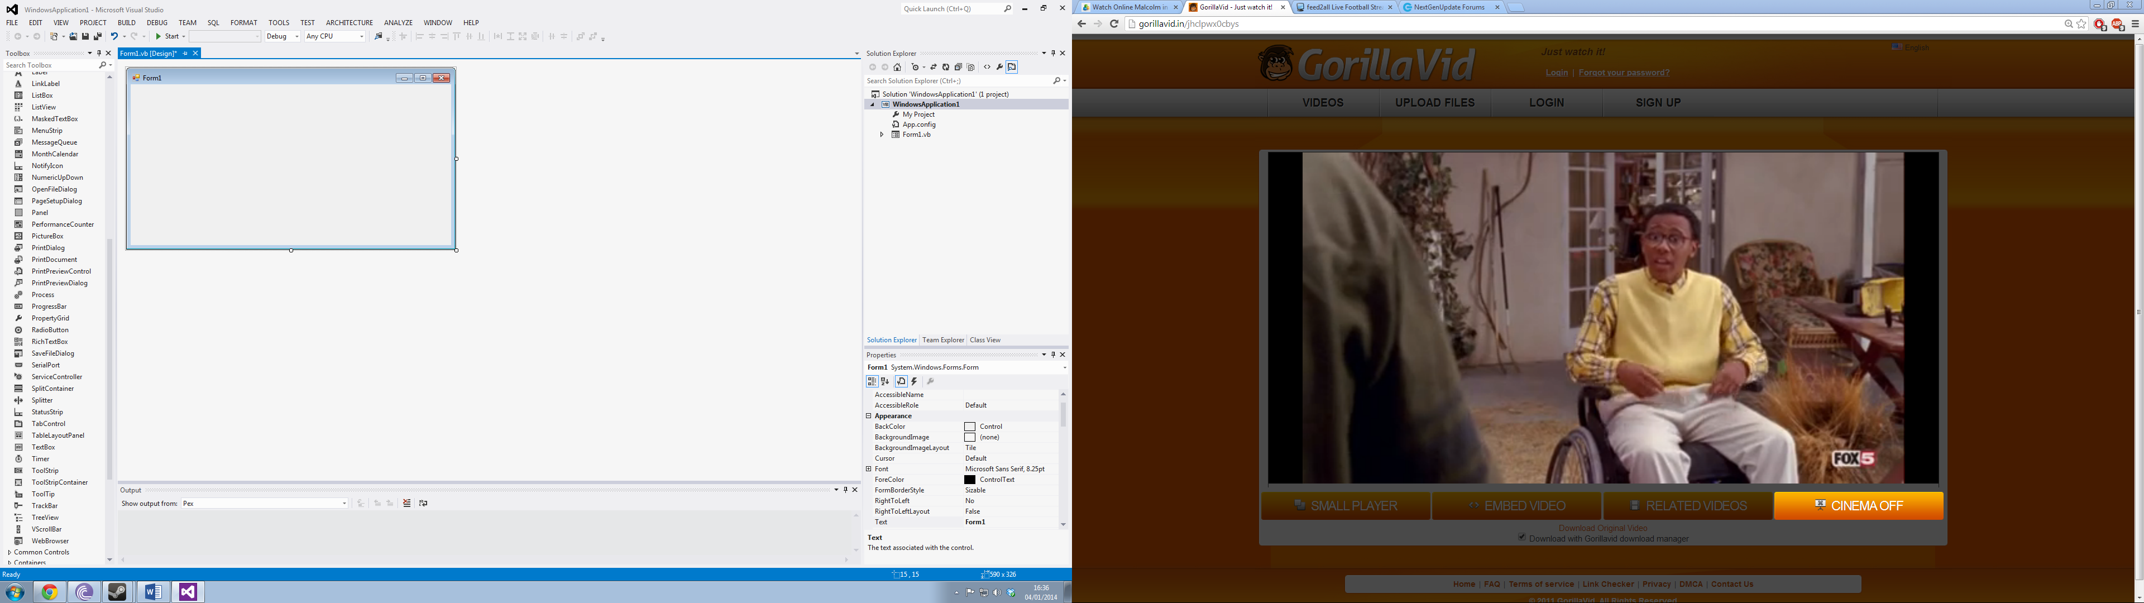

From the form application, the developer can add buttons, add graphs and add visual effects to the program which processes are taking place.

In this solution to the Postmortem project, the developer will use the following components of VB.net:

1. Buttons
2. Labels
3. GroupBox
4. MenuStrip
5. ProgressBar
6. TextBox
7. PrintPreviewControl
8. PrintDialog

Another solution to the Postmortem project is how all of the VB.net components will come together. Below is a simple design of how the Postmortem program can look like. \**subject to change*

Menu Bar

Algorithm Choices

Hashing Options and captions

Hash

The last and an important part of the software application is the database accessibility. For the application to fully utilise Microsoft Access, the developer will be using ADO.net to connect to the Access database.

The simplest method to connect to the Access Database is the following code snippets which are implemented by the developer:

**Connection Object:**

Dim con As New OleDb.OleDbConnection

**Connection String:**

Dim dbProvider As String

Dim dbSource As String

dbProvider = "PROVIDER=Microsoft.Jet.OLEDB.4.0;"

dbSource = "Data Source = DATABASELOCATION"

con.ConnectionString = dbProvider & dbSource

**Or**

con.ConnectionString = "PROVIDER=Microsoft.Jet.OLEDB.4.0;Data Source = DATABASELOCATION"

**Opening and Closing the Connection:**

Con.Open()

Con.Close()

The first solution offers many ways of how to connect to a database which is an important client requirement. As well as offering ways to connected to a database, the VB.net solution to the Postmortem program is a good one. The solution provides three types of hashing cryptography to the forensic analyst; AES, MD5 and SHA1. The analyst can chose which evidence files to encrypt depending on how important said evidence is. The first solution is a very good way on how the program will look and operate.

**Second Solution Analysed:**

The second solution provided for the Postmortem project is by using C++. Microsoft not only provide libraries for VB.net, they also provide the System.Security.Cryptography for C++ as well.

The System.Security.Cryptography library offers a large amount of support for cryptography uses, this opens up a large amount of algorithms which the software developer is able to use. The three main security algorithms which can be implemented into the Postmortem program are:

1. AES
2. MD5
3. SHA1

Within the Security library, there is the AES class. Within the AES Class, the developer is able to implement AES hashing. There are many different AES sizes which range from: 1bit, 2bit, 4bit, 8bit, 16bit, 32bit, 64bit, 128 bit and 256bit with 256 being the most secure. From different block sizes of AES, this becomes an issue with security and relevant data protection laws. A 16bit AES encryption key allows a possible 65536 combinations and a 256bit encryption provides 1.1 x 10^77 possible combinations. However, AES 128bit or AES 256bit have never been cracked because it would take quantum computing for that to be possible. (Arora, 2012) Furthermore, the AES class in the C++ library allows the developer to choose their block size thus making it readily available for 256bit or 128bit hashing.

The most important hashing algorithm for forensic computing is MD5. Just like AES, the C++ programming language has a MD5 library available to the developer. The libraries provided by Microsoft make it much easier to implement cryptography into applications through those libraries.

To implement an instance of MD5 into the C++ console application, the developer would use the MD5 class. An example of how it is implemented into a C++ application:

[ComVisibleAttribute(true)]

public ref class MD5 abstract : public HashAlgorithm

The features of the MD5 class is very big and provides many tools for the developer to use to fully implement the class. C++ has a large range of methods and functions. A table showing the methods, properties, fields and functions is provided below.

|  |  |
| --- | --- |
| **Name** | **Description** |
| CanReuseTransform | Gets a value indicating whether the current transform can be reused. |
| InputBlockSize | When overridden in a derived class, gets the input block size. |
| OutputBlockSize | When overridden in a derived class, gets the output block size. |
| ComputeHash(array<Byte>) | Computes the hash value for the specified byte array. |
| Hash | Gets the value of the computed hash code. |
| HashSize | Gets the size, in bits, of the computed hash code. |
| Create() | Creates an instance of the specified implementation of the MD5 hash algorithm. |
| HashSizeValue | Represents the size, in bits, of the computed hash code. |
| HashValue | Represents the value of the computed hash code. |

(MSDN Microsoft, 2013)

The above table shows that the C++ has large support for cryptography as it is a very important issue in software programs and development.

The third and last algorithm which will be implemented into the Postmortem application is SHA1. The SHA1 algorithm is implemented the same way as MD5 and AES, through initialising it in the applications source code:

Public MustInherit Class SHA1 _

Inherits HashAlgorithm

The same methods, functions, fields and properties are available to the developer as well as MD5. SHA1 is a less secure hash against MD5 and AES being AES the most secure, as long as it is 128bit or more. Below is a table of how fast it is to brute force a SHA1 hash.

|  |  |  |
| --- | --- | --- |
| **Algorithm** | **Character Size** | **Time Taken To Decrypt** |
| SHA1 | 1-6 | 41 Minutes |

(Carvell, 2010)

However, the same context applies to all hashing techniques, if the evidence is tampered, the hash value is different from the original one. Thus making it still relevant to the forensic tools.

The second solution is a console application which means it uses DOS of the operating system. The visual application would have a base, that base is the following image:

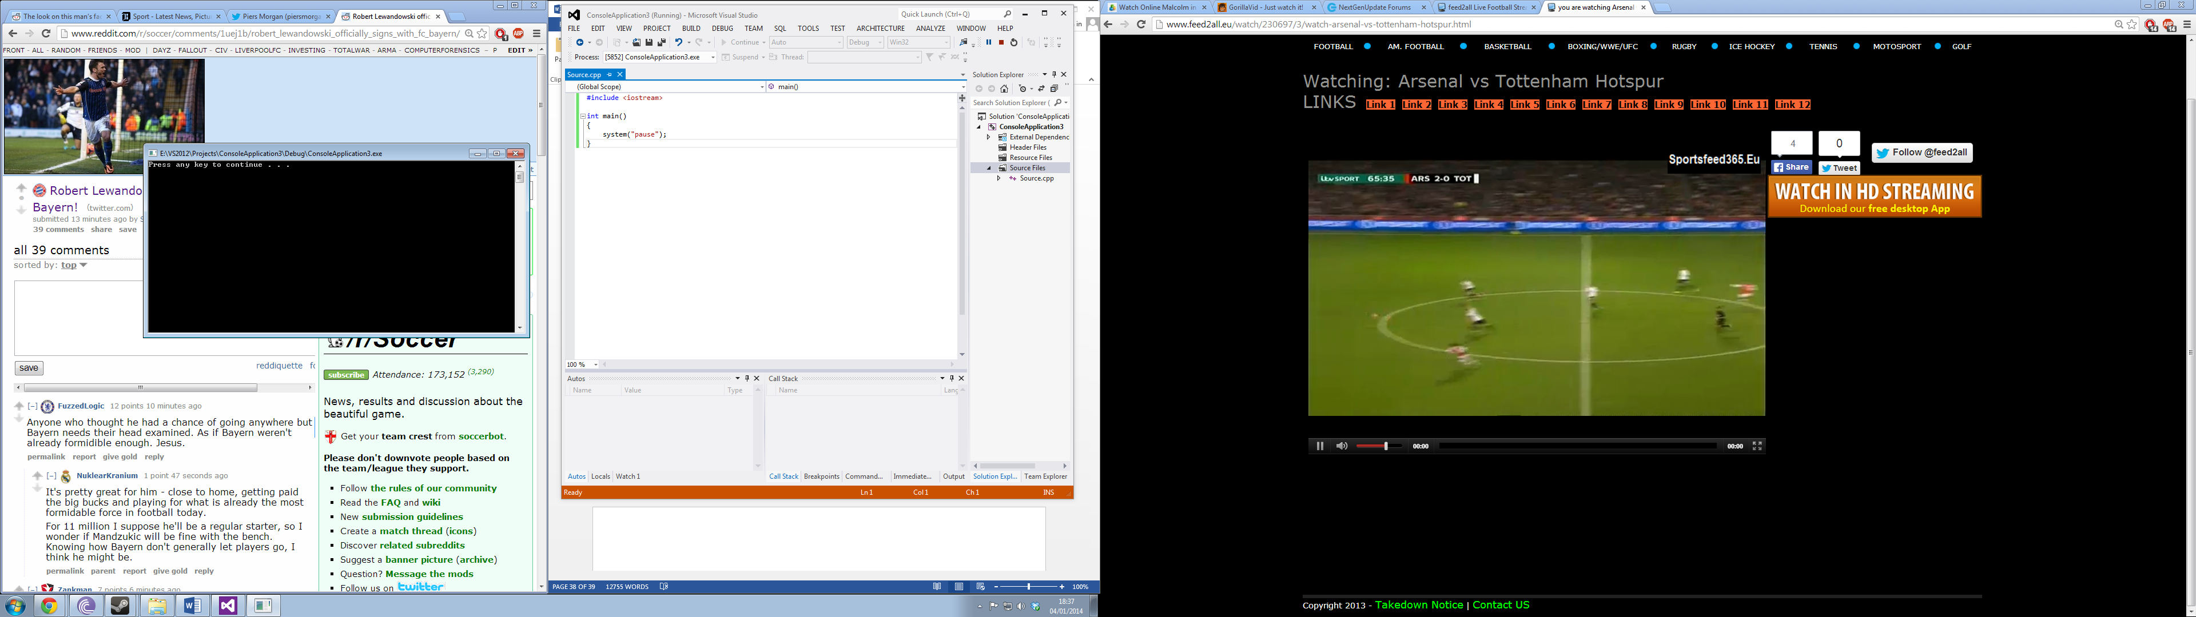

From the base console application, the developer can add options to the software such as a menu.

The menu can have multiple options which include:

1. Hash a file
2. Verify a Hash
3. Connect to database
4. Select Hashing Algorithm

To select the menu options, the client would need to press the corresponding key number on the keyboard. When the key is pressed, this would lead onto another screen which details on how to do what the option is.

The next part of the solution is how the application would look like in C++. Below is an example of how the application could look: *subject to change.

Main Screen:

POSTMORTEM IMAGE

MENU

Hashing Screen:

HASHING

OPTIONS

1. LOCATION
2. DIRECTORY

PROCESSING BOX

The last and an important aspect of the solution is how to connect the C++ application to a database either in SQL or Access. For this solution, it will be done in Access.

For the application to connect to an Access Database it requires a class library. The class library can be Active Template Library or the Microsoft Foundation Library which makes it easier to connect to database API’s.

The ways of accessing a database through C++ can be done via the following code snippets:

**Opening a File:**

HRESULT OpenFromFileName(

LPCOLESTR szFileName

) throw( );

**Loading the Database File:**

OleDbConnection^ conn = gcnewOleDbConnection("Provider=Microsoft.ACE.OLEDB.12.0;Data Source=F:\\Database1.accdb;Persist Security Info=True");

**Connecting the Database File:**

OleDbCommand^ com = gcnew OleDbCommand();

                            com->Connection = conn;

**Connection Data Adapter:**

OleDbDataAdapter^ adapt = gcnew OleDbDataAdapter();

The second solution just like the first solution is able to connect to an Access Database which is a very important client requirement. The second solution also meets all the other requirements however functions such as search and other functions will be on other screens which are also accessed via the menu options. This makes the application less simple to navigate compared to Visual Basic. Again, just like the Visual Basic solution, C++ can also provide hashing functions with MD5, AES and SHA1. Furthermore, the C++ solution meets all the requirements set by the client however, the last requirement being simplicity barely meets the criteria. Comparing the simplicity of VB.net and C++, VB.net is much easier to navigate.

**Appendix 7 –**

**Chosen Solution**

There are many topics which need to be evaluated regarding both solutions. The topics which will be evaluated against both solutions are:

1. Simplicity
2. Does it meet the requirements?
3. Can it connect to a database?
4. All the functions required can be implemented?

The first solution which is the Visual Basic application is simpler than the C++ application. This is due to a couple of reasons, the first is the navigation. The navigation in the VB.net solution is much easier than C++ because the client is able to see all of the options on one screen rather than navigating through other screens to their destination. As well as the advantage of using a mouse instead of keyboard inputs make it much easier to navigate.

Both of the solutions meet the requirements however, stated in the above paragraph, the VB.net requirements are more easily used and implemented.

Furthermore, the VB.net and C++ application are able to connect to an Access database if they so wish. However, there are many ways to connect to an Access database, this can be done through API’s and different methods of connecting in the source code.

Lastly, all of the function can be implemented in the Visual Basic application such as searching, on screen help and hashing however, the feature of searching cannot be done in the C++ application. The search feature in the C++ application will not be implemented due to the first topic of simplicity. It will be too difficult for the client to search for hashes via a console application.

As a conclusion, the proposed solution of C++ will not be considered due to one main factor which is simplicity for the client. Instead, the Postmortem program will be created in Visual Basic to make it more interactive and simpler for the client to use.

**Appendix 8 –**

**The Project Plan**

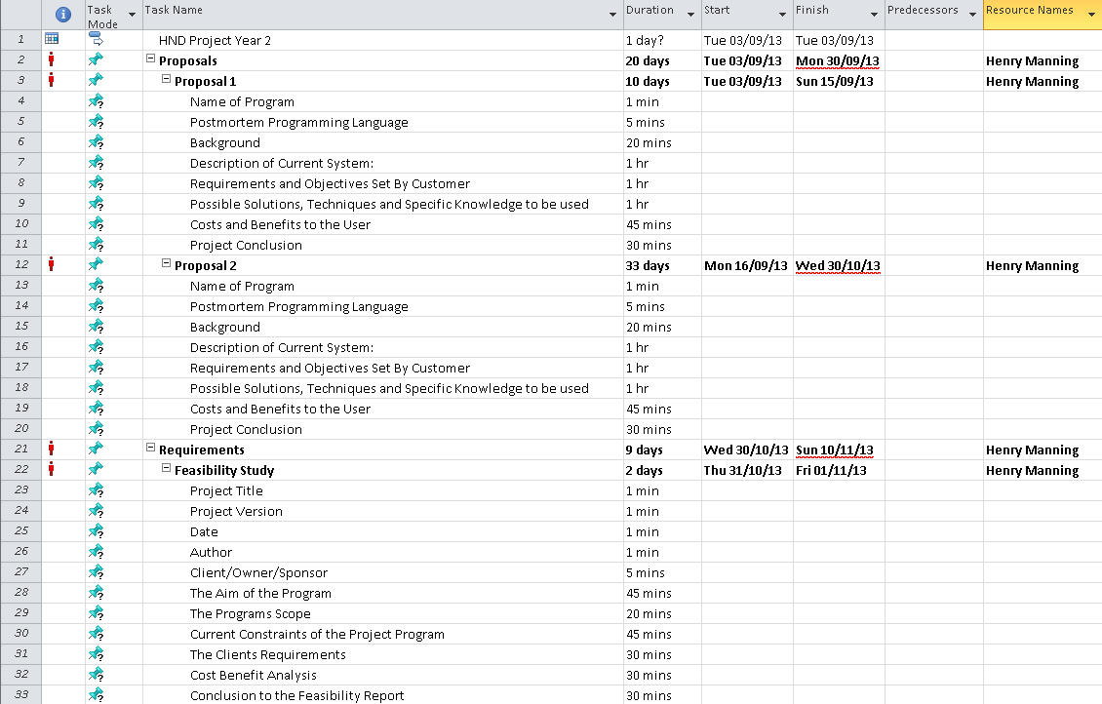

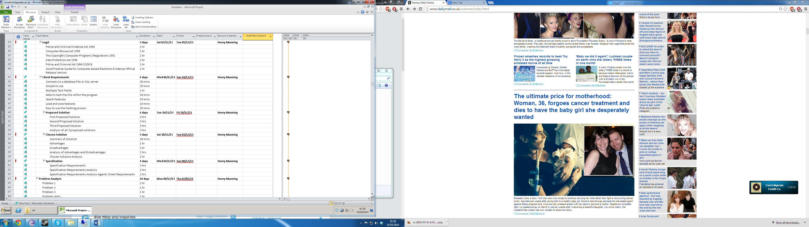

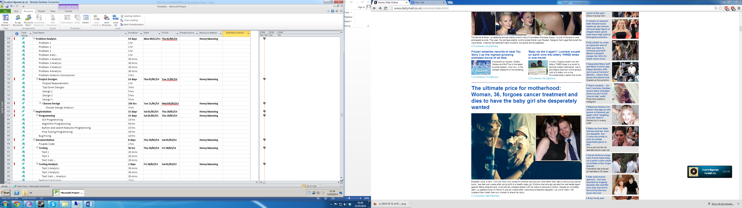

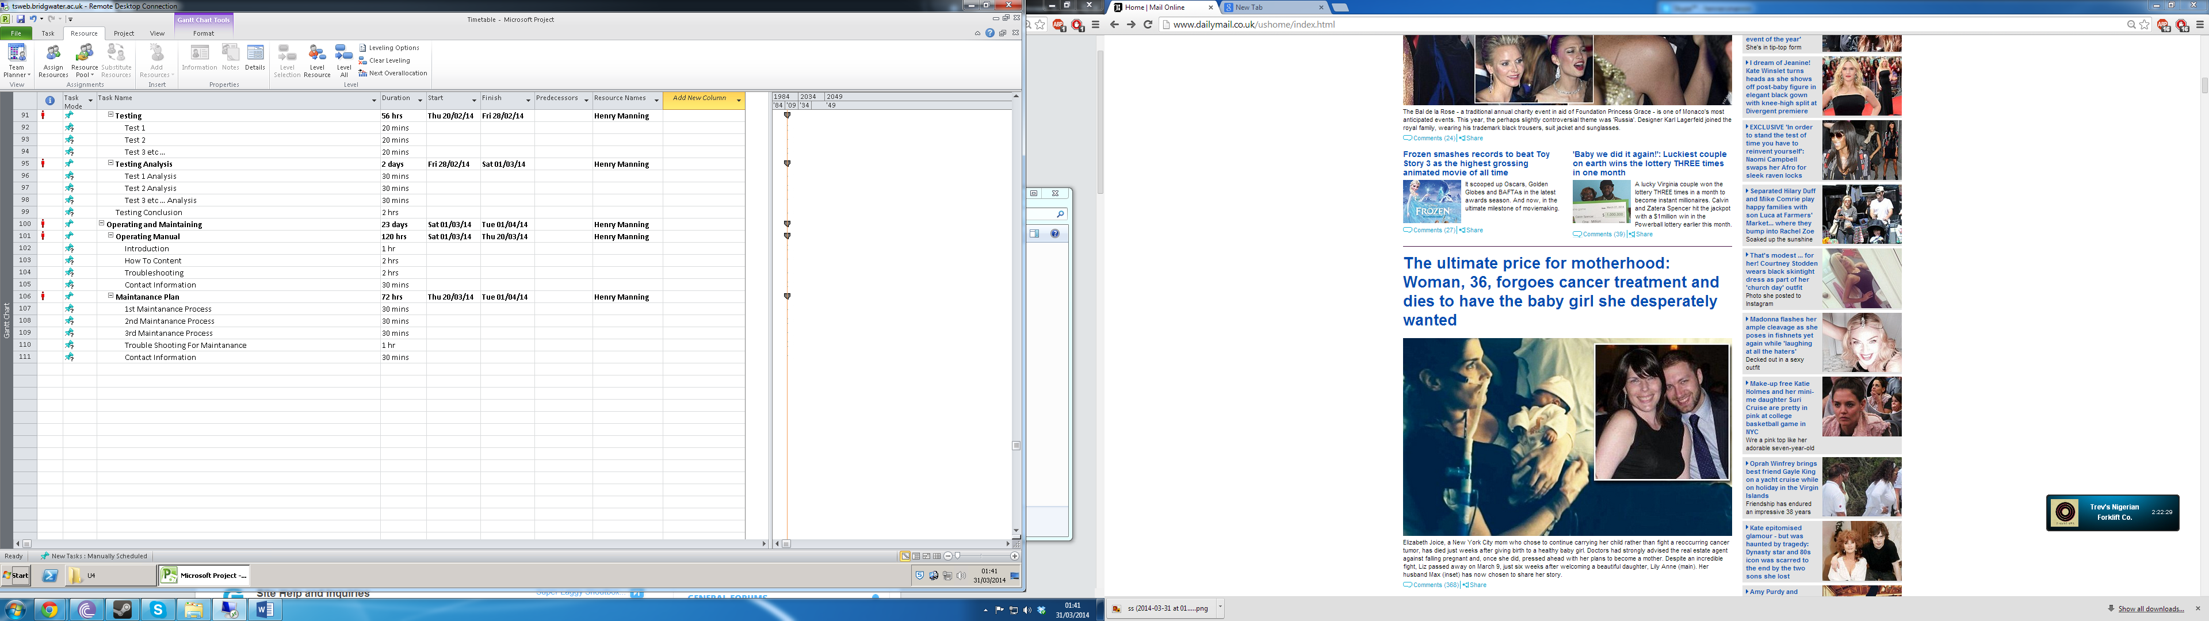



**Appendix 9 –**

**Designs**

Code Designs –

* Algorithms
  + MD5
  + SHA1
  + SHA256
  + SHA384
* Buttons
  + Browse for database
  + Load the database
  + First record
  + Previous record
  + Next record
  + Delete record
  + Search case number
  + Search hash number
  + Browse for evidence file
  + Load the evidence file
  + Hash file
  + Hash file again
  + Verify hash
  + Input information
  + Export Verification To Database
* Radio Buttons
  + MD5
  + SHA1
  + SHA256
  + SHA384
* List Box
  + Event Log
* Text Boxes
  + Database location
  + Evidence ID
  + Case number
  + Chain of custody
  + Date of hash
  + Serial ID
  + Hash algorithm
  + Hash value
  + Hash value 2
  + Hash verified value
  + Verified
  + Search hash
  + Search case number
  + File location
  + Enter case number
  + Enter chain of custody
  + Enter Serial ID
  + Hash value result
  + Hash value verified result
* Postmortem Form
  + Imports
* Variables
  + Global Variables
  + Database variables
* UML Diagrams
  + Logging into Postmortem
  + Connecting to Database
  + Navigation of Database
  + Selecting Evidence File
  + Hashing Evidence File
  + Exporting Evidence To Database

**Algorithms –**

The four algorithms being used are from the same namespace library. The four algorithms also use the same functions and methods thus making them pretty much the same as the others. This can make it look like they are the same algorithm but in reality, they are completely different.

**MD5:** The MD5 algorithm in the VB.net application is dependent on an import name space. The namespace is called “Cryptography”. To import this namespace, in the form there needs to be an import function. In the application it looks like the following code snippet:

Imports System.Security.Cryptography

Within that namespace, there are hundreds of classes and libraries. The class which the MD5 algorithm requires is the MD5 class.

To start the design process, the import namespace would need to be included into the form. Once the namespace has been included, to start the process of implementing the MD5 class there needs to be a new provider.

The provider needs to be a new variable which will be named “MD5”. The MD5 variable while then be declared as a new provider and the code to this will be the following code snippet:

Dim MD5 As MD5CryptoServiceProvider = New MD5CryptoServiceProvider

The above code does two things; it firsts declares MD5 as an MD5CryptoServiceProvider and then starts a new instance of it by equalling it to New MD5CryptoServiceProvider.

Once, the MD5 has been initialised, the algorithm needs to have a file stream which will allow the program to open access and read the file which will be hashed. To start the file streaming, a file stream needs to be implemented into the program. This will be done using the FileStream data type:

Dim FileStreamMD5 As FileStream = New FileStream

The above code declares “FileStreamMD5” as the variable name for the file stream but there also needs to be parameters of the file stream. These parameters are used to open the file, access the file and read the file. The parameters being implemented are:

(Filelocation, FileMode.Open, FileAccess.Read, FileShare.Read)

The “filelocation” is the location of the evidence file which is going to be hashed. Together, the initialising string and parameters of the algorithm will look like the following code snippet:

Dim FileStreamMD5 As FileStream = New FileStream(Filelocation, FileMode.Open, FileAccess.Read, FileShare.Read)

Once the file stream has been implemented into the program, the MD5 function needs to be implemented. There will be two methods being used with the MD5 function. To start this process, the MD5 provider needs to be connected with the File stream so that is will open the file then hash the file. The first code implementation will be the MD5 this is done by using the “ComputerHash” function. The code looks like the following code snippet:

MD5.ComputeHash(FileStreamMD5)

The ComputeHash is a method which is coming from the MD5 provider which means that the program will compute a hash of the MD5 library. The parameter is the FileStream because it has the location of the file going to be hashed so it is all done in one line. The next code design is to close the filestreamMD5. This would look like the following code snippet:

FileStreamMD5.Close()

The FileStream can then be closed once the operation has been completed which allows other algorithms to open their FileStream to hash a file when chosen.

Once the computed hash has been completed, the hash now needs to be retrieved. This can be done using the byte data type. The MD5 provider will also be used by adding a parameter to it. The code snippet would look like the following:

Dim HashByte As Byte() = MD5.Hash

The next stage to receive the computed hash code is to implement a string builder. The string builder creates the hash which is just a string of characters. To implement the StringBuilder is the following code snippet:

Dim HashBuff As StringBuilder = New StringBuilder

The third stage to start the hash receiving process is to declare a byte. The declaration being used is of the data type byte. This can be done by using the following code snippet:

Dim ByteHash As Byte

To finalise the hash string, there needs to be many methods and functions so that the client can retrieve the hash. The first aspect to implement is the ByteHash variable into the HashByte value. The HashByte value has the hash and is in a byte format. The HashBuff is then used with the ByteHash using the “Append” method. This code would look like the following snippet:

For Each ByteHash In HashByte

HashBuff.Append(String.Format("{0:X2}", ByteHash))

Next

The above code appends the value of the HashByte to a string. Once it has done that function it will go to the next part of the algorithm which is putting the HashBuff into a usable string format.

To implement the string the following code snippet will be used:

Dim MD5String As String

The above code declares the variable “MD5String” as a string data type which can then be used for functions. The HashBuff which stores the hash value from the original hash and computer hash methods would now be transferred to a string using another method. The method being used is the “ToString” method which converts the HashBuff value into a usable string. To do this, the code snippet will be the following:

MD5String = HashBuff.ToString()

The above MD5String now stores the visible and usable string value which can be used to do many functions. They can be used in textboxes, background workers and other properties, in this situation; they will be used in background workers. To finalise the exportation of the string, the result needs to be represented for an asynchronous operation. The code snippet to do that is the following code:

e.Result = MD5String

Once the above code has been implemented, the algorithm has been fully implemented into the program.

The MD5 algorithm is a very common algorithm used in the computer forensic complex. It is used to keep evidence integrity via hashing the file. If the hash has changed since its original hash, it has been compromised.

MD5 Time Test:

|  |  |
| --- | --- |
| **File Size:** | **Time Taken To Hash:** |
| 1.5GB | 9.4 Seconds |
| 7.8GB | 47.5 Seconds |
| 14.4GB | 1 min 28.5 Seconds |

**SHA1:** The SHA1 algorithm in the VB.net application is dependent on an import name space. The namespace is called “Cryptography”. To import this namespace, in the form there needs to be an import function. In the application it looks like the following code snippet:

Imports System.Security.Cryptography

Within that namespace, there are hundreds of classes and libraries. The class which the SHA1 algorithm requires is the SHA1 class.

To start the design process, the import namespace would need to be included into the form. Once the namespace has been included, to start the process of implementing the SHA1 class there needs to be a new provider.

The provider needs to be a new variable which will be named “SHA1”. The SHA1 variable while then be declared as a new provider and the code to this will be the following code snippet:

Dim SHA As SHA1CryptoServiceProvider = New SHA1CryptoServiceProvider

The above code does two things; it firsts declares SHA1 as a SHA1CryptoServiceProvider and then starts a new instance of it by equalling it to New MD5CryptoServiceProvider.

Once, the SHA1 has been initialised, the algorithm needs to have a file stream which will allow the program to open access and read the file which will be hashed. To start the file streaming, a file stream needs to be implemented into the program. This will be done using the FileStream data type:

Dim FileStreamSHA As FileStream = New FileStream

The above code declares “FileStreamSHA” as the variable name for the file stream but there also needs to be parameters of the file stream. These parameters are used to open the file, access the file and read the file. The parameters being implemented are:

(Filelocation, FileMode.Open, FileAccess.Read, FileShare.Read)

The “filelocation” is the location of the evidence file which is going to be hashed. Together, the initialising string and parameters of the algorithm will look like the following code snippet:

Dim FileStreamSHA As FileStream = New FileStream(Filelocation, FileMode.Open, FileAccess.Read, FileShare.Read)

Once the file stream has been implemented into the program, the SHA1 function needs to be implemented. There will be two methods being used with the SHA1 function. To start this process, the SHA1 provider needs to be connected with the File stream so that is will open the file then hash the file. The first code implementation will be the SHA1this is done by using the “ComputerHash” function. The code looks like the following code snippet:

SHA.ComputeHash(FileStreamSHA)

The ComputeHash is a method which is coming from the SHA1 provider which means that the program will compute a hash of the SHA1 library. The parameter is the FileStream because it has the location of the file going to be hashed so it is all done in one line. The next code design is to close the filestreamSHA. This would look like the following code snippet:

FileStreamSHA.Close()

The FileStream can then be closed once the operation has been completed which allows other algorithms to open their FileStream to hash a file when chosen.

Once the computed hash has been completed, the hash now needs to be retrieved. This can be done using the byte data type. The SHA1 provider will also be used by adding a parameter to it. The code snippet would look like the following:

Dim SHAHashByte As Byte() = SHA1.Hash

The next stage to receive the computed hash code is to implement a string builder. The string builder creates the hash which is just a string of characters. To implement the StringBuilder is the following code snippet:

Dim SHAHashBuff As StringBuilder = New StringBuilder

The third stage to start the hash receiving process is to declare a byte. The declaration being used is of the data type byte. This can be done by using the following code snippet:

Dim SHAByteHash As Byte

To finalise the hash string, there needs to be many methods and functions so that the client can retrieve the hash. The first aspect to implement is the SHAByteHash variable into the SHAHashByte value. The SHAHashByte value has the hash and is in a byte format. The SHAHashBuff is then used with the SHAByteHash using the “Append” method. This code would look like the following snippet:

For Each SHAByteHash In SHAHashByte

SHAHashBuff.Append(String.Format("{0:X2}", SHAByteHash))

Next

The above code appends the value of the SHAHashByte to a string. Once it has done that function it will go to the next part of the algorithm which is putting the SHAHashBuff into a usable string format.

To implement the string the following code snippet will be used:

Dim shaString As String

The above code declares the variable “SHAString” as a string data type which can then be used for functions. The SHAHashBuff which stores the hash value from the original hash and computer hash methods would now be transferred to a string using another method. The method being used is the “ToString” method which converts the SHAHashBuff value into a usable string. To do this, the code snippet will be the following:

SHAString = SHAHashBuff.ToString()

The above SHAString now stores the visible and usable string value which can be used to do many functions. They can be used in textboxes, background workers and other properties, in this situation; they will be used in background workers. To finalise the exportation of the string, the result needs to be represented for an asynchronous operation. The code snippet to do that is the following code:

e.Result = SHAString

Once the above code has been implemented, the algorithm has been fully implemented into the program.

The SHA1 hashing algorithm was designed by the NSA and was published by NST. SHA1 outputs a 160bit digest of any size and any file. It has the same construction as MD4 and MD5 and uses the same initial hash sizes.

SHA1 Time Test:

|  |  |
| --- | --- |
| **File Size:** | **Time Taken To Hash:** |
| 1.5GB | 4.3 Seconds |
| 7.8GB | 47.1 Seconds |
| 14.4GB | 1 min 27.2 Seconds |

**SHA256:** The SHA256 algorithm in the VB.net application is dependent on an import name space. The namespace is called “Cryptography”. To import this namespace, in the form there needs to be an import function. In the application it looks like the following code snippet:

Imports System.Security.Cryptography

Within that namespace, there are hundreds of classes and libraries. The class which the SHA256 algorithm requires is the SHA256 class.

To start the design process, the import namespace would need to be included into the form. Once the namespace has been included, to start the process of implementing the SHA256 class there needs to be a new provider.

The provider needs to be a new variable which will be named “SHA256”. The SHA256 variable while then be declared as a new provider and the code to this will be the following code snippet:

Dim SHA256 As SHA256CryptoServiceProvider = New SHA256CryptoServiceProvider

The above code does two things; it firsts declares SHA256 as a SHA256CryptoServiceProvider and then starts a new instance of it by equalling it to New SHA256CryptoServiceProvider.

Once, the SHA256 has been initialised, the algorithm needs to have a file stream which will allow the program to open access and read the file which will be hashed. To start the file streaming, a file stream needs to be implemented into the program. This will be done using the FileStream data type:

Dim FileStreamSHA256 As FileStream = New FileStream

The above code declares “FileStream SHA256” as the variable name for the file stream but there also needs to be parameters of the file stream. These parameters are used to open the file, access the file and read the file. The parameters being implemented are:

(Filelocation, FileMode.Open, FileAccess.Read, FileShare.Read)

The “filelocation” is the location of the evidence file which is going to be hashed. Together, the initialising string and parameters of the algorithm will look like the following code snippet:

Dim FileStreamSHA256 As FileStream = New FileStream(Filelocation, FileMode.Open, FileAccess.Read, FileShare.Read)

Once the file stream has been implemented into the program, the SHA256 function needs to be implemented. There will be two methods being used with the SHA256 function. To start this process, the SHA256 provider needs to be connected with the File stream so that is will open the file then hash the file. The first code implementation will be the SHA256 this is done by using the “ComputerHash” function. The code looks like the following code snippet:

SHA256.ComputeHash(FileStreamSHA)

The ComputeHash is a method which is coming from the SHA256 provider which means that the program will compute a hash of the SHA256 library. The parameter is the FileStream because it has the location of the file going to be hashed so it is all done in one line. The next code design is to close the filestreamSHA256. This would look like the following code snippet:

FileStreamSHA256.Close()

The FileStream can then be closed once the operation has been completed which allows other algorithms to open their FileStream to hash a file when chosen.

Once the computed hash has been completed, the hash now needs to be retrieved. This can be done using the byte data type. The SHA256 provider will also be used by adding a parameter to it. The code snippet would look like the following:

Dim SHA256HashByte As Byte() = SHA256.Hash

The next stage to receive the computed hash code is to implement a string builder. The string builder creates the hash which is just a string of characters. To implement the StringBuilder is the following code snippet:

Dim SHA256HashBuff As StringBuilder = New StringBuilder

The third stage to start the hash receiving process is to declare a byte. The declaration being used is of the data type byte. This can be done by using the following code snippet:

Dim SHA256ByteHash As Byte

To finalise the hash string, there needs to be many methods and functions so that the client can retrieve the hash. The first aspect to implement is the SHA256ByteHash variable into the SHA256HashByte value. The SHA256HashByte value has the hash and is in a byte format. The SHA256HashBuff is then used with the SHA256ByteHash using the “Append” method. This code would look like the following snippet:

For Each SHA256ByteHash In SHA256HashByte

SHA256HashBuff.Append(String.Format("{0:X2}", SHA256ByteHash))

Next

The above code appends the value of the SHA256HashByte to a string. Once it has done that function it will go to the next part of the algorithm which is putting the SHA256HashBuff into a usable string format.

To implement the string the following code snippet will be used:

Dim SHA256String As String

The above code declares the variable “SHA256String” as a string data type which can then be used for functions. The SHA256HashBuff which stores the hash value from the original hash and computer hash methods would now be transferred to a string using another method. The method being used is the “ToString” method which converts the SHA256HashBuff value into a usable string. To do this, the code snippet will be the following:

SHA256String = SHA256HashBuff.ToString()

The above SHA256String now stores the visible and usable string value which can be used to do many functions. They can be used in textboxes, background workers and other properties, in this situation; they will be used in background workers. To finalise the exportation of the string, the result needs to be represented for an asynchronous operation. The code snippet to do that is the following code:

e.Result = SHA256String

Once the above code has been implemented, the algorithm has been fully implemented into the program.

The SHA256 hashing algorithm operates on a 512bit message block and is a 256bit block cipher. There are two components to the 256 algorithm, the compression function and the 256 message schedule.

SHA256 Time Tests:

|  |  |
| --- | --- |
| **File Size:** | **Time Taken To Hash:** |
| 1.5GB | 13.5 Seconds |
| 7.8GB | 1min 9 Seconds |
| 14.4GB | 2min 6 Seconds |

**SHA384:** The SHA384 algorithm in the VB.net application is dependent on an import name space. The namespace is called “Cryptography”. To import this namespace, in the form there needs to be an import function. In the application it looks like the following code snippet:

Imports System.Security.Cryptography

Within that namespace, there are hundreds of classes and libraries. The class which the SHA384 algorithm requires is the SHA384 class.

To start the design process, the import namespace would need to be included into the form. Once the namespace has been included, to start the process of implementing the SHA384 class there needs to be a new provider.

The provider needs to be a new variable which will be named “SHA384”. The SHA384 variable while then be declared as a new provider and the code to this will be the following code snippet:

Dim SHA384 As SHA384CryptoServiceProvider = New SHA384CryptoServiceProvider

The above code does two things; it firsts declares SHA384 as a SHA384CryptoServiceProvider and then starts a new instance of it by equalling it to New SHA384CryptoServiceProvider.

Once, the SHA384 has been initialised, the algorithm needs to have a file stream which will allow the program to open access and read the file which will be hashed. To start the file streaming, a file stream needs to be implemented into the program. This will be done using the FileStream data type:

Dim FileStreamSHA386 As FileStream = New FileStream

The above code declares “FileStreamSHA384” as the variable name for the file stream but there also needs to be parameters of the file stream. These parameters are used to open the file, access the file and read the file. The parameters being implemented are:

(Filelocation, FileMode.Open, FileAccess.Read, FileShare.Read)

The “filelocation” is the location of the evidence file which is going to be hashed. Together, the initialising string and parameters of the algorithm will look like the following code snippet:

Dim FileStreamSHA384 As FileStream = New FileStream(Filelocation, FileMode.Open, FileAccess.Read, FileShare.Read)

Once the file stream has been implemented into the program, the SHA384 function needs to be implemented. There will be two methods being used with the SHA384 function. To start this process, the SHA384 provider needs to be connected with the File stream so that is will open the file then hash the file. The first code implementation will be the SHA384 this is done by using the “ComputerHash” function. The code looks like the following code snippet:

SHA384.ComputeHash(FileStreamSHA)

The ComputeHash is a method which is coming from the SHA384 provider which means that the program will compute a hash of the SHA384 library. The parameter is the FileStream because it has the location of the file going to be hashed so it is all done in one line. The next code design is to close the filestream SHA384. This would look like the following code snippet:

FileStreamSHA384.Close()

The FileStream can then be closed once the operation has been completed which allows other algorithms to open their FileStream to hash a file when chosen.

Once the computed hash has been completed, the hash now needs to be retrieved. This can be done using the byte data type. The SHA384 provider will also be used by adding a parameter to it. The code snippet would look like the following:

Dim SHA384HashByte As Byte() = SHA384.Hash

The next stage to receive the computed hash code is to implement a string builder. The string builder creates the hash which is just a string of characters. To implement the StringBuilder is the following code snippet:

Dim SHA384HashBuff As StringBuilder = New StringBuilder

The third stage to start the hash receiving process is to declare a byte. The declaration being used is of the data type byte. This can be done by using the following code snippet:

Dim SHA384ByteHash As Byte

To finalise the hash string, there needs to be many methods and functions so that the client can retrieve the hash. The first aspect to implement is the SHA384ByteHash variable into the SHA384HashByte value. The SHA384HashByte value has the hash and is in a byte format. The SHA384HashBuff is then used with the SHA384ByteHash using the “Append” method. This code would look like the following snippet:

For Each SHA384ByteHash In SHA384HashByte

SHA384HashBuff.Append(String.Format("{0:X2}", SHA384ByteHash))

Next

The above code appends the value of the SHA384HashByte to a string. Once it has done that function it will go to the next part of the algorithm which is putting the SHA384HashBuff into a usable string format.

To implement the string the following code snippet will be used:

Dim SHA384String As String

The above code declares the variable “SHA384String” as a string data type which can then be used for functions. The SHA384HashBuff which stores the hash value from the original hash and computer hash methods would now be transferred to a string using another method. The method being used is the “ToString” method which converts the SHA384HashBuff value into a usable string. To do this, the code snippet will be the following:

SHA384String = SHA384HashBuff.ToString()

The above SHA384String now stores the visible and usable string value which can be used to do many functions. They can be used in textboxes, background workers and other properties, in this situation; they will be used in background workers. To finalise the exportation of the string, the result needs to be represented for an asynchronous operation. The code snippet to do that is the following code:

e.Result = SHA384String

Once the above code has been implemented, the algorithm has been fully implemented into the program.

The SHA384 hashing algorithm uses complex mathematical equations. The initial hash value is based on fractional parts of the square roots of the ninth through sixteenth primes.

SHA384 Time Test:

|  |  |
| --- | --- |
| **File Size:** | **Time Taken To Hash:** |
| 1.5GB | 18 Seconds |
| 7.8GB | 1min 39.4 Seconds |
| 14.4GB | 3min 1.5 Seconds |

**Buttons –**

**Browse for Database:** The first button on the Postmortem application is to browse the computer system for the database file. There are two ways to achieve this, it can be through a basic textbox which declares the text in the box to a variable, or it can be done via a Dialog Result and this application will use a Dialog Result because it’s more professional.

To achieve a dialog result in the Postmortem application, a namespace needs to be imported into the source code. The namespace which will be added to the application is:

Imports System.Windows.Forms.DialogResult

The namespace of Forms.DialogResult allows the user to access the Dialog libraries which can be used to create dialogs for their appropriate use.

Once the namespace has been implemented, the next stage is to declare a new OpenFileDialog. To declare it, the code snippet would be:

Dim FileDialog As OpenFileDialog = New OpenFileDialog()

The FileDialog name can now be used with methods and properties to open a dialog which can be used to search for a file. There will be six methods used to achieve a professional looking dialog:

1. Title
2. Initial Directory
3. Filter
4. FilterIndex
5. RestoreDirectory
6. ShowDialog

The six methods being used in the code looks like the following code snippet:

FileDialog.Title = "Select A File"

FileDialog.InitialDirectory = "c:\"

FileDialog.Filter = "accdb files (*.accdb)|*.accdb|All files (*.*)|*.*"

FileDialog.FilterIndex = 2

FileDialog.RestoreDirectory = True

FileDialog.ShowDialog()

The “FileDialog.Title” code piece is used to name the dialog. It shows the string of the characters entered. The “FileDialog.InitialDirectory” is set at the C: drive so it automatically loads the C: drive as default. The “FileDialog.Filter” code snippet is used to filter out files which are not applicable. Thus this code has been set to only allow database files. The “FileDialog.RestoreDirectory” has been set to true because if the button to browse for the database is open again, it resets back to the C: drive instead of the location of the database file. The last part of the browse button to implement a properly coded dialog result is to add “FileDialog.ShowDialog()”. This shows the dialog with the coded methods.

**Load the Database:** Once the database has been chosen, the database now needs to be loaded into the Postmortem Application. There are many parts of code to implement into the program to allow a connection between the two entities. Just like the DialogResult, the Postmortem needs a namespace which provides the libraries to achieve a connection between the database and the program. This is done just like DialogResult:

Imports System.Data.OleDb

The OleDB namespace gives many methods and options to allow access to a database through a VB.net application. The first aspect of connecting to a database is using a connection string and a database provider. The code to achieve this is the following snippet:

Dim strConnectionString = "Provider=Microsoft.Jet.OLEDB.4.0;Data Source=" & txtboxDatabaseLocation.Text & ";"

cnnOLEDB.ConnectionString = strConnectionString

cnnOLEDB.Open()

The “strConnectionString” is a string variable and is used as a provider because each provider string is different for each version of access database. The second part to the connection string is the database location, this was achieved via the dialog result in the browse database button. The next part to get a connection between the two applications, is to declare a Connection string with the OleDB.

The “cnnOLEDB.ConnectionString” is now equalled to the database location and provider. To finalise a connection between the two applications, it needs to be opened which was done via the “Open” method.

**First Record:** When the database has been connected to the database. The information from the database will be automatically field with the data. To navigate the database via the UI of the Postmortem application, there will be a first record button. The first record button will allow the user to go to the first record of the database. The code to go to the first record of the database is the following snippet:

txtboxEvidenceID.Text = DSet.Tables("Load").Rows(0).Item(0)

txtboxCaseNumber.Text = DSet.Tables("Load").Rows(0).Item(1)

txtboxChain.Text = DSet.Tables("Load").Rows(0).Item(2)

txtboxDate.Text = DSet.Tables("Load").Rows(0).Item(3)

txtboxSerial.Text = DSet.Tables("Load").Rows(0).Item(4)

txtboxHAlgo.Text = DSet.Tables("Load").Rows(0).Item(5)

txtboxHValue.Text = DSet.Tables("Load").Rows(0).Item(6)

txtboxHVValue.Text = DSet.Tables("Load").Rows(0).Item(7)

txtboxVerified.Text = DSet.Tables("Load").Rows(0).Item(8)

The textboxes being used are related to the database textboxes which are filled with the information from the database. The “Item(0)” is related the column of the database table and since it’s the first record it will only display the first record in the database. The “Rows(0)” will only allow the database to show the first row of the database. Thus when together they will show the first row and the first record of the database.

**Previous Record:** Another button for the usage of navigating the database is the previous record button. The code snippet to do this function is the following:

If inc > 0 Then

inc = inc - 1

NavigateRecords()

Else

MsgBox("Start of Database")

End If

The inc variable is used as an incremental tool to allow the previous button to work. If the inc is greater than the value of 0 then it will decrement the value of inc by one. This will then call the function “NavigateRecords”. Navigate records will then make the database go up a row which will fill the Postmortem database with the previous record.

**Next Record:** The third button being used for navigation of the database is the next record. This is used to go to the next record of the database for the Postmortem application. This is accomplished by the same way the previous button is done. The code snippet to this is:

If inc <> MaxRowsEvidence - 1 Then

inc = inc + 1

NavigateRecords()

Else

MsgBox("End of Database")

End If

Instead of decrementing the value of inc, the inc is incremented by 1 which thus, goes to the next record of the database.

**Delete Record:** The fourth button relating to the navigation of the database is the delete button. This allows the user to delete a record however, it has a message system which makes sure that it is not accidently deleted. To implement a message system, the code snippet is the following:

MessageBox.Show("Are you sure you want to delete record?", "Delete", MessageBoxButtons.YesNo, MessageBoxIcon.Warning) = Windows.Forms.DialogResult.No

A messagebox is shown with the statement, and on the messagebox dialog it has two buttons. Those two buttons are Yes and No, if yes is clicked, it will execute the delete command, if No is clicked, it will abort the operation.

To delete a record, only two lines of code are used. The dataset needs to delete the record and the rows in the Postmortem application will need to automatically go to the next record. The code to do this is the following snippet:

DSet.Tables("Load").Rows(inc).Delete()

MaxRowsEvidence = MaxRowsEvidence - 1

The “Delete()” function deletes the currently viewed record and then changes the position of the database shown in Postmortem. To fully delete the record, another four lines of code need to be added. The code to do this is the following:

inc = 0

DAdapter.Update(DSet, "Load")

NavigateRecords()

ListBoxEvent.Items.Add("Record has been deleted")

The inc variable is now declared as 0 which is used to establish a database order. The Data adapter then updates the dataset which will update the database with the delete function.

**Search Case Number:** The fifth button used in navigating the database is the search case number button. This is an important feature in the program because it was required by the client. To search for a particular case number, there needs to be a SQL statement which can be executed to find that number. The code to this is:

CaseSearchSQL = "SELECT * FROM tblEvidence WHERE [Case_Number] LIKE '%" & txtboxCSearch.Text & "%' ;"

An SQL statement to find a value requires the “SELECT” command. This is where it will select the value stated in the textbox.

Once, the SQL has been declared, it will execute the following code:

DAdapter = New OleDb.OleDbDataAdapter(CaseSearchSQL, cnnOLEDB)

DAdapter.Fill(DSet, "SearchCase")

The database adapter will then execute the SQL statement along with the database connection. Once the SQL statement has been executed, the Data adapter will then fill the dataset with the results of that query. The “SearchCase” is the dataset name and the textboxes in the application will be filled with the information. The code to to do this:

txtboxEvidenceID.Text = DSet.Tables("SearchCase").Rows(0).Item(0)

txtboxCaseNumber.Text = DSet.Tables("SearchCase").Rows(0).Item(1)

txtboxChain.Text = DSet.Tables("SearchCase").Rows(0).Item(2)

txtboxDate.Text = DSet.Tables("SearchCase").Rows(0).Item(3)

txtboxSerial.Text = DSet.Tables("SearchCase").Rows(0).Item(4)

txtboxHAlgo.Text = DSet.Tables("SearchCase").Rows(0).Item(5)

txtboxHValue.Text = DSet.Tables("SearchCase").Rows(0).Item(6)

txtboxHVValue.Text = DSet.Tables("SearchCase").Rows(0).Item(7)

txtboxVerified.Text = DSet.Tables("SearchCase").Rows(0).Item(8)

ListBoxEvent.Items.Add("Case number searched")

**Search Hash Number:** The sixth button being used in the navigation of the database is the search hash button. It uses the same principle as the search case number button where the SQL code is needed and the code to the SQL query is:

"SELECT * FROM tblEvidence WHERE [Hash_Value] LIKE '%" & txtboxHSearch.Text & "%' ;"

Again, just like the search case number the SQL statement will be executed along with the Data adapter and dataset. This will fill the dataset and then populate the textboxes with the following code snippet:

DAdapter = New OleDb.OleDbDataAdapter(HashSearchSQL, cnnOLEDB)

DAdapter.Fill(DSet, "SearchHash")

txtboxEvidenceID.Text = DSet.Tables("SearchHash").Rows(inc).Item(0)

txtboxCaseNumber.Text = DSet.Tables("SearchHash").Rows(inc).Item(1)

txtboxChain.Text = DSet.Tables("SearchHash").Rows(inc).Item(2)

txtboxDate.Text = DSet.Tables("SearchHash").Rows(inc).Item(3)

txtboxSerial.Text = DSet.Tables("SearchHash").Rows(inc).Item(4)

txtboxHAlgo.Text = DSet.Tables("SearchHash").Rows(inc).Item(5)

txtboxHValue.Text = DSet.Tables("SearchHash").Rows(inc).Item(6)

txtboxHVValue.Text = DSet.Tables("SearchHash").Rows(inc).Item(7)

txtboxVerified.Text = DSet.Tables("SearchHash").Rows(inc).Item(8)

ListBoxEvent.Items.Add("Hash search completed")

**Browse for Evidence File:** The browse for evidence file button uses the same concept as the browse database button. It uses the same dialog code and fills the textbox with the location of the evidence file when pressed.

**Load the Evidence File:** To load the evidence file into the program, there needs to be a string variable declared. The code to do this is:

Public Filelocation As String

The Public keyword allows the Filelocation to be used in all subs and private subs in the form. It is then declared as a string. To equal “FileLocation” to the string, the following code would be used:

Filelocation = txtboxFileLocation.Text

The data in the textbox will then allow the FileLocation to equal that data so if the textbox was filled with “C:\Users\User\Test.png” the FileLocation would also be “C:\Users\User\Test.png”.

**Hash File:** There are four hashing options available to the user manning the Postmortem application, those are: MD5, SHA1, SHA256 and SHA384. These are accessed via radio buttons.

The program has four integers relating to each choice of algorithm. 1 is for MD5, 2 is for SHA1, 3 is for SHA256 and 4 is for SHA384. The code to execute the hashing algorithms if the following snippet:

If AlgorithmSelection = 1 Then

bkwMD5.RunWorkerAsync()

End If

If AlgorithmSelection = 2 Then

bkwSHA.RunWorkerAsync()

End If

If AlgorithmSelection = 3 Then

bkwShad256.RunWorkerAsync()

End If

If AlgorithmSelection = 4 Then

bkw384.RunWorkerAsync()

End If

The if statement is a very important method being used because if the radio button MD5 was pressed, the algorithm Selection would then be 1, allowing the program to execute that background worker for MD5.

**Hash File Again:** The hash file again button follows the exact same code as the hash file button. This is due to the program hashing the file twice. The code just like the hash file is the following snippet:

If AlgorithmSelection = 1 Then

BKWMD5V.RunWorkerAsync()

End If

If AlgorithmSelection = 2 Then

bkwSHAV.RunWorkerAsync()

End If

If AlgorithmSelection = 3 Then

BKWSHA256V.RunWorkerAsync()

End If

If AlgorithmSelection = 4 Then

bwk384V.RunWorkerAsync()

End If

**Verify Hash Values:** Once both of the hashes have completed, there is an option to verify the hashes. This is done to make sure both of the hash values are the same to avoid any mishaps when providing the evidence in a court of law. There are two parts of code to accomplish this, if the hash values are the same, the snippet is:

If txtboxHashVerified.Text = txtboxHashValue.Text Then

Dim BoxMsg As DialogResult

Dim Message1 As String = "HASHES ARE VERIFIED"

Dim MsgBoxTitle2 = "Successfull Hash Verification"

BoxMsg = MessageBox.Show(Message1, MsgBoxTitle2)

txtboxHashVerified.ForeColor = Color.Green

ListBoxEvent.Items.Add("Hash verification process has been completed - VERIFIED")

The first part of the code is checking the values against the two of each textbox. If the hash value is the same then the program will give off a messagebox with a message and a title. The colour of the textbox will also change to green to give off a visual warning to the user of the program.

If the hash values are not the same then the code to this is the following snippet:

Else

Dim BoxMsg1 As DialogResult

Dim Message2 As String = "**WARNING:HASHES ARE NOT VERIFIED**"""

Dim MsgBoxTitle3 = "Unsuccessfull Hash Verification"

BoxMsg1 = MessageBox.Show(Message2, MsgBoxTitle3)

txtboxHashVerified.ForeColor = Color.Red

ListBoxEvent.Items.Add("Hash verification process has been completed - FAILED")

End If

Just like the first messagebox, this one is also given off but with a not verified warning. The textbox will turn red to show the user that they are not the same in a visual representation.

**Input Information:** When the hashing of the evidence file has been completed, the user of the program will now have to enter very important information. This information is very important to the integrity of the evidence file. There needs to be a case number, chain of command and the serial number of the evidence seized. Those three aspects are done in textboxes in the Postmortem program. When the information has been entered, the input information button will execute the following code:

ExportCase = txtboxExportCase.Text

ExportChain = txtboxExportChain.Text

ExportSerial = txtboxExportSerial.Text

That information is now passed to the variables of; “ExportCase”, “ExportChain” and ExportSerial. This is used in the last stage of exporting to a database.

**Export Verification to Database:** The last stage of exporting the hash values and other important information. All of the values taken from the input information variables, hash values and the verified option are now used to export this information into the database connected to the Postmortem program. There are many parts to exporting the information, the first is to see which algorithm was used, this done by the following code snippet:

If rdoMD5.Checked = True Then

ExportAlgorithm = "MD5"

End If

If rdoSHA.Checked = True Then

ExportAlgorithm = "SHA1"

End If

If rdoSHA256.Checked = True Then

ExportAlgorithm = "SHA256"

End If

If rdoSHA384.Checked = True Then

ExportAlgorithm = "SHA384"

End If

The ExportAlgorithm variable is equalled to which radio button is checked so if the radio button SHA was checked, the ExportAlgorithm would equal SHA1. The next part of the export process is the verification of the hash values. The code snippet to do this is the following:

If txtboxHashValue.Text = txtboxHashVerified.Text Then

ExportVerified = "YES"

Else

ExportVerified = "NO"

End If

The above code takes information from the two hash box values and if the values are correct then the string variable of ExportVerified is “Yes” if not then the value of the variable is “No”. The next part of the export process is to execute the SQL query to implement the information into the database. The SQL statement to do this is the following code:

ExportSQL = "INSERT INTO tblEvidence (Case_Number, Chain_of_Custody, Date_of_Hash, SerialID, Hash_Algorithm, Hash_Value, Hash_Verified_Value, Verified) VALUES ('" & ExportCase & "','" & ExportChain & "','" & Date.Today & "','" & ExportSerial & "','" & ExportAlgorithm & "','" & txtboxHashValue.Text & "','" & txtboxHashVerified.Text & "','" & ExportVerified & "')"

There are a lot of parts to the SQL statement, the characters within the brackets are the column names of the database. Each column is represented by the values in the VALUES bracket section. So the variable ExportCase is for the first column in the table. The SQL statement takes all the information from the variables and textboxes and uses it against a command.

To start the command, there needs to be a new command, this is done with the following code snippet:

Dim run = New OleDb.OleDbCommand

The OleDBCommand allows queries to be executed in a different way. The database needs to be reopened with the program and just like before it is done via the “Open()” method:

cnnOLEDB.Open()

When the database connection has been opened, the command needs to be executed. To start the execution process, the command needs to be equalled to the SQL statement and the database connection string:

run = New OleDbCommand(ExportSQL, cnnOLEDB)

After this has been accomplished, the whole query needs to be executed and is done via the run variable which now has the SQL query and connection string connected to it:

run.ExecuteNonQuery()

The above code executes the query alongside the run command which adds the hash information to the database. This completes the export verification however, a conformation needs to be added to the program to allow the client to know that there has been a successful implementation of the information. This can be done with a simple message box:

MsgBox("New Hash Added to the Database")

The message box will show the string of “New hash added to the database”.

**Radio Buttons –**

**MD5:** The MD5 radio button is used to hash a file in the MD5 algorithm. The code behind the radio behind is used to decide what algorithm has been chosen by the user. The code of the radio button is the following snippet:

If rdoMD5.Enabled = True Then

AlgorithmSelection = 1

End If

The MD5 algorithm radio button is the first radio button on the form and is renamed to rdoMD5 for professional purposes. If the button is checked then it will value to the “AlgorithmSelection” as the integer 1.

**SHA1:** The SHA1 radio button is used to hash a file in the SHA1 algorithm. The code behind the radio behind is used to decide what algorithm has been chosen by the user. The code of the radio button is the following snippet:

If rdoSHA.Enabled = True Then

AlgorithmSelection = 2

End If

The SHA1 algorithm radio button is the first radio button on the form and is renamed to rdoSHA for professional purposes. If the button is checked then it will value to the “AlgorithmSelection” as the integer 2.

**SHA256:** The SHA256 radio button is used to hash a file in the SHA256 algorithm. The code behind the radio behind is used to decide what algorithm has been chosen by the user. The code of the radio button is the following snippet:

If rdoSHA256.Enabled = True Then

AlgorithmSelection = 3

End If

The SHA256 algorithm radio button is the first radio button on the form and is renamed to rdoSHA256 for professional purposes. If the button is checked then it will value to the “AlgorithmSelection” as the integer 3.

**SHA384:** The SHA384 radio button is used to hash a file in the SHA384 algorithm. The code behind the radio behind is used to decide what algorithm has been chosen by the user. The code of the radio button is the following snippet:

If rdoSHA384.Enabled = True Then

AlgorithmSelection = 4

End If

The SHA384 algorithm radio button is the first radio button on the form and is renamed to rdoSHA384 for professional purposes. If the button is checked then it will value to the “AlgorithmSelection” as the integer 4.

**List Box –**

**Event Log:** Within the Postmortem application, there is an event log which stores the procedures which have been activated during the program. So if the algorithm SHA384 has been chosen, it will display that it has been chosen in the list box. There are many processes which activate the event log such as hashing file, loading the evidence file into the Postmortem program.

The code behind the event log is a simple list box with a one line command. The list box can have text added to it with the following code snippet:

ListBoxEvent.Items.Add

This will allow the developer to add text by using the parameters (“”). An example of events being used in the list box, the following code snippets will be implemented:

ListBoxEvent.Items.Add("File location has been loaded into the Postmortem program")

ListBoxEvent.Items.Add("Database connected")

ListBoxEvent.Items.Add("Record has been deleted")

ListBoxEvent.Items.Add("Inputted information and hash information exported to your chosen database")

ListBoxEvent.Items.Add("SHA384 hashing process has been completed, hash value is in " & "'Hash Value' text box")

ListBoxEvent.Items.Add("SHA256 algorithm has been selected")

There will be more than just the above code snippets.

**Text Boxes –**

**Database Location:** The database location textbox is connected to the browse database button. The variable which is used to declare where the database is used is related to this textbox. The code behind this is:

txtboxDatabaseLocation.Text = FileDialog.FileName()

The textbox is equalled to the database file name which is used to find and browse the database.

**Evidence ID:** The evidence ID textbox is being used to show the evidence ID of the evidence being shown in the database section. The textbox is filled with the following code snippet:

txtboxEvidenceID.Text = DSet.Tables("Load").Rows(inc).Item(0)

The textbox is equalled to the dataset row and item which the first item is the record ID.

**Case Number:** The case number textbox is again used to show the case number of the evidence being shown in the database section. The textbox is filled with the code snippet:

txtboxCaseNumber.Text = DSet.Tables("Load").Rows(inc).Item(1)

The textbox is equalled to the dataset information which in this case is the case number column.

**Chain of Custody:** The chain of custody textbox is used to show the user the chain of custody in the database section of the Postmortem application. The textbox is filled with the code snippet:

txtboxChain.Text = DSet.Tables("Load").Rows(inc).Item(2)

The textbox is then filled with the dataset from the name “Load”, once it has loaded, it will fill the textbox from the chain of custody column.

**Date of Hash:** The date of hash textbox is used to show the client the date which the hashing took place in the database section of the application. The textbox is filled with the following code snippet:

txtboxDate.Text = DSet.Tables("Load").Rows(inc).Item(3)

The textbox is filled with the information from the dataset, this includes the date of hash column in the database table.

**Serial ID:** The serial ID textbox is used to show the client the serial number of the evidence. The serial number is the number of the evidence when it was seized by peace officers whom are required by law to number and date it. The textbox is filled with the following code snippet:

txtboxSerial.Text = DSet.Tables("Load").Rows(inc).Item(4)

The textbox is filled with the Serial ID column from the database and is done via the dataset method in the application.

**Hash Algorithm:** The hash algorithm textbox is deployed to show the client the hashing algorithm of the hash when it was taken. The textbox is filled with the following code snippet:

txtboxHAlgo.Text = DSet.Tables("Load").Rows(inc).Item(5)

The textbox is filled with the hash algorithm column information which is derived from the dataset and the data adapter in the Postmortem application.

**Hash Value:** The hash value textbox is used to show the client the value of the hash when the evidence was hashed. The textbox is filled with the following code snippet:

txtboxHValue.Text = DSet.Tables("Load").Rows(inc).Item(6)

The textbox is filled with the hash value data which is created from the database table by the data set and the data adapter.

**Hash Value 2:** The hash value 2 textbox is used to show the client the second value of the hash when the evidence was being processed. The textbox is filled by using the following code snippet:

txtboxHVValue.Text = DSet.Tables("Load").Rows(inc).Item(7)

The textbox is filled with the second hash value from the database utilising the dataset.

**Verified:** The verified textbox was created to show the client if the hash chosen was verified or not. The textbox is filled by using the following code snippet:

txtboxVerified.Text = DSet.Tables("Load").Rows(inc).Item(8)

The textbox is filled with the verification string by using the ninth column from the database which is done via the dataset.

**Search Hash:** The search hash textbox is related to the search hash button and is used to find the correct hash from the database which is then displayed in the database section of the database.

The textbox is equalled to a string variable where it is used in a SQL statement. The code which is being used for this is the following code snippet:

HashSearchSQL = "SELECT * FROM tblEvidence WHERE [Hash_Value] LIKE '%" & txtboxHSearch.Text & "%' ;"

The textbox section of the SQL statement is used as a search criteria for the database. It then populates the database section textboxes with the relevant information.

**Search Case Number:** The search case number textbox is related to the search case number button is used to find a particular case from which the analyst wishes to view. The search case number button would load the inputted case number and load the relevant case number information into the database section of the application. The code to do this is the following code snippet:

CaseSearchSQL = "SELECT * FROM tblEvidence WHERE [Case_Number] LIKE '%" & txtboxCSearch.Text & "%' ;"

The textbox section of the SQL statement is used for the information inputted and is known as criteria. This information will populate the rest of the database section textboxes with the appropriate hash and information.

**File Location:** The file location textbox is used for adding a file to the Postmortem application where it can be hashed and verified etc… The textbox is then equalled to the “FileLocation” database and is done via the following code snippet:

Filelocation = txtboxFileLocation.Text

The textbox is then equalled to the file location variable which is done by the Load button.

**Enter Case Number:** The enter case number text box is used for the adding a new hash to the database of the Postmortem application. The case number is used for a variable declaration and the code snippet to accomplish this is the following:

ExportCase = txtboxExportCase.Text

The export case variable which is now equalled to a string is then entered into a SQL statement where it will add a new hash record to the database.

**Enter Chain of Custody:** The enter chain of custody textbox is for adding a new hash to the database. The chain of custody is used for adding a chain of custody name to the database also because it is required by law. The code snippet to do this is the following:

ExportChain = txtboxExportChain.Text

The export chain variable which is now the same as the inputted information is injected into a SQL statement where it will add the information to the database for a new record.

**Enter Serial ID:** The serial id textbox is used for assisting the chain of custody in the Postmortem application. The serial ID is used for the evidence number which is required by the law. The code behind this is the following snippet:

ExportSerial = txtboxExportSerial.Text

The export serial variable would be equalled to the text inputted into the textbox and used in the SQL statement. The SQL statement would execute and enter the information into the database.

**Hash Value Result:** The textbox hash value result is used by many functions in the Postmortem application. It is used to display the hashing results and the code from this is the following snippet:

txtboxHashValue.Text = e.Result.ToString

The textbox hash value will be populated by the result of the hashing algorithm. The textbox is also connected to a variable which is used for an SQL statement to include the hash value into the database.

**Hash Value Verified Result:** The textbox hash value verified result is used again by many functions in the Postmortem application. It is again used to display the hashing results from the Hash File Again button. The code done by this is the following snippet:

txtboxHashVerified.Text = e.Result.ToString

The textbox hash verified value will be populated by the hashing algorithm. Just like the hash value textbox it is also connected to a variable where it will be used in a SQL statement to add a record to the database.

**Postmortem Form –**

**Imports:** In the Postmortem application, most of the components needed to complete the project are not in the normal library of the Visual Studio. To achieve functions which are not normally able to be done, there needs to be a number of imports in the form.

These imports are used to access extra libraries for the developers use. To use these extra libraries, the developer needs to import these namespaces and is done by using the import function:

Imports

There are a number of extra libraries which will be used. The namespaces are import with the following code snippet:

Imports System.Security.Cryptography

Imports System.Text

Imports System.Data.OleDb

Imports System.Windows.Forms.DialogResult

Imports System.ComponentModel

Each imported namespace is related to the program itself which provides libraries to complete functions which were not viable if they were not included.

The first imports:

System.Security.Cryptography

Provides access to cryptography classes such as the MD5, SHA which are being utilised in the program.

The second imports:

System.Text

Provides manipulation of the text colours in the Postmortem application.

The third imports:

System.Data.OleDb

Provides functions and methods to access databases in the application. It provides SQL commands and OleDB connectivity to databases.

The fourth imports:

System.Windows.Forms.DialogResult

Provides tools and properties to create dialog events in the Postmortem application. An example of it being used in the application is for the browse database buttons and the find evidence file buttons.

The fifth imports:

System.ComponentModel

Provides the key element of background workers in the Postmortem application. The arguments which are needed to complete the background workers are a part of the particular namespace.

**Variables –**

**Global Variables:** Within the Postmortem application, variables need to be accessed by most of the subs and private subs in the source code. To do this, a module needs to be added to the application where the variables can be added.

To start this process, the module needs to be public which is done via the following code snippet:

Public Module Module1

This creates a public module where the variables can be then publicly accessed. Each variable needs to start with the keyword “Public” to be publicly accessed. The variables being used in the module are:

Public VerifyHash As String

Public VerifiedHash As String

Public Filelocation As String

Public EventLogStatement1 As String

Public EventLogStatement2 As String

Public EventLogStatement3 As String

Public EventLogStatement4 As String

Public EventLogStatement5 As String

Public AlgorithmSelection As Integer

Public TheEvidenceFile As String

Public HashCalculation As String

Public TheEvidenceFileVerify As String

Public HashCalculationVerify As String

Public SHATheEvidenceFile As String

Public SHAHashCalculation As String

Public SHATheEvidenceFileVerify As String

Public SHAHashCalculationVerify As String

Public SHA256TheEvidenceFile As String

Public SHA256HashCalculation As String

Public SHA256TheEvidenceFileVerify As String

Public SHA256HashCalculationVerify As String

Public SHA384TheEvidenceFile As String

Public SHA384HashCalculation As String

Public SHA384TheEvidenceFileVerify As String

Public SHA384HashCalculationVerify As String

Public DBLocation As String

Public DatabaseProvider As String

Public DAdapter As New OleDb.OleDbDataAdapter

Public DSet As New DataSet

Public inc As Integer

Public MaxRowsEvidence As Integer

Public MaxRowsEvidenceSearch As Integer

Public CaseSearch As Integer

Public HashSearch As String

Public cnnOLEDB As New OleDbConnection

Public ExportCase As String

Public ExportChain As String

Public ExportSerial As String

Public ExportDate As Date

Public ExportVerified As String

Public ExportAlgorithm As String

All of these variables have different data types such as integer, string, data adapter, date, OleDBConnection and Datasets.

**Database variables:** Database variables are done via SQL statements in the Postmortem application. An SQL statement with variables implemented into the application would be the following snippet:

Dim HashSearchSQL As String

HashSearchSQL = "SELECT * FROM tblEvidence WHERE [Hash_Value] LIKE '%" & txtboxHSearch.Text & "%' ;"

The variable of “HashSearchSQL” is a variable used to declare a SQL statement in this instance.

**UML Diagrams –**

**Logging into Postmortem:**

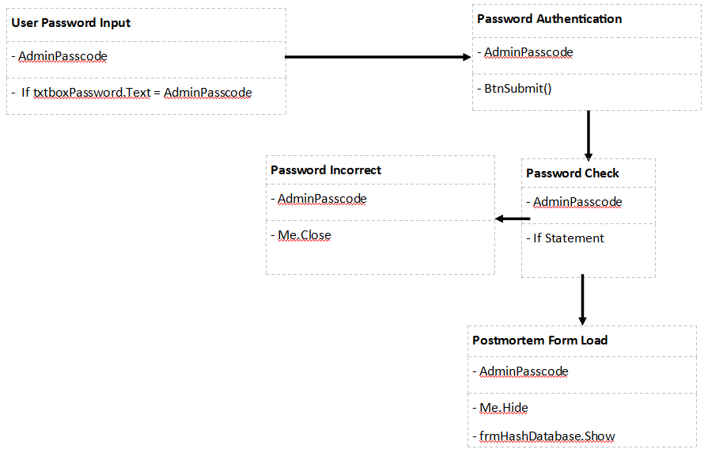

**Connecting to Database:**

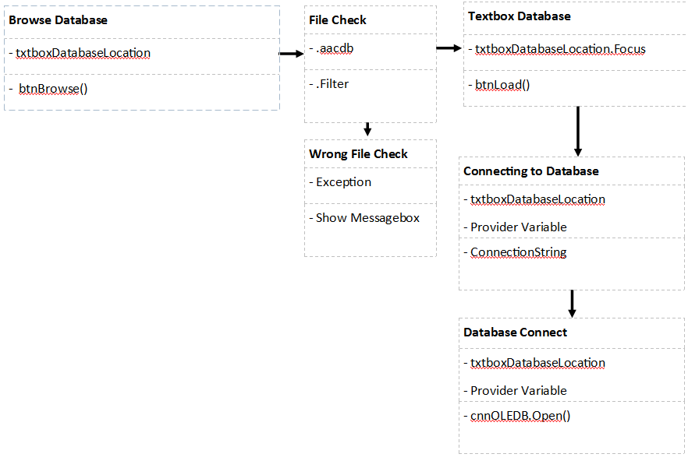

**Navigation of Database:**

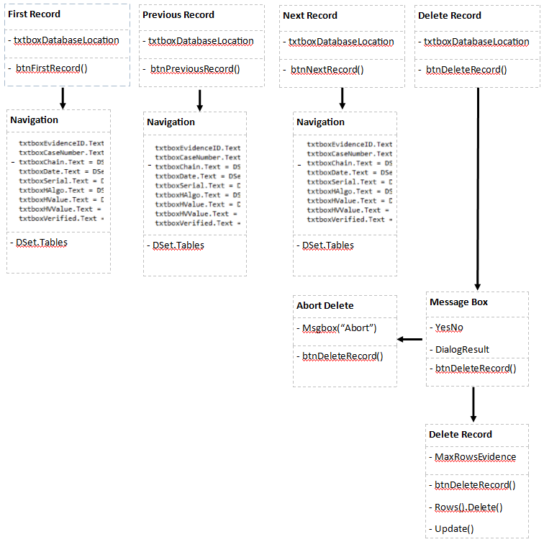

**Selecting Evidence File:**

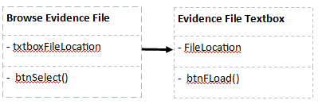

**Hashing Evidence File:**

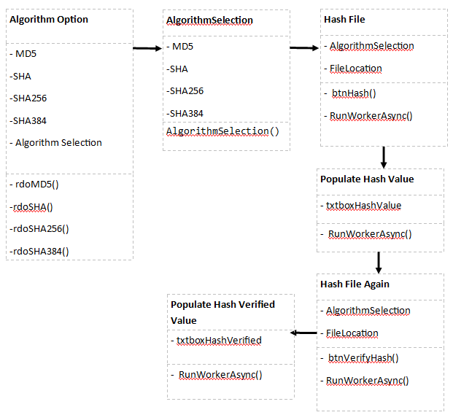

**Exporting Evidence to Database:**

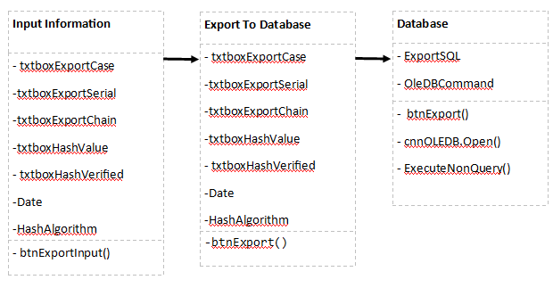

**Form Designs –**

There will be two main forms for the Postmortem project:

1. Password Authentication Form
2. Hashing and Database Form

**Password Authentication Form:-**

**In the Form:** Within the password authentication form, there will be only 3 control types in the form itself:

1. A label
2. A textbox
3. A button

The three control types create a simple password form to allow access to the more heavily advanced hashing program.

The label control type will have the name of “lblEnter” and will hold a string of a command which will tell the user what to do. The string which is being held by the label is: “Enter your unique password in the input box below:”

The textbox control type will have the name of “txtPassword” and will be used for the user to enter their password. These password will be used in an “if” statement where if the password is the correct one and matches with the private password in the form, then it will allow the client to view the hashing form.

The button control type will have the name of “btnSubmit” and will be used to start the login procedure of the Postmortem application. The password which was inputted into the textbox will be checked against the existing admin password in the source code of the Postmortem application. If the password is the same as the source code password, the button will bring up the hashing and database form. If the password is not the same, the button will close down the form and give out an error message saying it is the wrong password.

**Visual Design of the Form:**

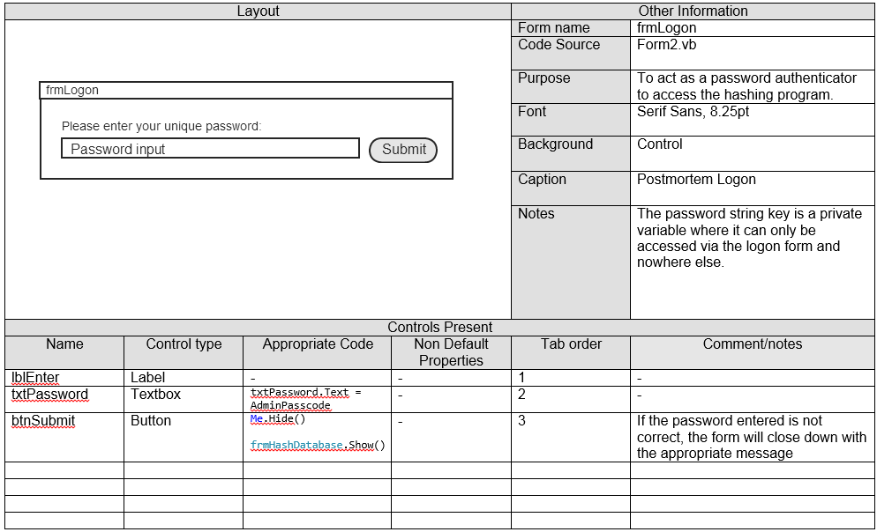

**Hashing and Database Form:-**

**In the Form:** Within the hashing and database form, there are many controls to complete the requirements of the client. There are several textboxes, buttons, labels and a ListBox to satisfactory complete the project.

Each section of the Hash and Database form is related to what it can do, on the left hand side of the form there is the database functions and on the right hand side there is the hashing functions.

On the left side of the form, there are functions to accomplish a successful connection to the database. The first aspect to implement is the browse and loading function of the database. This will be done using two buttons and a textbox. The browse button will load the database into the textbox. The Load button will declare the database location to a string where it will then use a connection string to connect to the database.

With the connection string, there is also a Try Catch Error method where if there is not a database, it will give the error of not being one. Another part of the error catching is that if the select database is not the correct format, it will also give the error to show this to the client.

**Visual Designs of the Form:**

**Database Side of the Form –**

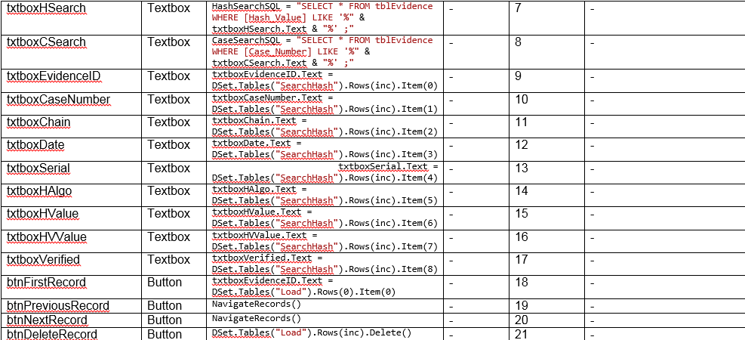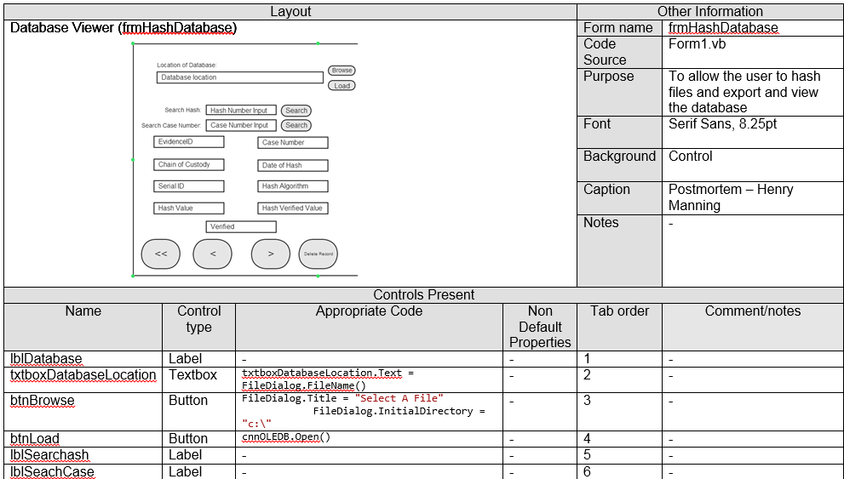

All of the text boxes below the database location textbox are very important as they relate to each other. The design of the search being very close to the related textboxes make it more understandable to the client. Instead of having the textboxes on the other side of the form, it is simpler and ergonomically viable to have it in the same section.

The buttons at the bottom of the form in the database section are also in a particular place. They are put there for just like the textboxes, ergonomic reasons. There are four buttons for the navigation of the database. They are placed in a logical order of being; First Record (<<), Previous Record (<), Next Record (>) and Delete record. The database textboxes of the nine in the center are populated and designed by the developer to update whenever there is an event happening such as next record, first record or delete record. The design has also incorporated that when a new case or hash been searched, the textboxes are automatically filled to save the client refreshing the program every single time.

**Hashing Functions Side of the Form –**

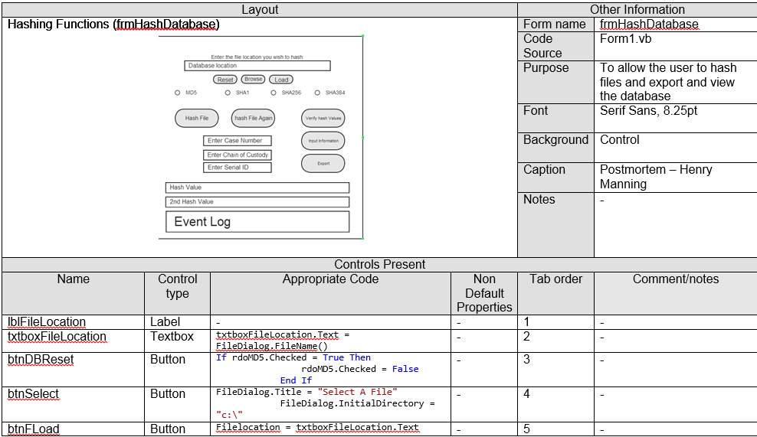

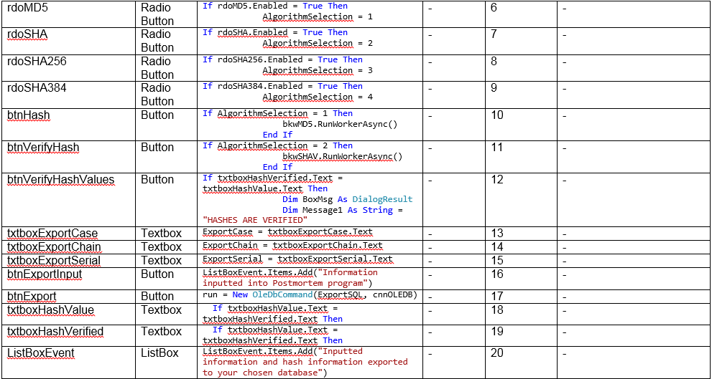

On the right hand side of the Postmortem application is the main part of the program, the hashing functions and export process. It is in the same logical order as the database functions where the file location browse starts. There are two buttons and a textbox relating to the file location chooser; the browse button and the load button where the load button will load the file location into a string variable.

The next in logical order is the algorithm choice. These are done in radio buttons as the client can only hash one file at a time so in the design choice, it is preferred to have radio buttons instead of check boxes. These radio buttons are connected to an integer variable where if a particular algorithm is checked, then it will give it a number, i.e. SHA equals 2.

The next in logical order is the buttons relating to the hashing of the file and other database related functionalities. The order of pressing the buttons is defined in the following diagram:

Hash File -> Hash File Again -> Verify Hash Values -> Input Info -> Export

This makes it a logical order based on what operation they all do. The hash file button hashes the file, the hash file again button hashes the file again, the verify hash values button which compares the two hash strings, the input information where the user would input the information relating to the hash and then export which will export the hash and inputted information.

Below the buttons are the two textboxes relating to the hash numbers of the evidence file. These two are put close together to make it easier on the client to check them both visually. However, with the extra button of verifying the two hash files, it also creates more assurance in the quality of hashing.

The event log is utilised in the program by the client completing functions on the Postmortem application. For example, if the hash file button is pressed, it will parse a message to the ListBox to add a statement about what has happened.

**Overview of the Whole Form:**

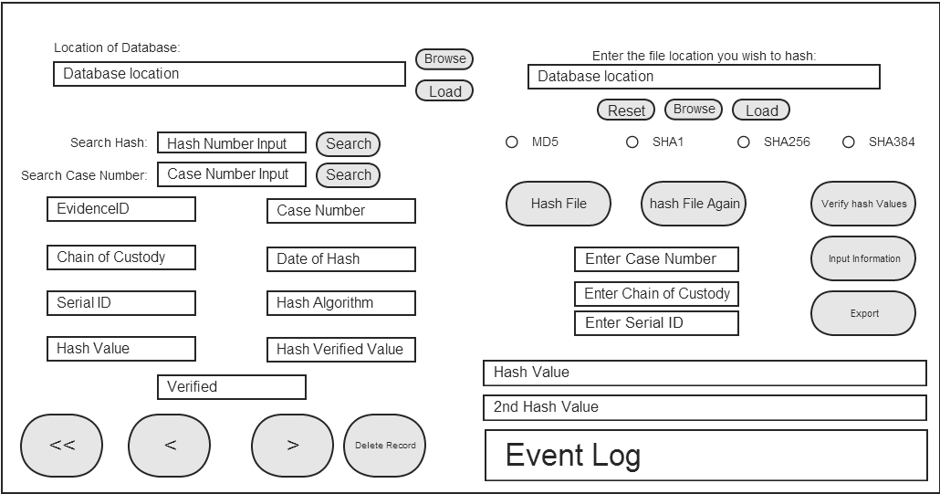

**Conclusion of Designs:** The main goal of the Postmortem application design is the logical order of the functions in the program. The order of the buttons and the textboxes which accompany the functions was an important design point of the Postmortem application.

The database section of the Postmortem program has all of the client requirements which they requested in the proposal of the project. The first requirement of a database will be successfully implemented by the connection object and the OleDB commands within the source code of the application.

This design also meets the client requirement of a search function where there are two options of search, hash and case number. The design of having the text boxes which are populated by the query of the search is also important as it makes it easier to view and it keeps it simple.

The overall design of the Postmortem application keeps the whole process of hashing a file and exporting the hash with the relevant information is important. The buttons of the hash process starts with the “Hash File” button, there is many pieces of code behind these buttons such as the “.Enabled” method:

btnVerifyHash.Enabled = True

btnHash.Enabled = False

Once the button has been activated it will disable the button where it will tell the user the next stage of the hashing process is to activate the “Hash File Again” button. This is a sequence in the hashing process and is another design view. Once the sequence has been activated and the process has been completed, the user is able to reset the process and complete another hash. This was another design plan so that this saves the client closing the application and redoing the password form which wastes time. The reset button will accompany browse and load file location button so it is in a simple place which is easily accessible to the user.

Overall, the design of the Postmortem is very good since it is not too cluttered and is in a logical order which helps the functionality of the program.

**Appendix 10 –**

**Pseudo Code and Postmortem Code**

**Pseudo Code of Form 1.vb:**

Import System.Security.Cryptography

Import System.IO

Import System.Text

Import System.Environment

Import System.Diagnostics

Import System.Data.OleDb

Import System.Windows.Forms.DialogResult

Import System.Drawing

Import System.ComponentModel

**Public class frmHashDatabase**

***Private Sub Function of NavigateRecords***

Textbox EvidenceID equals Dataset rows incremented and item 0

Textbox CaseNumber equals Dataset rows incremented and item 1

Textbox Chain equals Dataset rows incremented and item 2

Textbox Date equals Dataset rows incremented and item 3

Textbox Serial equals Dataset rows incremented and item 4

Textbox Hash Algorithm equals Dataset rows incremented and item 5

Textbox Hash Value equals Dataset rows incremented and item 6

Textbox Hash Verified Value equals Dataset rows incremented and item 7

Textbox Verified equals Dataset rows incremented and item 8

***End Sub***

***Private Sub BtnSelect Click***

Try

Create new OpenFileDialog function

Title of FileDialog = “Select a File”

Directory of FileDialog = C Drive

Filter of FileDialog = Database files

Filter of FileDialog = 2

FileDialog Restore Directory = True

Show FileDialog

Textbox File Lication = File selected

Give focus to textbox

Catch error

Show error in message

End Try

***End Sub***

***Private Sub btnShowLocation Click***

Messagebox title = “Postmortem File Location Confirmation”

Messagebox shows file location and message box title

Add statement to ListBox

***End Sub***

***Private Sub Radio Button MD5 Checked Changed***

If Radio button MD5 is checked then

Algorithm = 1

Add statement to ListBox

***End Sub***

***Private Sub Radio Button SHA Checked Changed***

If Radio button SHA is checked then

Algorithm = 2

Add statement to ListBox

***End Sub***

***Private Sub Radio Button SHA256 Checked Changed***

If Radio button SHA256 is checked then

Algorithm = 3

Add statement to ListBox

***End Sub***

***Private Sub Radio Button SHA384 Checked Changed***

If Radio button SHA384 is checked then

Algorithm = 4

Add statement to ListBox

***End Sub***

***Private Sub btnHash Click***

Try

btnVerifyHash enabled

btnHash disabled

If algorithm selection = 1

Run MD5 background worker

If algorithm selection = 2

Run SHA background worker

If algorithm selection = 3

Run SHA256 background worker

If algorithm selection = 4

Run SHA384 background worker

Catch error

Show error in message

End Try

***End Sub***

***Private Sub btnVerifyHash Click***

Try

btnVerifyHash enabled

btnHash disabled

If algorithm selection = 1

Run MD5 background worker

If algorithm selection = 2

Run SHA background worker

If algorithm selection = 3

Run SHA256 background worker

If algorithm selection = 4

Run SHA384 background worker

Catch error

Show error in message

End Try

***End Sub***

***Private Sub btnRestart Click***

Try

Add statement to ListBox

TheEvidenceFile = null

HashCalculation = null

TheEvidenceFileVerify = null

HashCalculationVerify= null

SHAHashCalucation = null

SHATheEvidenceFileVerify = null

SHAHashCalucationVerify= null

DBLocation = null

Clear textbox Filelocation

Clear textbox HashValue

Clear textbox HashVerified

Radio button MD5 enabled

Radio button SHA enabled

Radio button SHA256 enabled

Radio button SHA384 enabled

If radio button MD5 is checked then

Radio button MD5 = unchecked

If radio button SHA is checked then

Radio button SHA = unchecked

If radio button SHA256 is checked then

Radio button SHA256 = unchecked

If radio button SHA384 is checked then

Radio button SHA384 = unchecked

End Try

***End Sub***

***Private Sub btnExit Click***

Exit Application

***End Sub***

***Private Sub btnLoad Click***

Try

If button browse is enabled then

Button browse = disabled

Button load = disabled

LoadSQL declared as String

cmdOleDB declared as OleDBCommand

strConnectionString = Provider and database location textbox

cnnOLEDB Connection string = strConnectionString

Open Connection

Show message box statement

Add statement to Listbox

SQL statement declared

Variable declared as a data adapter with SQL and connection string

Fill Dataset

Increment = 0

Count Database Record Rows

Close Connection

Textbox EvidenceID equals Dataset rows incremented and item 0

Textbox CaseNumber equals Dataset rows incremented and item 1

Textbox Chain equals Dataset rows incremented and item 2

Textbox Date equals Dataset rows incremented and item 3

Textbox Serial equals Dataset rows incremented and item 4

Textbox Hash Algorithm equals Dataset rows incremented and item 5

Textbox Hash Value equals Dataset rows incremented and item 6

Textbox Hash Verified Value equals Dataset rows incremented and item 7

Textbox Verified equals Dataset rows incremented and item 8

End Try

Button CSearch Enabled

Button DBReset Enabled

Button DeleteRecord Enabled

Button FirstRecord Enabled

Button FLoad Enabled

Button Hash Enabled

Button HSearch Enabled

Button NextRecord Enabled

Button PreviousRecord Enabled

Button Select Enabled

Radio Button MD5 Enabled

Radio Button SHA Enabled

Radio Button SHA256 Enabled

Radio Button SHA384 Enabled

Textbox Case Number Enabled

Textbox Chain Enabled

Textbox CSearch Enabled

Textbox Date Enabled

Textbox EvidenceID Enabled

Textbox Filelocation Enabled

Textbox HAlgo Enabled

Textbox HashValue Enabled

Textbox HashVerified Enabled

Textbox HSearch Enabled

Textbox HValue Enabled

Textbox HVValue Enabled

Textbox Serial Enabled

Textbox Verified Enabled

Textbox ExportCase Enabled

Textbox ExportChain Enabled

Textbox Export Serial Enabled

***End Sub***

***Private Sub btnBrowse Click***

Try

Create new OpenFileDialog function

Title of FileDialog = “Select a File”

Directory of FileDialog = C Drive

Filter of FileDialog = Any File

Filter of FileDialog = 2

FileDialog Restore Directory = True

Show FileDialog

Textbox File Lication = File selected

Give focus to textbox

Catch error

Show error in message

End Try

***End Sub***

***Private Sub btnPrevious Record Click***

If inc is greater than 0 Then

Inc = inc minus 1

Call NavigateRecord function

Show Messagebox

***End Sub***

***Private Sub btnNextRecord Click***

If inc is less than 0 Then

Inc = inc plus 1

Call NavigateRecord function

Show Messagebox

***End Sub***

***Private Sub btnFLoad Click***

Filelocation = Textbox FileLocation

Add statement to Listbox

***End Sub***

***Private Sub btnFirstRecord Click***

Textbox EvidenceID equals Dataset rows 0 and item 0

Textbox CaseNumber equals Dataset rows 0 and item 1

Textbox Chain equals Dataset rows 0 and item 2

Textbox Date equals Dataset rows 0 and item 3

Textbox Serial equals Dataset rows 0 and item 4

Textbox Hash Algorithm equals Dataset rows 0 and item 5

Textbox Hash Value equals Dataset rows 0 and item 6

Textbox Hash Verified Value equals Dataset rows 0 and item 7

Textbox Verified equals Dataset rows 0 and item 8

***End Sub***

***Private Sub btnHSearch Click***

Try

Clear Textbox EvidenceID

Clear Textbox CaseNumber

Clear Textbox Chain

Clear Textbox Date

Clear Textbox Serial

Clear Textbox HAlgo

Clear Textbox HValue

Clear Textbox HVValue

Clear Textbox Verified

HashSearchSQL = String Variable

HashSearchSQL = SQL statement

Data adapter = HashSearchSQL and ConnectionString

Fill Dataset

Count database rows

Inc = minus 1

If inc = MaxRowsEvidence then

Inc = inc plus 1

Show Messagebox

Textbox EvidenceID equals Dataset rows incremented and item 0

Textbox CaseNumber equals Dataset rows incremented and item 1

Textbox Chain equals Dataset rows incremented and item 2

Textbox Date equals Dataset rows incremented and item 3

Textbox Serial equals Dataset rows incremented and item 4

Textbox Hash Algorithm equals Dataset rows incremented and item 5

Textbox Hash Value equals Dataset rows incremented and item 6

Textbox Hash Verified Value equals Dataset rows incremented and item 7

Textbox Verified equals Dataset rows incremented and item 8

End Try

***End Sub***

***Private Sub btnCSearch Click***

Try

Clear Textbox EvidenceID

Clear Textbox CaseNumber

Clear Textbox Chain

Clear Textbox Date

Clear Textbox Serial

Clear Textbox HAlgo

Clear Textbox HValue

Clear Textbox HVValue

Clear Textbox Verified

CaseSearchSQL = String Variable

CaseSearch SQL = SQL statement

Data adapter = CaseSearchSQL and ConnectionString

Fill Dataset

Count database rows

Inc = minus 1

If inc = MaxRowsEvidence then

Inc = inc plus 1

Show Messagebox

Textbox EvidenceID equals Dataset rows incremented and item 0

Textbox CaseNumber equals Dataset rows incremented and item 1

Textbox Chain equals Dataset rows incremented and item 2

Textbox Date equals Dataset rows incremented and item 3

Textbox Serial equals Dataset rows incremented and item 4

Textbox Hash Algorithm equals Dataset rows incremented and item 5

Textbox Hash Value equals Dataset rows incremented and item 6

Textbox Hash Verified Value equals Dataset rows incremented and item 7

Textbox Verified equals Dataset rows incremented and item 8

End Try

***End Sub***

***Private Sub btnDBReset Click***

Try

Textbox FileLocation = “”

Textbox ExportCase = “”

Textbox ExportChain = “”

Textbox ExportSerial = “”

Textbox HashValue = “”

Textbox HashVerified = “”

Clear Listbox

If radio button MD5 is checked then

Radio button MD5 = unchecked

If radio button SHA is checked then

Radio button SHA = unchecked

If radio button SHA256 is checked then

Radio button SHA256 = unchecked

If radio button SHA384 is checked then

Radio button SHA384 = unchecked

Button Hash Enabled

Button VerifyHash Disabled

Button VerifyHashValues Disabled

Button ExportInput Disabled

Button Export Disabled

Clear Listbox

Add statement to Listbox

Catch Error

Show message box

End Try

***End Sub***

***Private Sub Form_1 Load***

Button Browse Enabled

Textbox DatabaseLocation Disabled

Button ExportInput Disabled

Button Load Disabled

Button CSearch Disabled

Button DBReset Disabled

Button DeleteRecord Disabled

Button Export Disabled

Button FirstRecord Disabled

Button FLoad Disabled

Button Hash Disabled

Button HSearch Disabled

Button VerifyHash Disabled

Button NextRecord Disabled

Button PreviousRecord Disabled

Button VerifyHashValues Disabled

Button Select Disabled

Button VerifyHash Disabled

Radio Button MD5 Disabled

Radio Button SHA Disabled

Radio Button SHA256 Disabled

Radio Button SHA384 Disabled

Textbox CaseNumber Disabled

Textbox Chain Disabled

Textbox CSearch Disabled

Textbox Date Disabled

Textbox EvidenceID Disabled

Textbox FileLocation Disabled

Textbox HAlgo Disabled

Textbox HashValue Disabled

Textbox HashVerified Disabled

Textbox HSearch Disabled

Textbox HValue Disabled

Textbox HVValue Disabled

Textbox Serial Disabled

Textbox Verified Disabled

Textbox ExportCase Disabled

Textbox ExportChain Disabled

Textbox ExportSerial Disabled

***End Sub***

***Private Sub btnDeleteRecord Click***

Try

Declare new command builder with Data adapter

Messagebox with buttons

Delete Record

If No button selected

Msgbox with statement

Else

Delete Record Row

MaxRowsEvidence – 1

Inc = 0

Update Database with Data Adapter

Call NavigateRecords Function

Add statement to ListBox

Catch Error

Show Error Messagebox

End Try

***End Sub***

***Private Sub btnExport Click***

Try

Button Export Disabled

If Radio button MD5 is Checked Then

ExportAlgorithm = MD5

If Radio button SHA is Checked Then

ExportAlgorithm = SHA1

If Radio button SHA256 is Checked Then

ExportAlgorithm = SHA256

If Radio button SHA384 is Checked Then

ExportAlgorithm = SHA384

If Textbox hash Value = Textbox Hash Verified Then

ExportVerified = Yes

Else

ExportVerified = No

Declare ExportSQL as string variable

ExportSQL = SQLStatement

Declare run as OleDBCommand

Open Connection

Run OleDBCommand with Connectionstring and ExportSQL

Add statement to ListBox

Messagebox Shows with statement

Close Connection

Catch Error

Show Error Messagebox

End Try

***End Sub***

***Private Sub btnExportInput Click***

Button ExportInput Disabled

Button Export Enabled

ExportCase = Textbox ExportCase

ExportChain = Textbox ExportChain

ExportSerial = Textbox Export Serial

Add statement to ListBox

***End Sub***

***Private Sub bkw384 DoWork***

Try

Declare new instance of SHA384 Class

Declare FileStream As New FileStraming with FileMode Open, FileMode Read, FileMode Read

Declare FileStreamSHA384 = FileLocation, FileMode Open, FileMode Read, FileMode Read

SHA384 Generate Hash

Close FileStream

Delcare SHA384HashByte As Byte = Generated Hash Value

Declare SHA384HashBuff As StringBuilder = New StringBuilder

Declare SHA384ByteHash As Byte variable

SHA384HashBuff Append as a String Format

Declare SHA384String As String Variable

SHA384String = SHA384HashBuff

Result = SHA384String

Catch Error

Show Error Messagebox

End Try

***End Sub***

***Private Sub bkw384 RunWorkerCompleted***

Textbox Hash Value = Result

Add statement to Listbox

***End Sub***

***Private Sub bkwShad256 DoWork***

Try

Declare new instance of SHA256 Class

Declare FileStream As New FileStraming with FileMode Open, FileMode Read, FileMode Read

Declare FileStreamSHA256 = FileLocation, FileMode Open, FileMode Read, FileMode Read

SHA256 Generate Hash

Close FileStream

Declare SHA256HashByte As Byte = Generated Hash Value

Declare SHA256HashBuff As StringBuilder = New StringBuilder

Declare SHA256ByteHash As Byte variable

SHA256HashBuff Append as a String Format

Declare SHA256String As String Variable

SHA256String = SHA256HashBuff

Result = SHA256String

Catch Error

Show Error Messagebox

End Try

***End Sub***

***Private Sub bkwShad256 RunWorkerCompleted***

Textbox Hash Value = Result

Add statement to Listbox

***End Sub***

***Private Sub bkwShad RunWorkerCompleted***

Textbox Hash Value = Result

Add statement to Listbox

***End Sub***

***Private Sub bkwMD5 DoWork***

Try

Declare new instance of MD5 Class

Declare FileStream As New FileStraming with FileMode Open, FileMode Read, FileMode Read

Declare FileStreamMD5 = FileLocation, FileMode Open, FileMode Read, FileMode Read

MD5 Generate Hash

Close FileStream

Declare MD5HashByte As Byte = Generated Hash Value

Declare MD5HashBuff As StringBuilder = New StringBuilder

Declare MD5ByteHash As Byte variable

MD5HashBuff Append as a String Format

Declare MD5String As String Variable

MD5String = MD5HashBuff

Result = MD5String

Catch Error

Show Error Messagebox

End Try

***End Sub***

***Private Sub bkwMD5 RunWorkerCompleted***

Textbox Hash Value = Result

Add statement to Listbox

***End Sub***

***Private Sub bkwMD5V DoWork***

Try

Declare new instance of MD5 Class

Declare FileStream As New FileStraming with FileMode Open, FileMode Read, FileMode Read

Declare FileStreamMD5 = FileLocation, FileMode Open, FileMode Read, FileMode Read

MD5 Generate Hash

Close FileStream

Declare MD5HashByte As Byte = Generated Hash Value

Declare MD5HashBuff As StringBuilder = New StringBuilder

Declare MD5ByteHash As Byte variable

MD5HashBuff Append as a String Format

Declare MD5String As String Variable

MD5String = MD5HashBuff

Result = MD5String

Catch Error

Show Error Messagebox

End Try

***End Sub***

***Private Sub bkwMD5V RunWorkerCompleted***

Textbox Hash Verified = Result

Add statement to ListBox

***End Sub***

***Private Sub bkwSHA256V DoWork***

Try

Declare new instance of SHA256 Class

Declare FileStream As New FileStraming with FileMode Open, FileMode Read, FileMode Read

Declare FileStreamSHA256 = FileLocation, FileMode Open, FileMode Read, FileMode Read

SHA256 Generate Hash

Close FileStream

Declare SHA256HashByte As Byte = Generated Hash Value

Declare SHA256HashBuff As StringBuilder = New StringBuilder

Declare SHA256ByteHash As Byte variable

SHA256HashBuff Append as a String Format

Declare SHA256String As String Variable

SHA256String = SHA256HashBuff

Result = SHA256String

Catch Error

Show Error Messagebox

End Try

***End Sub***

***Private Sub bkwSHA256V RunWorkerCompleted***

Textbox Hash Verified = Result

Add statement to ListBox

***End Sub***

***Private Sub btnVerifyHashValues Click***

Try

Button VerifyHashValues Disabled

Button ExportInput Enabled

If Textbox HashVerified = Textbox HashValue Then

Declare BoxMsg as DialogResult

Declare Message As String Variable

Declare MsgBox Title As String

BoxMsg = Show Messagebox

Textbox Hash Verified colour = Green

Add statement to Listbox

Else

Declare BoxMsg as DialogResult

Declare Message As String Variable

Declare MsgBox Title As String

BoxMsg = Show Messagebox

Textbox Hash Verified colour = Red

Catch Error

Show Error Messagebox

End Try

***End Sub***

***Private Sub bkw384V DoWork***

Try

Declare new instance of SHA384 Class

Declare FileStream As New FileStraming with FileMode Open, FileMode Read, FileMode Read

Declare FileStreamSHA384 = FileLocation, FileMode Open, FileMode Read, FileMode Read

SHA384 Generate Hash

Close FileStream

Declare SHA384HashByte As Byte = Generated Hash Value

Declare SHA384HashBuff As StringBuilder = New StringBuilder

Declare SHA384ByteHash As Byte variable

SHA384HashBuff Append as a String Format

Declare SHA384String As String Variable

SHA384String = SHA384HashBuff

Result = SHA384String

Catch Error

Show Error Messagebox

End Try

***End Sub***

***Private Sub bkw384V RunWorkerCompleted***

Textbox Hash Verified = Result

Add statement to ListBox

***End Sub***

***Private Sub bkwSHA DoWork***

Try

Declare new instance of SHA Class

Declare FileStream As New FileStraming with FileMode Open, FileMode Read, FileMode Read

Declare FileStreamSHA = FileLocation, FileMode Open, FileMode Read, FileMode Read

SHA Generate Hash

Close FileStream

Declare SHAHashByte As Byte = Generated Hash Value

Declare SHAHashBuff As StringBuilder = New StringBuilder

Declare SHAByteHash As Byte variable

SHAHashBuff Append as a String Format

Declare SHAString As String Variable

SHAString = SHAHashBuff

Result = SHAString

Catch Error

Show Error Messagebox

End Try

***End Sub***

***Private Sub bkwSHA RunWorkerCompleted***

Textbox Hash Value = Result

Add statement to ListBox

***End Sub***

***Private Sub bkwSHAV DoWork***

Try

Declare new instance of SHA Class

Declare FileStream As New FileStraming with FileMode Open, FileMode Read, FileMode Read

Declare FileStreamSHA = FileLocation, FileMode Open, FileMode Read, FileMode Read

SHA Generate Hash

Close FileStream

Declare SHAHashByte As Byte = Generated Hash Value

Declare SHAHashBuff As StringBuilder = New StringBuilder

Declare SHAByteHash As Byte variable

SHAHashBuff Append as a String Format

Declare SHAString As String Variable

SHAString = SHAHashBuff

Result = SHAString

Catch Error

Show Error Messagebox

End Try

***End Sub***

***Private Sub bkwSHAV RunWorkerCompleted***

Textbox Hash Verified = Result

Add statement to ListBox

***End Sub***

***Private Sub btnExitProgram Click***

Application Exit

***End Sub***

***Private Sub btnExit Click***

Application Exit

***End Sub***

**Pseudo Code of Form 2.vb:**

***Public Class frmLogon***

Private variable AdminPasscode = QWERTYUIOP

***Private Sub btnSubmit Click***

If Textbox Password = AdminPasscode Then

Hide Form 2

Show Postmortem form

Else

Show Messagebox with statement

Close Form 2

***End Sub***

***Private Sub txtPassword KeyPress***

If key “Enter” is pressed

Button Submit Click

End if

***End Sub***

***End Class***

**Form 1.vb Code –**

Imports System.Security.Cryptography 'import library for algorithms

Imports System.IO 'import library

Imports System.Text 'import library for colours

Imports System.Environment 'import library

Imports System.Diagnostics 'import library

Imports System.Data.OleDb 'import library for database connection

Imports System.Windows.Forms.DialogResult 'import library for dialogs such as browse

Imports System.Drawing 'import library

Imports System.ComponentModel 'import library for background workers

Public Class frmHashDatabase

Private Sub NavigateRecords() 'Private sub for navigation of records

txtboxEvidenceID.Text = DSet.Tables("Load").Rows(inc).Item(0)

txtboxCaseNumber.Text = DSet.Tables("Load").Rows(inc).Item(1)

txtboxChain.Text = DSet.Tables("Load").Rows(inc).Item(2)

txtboxDate.Text = DSet.Tables("Load").Rows(inc).Item(3)

txtboxSerial.Text = DSet.Tables("Load").Rows(inc).Item(4)

txtboxHAlgo.Text = DSet.Tables("Load").Rows(inc).Item(5)

txtboxHValue.Text = DSet.Tables("Load").Rows(inc).Item(6)

txtboxHVValue.Text = DSet.Tables("Load").Rows(inc).Item(7)

txtboxVerified.Text = DSet.Tables("Load").Rows(inc).Item(8)

End Sub

Private Sub btnSelect_Click(sender As Object, e As EventArgs) Handles btnSelect.Click

Try 'Try statement

Dim FileDialog As OpenFileDialog = New OpenFileDialog() 'instantiates a new openfiledialog

FileDialog.Title = "Select A File" 'titles the dialog

FileDialog.InitialDirectory = "c:\" 'starts the dialog with the C drive

FileDialog.Filter = "accdb files (*.accdb)|*.accdb|All files (*.*)|*.*" 'filters out all other files except for database files

FileDialog.FilterIndex = 2

FileDialog.RestoreDirectory = True

FileDialog.ShowDialog() 'Shows the dialog

txtboxFileLocation.Text = FileDialog.FileName() 'the textbox is filled with the selected file name

txtboxFileLocation.Focus() 'Gives focus to the textbox

Catch ex As Exception

MessageBox.Show(ex.Message)

End Try 'ends try statement

End Sub

Private Sub btnShowLocation_Click(sender As Object, e As EventArgs)

Dim MsgBoxTitle1 = "Postmortem File Location Confirmation" 'Title of the MsgBox adds more simplicity '

MsgBox(Filelocation, , MsgBoxTitle1) 'Shows the user the Filelocation String text if correctly inputted

ListBoxEvent.Items.Add("Inputted File Location Displayed") 'Event log shows that the file location has been inputted into the console

End Sub

Private Sub rdoMD5_CheckedChanged(sender As Object, e As EventArgs) Handles rdoMD5.CheckedChanged

If rdoMD5.Enabled = True Then 'if statement

AlgorithmSelection = 1 'Variable = 1

ListBoxEvent.Items.Add("MD5 algorithm has been selected") 'Add statement to the listbox

End If

End Sub

Private Sub rdoSHA_CheckedChanged(sender As Object, e As EventArgs) Handles rdoSHA.CheckedChanged

If rdoSHA.Enabled = True Then 'if statement

AlgorithmSelection = 2 'variable = 2

ListBoxEvent.Items.Add("SHA1 algorithm has been selected") 'Add statement to the listbox

End If

End Sub

Private Sub rdoSHA256_CheckedChanged(sender As Object, e As EventArgs) Handles rdoSHA256.CheckedChanged

If rdoSHA256.Enabled = True Then 'if statement

AlgorithmSelection = 3 'variable = 3

ListBoxEvent.Items.Add("SHA256 algorithm has been selected") 'Add statement to the listbox

End If

End Sub

Private Sub rdoSHA384_CheckedChanged(sender As Object, e As EventArgs) Handles rdoSHA384.CheckedChanged

If rdoSHA384.Enabled = True Then 'if statement

AlgorithmSelection = 4 'variable = 4

ListBoxEvent.Items.Add("SHA384 algorithm has been selected") 'Add statement to the listbox

End If

End Sub

Private Sub btnHash_Click(sender As Object, e As EventArgs) Handles btnHash.Click

Try 'try statement

btnVerifyHash.Enabled = True 'button is enabled

btnHash.Enabled = False 'button is disabled

If AlgorithmSelection = 1 Then 'if statement

bkwMD5.RunWorkerAsync() 'starts background worker

End If

If AlgorithmSelection = 2 Then 'if statement

bkwSHA.RunWorkerAsync() 'starts background worker

End If

If AlgorithmSelection = 3 Then 'if statement

bkwShad256.RunWorkerAsync() 'starts background worker

End If

If AlgorithmSelection = 4 Then 'if statement

bkw384.RunWorkerAsync() 'starts background worker

End If

Catch ex As Exception

MessageBox.Show(ex.Message)

End Try 'end try statement

End Sub

Private Sub btnVerifyHash_Click(sender As Object, e As EventArgs) Handles btnVerifyHash.Click

Try 'try statement

btnVerifyHash.Enabled = False 'button is disabled

btnVerifyHashValues.Enabled = True 'button is enabled

If AlgorithmSelection = 1 Then 'if statement

BKWMD5V.RunWorkerAsync() 'starts background worker

End If

If AlgorithmSelection = 2 Then 'if statement

bkwSHAV.RunWorkerAsync() 'starts background worker

End If

If AlgorithmSelection = 3 Then 'if statement

BKWSHA256V.RunWorkerAsync() 'starts background worker

End If

If AlgorithmSelection = 4 Then 'if statement

bwk384V.RunWorkerAsync() 'starts background worker

End If

Catch ex As Exception

MessageBox.Show(ex.Message)

End Try 'end try statement

End Sub

Private Sub btnRestart_Click(sender As Object, e As EventArgs)

Try 'try statement

ListBoxEvent.Items.Add("Hashing settings have been reset") 'adds statement to listbox

TheEvidenceFile = vbNullString 'variable = null

HashCalculation = vbNullString 'variable = null

TheEvidenceFileVerify = vbNullString 'variable = null

HashCalculationVerify = vbNullString 'variable = null

SHAHashCalculation = vbNullString 'variable = null

SHATheEvidenceFileVerify = vbNullString 'variable = null

SHAHashCalculationVerify = vbNullString 'variable = null

DBLocation = vbNullString 'variable = null

txtboxFileLocation.Clear() 'clears textbox

txtboxHashValue.Clear() 'clears textbox

txtboxHashVerified.Clear() 'clears textbox

rdoMD5.Enabled = True 'radio button enabled

rdoSHA.Enabled = True 'radio button enabled

rdoSHA256.Enabled = True 'radio button enabled

rdoSHA384.Enabled = True 'radio button enabled

If rdoMD5.Checked = True Then 'if statement

rdoMD5.Checked = False 'radio button = false

End If

If rdoSHA.Checked = True Then 'if statement

rdoSHA.Checked = False 'radio button = false

End If

If rdoSHA256.Checked = True Then 'if statement

rdoSHA256.Checked = False 'radio button = false

End If

If rdoSHA384.Checked = True Then 'if statement

rdoSHA384.Checked = False 'radio button = false

End If

Catch ex As Exception

MessageBox.Show(ex.Message)

End Try 'end try statement

End Sub

Private Sub btnExit_Click(sender As Object, e As EventArgs)

Application.Exit() 'Exits application

End Sub

Private Sub btnLoad_Click(sender As Object, e As EventArgs) Handles btnLoad.Click

Try 'try statement

If btnBrowse.Enabled = True Then 'if statement

btnBrowse.Enabled = False 'button is disabled

btnLoad.Enabled = False 'button is disabled

End If

Dim LoadSQL As String 'new variable declaration

Dim cmdOLEDB As New OleDbCommand 'new oledbcommand declaration

Dim strConnectionString = "Provider=Microsoft.Jet.OLEDB.4.0;Data Source=" & txtboxDatabaseLocation.Text & ";" 'connection string and connection provider

cnnOLEDB.ConnectionString = strConnectionString 'Connection string = the provider and the textbox database location

cnnOLEDB.Open() 'opens the connection

MsgBox("Database Connection Has Been Established") 'Msgbox displays

ListBoxEvent.Items.Add("Database connected") 'adds statement to the listbox

LoadSQL = "SELECT * FROM tblEvidence" 'SQL statement decleration

DAdapter = New OleDb.OleDbDataAdapter(LoadSQL, cnnOLEDB) 'data adapter = SQL statement and the connection string

DAdapter.Fill(DSet, "Load") 'Fills the load dataset

inc = 0 'incrementation = 0

MaxRowsEvidence = DSet.Tables("Load").Rows.Count 'Counts the rows of the table

cnnOLEDB.Close() 'closes the connection

txtboxEvidenceID.Text = DSet.Tables("Load").Rows(inc).Item(0) 'populates the textbox

txtboxCaseNumber.Text = DSet.Tables("Load").Rows(inc).Item(1) 'populates the textbox

txtboxChain.Text = DSet.Tables("Load").Rows(inc).Item(2) 'populates the textbox

txtboxDate.Text = DSet.Tables("Load").Rows(inc).Item(3) 'populates the textbox

txtboxSerial.Text = DSet.Tables("Load").Rows(inc).Item(4) 'populates the textbox

txtboxHAlgo.Text = DSet.Tables("Load").Rows(inc).Item(5) 'populates the textbox

txtboxHValue.Text = DSet.Tables("Load").Rows(inc).Item(6) 'populates the textbox

txtboxHVValue.Text = DSet.Tables("Load").Rows(inc).Item(7) 'populates the textbox

txtboxVerified.Text = DSet.Tables("Load").Rows(inc).Item(8) 'populates the textbox

Catch ex As Exception

MessageBox.Show(ex.Message)

End Try 'end try statement

btnCSearch.Enabled = True 'button enabled

btnDBReset.Enabled = True 'button enabled

btnDeleteRecord.Enabled = True 'button enabled

btnFirstRecord.Enabled = True 'button enabled

btnFLoad.Enabled = True 'button enabled

btnHash.Enabled = True 'button enabled

btnHSearch.Enabled = True 'button enabled

btnNextRecord.Enabled = True 'button enabled

btnPreviousRecord.Enabled = True 'button enabled

btnSelect.Enabled = True 'button enabled

rdoMD5.Enabled = True 'button enabled

rdoSHA.Enabled = True 'radio button enabled

rdoSHA256.Enabled = True 'radio button enabled

rdoSHA384.Enabled = True 'radio button enabled

txtboxCaseNumber.Enabled = True 'textbox enabled

txtboxChain.Enabled = True 'textbox enabled

txtboxCSearch.Enabled = True 'textbox enabled

txtboxDate.Enabled = True 'textbox enabled

txtboxEvidenceID.Enabled = True 'textbox enabled

txtboxFileLocation.Enabled = True 'textbox enabled

txtboxHAlgo.Enabled = True 'textbox enabled

txtboxHashValue.Enabled = True 'textbox enabled

txtboxHashVerified.Enabled = True 'textbox enabled

txtboxHSearch.Enabled = True 'textbox enabled

txtboxHValue.Enabled = True 'textbox enabled

txtboxHVValue.Enabled = True 'textbox enabled

txtboxSerial.Enabled = True 'textbox enabled

txtboxVerified.Enabled = True 'textbox enabled

txtboxExportCase.Enabled = True 'textbox enabled

txtboxExportChain.Enabled = True 'textbox enabled

txtboxExportSerial.Enabled = True 'textbox enabled

End Sub

Private Sub btnBrowse_Click(sender As Object, e As EventArgs) Handles btnBrowse.Click

Try 'try statement

Dim FileDialog As OpenFileDialog = New OpenFileDialog() 'instantiates new openfiledialog

FileDialog.Title = "Select A File" 'titles the dialog

FileDialog.InitialDirectory = "c:\" 'defaults to C drive

FileDialog.Filter = "accdb files (*.accdb)|*.accdb|All files (*.*)|*.*" 'filters out all files except database files

FileDialog.FilterIndex = 2

FileDialog.RestoreDirectory = True

FileDialog.ShowDialog() 'shows the dialog

txtboxDatabaseLocation.Text = FileDialog.FileName() 'File location is filled to the textbox

txtboxDatabaseLocation.Focus() 'textbox focus

btnLoad.Enabled = True 'button enabled

Catch ex As Exception

MessageBox.Show(ex.Message)

End Try 'end try statement

End Sub

Private Sub btnPreviousRecord_Click(sender As Object, e As EventArgs) Handles btnPreviousRecord.Click

If inc > 0 Then 'if statement

inc = inc - 1 'inc minus 1

NavigateRecords() 'calls navigate function

Else

MsgBox("Start of Database") 'message box

End If

End Sub

Private Sub btnNextRecord_Click(sender As Object, e As EventArgs) Handles btnNextRecord.Click

If inc <> MaxRowsEvidence - 1 Then 'if statement

inc = inc + 1 'inc plus 1

NavigateRecords() 'calls navigate function

Else

MsgBox("End of Database") 'message box

End If

End Sub

Private Sub btnFLoad_Click(sender As Object, e As EventArgs) Handles btnFLoad.Click

Filelocation = txtboxFileLocation.Text 'Text input declares the FileLocation variable

ListBoxEvent.Items.Add("File location has been loaded into the Postmortem program") 'adds statement to the listbox

End Sub

Private Sub btnFirstRecord_Click(sender As Object, e As EventArgs) Handles btnFirstRecord.Click

txtboxEvidenceID.Text = DSet.Tables("Load").Rows(0).Item(0) 'populates the textbox

txtboxCaseNumber.Text = DSet.Tables("Load").Rows(0).Item(1) 'populates the textbox

txtboxChain.Text = DSet.Tables("Load").Rows(0).Item(2) 'populates the textbox

txtboxDate.Text = DSet.Tables("Load").Rows(0).Item(3) 'populates the textbox

txtboxSerial.Text = DSet.Tables("Load").Rows(0).Item(4) 'populates the textbox

txtboxHAlgo.Text = DSet.Tables("Load").Rows(0).Item(5) 'populates the textbox

txtboxHValue.Text = DSet.Tables("Load").Rows(0).Item(6) 'populates the textbox

txtboxHVValue.Text = DSet.Tables("Load").Rows(0).Item(7) 'populates the textbox

txtboxVerified.Text = DSet.Tables("Load").Rows(0).Item(8) 'populates the textbox

End Sub

Private Sub btnHSearch_Click(sender As Object, e As EventArgs) Handles btnHSearch.Click

Try

txtboxEvidenceID.Clear() 'Clears the textbox

txtboxCaseNumber.Clear() 'Clears the textbox

txtboxChain.Clear() 'Clears the textbox

txtboxDate.Clear() 'Clears the textbox

txtboxSerial.Clear() 'Clears the textbox

txtboxHAlgo.Clear() 'Clears the textbox

txtboxHValue.Clear() 'Clears the textbox

txtboxHVValue.Clear() 'Clears the textbox

txtboxVerified.Clear() 'Clears the textbox

Dim HashSearchSQL As String 'declares a new string variable

HashSearchSQL = "SELECT * FROM tblEvidence WHERE [Hash_Value] LIKE '%" & txtboxHSearch.Text & "%' ;" 'SQL statement stated

DAdapter = New OleDb.OleDbDataAdapter(HashSearchSQL, cnnOLEDB) 'data adapter equals SQL and connection string

DAdapter.Fill(DSet, "SearchHash") 'Fills the dataset

MaxRowsEvidence = DSet.Tables("SearchHash").Rows.Count 'counts the rows of the dataset

inc = -1 'inc equals negative 1

If inc <> MaxRowsEvidence - 1 Then 'if statement

inc = inc + 1 'inc equals inc plus 1

Else

MsgBox("No More Rows") 'msgbox

End If

txtboxEvidenceID.Text = DSet.Tables("SearchHash").Rows(inc).Item(0) 'populates the textbox

txtboxCaseNumber.Text = DSet.Tables("SearchHash").Rows(inc).Item(1) 'populates the textbox

txtboxChain.Text = DSet.Tables("SearchHash").Rows(inc).Item(2) 'populates the textbox

txtboxDate.Text = DSet.Tables("SearchHash").Rows(inc).Item(3) 'populates the textbox

txtboxSerial.Text = DSet.Tables("SearchHash").Rows(inc).Item(4) 'populates the textbox

txtboxHAlgo.Text = DSet.Tables("SearchHash").Rows(inc).Item(5) 'populates the textbox

txtboxHValue.Text = DSet.Tables("SearchHash").Rows(inc).Item(6) 'populates the textbox

txtboxHVValue.Text = DSet.Tables("SearchHash").Rows(inc).Item(7) 'populates the textbox

txtboxVerified.Text = DSet.Tables("SearchHash").Rows(inc).Item(8) 'populates the textbox

ListBoxEvent.Items.Add("Hash search completed") 'add statement to the list box

Catch ex As Exception

MessageBox.Show(ex.Message)

End Try 'end try statement

End Sub

Private Sub btnCSearch_Click(sender As Object, e As EventArgs) Handles btnCSearch.Click

Try

txtboxEvidenceID.Clear() 'clears textbox

txtboxCaseNumber.Clear() 'clears textbox

txtboxChain.Clear() 'clears textbox

txtboxDate.Clear() 'clears textbox

txtboxSerial.Clear() 'clears textbox

txtboxHAlgo.Clear() 'clears textbox

txtboxHValue.Clear() 'clears textbox

txtboxHVValue.Clear() 'clears textbox

txtboxVerified.Clear() 'clears textbox

Dim CaseSearchSQL As String 'new variable string

CaseSearchSQL = "SELECT * FROM tblEvidence WHERE [Case_Number] LIKE '%" & txtboxCSearch.Text & "%' ;" 'sql statement

DAdapter = New OleDb.OleDbDataAdapter(CaseSearchSQL, cnnOLEDB) 'new dataadapter equals SQL statement and connection string

DAdapter.Fill(DSet, "SearchCase") 'fills the dataset

MaxRowsEvidence = DSet.Tables("SearchCase").Rows.Count 'counts the rows

inc = -1 'inc = negative 1

If inc <> MaxRowsEvidence - 1 Then 'if statement

inc = inc + 1 'inc = inc + 1

Else

MsgBox("No More Rows") 'msgbox

End If

txtboxEvidenceID.Text = DSet.Tables("SearchCase").Rows(0).Item(0) 'populates the textbox

txtboxCaseNumber.Text = DSet.Tables("SearchCase").Rows(0).Item(1) 'populates the textbox

txtboxChain.Text = DSet.Tables("SearchCase").Rows(0).Item(2) 'populates the textbox

txtboxDate.Text = DSet.Tables("SearchCase").Rows(0).Item(3) 'populates the textbox

txtboxSerial.Text = DSet.Tables("SearchCase").Rows(0).Item(4) 'populates the textbox

txtboxHAlgo.Text = DSet.Tables("SearchCase").Rows(0).Item(5) 'populates the textbox

txtboxHValue.Text = DSet.Tables("SearchCase").Rows(0).Item(6) 'populates the textbox

txtboxHVValue.Text = DSet.Tables("SearchCase").Rows(0).Item(7) 'populates the textbox

txtboxVerified.Text = DSet.Tables("SearchCase").Rows(0).Item(8) 'populates the textbox

ListBoxEvent.Items.Add("Case number searched") 'add statement to the listbox

Catch ex As Exception

MessageBox.Show(ex.Message)

End Try 'end try statement

End Sub

Private Sub btnDBReset_Click(sender As Object, e As EventArgs) Handles btnDBReset.Click

Try

txtboxFileLocation.Text = "" 'textbox equals nothing

txtboxExportCase.Text = "" 'textbox equals nothing

txtboxExportChain.Text = "" 'textbox equals nothing

txtboxExportSerial.Text = "" 'textbox equals nothing

txtboxHashValue.Text = "" 'textbox equals nothing

txtboxHashVerified.Text = "" 'textbox equals nothing

ListBoxEvent.Items.Clear() 'clears the listbox

If rdoMD5.Checked = True Then 'if statement

rdoMD5.Checked = False 'radio button disabled

End If

If rdoSHA.Checked = True Then 'if statement

rdoSHA.Checked = False 'radio button disabled

End If

If rdoSHA256.Checked = True Then 'if statement

rdoSHA256.Checked = False 'radio button disabled

End If

If rdoSHA384.Checked = True Then 'if statement

rdoSHA384.Checked = False 'radio button disabled

End If

btnHash.Enabled = True 'button enabled

btnVerifyHash.Enabled = False 'button disabled

btnVerifyHashValues.Enabled = False 'button disabled

btnExportInput.Enabled = False 'button disabled

btnExport.Enabled = False 'button disabled

ListBoxEvent.Items.Clear() 'clears listbox

ListBoxEvent.Items.Add("Hashing process has been reset")

Catch ex As Exception

MessageBox.Show(ex.Message) 'msgbox

End Try 'end try statement

End Sub

Private Sub Form1_Load(sender As Object, e As EventArgs) Handles MyBase.Load

btnBrowse.Enabled = True 'button enabled

txtboxDatabaseLocation.Enabled = True 'textbox enabled

btnExportInput.Enabled = False 'button disabled

btnLoad.Enabled = False 'button disabled

btnCSearch.Enabled = False 'button disabled

btnDBReset.Enabled = False 'button disabled

btnDeleteRecord.Enabled = False 'button disabled

btnExport.Enabled = False 'button disabled

btnFirstRecord.Enabled = False 'button disabled

btnFLoad.Enabled = False 'button disabled

btnHash.Enabled = False 'button disabled

btnHSearch.Enabled = False 'button disabled

btnVerifyHash.Enabled = False 'button disabled

btnNextRecord.Enabled = False 'button disabled

btnPreviousRecord.Enabled = False 'button disabled

btnVerifyHashValues.Enabled = False 'button disabled

btnSelect.Enabled = False 'button disabled

btnVerifyHash.Enabled = False 'button disabled

rdoMD5.Enabled = False 'radio button disabled

rdoSHA.Enabled = False 'radio button disabled

rdoSHA256.Enabled = False 'radio button disabled

rdoSHA384.Enabled = False 'radio button disabled

txtboxCaseNumber.Enabled = False 'textbox disabled

txtboxChain.Enabled = False 'textbox disabled

txtboxCSearch.Enabled = False 'textbox disabled

txtboxDate.Enabled = False 'textbox disabled

txtboxEvidenceID.Enabled = False 'textbox disabled

txtboxFileLocation.Enabled = False 'textbox disabled

txtboxHAlgo.Enabled = False 'textbox disabled

txtboxHashValue.Enabled = False 'textbox disabled

txtboxHashVerified.Enabled = False 'textbox disabled

txtboxHSearch.Enabled = False 'textbox disabled

txtboxHValue.Enabled = False 'textbox disabled

txtboxHVValue.Enabled = False 'textbox disabled

txtboxSerial.Enabled = False 'textbox disabled

txtboxVerified.Enabled = False 'textbox disabled

txtboxExportCase.Enabled = False 'textbox disabled

txtboxExportChain.Enabled = False 'textbox disabled

txtboxExportSerial.Enabled = False 'textbox disabled

End Sub

Private Sub btnDeleteRecord_Click(sender As Object, e As EventArgs) Handles btnDeleteRecord.Click

Try

Dim CommandBuilderDelete As New OleDb.OleDbCommandBuilder(DAdapter) 'instantiates a new oledbcommand builer

If MessageBox.Show("Are you sure you want to delete record?", "Delete", MessageBoxButtons.YesNo, MessageBoxIcon.Warning) = Windows.Forms.DialogResult.No Then 'messagebox with buttons

MsgBox("Delete Operating Aborted") 'msgbox

Exit Sub

Else

DSet.Tables("Load").Rows(inc).Delete() 'Deletes the database record

MaxRowsEvidence = MaxRowsEvidence - 1 'integer reduced by 1

inc = 0 'inc = 0

DAdapter.Update(DSet, "Load") 'Updates the dataset

NavigateRecords() 'calls the navigate record function

ListBoxEvent.Items.Add("Record has been deleted")

End If

Catch ex As Exception

MessageBox.Show(ex.Message)

End Try 'end try statement

End Sub

Private Sub btnExport_Click(sender As Object, e As EventArgs) Handles btnExport.Click

Try

btnExport.Enabled = False 'button disabled

'txtboxExportCase.Text = ExportCase

'txtboxExportChain.Text = ExportChain

'txtboxExportSerial.Text = ExportSerial

If rdoMD5.Checked = True Then 'if statement

ExportAlgorithm = "MD5" 'variable named

End If

If rdoSHA.Checked = True Then 'if statement

ExportAlgorithm = "SHA1" 'variable named

End If

If rdoSHA256.Checked = True Then 'if statement

ExportAlgorithm = "SHA256" 'variable named

End If

If rdoSHA384.Checked = True Then 'if statement

ExportAlgorithm = "SHA384" 'variable named

End If

If txtboxHashValue.Text = txtboxHashVerified.Text Then 'if the values of both textboxes are the same

ExportVerified = "YES" 'variable named

Else

ExportVerified = "NO" 'variable named

End If

Dim ExportSQL As String 'string variable declared

ExportSQL = "INSERT INTO tblEvidence (Case_Number, Chain_of_Custody, Date_of_Hash, SerialID, Hash_Algorithm, Hash_Value, Hash_Verified_Value, Verified) VALUES ('" & ExportCase & "','" & ExportChain & "','" & Date.Today & "','" & ExportSerial & "','" & ExportAlgorithm & "','" & txtboxHashValue.Text & "','" & txtboxHashVerified.Text & "','" & ExportVerified & "')" 'SQL statement

Dim run = New OleDb.OleDbCommand 'new oledbcommand

cnnOLEDB.Open() 'opens the connection

run = New OleDbCommand(ExportSQL, cnnOLEDB) 'command runs the sql statement and the connection string

run.ExecuteNonQuery() 'exectutes the query of "run"

ListBoxEvent.Items.Add("Inputted information and hash information exported to your chosen database") 'adds a statement to the listbox

MsgBox("New Hash Added to the Database") 'msg box

cnnOLEDB.Close() 'closes the connection

Catch ex As Exception

MessageBox.Show(ex.Message)

End Try 'end try statement

End Sub

Private Sub btnExportInput_Click(sender As Object, e As EventArgs) Handles btnExportInput.Click

btnExportInput.Enabled = False 'button disabled

btnExport.Enabled = True 'button enabled

ExportCase = txtboxExportCase.Text 'variable = the textbox

ExportChain = txtboxExportChain.Text 'variable = the textbox

ExportSerial = txtboxExportSerial.Text 'variable = the textbox

ListBoxEvent.Items.Add("Information inputted into Postmortem program") 'add statement to the listbox

End Sub

Private Sub bkwShad384_DoWork(sender As Object, e As System.ComponentModel.DoWorkEventArgs)

Try

Dim SHA384 As SHA384CryptoServiceProvider = New SHA384CryptoServiceProvider 'instantiates the algorithm

Dim FileStreamSHA384 As FileStream = New FileStream(Filelocation, FileMode.Open, FileAccess.Read, FileShare.Read, 8192) 'Opens a filestream which provides access

FileStreamSHA384 = New FileStream(Filelocation, FileMode.Open, FileAccess.Read, FileShare.Read, 8192) 'variable = the filestream properties

SHA384.ComputeHash(FileStreamSHA384) 'creates the hash value

FileStreamSHA384.Close()

Dim SHA384HashByte As Byte() = SHA384.Hash 'the hash value equals the vaiable

Dim SHA384HashBuff As StringBuilder = New StringBuilder 'new stringbuilder

Dim SHA384ByteHash As Byte 'new variable

For Each SHA384ByteHash In SHA384HashByte

SHA384HashBuff.Append(String.Format("{0:X2}", SHA384ByteHash)) 'appends the hash value

Next

Dim SHA384String As String

SHA384String = SHA384HashBuff.ToString() 'the hash value is converted to string

e.Result = SHA384String 'result = the hash value string

Catch ex As Exception

MessageBox.Show(ex.Message)

End Try 'end try statement

End Sub

Private Sub bkwShad384_RunWorkerCompleted(sender As Object, e As System.ComponentModel.RunWorkerCompletedEventArgs)

txtboxHashValue.Text = e.Result.ToString 'textbox = the hash value

ListBoxEvent.Items.Add("SHA384 hashing process has been completed, hash value is in " & "'Hash Value' text box") 'add statement to listbox

End Sub

Private Sub bkwShad256_DoWork(sender As Object, e As System.ComponentModel.DoWorkEventArgs) Handles bkwShad256.DoWork

Try

Dim SHA256 As SHA256CryptoServiceProvider = New SHA256CryptoServiceProvider 'instantiates the algorithm

Dim FileStreamSHA256 As FileStream = New FileStream(Filelocation, FileMode.Open, FileAccess.Read, FileShare.Read, 8192) 'Opens a filestream which provides access

FileStreamSHA256 = New FileStream(Filelocation, FileMode.Open, FileAccess.Read, FileShare.Read, 8192) 'variable = the filestream properties

SHA256.ComputeHash(FileStreamSHA256) 'creates the hash value

FileStreamSHA256.Close()

Dim SHA256HashByte As Byte() = SHA256.Hash 'the hash value equals the vaiable

Dim SHA256HashBuff As StringBuilder = New StringBuilder 'new stringbuilder

Dim SHA256ByteHash As Byte 'new variable

For Each SHA256ByteHash In SHA256HashByte

SHA256HashBuff.Append(String.Format("{0:X2}", SHA256ByteHash)) 'appends the hash value

Next

Dim SHA256String As String

SHA256String = SHA256HashBuff.ToString() 'the hash value is converted to string

e.Result = SHA256String 'result = the hash value string

Catch ex As Exception

MessageBox.Show(ex.Message)

End Try

End Sub

Private Sub bkwShad256_RunWorkerCompleted(sender As Object, e As System.ComponentModel.RunWorkerCompletedEventArgs) Handles bkwShad256.RunWorkerCompleted

txtboxHashValue.Text = e.Result.ToString 'textbox = the hash value

ListBoxEvent.Items.Add("SHA256 hashing process has been completed, hash value is in " & "'Hash Value' text box") 'add statement to listbox

End Sub

Private Sub bkwShad_RunWorkerCompleted(sender As Object, e As System.ComponentModel.RunWorkerCompletedEventArgs)

txtboxHashValue.Text = e.Result.ToString 'textbox = the hash value

ListBoxEvent.Items.Add("SHA hashing process has been completed, hash value is in " & "'Hash Value' text box") 'add statement to listbox

End Sub

Private Sub bkwMD5_DoWork(sender As Object, e As System.ComponentModel.DoWorkEventArgs) Handles bkwMD5.DoWork

Try

Dim MD5 As MD5CryptoServiceProvider = New MD5CryptoServiceProvider 'instantiates the algorithm

Dim FileStreamMD5 As FileStream = New FileStream(Filelocation, FileMode.Open, FileAccess.Read, FileShare.Read) 'Opens a filestream which provides access

MD5.ComputeHash(FileStreamMD5) 'creates the hash value

FileStreamMD5.Close()

Dim HashByte As Byte() = MD5.Hash 'the hash value equals the vaiable

Dim HashBuff As StringBuilder = New StringBuilder 'new stringbuilder

Dim ByteHash As Byte 'new variable

For Each ByteHash In HashByte

HashBuff.Append(String.Format("{0:X2}", ByteHash)) 'appends the hash value

Next

Dim MD5String As String

MD5String = HashBuff.ToString() 'the hash value is converted to string

e.Result = MD5String 'result = the hash value string

Catch ex As Exception

MessageBox.Show(ex.Message)

End Try 'end try statement

End Sub

Private Sub bkwMD5_RunWorkerCompleted(sender As Object, e As System.ComponentModel.RunWorkerCompletedEventArgs) Handles bkwMD5.RunWorkerCompleted

txtboxHashValue.Text = e.Result.ToString 'textbox = the hash value

ListBoxEvent.Items.Add("MD5 hashing process has been completed, hash value is in " & "'Hash Value' text box") 'add statement to listbox

End Sub

Private Sub BKWMD5V_DoWork(sender As Object, e As System.ComponentModel.DoWorkEventArgs) Handles BKWMD5V.DoWork

Try

Dim MD5 As MD5CryptoServiceProvider = New MD5CryptoServiceProvider 'instantiates the algorithm

Dim FileStreamMD5 As FileStream = New FileStream(Filelocation, FileMode.Open, FileAccess.Read, FileShare.Read) 'Opens a filestream which provides access

MD5.ComputeHash(FileStreamMD5) 'creates the hash value

FileStreamMD5.Close()

Dim HashByte As Byte() = MD5.Hash 'the hash value equals the vaiable

Dim HashBuff As StringBuilder = New StringBuilder 'new stringbuilder

Dim ByteHash As Byte 'new variable

For Each ByteHash In HashByte

HashBuff.Append(String.Format("{0:X2}", ByteHash)) 'appends the hash value

Next

Dim MD5String As String

MD5String = HashBuff.ToString() 'the hash value is converted to string

e.Result = MD5String 'result = the hash value string

Catch ex As Exception

MessageBox.Show(ex.Message)

End Try

End Sub

Private Sub bkwMD5V_RunWorkerCompleted(sender As Object, e As System.ComponentModel.RunWorkerCompletedEventArgs) Handles BKWMD5V.RunWorkerCompleted

txtboxHashVerified.Text = e.Result.ToString 'textbox = the hash value

End Sub

Private Sub BKWSHA256V_DoWork(sender As Object, e As System.ComponentModel.DoWorkEventArgs) Handles BKWSHA256V.DoWork

Try

Dim SHA256 As SHA256CryptoServiceProvider = New SHA256CryptoServiceProvider 'instantiates the algorithm

Dim FileStreamSHA256 As FileStream = New FileStream(Filelocation, FileMode.Open, FileAccess.Read, FileShare.Read) 'Opens a filestream which provides access

FileStreamSHA256 = New FileStream(Filelocation, FileMode.Open, FileAccess.Read, FileShare.Read) 'variable = the filestream properties

SHA256.ComputeHash(FileStreamSHA256) 'creates the hash value

FileStreamSHA256.Close()

Dim SHA256HashByte As Byte() = SHA256.Hash 'the hash value equals the vaiable

Dim SHA256HashBuff As StringBuilder = New StringBuilder 'new stringbuilder

Dim SHA256ByteHash As Byte 'new variable

For Each SHA256ByteHash In SHA256HashByte

SHA256HashBuff.Append(String.Format("{0:X2}", SHA256ByteHash)) 'appends the hash value

Next

Dim SHA256String As String

SHA256String = SHA256HashBuff.ToString() 'the hash value is converted to string

e.Result = SHA256String 'result = the hash value string

Catch ex As Exception

MessageBox.Show(ex.Message)

End Try 'end try statement

End Sub

Private Sub BKWSHA256V_RunWorkerCompleted(sender As Object, e As System.ComponentModel.RunWorkerCompletedEventArgs) Handles BKWSHA256V.RunWorkerCompleted

txtboxHashVerified.Text = e.Result.ToString 'textbox = the hash value

End Sub

Private Sub btnVerifyHashValues_Click(sender As Object, e As EventArgs) Handles btnVerifyHashValues.Click

Try

btnVerifyHashValues.Enabled = False 'button disabled

btnExportInput.Enabled = True 'button enabled

If txtboxHashVerified.Text = txtboxHashValue.Text Then 'if textbox values = the same

Dim BoxMsg As DialogResult 'instantiates dialog result

Dim Message1 As String = "HASHES ARE VERIFIED" 'msgbox message

Dim MsgBoxTitle2 = "Successfull Hash Verification" 'title of messagebox

BoxMsg = MessageBox.Show(Message1, MsgBoxTitle2) 'msgbox =s the title and message

txtboxHashVerified.ForeColor = Color.Green 'colour of textbox = green

ListBoxEvent.Items.Add("Hash verification process has been completed - VERIFIED") 'adds statement to the listbox

Else

Dim BoxMsg1 As DialogResult 'instantiates dialog result

Dim Message2 As String = "**WARNING:HASHES ARE NOT VERIFIED**""" 'msgbox message

Dim MsgBoxTitle3 = "Unsuccessfull Hash Verification" 'title of messagebox

BoxMsg1 = MessageBox.Show(Message2, MsgBoxTitle3) 'msgbox =s the title and message

txtboxHashVerified.ForeColor = Color.Red 'colour of textbox = red

ListBoxEvent.Items.Add("Hash verification process has been completed - FAILED") 'adds statement to the listbox

End If

Catch ex As Exception

MessageBox.Show(ex.Message)

End Try

End Sub

Private Sub bkw384_DoWork(sender As Object, e As System.ComponentModel.DoWorkEventArgs) Handles bkw384.DoWork

Try

Dim SHA384 As SHA384CryptoServiceProvider = New SHA384CryptoServiceProvider 'instantiates the algorithm

Dim FileStreamSHA384 As FileStream = New FileStream(Filelocation, FileMode.Open, FileAccess.Read, FileShare.Read) 'Opens a filestream which provides access

FileStreamSHA384 = New FileStream(Filelocation, FileMode.Open, FileAccess.Read, FileShare.Read) 'variable = the filestream properties

SHA384.ComputeHash(FileStreamSHA384) 'creates the hash value

FileStreamSHA384.Close()

Dim SHA384HashByte As Byte() = SHA384.Hash 'the hash value equals the vaiable

Dim SHA384HashBuff As StringBuilder = New StringBuilder 'new stringbuilder

Dim SHA384ByteHash As Byte 'new variable

For Each SHA384ByteHash In SHA384HashByte

SHA384HashBuff.Append(String.Format("{0:X2}", SHA384ByteHash)) 'appends the hash value

Next

Dim SHA384String As String

SHA384String = SHA384HashBuff.ToString() 'the hash value is converted to string

e.Result = SHA384String 'result = the hash value string

Catch ex As Exception

MessageBox.Show(ex.Message)

End Try 'end try statement

End Sub

Private Sub BKW384_RunWorkerCompleted(sender As Object, e As System.ComponentModel.RunWorkerCompletedEventArgs) Handles bkw384.RunWorkerCompleted

txtboxHashValue.Text = e.Result.ToString 'textbox = the hash value

End Sub

Private Sub bwk384V_DoWork(sender As Object, e As System.ComponentModel.DoWorkEventArgs) Handles bwk384V.DoWork

Try

Dim SHA384 As SHA384CryptoServiceProvider = New SHA384CryptoServiceProvider 'instantiates the algorithm

Dim FileStreamSHA384 As FileStream = New FileStream(Filelocation, FileMode.Open, FileAccess.Read, FileShare.Read) 'Opens a filestream which provides access

FileStreamSHA384 = New FileStream(Filelocation, FileMode.Open, FileAccess.Read, FileShare.Read) 'variable = the filestream properties

SHA384.ComputeHash(FileStreamSHA384) 'creates the hash value

FileStreamSHA384.Close()

Dim SHA384HashByte As Byte() = SHA384.Hash 'the hash value equals the vaiable

Dim SHA384HashBuff As StringBuilder = New StringBuilder 'new stringbuilder

Dim SHA384ByteHash As Byte 'new variable

For Each SHA384ByteHash In SHA384HashByte

SHA384HashBuff.Append(String.Format("{0:X2}", SHA384ByteHash)) 'appends the hash value

Next

Dim SHA384String As String

SHA384String = SHA384HashBuff.ToString() 'the hash value is converted to string

e.Result = SHA384String 'result = the hash value string

Catch ex As Exception

MessageBox.Show(ex.Message)

End Try 'end try statement

End Sub

Private Sub bwk384V_RunWorkerCompleted(sender As Object, e As System.ComponentModel.RunWorkerCompletedEventArgs) Handles bwk384V.RunWorkerCompleted

txtboxHashVerified.Text = e.Result.ToString 'textbox = the hash value

End Sub

Private Sub bkwSHA_DoWork(sender As Object, e As System.ComponentModel.DoWorkEventArgs) Handles bkwSHA.DoWork

Try

Dim SHA As SHA1CryptoServiceProvider = New SHA1CryptoServiceProvider 'instantiates the algorithm

Dim FileStreamSHA As FileStream = New FileStream(Filelocation, FileMode.Open, FileAccess.Read, FileShare.Read) 'Opens a filestream which provides access

FileStreamSHA = New FileStream(Filelocation, FileMode.Open, FileAccess.Read, FileShare.Read) 'variable = the filestream properties

SHA.ComputeHash(FileStreamSHA) 'creates the hash value

FileStreamSHA.Close()

Dim SHAHashByte As Byte() = SHA.Hash 'the hash value equals the vaiable

Dim SHAHashBuff As StringBuilder = New StringBuilder 'new stringbuilder

Dim SHAByteHash As Byte 'new variable

For Each SHAByteHash In SHAHashByte

SHAHashBuff.Append(String.Format("{0:X2}", SHAByteHash)) 'appends the hash value

Next

Dim SHAString As String

SHAString = SHAHashBuff.ToString() 'the hash value is converted to string

e.Result = SHAString 'result = the hash value string

Catch ex As Exception

MessageBox.Show(ex.Message)

End Try 'end try statement

End Sub

Private Sub bkwSHA_RunWorkerCompleted(sender As Object, e As System.ComponentModel.RunWorkerCompletedEventArgs) Handles bkwSHA.RunWorkerCompleted

txtboxHashValue.Text = e.Result.ToString 'textbox = the hash value

End Sub

Private Sub bkwSHAV_DoWork(sender As Object, e As System.ComponentModel.DoWorkEventArgs) Handles bkwSHAV.DoWork

Try

Dim SHA As SHA1CryptoServiceProvider = New SHA1CryptoServiceProvider 'instantiates the algorithm

Dim FileStreamSHA As FileStream = New FileStream(Filelocation, FileMode.Open, FileAccess.Read, FileShare.Read) 'Opens a filestream which provides access

FileStreamSHA = New FileStream(Filelocation, FileMode.Open, FileAccess.Read, FileShare.Read) 'variable = the filestream properties

SHA.ComputeHash(FileStreamSHA) 'creates the hash value

FileStreamSHA.Close()

Dim SHAHashByte As Byte() = SHA.Hash 'the hash value equals the vaiable

Dim SHAHashBuff As StringBuilder = New StringBuilder 'new stringbuilder

Dim SHAByteHash As Byte 'new variable

For Each SHAByteHash In SHAHashByte

SHAHashBuff.Append(String.Format("{0:X2}", SHAByteHash)) 'the hash value is converted to string

Next

Dim SHAString As String

SHAString = SHAHashBuff.ToString() 'result = the hash value string

e.Result = SHAString

Catch ex As Exception

MessageBox.Show(ex.Message)

End Try 'end try statement

End Sub

Private Sub bkwSHAV_RunWorkerCompleted(sender As Object, e As System.ComponentModel.RunWorkerCompletedEventArgs) Handles bkwSHAV.RunWorkerCompleted

txtboxHashVerified.Text = e.Result.ToString 'textbox = the hash value

End Sub

Private Sub btnExitProgram_Click(sender As Object, e As EventArgs)

Application.Exit() 'Exits the application

End Sub

Private Sub btnExit_Click_1(sender As Object, e As EventArgs) Handles btnExit.Click

Application.Exit() 'Exits the application

End Sub

End Class

**Form 2.vb Code –**

Public Class frmLogon

Private AdminPasscode As String = "QWERTYUIOP" 'admin password

Private Sub btnSubmit_Click() Handles btnSubmit.Click

If txtPassword.Text = AdminPasscode Then 'if statement

Me.Hide() 'hides form 2

frmHashDatabase.Show() 'shows the Postmortem form

Else

MsgBox("Incorrect credentials - Exiting program") 'msg box

Me.Close() 'closes the application

End If

End Sub

Private Sub txtPassword_KeyPress(sender As Object, e As KeyPressEventArgs) Handles txtPassword.KeyPress

If e.KeyChar = Microsoft.VisualBasic.ChrW(Keys.Return) Then 'If enter key is pressed instead of clicking with mouse button

btnSubmit_Click() 'execute click function

End If

End Sub

Private Sub frmLogon_Load(sender As Object, e As EventArgs) Handles MyBase.Load

End Sub

End Class

**Module1.vb Code –**

Imports System.Security.Cryptography 'import library

Imports System.IO 'import library

Imports System.Text 'import library

Imports System.Environment 'import library

Imports System.Diagnostics 'import library

Imports System.Threading 'import library

Imports System.Data.OleDb 'import library

Imports System.Windows.Forms.DialogResult 'import library

Imports System.Drawing 'import library

Public Module Module1

Public VerifyHash As String 'public string variable declaration

Public VerifiedHash As String 'public string variable declaration

Public Filelocation As String 'public string variable declaration

Public EventLogStatement1 As String 'public string variable declaration

Public EventLogStatement2 As String 'public string variable declaration

Public EventLogStatement3 As String 'public string variable declaration

Public EventLogStatement4 As String 'public string variable declaration

Public EventLogStatement5 As String 'public string variable declaration

Public AlgorithmSelection As Integer 'public integer variable declaration

Public TheEvidenceFile As String 'public string variable declaration

Public HashCalculation As String 'public string variable declaration

Public TheEvidenceFileVerify As String 'public string variable declaration

Public HashCalculationVerify As String 'public string variable declaration

Public SHATheEvidenceFile As String 'public string variable declaration

Public SHAHashCalculation As String 'public string variable declaration

Public SHATheEvidenceFileVerify As String 'public string variable declaration

Public SHAHashCalculationVerify As String 'public string variable declaration

Public SHA256TheEvidenceFile As String 'public string variable declaration

Public SHA256HashCalculation As String 'public string variable declaration

Public SHA256TheEvidenceFileVerify As String 'public string variable declaration

Public SHA256HashCalculationVerify As String 'public string variable declaration

Public SHA384TheEvidenceFile As String 'public string variable declaration

Public SHA384HashCalculation As String 'public string variable declaration

Public SHA384TheEvidenceFileVerify As String 'public string variable declaration

Public SHA384HashCalculationVerify As String 'public string variable declaration

Public DBLocation As String 'public string variable declaration

Public DatabaseProvider As String 'public string variable declaration

Public DAdapter As New OleDb.OleDbDataAdapter 'public data adapter declaration

Public DSet As New DataSet 'public integer variable declaration

Public inc As Integer 'public integer variable declaration

Public MaxRowsEvidence As Integer 'public integer variable declaration

Public MaxRowsEvidenceSearch As Integer 'public integer variable declaration

Public CaseSearch As Integer 'public integer variable declaration

Public HashSearch As String 'public string variable declaration

Public cnnOLEDB As New OleDbConnection 'public oledb declaration

Public ExportCase As String 'public string variable declaration

Public ExportChain As String 'public string variable declaration

Public ExportSerial As String 'public string variable declaration

Public ExportDate As Date 'public date variable declaration

Public ExportVerified As String 'public string variable declaration

Public ExportAlgorithm As String 'public string variable declaration

End Module

**Appendix 11 –**

**User Manual**

**Software Development Project**

**User Guide and Troubleshooting**

Henry Manning – HND2 Group B



**Postmortem v1.6.0**

© Copyright - Postmortem, Henry Manning, 25/1/14, All Rights Reserved

**Copyright information**

Copyright © 2014 by Henry Manning

All rights reserved. Subject to Copyright, Designs and Patents Act 1988, no part of Postmortem may be reproduced, distributed, or transmitted in any form or by any means, including photocopying, recording, or other electronic or mechanical methods, without the prior written permission of the publisher, except in the case of brief quotations embodied in critical reviews and certain other non-commercial uses permitted by copyright law. For permission requests, contact the author of Postmortem at the end of this document.

**Table of contents**

Table of Contents

* Synopsis of Postmortem……………………………………………………………...………….1
* Copyright Information…………………………………………………………………………..2
* Layout of Postmortem……………………………………………………………..…………..3
* How to Use Postmortem…………………………………………………….……..…………….4
* Solutions to common problems……………………………………………………..…..………………..12
* Contact information……………………………...…….………………………...….…..….13

**Synopsis of Postmortem**

The Postmortem program was created for the use of evidence integrity. Within the program, there are many tools and functions which help the user of Postmortem to accomplish their task of hashing evidence.

There are two parts to the Postmortem program, the database section and the hashing section. The database section is used for connecting to a local database where the evidence hashes are stored. Along with hashes there are names of the computer forensic analyst, verification of the hash, date and the actual hash value. The hashing section of the Postmortem application is where the computer analyst can select a file, hash a file in either; MD5, SHA1, SHA256 or SHA384. Once the computer analyst has hashed the file, they can then enter information and export the hash values and the inputted information to the connected database.

**Layout of Postmortem**

The layout of the Postmortem program –

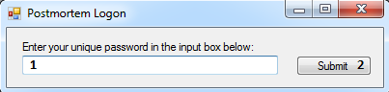**User Login:**

1. User password input box
2. Submit password button

**Postmortem:**

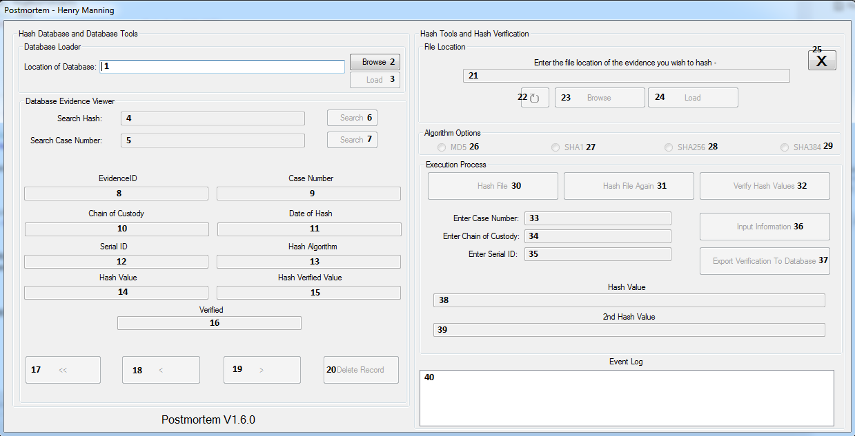

1. Database location textbox
2. Browse database location button
3. Load database button
4. Hash value search input box
5. Case number search input box
6. Search hash value button
7. Case number search button
8. EvidenceID textbox
9. Case number textbox
10. Chain of Custody textbox
11. Date of hash textbox
12. SerialID textbox
13. Hash algorithm textbox
14. Hash value textbox
15. Hash verified value textbox
16. Verified textbox
17. First record button
18. Previous record button
19. Next record button
20. Delete record button
21. Evidence file location textbox
22. Reset hashing section button
23. Browse for evidence file button
24. Load database button
25. Exit program button
26. MD5 hashing algorithm radio button
27. SHA1 hashing algorithm radio button
28. SHA256 hashing algorithm radio button
29. SHA384 hashing algorithm radio button
30. Hash file button
31. Hash file again button
32. Verify hash values button
33. Case number input box
34. Chain of custody input box
35. SerialID input box
36. Input information button
37. Export verification button
38. Hash value textbox
39. Hash verified value textbox
40. Event log

**How to use Postmortem**

There are many functions which can be done using the Postmortem application, these are:

1. Logging into the Postmortem application
2. Loading a database into the Postmortem application
3. Searching a hash value from the Postmortem database
4. Searching a case number from the Postmortem database
5. Navigation of the Postmortem database
6. Hashing an evidence file
7. Exporting the hashed evidence file into the database

**Logging into the Postmortem application –**

**Stage 1:** When the login form loads when the user has started the program, enter your unique password into the textbox.

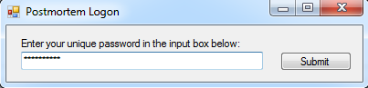

**Stage 2:** When the password has been entered, press the “Submit” button to load into the Postmortem program

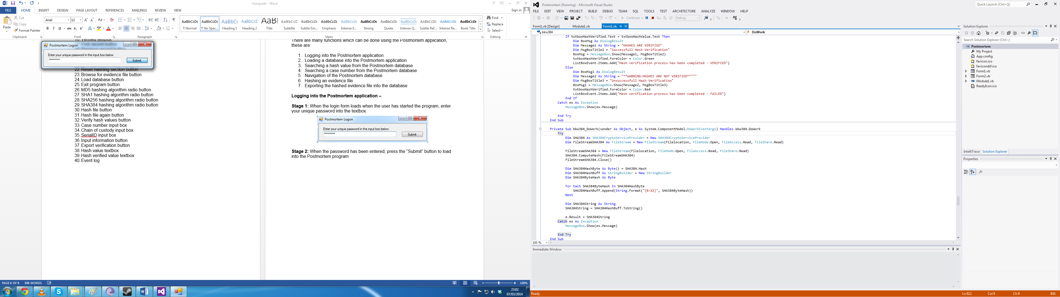

**Loading a database into the Postmortem application –**

**Stage 1:** On the right hand side of the Postmortem application is the database section. To load a database into the program, press the browse button.

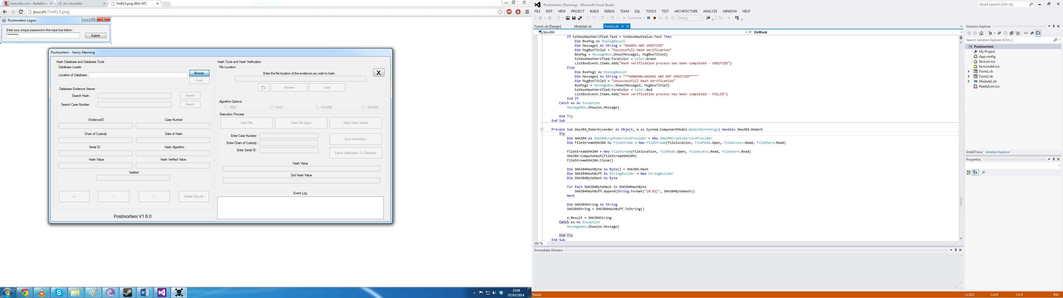

**Stage 2:** When the “Browse” button has been pressed, it will load a dialog where you can now search for the database file.

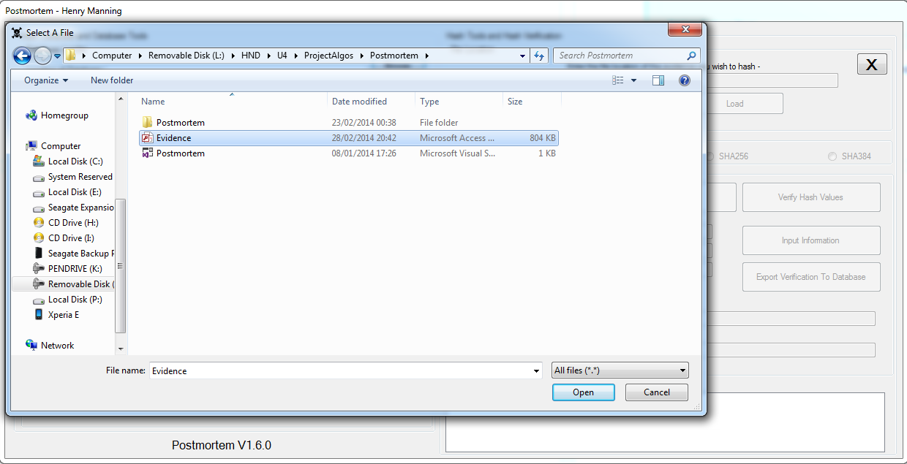

**Stage 3:** When you have selected the database file, press the “Open” button on the dialog to load the database file location into the textbox.

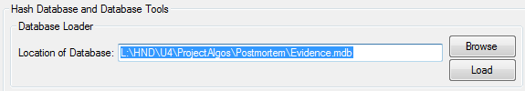

**Stage 4:** When the database location appears in the location textbox, press the “Load” button to load the database into the program to establish a connection to the file.

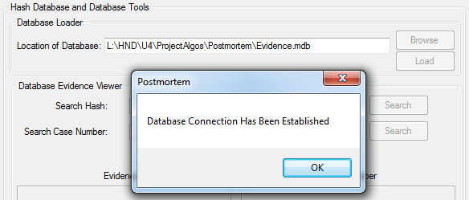

**Stage 5:** When the message box shows with the message of “Database Connection Has Been Established”, this confirms the connection between the two objects and allows manipulation of the database.

**Searching a hash value from the Postmortem database –**

**Stage 1:** To start the search a hash value process, enter the hash value into the appropriate textbox.

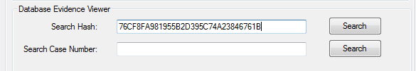

**Stage 2:** When the hash value has been entered into the textbox, press the search button to view all the information related to that hash.

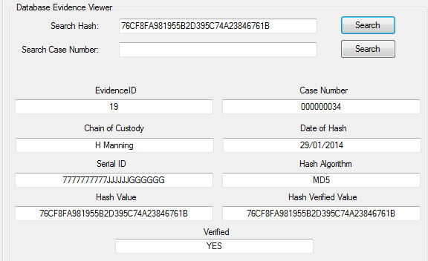

**Stage 3:** When the information has been filled out to the textboxes, this allows you the user to view the information relating to the evidence.

**Searching a case number from the Postmortem database –**

**Stage 1:** To start the search a case number process, enter the case number into the appropriate textbox.

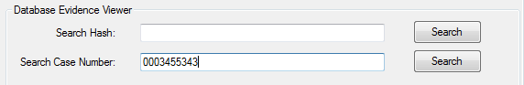

**Stage 2:** When the case number has been entered into the textbox, press the search button to view all the information related to that hash.

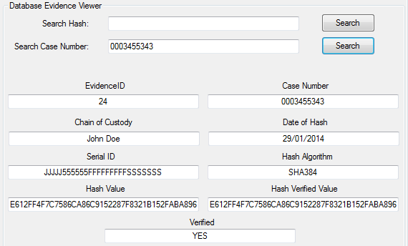

**Stage 3:** When the information has been filled out to the textboxes, this allows you the user to view the information relating to the evidence.

Navigation of the Postmortem database –

**Stage 1:** When the database has been loaded into the program, there are four options which relate to the navigation of the database. Those are; First Record, Previous Record, Next Record and Delete Record.



**Stage 2:** To go to the first record of the database, press the “<<” button.



**Stage 3:** To go to the previous record, press the “<” button.



**Stage 4:** To go to the next record, press the “>” button.



**Stage 5:** To delete a record, press the “Delete Record” button.



**Hashing an evidence file –**

**Stage 1:** Go to the hashing section of the Postmortem program and press the Browse button. By doing this, the application brings up a dialog where the user can then select an evidence file.

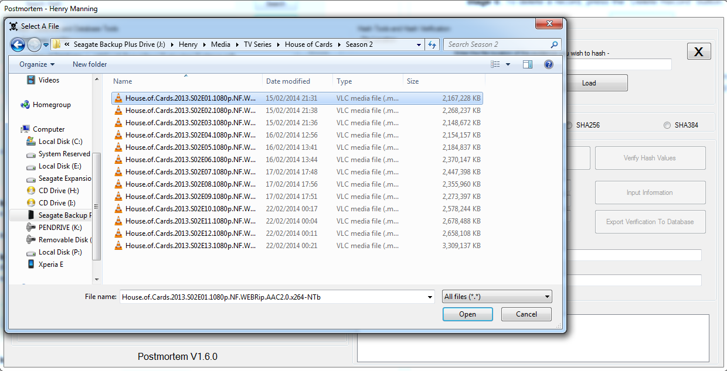

**Stage 2:** Select an evidence file by highlighting the file and then press open. This will put the file location of the evidence into the textbox of the hashing section.

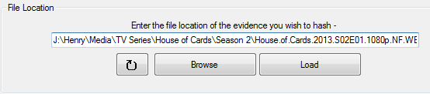

**Stage 3:** Press the “Load” button to load the file location of the evidence file into the Postmortem application. When the file has been loaded into the application, the event log will update to show conformation.



**Stage 4:** The next step of hashing a file is choosing a hashing algorithm. As an example, the hashing algorithm will be in MD5. There are four options MD5, SHA1, SHA256 and SHA384. Select the appropriate algorithm radio button to carry on with the hashing process.



**Stage 5:** Furthermore, the next step is to hash the file. Press the “Hash File” button to hash the file.

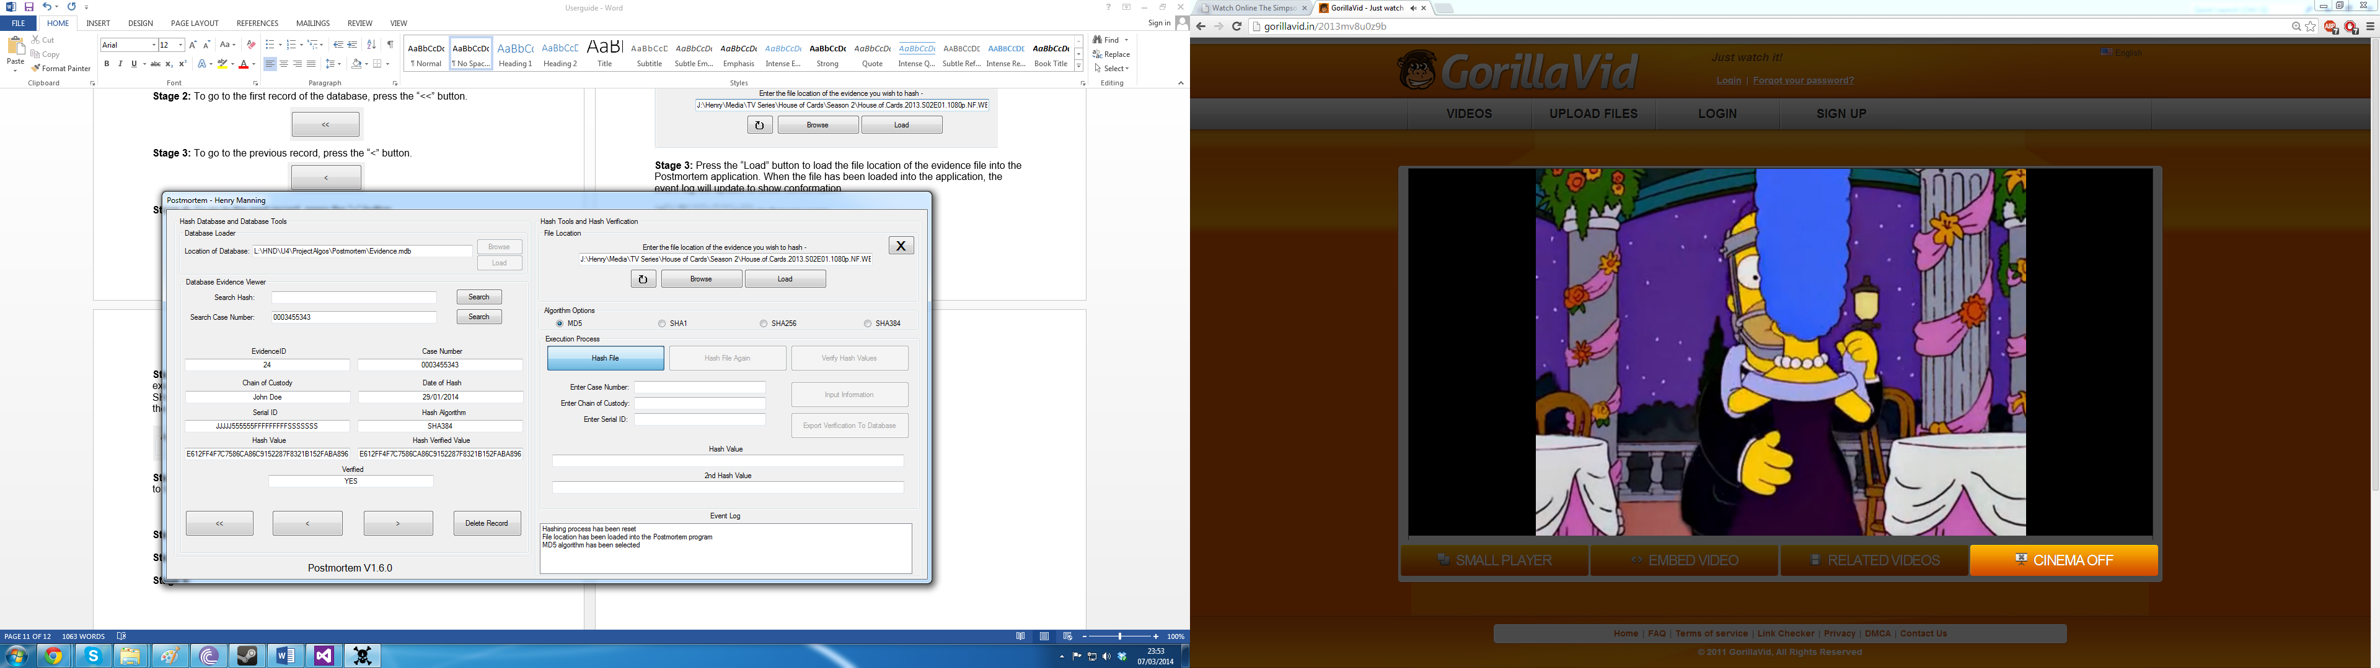

**Stage 6:** Once the first hash value has been retrieved, press the “Hash File Again” button to retrieve the second value of the hash.

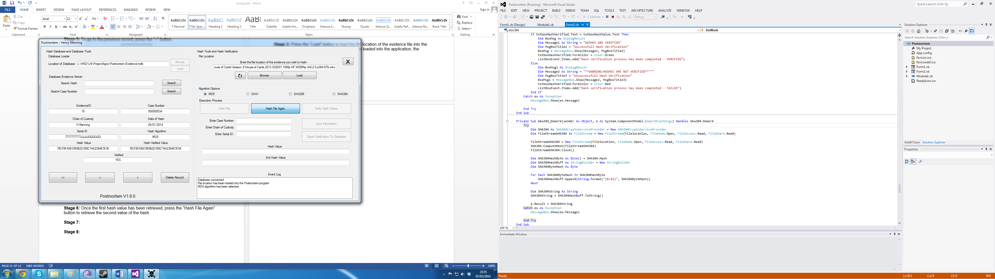

**Stage 7:** When both of the hashes have been created by the program, to verify the hashes generated, press the “Verify Hash Values” button.

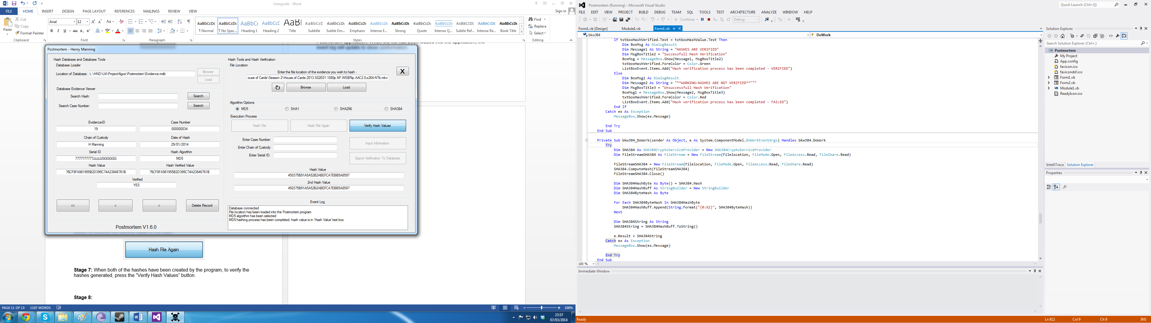

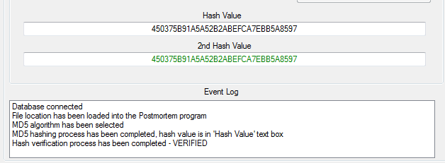**Stage 8:** Once all three buttons have been pressed, the hash values and the verification have been completed.

**Exporting the hashed evidence file into the database –**

**Stage 1:** When the hashing of the files and verification have taken place. The next step to complete the hashing process is inputting the information from the user of the program to the application input boxes. Enter the information relating to:

1. Case Number
2. Chain of Custody
3. Serial ID

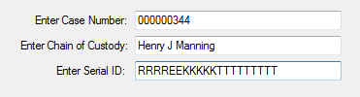

**Stage 2:** When the information has been inputted into the application, press the “Input Information” button.

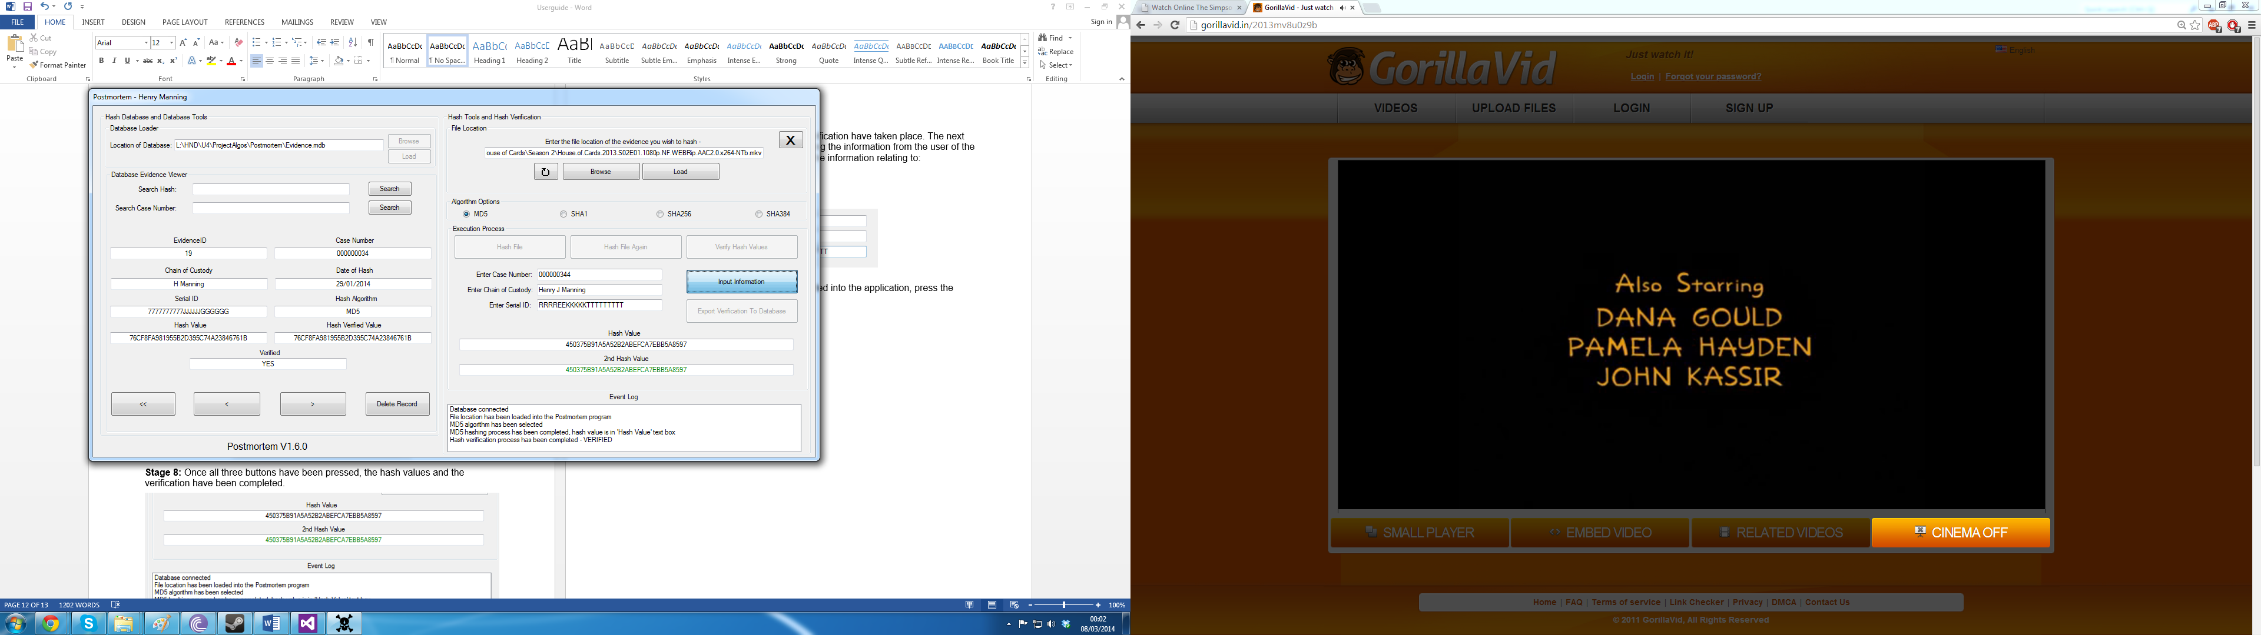

**Stage 3:** Once the information has been inputted, press the “Export Verification To Database” button to export all of the information into the database.

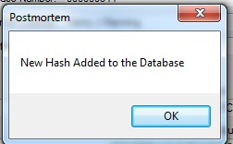

**Stage 4:** Now that the information has been exported to the database, the user of the program can now view that new hash record by restarting the program.

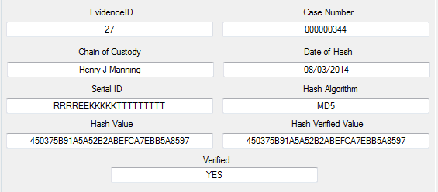

**Solutions to Common Problems**

There is only one known common problem which occur in the Postmortem application:

Database navigation “Start of Database” when searching for hash and case number values.

**Solution:** In the Postmortem version 1.6.0, there is only one solution to rectifying the “Start of Database” error when after searching for a value that this brings up the message box when either pressing the “Previous” button or the “Next” button.

**Stage 1:** When the following message box appears when pressing the “Next” or “Previous” buttons on the application, press the “Ok” button on the message box.

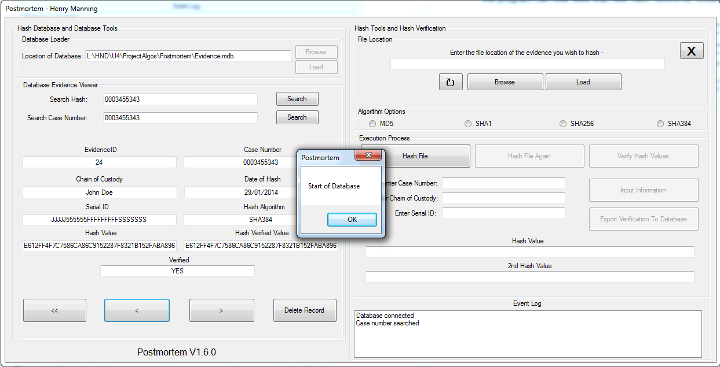

**Stage 2:** Exit the application by pressing the “X” button:

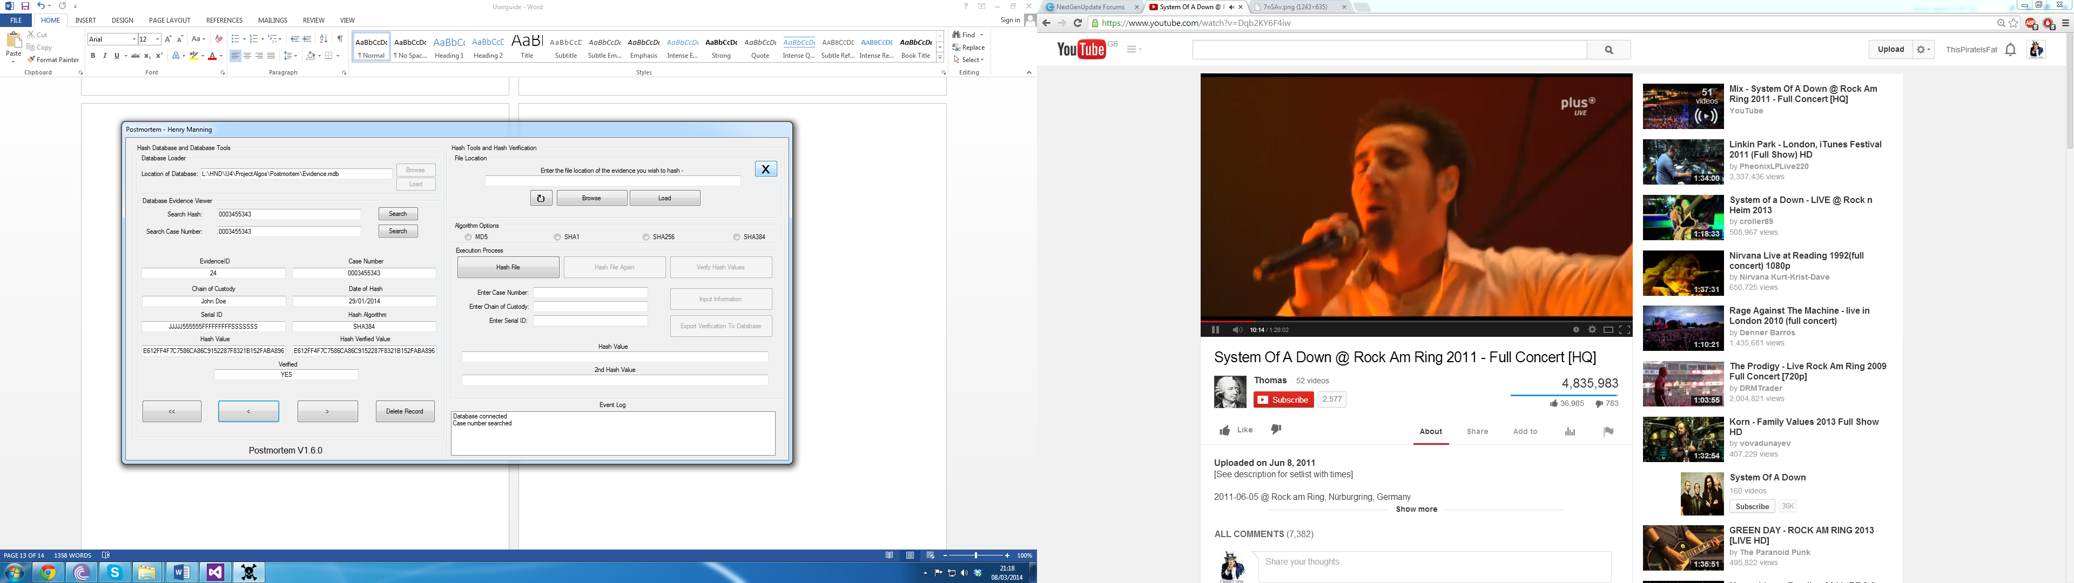

**Stage 3:** Restart the application and access the database again via the browse and load buttons in the database section of Postmortem program.

**NOTE:** This is the only current work around to counteract the problem. A future release will include a fix to the problem.

**Contact Information**

If you wish to contact the creator of Postmortem, their information is the following:

**Name and Address:**

Henry James Manning

21 Westfield Close

Bridgwater, Somerset

TA6 3RR

**Phone Number and Email Address:**

01278420721

[manning.henry@hotmail.co.uk](mailto:manning.henry@hotmail.co.uk)

© Copyright - Postmortem, Henry Manning, 25/1/14, All Rights Reserved

**Appendix 12 –**

**Testing**

Within the testing paradigm, there are two types of testing; Blackbox and Whitebox testing. To test the Postmortem application, both types of testing will be implemented.

**Blackbox Testing:** Blackbox testing is another name for the purpose which is functional testing of the application. Blackbox testing ignores the internal code and mechanisms of the application but focuses solely on the outputs generated by user actions from the Postmortem program.

The primary goal of the Blackbox testing method is to assess whether software does what it is meant to do. This especially matters in the requirements set by the client. There are four levels of Blackbox testing:

1. Unit Testing
2. Integration Testing
3. System Testing
4. Acceptance Testing
5. Algorithms

Each different level is used to test a different area of the software applications outputs. For example, the integration level of testing concentrates on the area of interacting modules while the system testing level focuses on performance and reliability.

The many various complex Blackbox testing strategies are critical to the reliability of the Postmortem application and are required to be done in order to fulfil the client’s requirements. (Gao, 2003)

**Whitebox Testing:** Whitebox testing is another name for the purpose which is structural testing. Structural testing takes into account the internal code and mechanisms of the application. The difference between Blackbox and Whitebox is that Whitebox testing requires knowledge surrounding the internal functions.

There are many different techniques for Whitebox testing as well as the hierarchy of different criteria. Those techniques are:

1. Flow Graph Notation
2. Path Testing
3. Statement Coverage
4. Branch Coverage

**Flow Graph Notation:** Whitebox testing relies upon the structure of the program. Thus needing a representation of the program needs to be defined first. Flow charts coming from the compiler are often used to depict logical control flow of a program.

**Path Testing:** The flow graph provides a way of showing program structures as well as test case execution. Each given flow graph and test cases can be corresponded to a path however, there can be unlimited amount of paths in a flow graph.

**Statement Coverage:** When the Postmortem application is being created, every statement inputted into the code is expected to be executed which in turn means that it should therefore run at least once. Complex statements require coverage of all portions of the statement so there can be a clear understanding and overview of it.

**Branch Coverage:** Within flow graphs, there are certain nodes called “Decision Nodes” which will determine the next operation or move of the application. To allow a decision node to calculate its next move, each predicate needs to be tested to be true at least once. Statement coverage and branch coverage criteria are near the same because there is only one main difference, the mechanism.

**Algorithms:** The Postmortem application has many algorithms being implemented into the program. Those algorithms are: MD5, SHA1, SHA256 and SHA384, each algorithm needs to be tested so it can fulfil the client’s requirements.

The main cause for using the Whitebox testing technique is to find bugs and errors within the program while Blackbox testing is used to find more bugs. Both techniques should be used together in order to have a successful testing stage of the Postmortem application. (Gao, 2003 )

**Test Plan –**

|  |  |  |  |  |
| --- | --- | --- | --- | --- |
| **No.** | **Type** | **What** | **Expectations** | **What Happened?** |
| 1 | Blackbox | Does frmLogon load first? | The form 2 should load first before anything else. |  |
| 2 | “ | If there is a successful password input, does the frmLogon hide? | The frmLogon should hide when the correct password is inputted |  |
| 3 | “ | If there is a successful password input, does the frmHashDatabase show? | The frmHashDatabase should show onto the screen of the clients system |  |
| 4 | “ | When the database browse button is pressed, does it load the dialog? | The dialog should load when the button is pressed |  |
| 5 | “ | When the dialog is shown, does it show the default C: drive? | The C drive should load into the dialog result |  |
| 6 | “ | When selecting the database file, does the location load into the database textbox? | The database location should be loaded into the textbox |  |
| 7 | “ | When the database browse button is pressed, does the Load button become enabled? | The Load button should become re enabled through the Postmortem application |  |
| 8 | “ | When the load button is pressed, does a messagebox show that a connection has been established to the database? | The messagebox should pop up onto the clients system showing that there has been a successful connection |  |
| 9 | “ | When the database has been connected, does 11 buttons become enabled on the Postmortem application? | When the database connects, 11 buttons should become enabled |  |
| 10 | “ | When the database has been connected does the 17 textboxes become enabled in the Postmortem application? | When the database connects, 17 textbox should become enabled |  |
| 11 | “ | When searching a hash value, does the database textboxes update with the correct information? | The correct information should populate the textboxes in the database section |  |
| 12 | “ | When searching a case number value, does the database textboxes update with the correct information? | The correct information should populate the textboxes in the database section |  |
| 13 | “ | When a case number has been searched, does the event log update? | The event log should update with what action the user has taken |  |
| 14 | “ | When a hash value has been searched, does the event log update? | The event log should update with what action the user has taken |  |
| 15 | “ | When the First Record button is pressed, does it go to the first record of the database? | The first record in the database should be shown when the button is pressed |  |
| 16 | “ | When the Next Record button is pressed, does it go to the next record? | The next record should populate the database textboxes |  |
| 17 | “ | When the Previous Record button is pressed, does it go to the previous record in the database? | The previous record should populate the database textboxes |  |
| 18 | “ | When the Delete Record button is pressed, does it show a messagebox with Yes and No options? | The messagebox with the Yes or No option should load into the clients view on the application |  |
| 19 | “ | When the Delete Record message box is shown, when the Yes button is pressed does the event log update with the action of the client? | The event log should update with the action of the client. |  |
| 20 | “ | When the Delete Record message box is shown, when the No button is pressed does a message box pop up with a message stating about the cancelation of the delete operation? | The message box should load to the user and say that the delete operation has been aborted |  |
| 21 | “ | When the evidence file location browse button is pressed, does it load the dialog? | The dialog should load onto the clients application |  |
| 22 | “ | When the dialog loads, does it automatically go to the C: drive? | The dialog should automatically go the clients C: drive |  |
| 23 | “ | When selecting the evidence file, does the Select button put the file location in the evidence file location textbox? | The evidence file location textbox should be populated by the dialogs select file button |  |
| 24 | “ | When the evidence file load button is pressed, does the event log update with the action of loading the file? | The event log should update with the client loading the file into the program |  |
| 25 | “ | When selecting MD5 radio button, does the event log update with the selection? | The event log should update with the action chosen by the client |  |
| 26 | “ | When selecting SHA radio button, does the event log update with the selection? | The event log should update with the action chosen by the client |  |
| 27 | “ | When selecting SHA256 radio button, does the event log update with the selection? | The event log should update with the action chosen by the client |  |
| 28 | “ | When selecting SHA384 radio button, does the event log update with the selection? | The event log should update with the action chosen by the client |  |
| 29 | “ | When the Hash File button is pressed, does the Hash File button become disabled? | The Hash File button should become disabled when pressed |  |
| 30 | “ | When the Hash File Again button is pressed, does the Hash File Again button become disabled? | The Hash File Again button should become disabled when pressed |  |
| 31 | “ | When the Verify Hash Values button is pressed, does the Verify Hash Values button become disabled? | The Verify Hash Values button should become disabled when pressed |  |
| 32 | “ | When the Verify Hash Values button has been pressed, does the messagebox show up with either a Failed Verification message or a Successful Verification message? | The message box should show with either a failed message or a successful message |  |
| 33 | “ | When the Input Information button has been pressed, does the Input Information button become disabled? | The button should become disabled when pressed |  |
| 34 | “ | When the Export To Database button is pressed, does the button become disabled when pressed? | The button should become disabled when it has been pressed |  |
| 35 | “ | When the Export To Database button is pressed, does the messagebox show that it has been exported to the database? | The messagebox should show with a conformation message when the export has been completed |  |
| 36 | “ | When the Reset button is pressed, does the event log update with its purpose? | The event log should update with a statement of what it has done |  |
| 37 | “ | When the Reset button is pressed, does it clear the hash values textboxes? | The Hash Values textboxes should be cleared of both values |  |
| 38 | “ | When the Reset button is pressed, does it clear the hash algorithm radio buttons? | The radio buttons should become unchecked which will allow a new hash to take place |  |
| 39 | “ | When the Reset button is pressed, does it clear the Evidence File Location textbox? | The textbox should be cleared where another location can be declared |  |
| 40 | “ | When the Exit button is pressed, does it exit the application? | The application should exit when the button has been pressed |  |
| 41 | Whitebox | Does the textboxes within the database section of the program correspond with the tables in the database file? | The textboxes should be populated with the correct information from the database |  |
| 42 | “ | When selecting a database file, the application should only accept aacdb files and no other types of files. | The application should bring up an error message stating that the file is unrecognised |  |
| 43 | “ | When searching a hash number, does the SQL statement within the program take it from the hash value textbox? | The textbox value should be used and then populate the database textboxes |  |
| 44 | “ | When searching a case number, does the SQL statement within the program take it from the case number textbox? | The textbox value should be used and then populate the database textboxes |  |
| 45 | “ | When a record has been deleted from the database, does the SQL statement in the application actually delete a record from the database file? | The record should be deleted from the database file |  |
| 46 | “ | When selecting the MD5 algorithm, does it equal HashAlgorithm 1? | The HashAlgorithm variable should equal 1 |  |
| 47 | “ | When selecting the SHA algorithm, does it equal HashAlgorithm 2? | The HashAlgorithm variable should equal 2 |  |
| 48 | “ | When selecting the SHA256 algorithm, does it equal HashAlgorithm 3? | The HashAlgorithm variable should equal 3 |  |
| 49 | “ | When selecting the SHA384 algorithm, does it equal HashAlgorithm 4? | The HashAlgorithm variable should equal 4 |  |
| 50 | “ | When pressing the Hash File button, if the algorithm selection is 1 does it start the MD5 hashing function? | If the algorithm selection is 1 then it should start the background worker regarding MD5 |  |
| 51 | “ | When pressing the Hash File button, if the algorithm selection is 2 does it start the SHA1 hashing function? | If the algorithm selection is 2 then it should start the background worker regarding SHA1 |  |
| 52 | “ | When pressing the Hash File button, if the algorithm selection is 3 does it start the SHA256 hashing function? | If the algorithm selection is 3 then it should start the background worker regarding SHA256 |  |
| 53 | “ | When pressing the Hash File button, if the algorithm selection is 4 does it start the SHA384 hashing function? | If the algorithm selection is 4 then it should start the background worker regarding SHA384 |  |
| 54 | “ | When pressing the Hash File Again button, if the algorithm selection is 1 does it start the MD5 Verification hashing function? | If the algorithm selection is 1 then it should start the background worker regarding MD5 verification |  |
| 55 | “ | When pressing the Hash File Again button, if the algorithm selection is 2 does it start the SHA1 Verification hashing function? | If the algorithm selection is 2 then it should start the background worker regarding SHA1 verification |  |
| 56 | “ | When pressing the Hash File Again button, if the algorithm selection is 3 does it start the SHA256 Verification hashing function? | If the algorithm selection is 3 then it should start the background worker regarding SHA3256 verification |  |
| 57 | “ | When pressing the Hash File Again button, if the algorithm selection is 4 does it start the SHA384 Verification hashing function? | If the algorithm selection is 4 then it should start the background worker regarding SHA384 verification |  |
| 58 | “ | When pressing the Verify Hash Values, does the compare function work correctly? | The function should compare the two values and display a message. |  |
| 59 | “ | When logging into the Postmortem application, if the password is not correct, does the program exit? | The Postmortem password submit form should close and then exit the whole application. |  |

**Testing –**

|  |  |  |  |  |
| --- | --- | --- | --- | --- |
| **No.** | **Type** | **What** | **Expectations** | **What Happened?** |
| 1 | Blackbox | Does frmLogon load first? | The form 2 should load first before anything else. | The frmLogon loaded which allowed the user to launch the Postmortem application |
| 2 | “ | If there is a successful password input, does the frmLogon hide? | The frmLogon should hide when the correct password is inputted | The frmLogon did hide in the background when the password was successful. |
| 3 | “ | If there is a successful password input, does the frmHashDatabase show? | The frmHashDatabase should show onto the screen of the clients system | The frmHashDatabase showed when the password input was successful |
| 4 | “ | When the database browse button is pressed, does it load the dialog? | The dialog should load when the button is pressed | The dialog was generated and allowed the user to use it |
| 5 | “ | When the dialog is shown, does it show the default C: drive? | The C drive should load into the dialog result | The C drive was the only drive visible to the user at the start, but they are able to change drive if they wish |
| 6 | “ | When selecting the database file, does the location load into the database textbox? | The database location should be loaded into the textbox | The database location was loaded into the textbox |
| 7 | “ | When the database browse button is pressed, does the Load button become enabled? | The Load button should become re enabled through the Postmortem application | The Load button became enabled |
| 8 | “ | When the load button is pressed, does a messagebox show that a connection has been established to the database? | The messagebox should pop up onto the clients system showing that there has been a successful connection | When the Postmortem application connected to the database, the messagebox popped up when it was successful. |
| 9 | “ | When the database has been connected, does 11 buttons become enabled on the Postmortem application? | When the database connects, 11 buttons should become enabled | When the Postmortem application connected to the database, all 11 buttons enabled on the form. |
| 10 | “ | When the database has been connected does the 17 textboxes become enabled in the Postmortem application? | When the database connects, 17 textbox should become enabled | When the Postmortem application connected to the database, all 17 textboxes became enabled on the form. |
| 11 | “ | When searching a hash value, does the database textboxes update with the correct information? | The correct information should populate the textboxes in the database section | When the button was searched, it correctly inputted the information required into the textboxes |
| 12 | “ | When searching a case number value, does the database textboxes update with the correct information? | The correct information should populate the textboxes in the database section | When the button was searched, it correctly inputted the information required into the textboxes |
| 13 | “ | When a case number has been searched, does the event log update? | The event log should update with what action the user has taken | The event log was updated with the correct action |
| 14 | “ | When a hash value has been searched, does the event log update? | The event log should update with what action the user has taken | The event log was updated with the correct action |
| 15 | “ | When the First Record button is pressed, does it go to the first record of the database? | The first record in the database should be shown when the button is pressed | When the button was pressed, the first record on the database was shown |
| 16 | “ | When the Next Record button is pressed, does it go to the next record? | The next record should populate the database textboxes | When the button was pressed, it populated the textboxes of the next record |
| 17 | “ | When the Previous Record button is pressed, does it go to the previous record in the database? | The previous record should populate the database textboxes | When the button was pressed, it populated the textboxes of the previous record |
| 18 | “ | When the Delete Record button is pressed, does it show a messagebox with Yes and No options? | The messagebox with the Yes or No option should load into the clients view on the application | The messagebox showed the two Yes or No options on the form |
| 19 | “ | When the Delete Record message box is shown, when the Yes button is pressed does the event log update with the action of the client? | The event log should update with the action of the client. | The event log was updated with the action wanted by the client |
| 20 | “ | When the Delete Record message box is shown, when the No button is pressed does a message box pop up with a message stating about the cancelation of the delete operation? | The message box should load to the user and say that the delete operation has been aborted | When the no button was pressed on the message box, another messagebox was generated to state that the function has been aborted |
| 21 | “ | When the evidence file location browse button is pressed, does it load the dialog? | The dialog should load onto the clients application | The browse evidence file dialog was loaded into the clients application |
| 22 | “ | When the dialog loads, does it automatically go to the C: drive? | The dialog should automatically go the clients C: drive | The dialog was automatically on the C: drive |
| 23 | “ | When selecting the evidence file, does the Select button put the file location in the evidence file location textbox? | The evidence file location textbox should be populated by the dialogs select file button | The evidence file textbox was filled with the file location of the selected file |
| 24 | “ | When the evidence file load button is pressed, does the event log update with the action of loading the file? | The event log should update with the client loading the file into the program | The event log was updated with the action done by the client of the Postmortem application |
| 25 | “ | When selecting MD5 radio button, does the event log update with the selection? | The event log should update with the action chosen by the client | The event log was updated with the action done by the client of the Postmortem application |
| 26 | “ | When selecting SHA radio button, does the event log update with the selection? | The event log should update with the action chosen by the client | The event log was updated with the action done by the client of the Postmortem application |
| 27 | “ | When selecting SHA256 radio button, does the event log update with the selection? | The event log should update with the action chosen by the client | The event log was updated with the action done by the client of the Postmortem application |
| 28 | “ | When selecting SHA384 radio button, does the event log update with the selection? | The event log should update with the action chosen by the client | The event log was updated with the action done by the client of the Postmortem application |
| 29 | “ | When the Hash File button is pressed, does the Hash File button become disabled? | The Hash File button should become disabled when pressed | When the button was pressed, it became disabled |
| 30 | “ | When the Hash File Again button is pressed, does the Hash File Again button become disabled? | The Hash File Again button should become disabled when pressed | When the button was pressed, it became disabled |
| 31 | “ | When the Verify Hash Values button is pressed, does the Verify Hash Values button become disabled? | The Verify Hash Values button should become disabled when pressed | When the button was pressed, it became disabled |
| 32 | “ | When the Verify Hash Values button has been pressed, does the messagebox show up with either a Failed Verification message or a Successful Verification message? | The message box should show with either a failed message or a successful message | The messagebox was generated and provided a successful message |
| 33 | “ | When the Input Information button has been pressed, does the Input Information button become disabled? | The button should become disabled when pressed | When the button was pressed, it became disabled |
| 34 | “ | When the Export To Database button is pressed, does the button become disabled when pressed? | The button should become disabled when it has been pressed | When the button was pressed, it became disabled |
| 35 | “ | When the Export To Database button is pressed, does the messagebox show that it has been exported to the database? | The messagebox should show with a conformation message when the export has been completed | When the Export To Database button was pressed, it generated a messagebox which confirmed that the record has been exported |
| 36 | “ | When the Reset button is pressed, does the event log update with its purpose? | The event log should update with a statement of what it has done | When the reset button was pressed, the event log was updated with the reset statement |
| 37 | “ | When the Reset button is pressed, does it clear the hash values textboxes? | The Hash Values textboxes should be cleared of both values | When the reset button was pressed, both of the hash value textboxes were cleared |
| 38 | “ | When the Reset button is pressed, does it clear the hash algorithm radio buttons? | The radio buttons should become unchecked which will allow a new hash to take place | When the reset button was pressed, all four of the hash algorithm radio buttons were cleared to unchecked |
| 39 | “ | When the Reset button is pressed, does it clear the Evidence File Location textbox? | The textbox should be cleared where another location can be declared | When the reset button was pressed the evidence file location textbox was cleared |
| 40 | “ | When the Exit button is pressed, does it exit the application? | The application should exit when the button has been pressed | When the Exit button was pressed, the application exited |
| 41 | Whitebox | Does the textboxes within the database section of the program correspond with the tables in the database file? | The textboxes should be populated with the correct information from the database | The database columns matched the Postmortem insert SQL statements. |
| 42 | “ | When selecting a database file, the application should only accept aacdb files and no other types of files. | The application should bring up an error message stating that the file is unrecognised | The Postmortem application did not crash when selecting a unrecognised format and the Postmortem application generated a messagebox to state it’s the wrong format |
| 43 | “ | When searching a hash number, does the SQL statement within the program take it from the hash value textbox? | The textbox value should be used and then populate the database textboxes | The value inputted into the textbox allowed a successful population of the correct data |
| 44 | “ | When searching a case number, does the SQL statement within the program take it from the case number textbox? | The textbox value should be used and then populate the database textboxes | The value inputted into the textbox allowed a successful population of the correct data |
| 45 | “ | When a record has been deleted from the database, does the SQL statement in the application actually delete a record from the database file? | The record should be deleted from the database file | The Postmortem application deleted the record when the SQL statement was invoked |
| 46 | “ | When selecting the MD5 algorithm, does it equal HashAlgorithm 1? | The HashAlgorithm variable should equal 1 | The variable HashAlgorithm was equalled to 1 |
| 47 | “ | When selecting the SHA algorithm, does it equal HashAlgorithm 2? | The HashAlgorithm variable should equal 2 | The variable HashAlgorithm was equalled to 2 |
| 48 | “ | When selecting the SHA256 algorithm, does it equal HashAlgorithm 3? | The HashAlgorithm variable should equal 3 | The variable HashAlgorithm was equalled to 3 |
| 49 | “ | When selecting the SHA384 algorithm, does it equal HashAlgorithm 4? | The HashAlgorithm variable should equal 4 | The variable HashAlgorithm was equalled to 4 |
| 50 | “ | When pressing the Hash File button, if the algorithm selection is 1 does it start the MD5 hashing function? | If the algorithm selection is 1 then it should start the background worker regarding MD5 | When the HashAlgorithm was 1 it started the MD5 hashing process |
| 51 | “ | When pressing the Hash File button, if the algorithm selection is 2 does it start the SHA1 hashing function? | If the algorithm selection is 2 then it should start the background worker regarding SHA1 | When the HashAlgorithm was 2 it started the SHA hashing process |
| 52 | “ | When pressing the Hash File button, if the algorithm selection is 3 does it start the SHA256 hashing function? | If the algorithm selection is 3 then it should start the background worker regarding SHA256 | When the HashAlgorithm was 3 it started the SHA256 hashing process |
| 53 | “ | When pressing the Hash File button, if the algorithm selection is 4 does it start the SHA384 hashing function? | If the algorithm selection is 4 then it should start the background worker regarding SHA384 | When the HashAlgorithm was 4 it started the SHA384 hashing process |
| 54 | “ | When pressing the Hash File Again button, if the algorithm selection is 1 does it start the MD5 Verification hashing function? | If the algorithm selection is 1 then it should start the background worker regarding MD5 verification | When the AlgorithmSelection was 1 it started the MD5 verification hashing process |
| 55 | “ | When pressing the Hash File Again button, if the algorithm selection is 2 does it start the SHA1 Verification hashing function? | If the algorithm selection is 2 then it should start the background worker regarding SHA1 verification | When the AlgorithmSelection was 2 it started the SHA verification hashing process |
| 56 | “ | When pressing the Hash File Again button, if the algorithm selection is 3 does it start the SHA256 Verification hashing function? | If the algorithm selection is 3 then it should start the background worker regarding SHA3256 verification | When the AlgorithmSelection was 3 it started the SHA256 verification hashing process |
| 57 | “ | When pressing the Hash File Again button, if the algorithm selection is 4 does it start the SHA384 Verification hashing function? | If the algorithm selection is 4 then it should start the background worker regarding SHA384 verification | When the AlgorithmSelection was 4 it started the SHA384 verification hashing process |
| 58 | “ | When pressing the Verify Hash Values, does the compare function work correctly? | The function should compare the two values and display a message. | When the function compared two sets of values, it successfully compared the two to decide if it was verified or not. |
| 59 | “ | When logging into the Postmortem application, if the password is not correct, does the program exit? | The Postmortem password submit form should close and then exit the whole application. | When entering the wrong password into the textbox, when the submit button was pressed, a messagebox appeared stating that it was shutting down the program |

**Test Evidence –**

**No 1 -** The frmLogon loaded which allowed the user to launch the Postmortem application

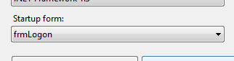

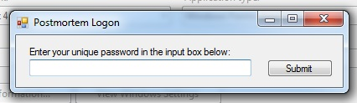

**No 2 -** The frmLogon did hide in the background when the password was successful.

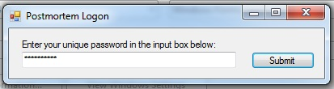

**No 3 -** The frmHashDatabase showed when the password input was successful

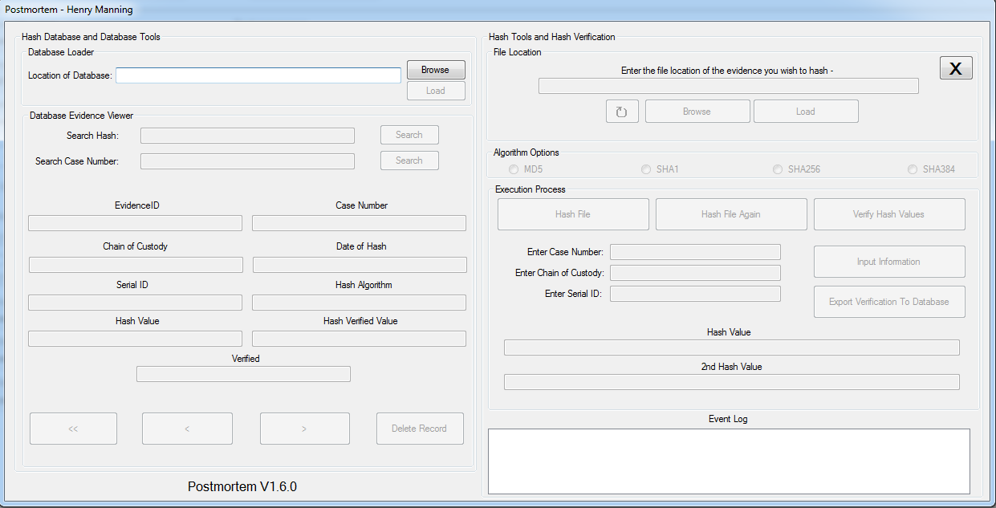

**No 4 & 5 -** The dialog was generated and allowed the user to use it. The C drive was the only drive visible to the user at the start, but they are able to change drive if they wish

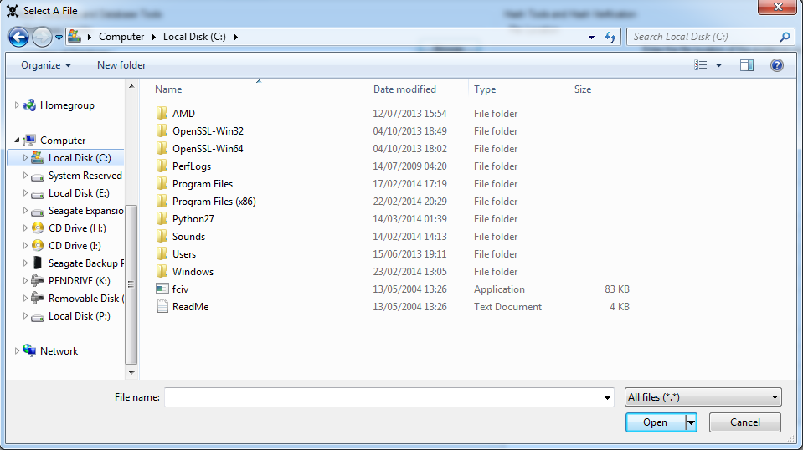

**No 6 -** The database location was loaded into the textbox

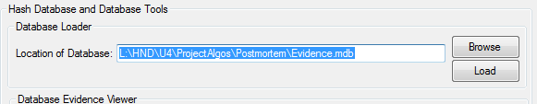

**No 7 -** The Load button became enabled

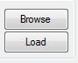

**No 8 -** When the Postmortem application connected to the database, the messagebox popped up when it was successful.

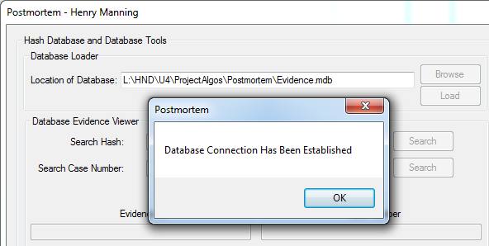

**No 9 –** When the Postmortem application connected to the database, all 11 buttons enabled on the form.

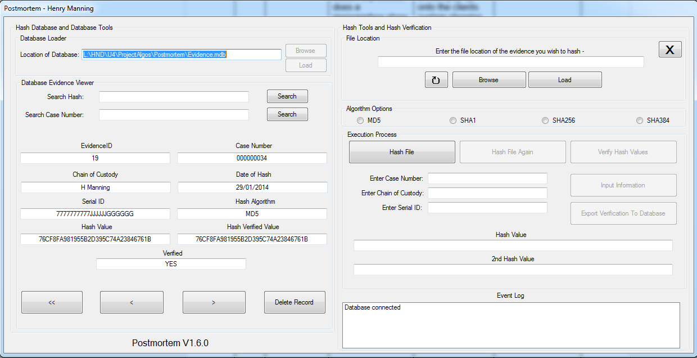

**No 10 –** When the Postmortem application connected to the database, all 17 textboxes became enabled on the form.



**No 11 -** When the button was searched, it correctly inputted the information required into the textboxes



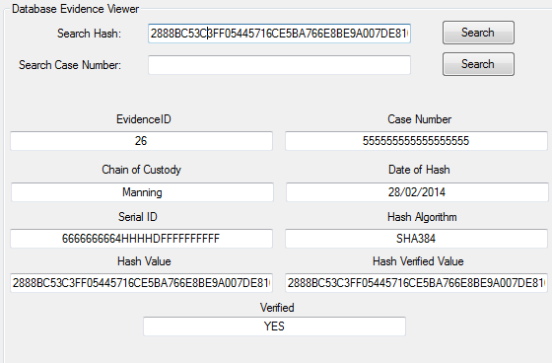

**No 12 -** When the button was searched, it correctly inputted the information required into the textboxes



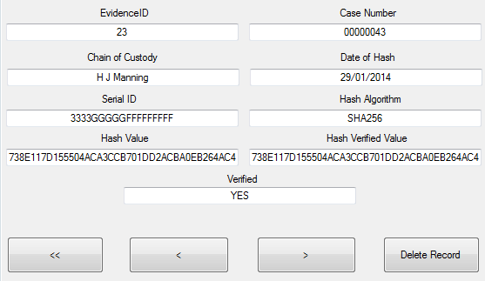

**No 13 -** The event log was updated with the correct action

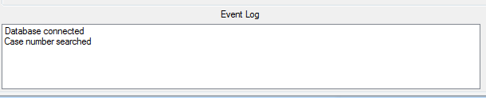

**No 14 –** The event log was updated with the correct action

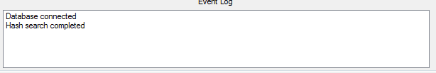

**No 15 -** When the button was pressed, the first record on the database was shown

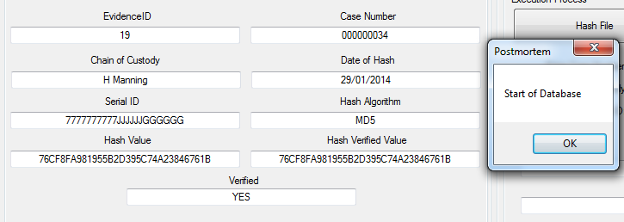

**No 16 -** When the button was pressed, it populated the textboxes of the next record

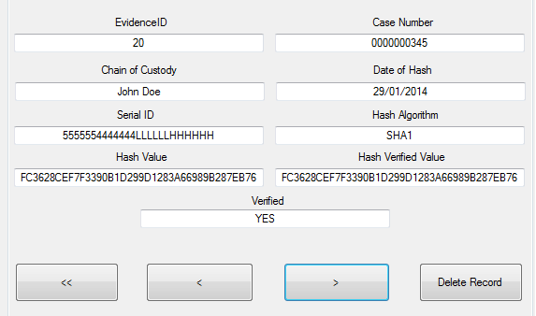

**No 17 -** When the button was pressed, it populated the textboxes of the previous record

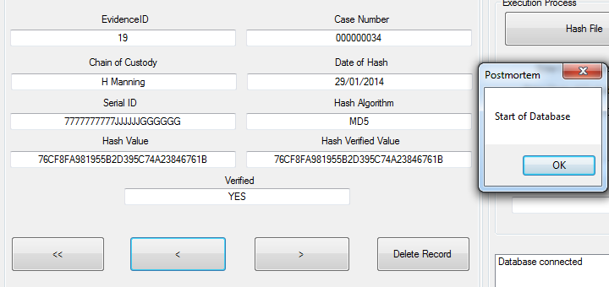

**No 18 -** The messagebox showed the two Yes or No options on the form

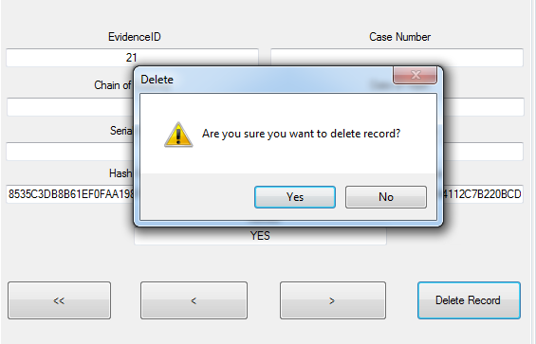

**No 19 -** The event log was updated with the action wanted by the client

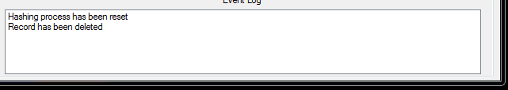

**No 20 -** When the no button was pressed on the message box, another messagebox was generated to state that the function has been aborted

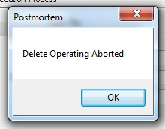

**No 21 & 22 –** The browse evidence file dialog was loaded into the client’s application. The dialog was automatically on the C: drive

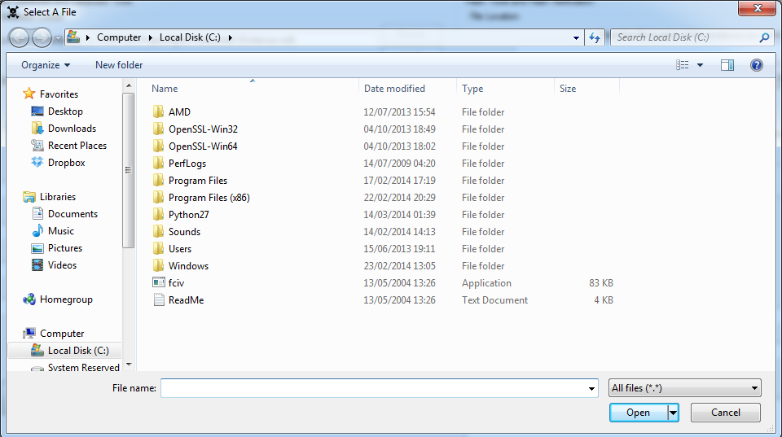

**No 23 -** The evidence file textbox was filled with the file location of the selected file

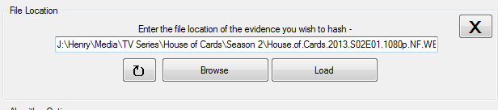

**No 24 -** The event log was updated with the action done by the client of the Postmortem application

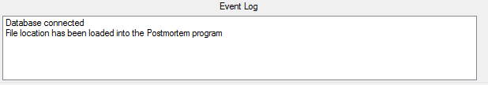

**No 25 -** The event log was updated with the action done by the client of the Postmortem application

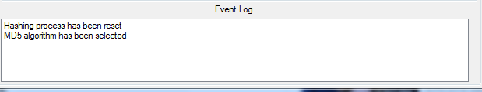

**No 26 -** The event log was updated with the action done by the client of the Postmortem application

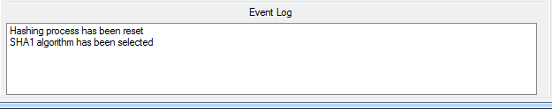

**No 27 -** The event log was updated with the action done by the client of the Postmortem application

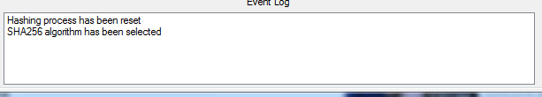

**No 28 -** The event log was updated with the action done by the client of the Postmortem application

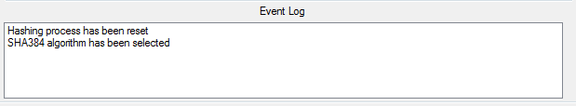

**No 29 –** When the button was pressed, it became disabled



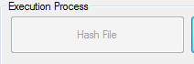

**No 30 –** When the button was pressed, it became disabled





**No 31 –** When the button was pressed, it became disabled





**No 32 –** The messagebox was generated and provided a successful message

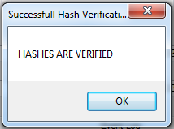

**No 33 –** When the button was pressed, it became disabled





**No 34 -** When the button was pressed, it became disabled





**No 35 -** When the Export To Database button was pressed, it generated a messagebox which confirmed that the record has been exported

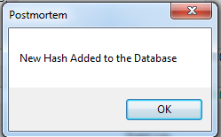

**No 36 –** When the reset button was pressed, the event log was updated with the reset statement



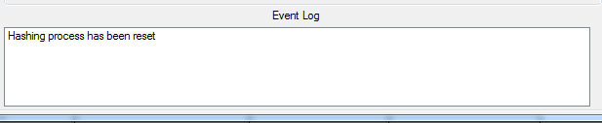

**No 37 -** When the reset button was pressed, both of the hash value textboxes were cleared



**No 38 –** When the reset button was pressed, all four of the hash algorithm radio buttons were cleared to unchecked



**No 39 -** When the reset button was pressed the evidence file location textbox was cleared



**No 40 –** When the Exit button was pressed, the application exited



**No 41 –** The database columns matched the Postmortem insert SQL statements.

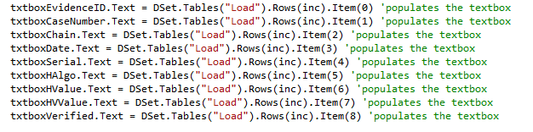



**No 42 –** The Postmortem application did not crash when selecting a unrecognised format and the Postmortem application generated a messagebox to state it’s the wrong format

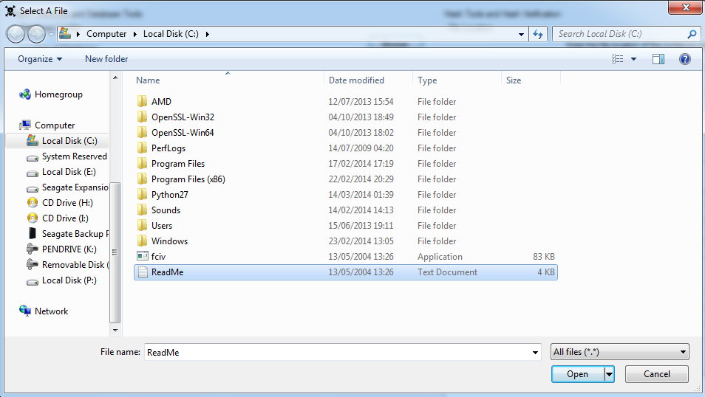

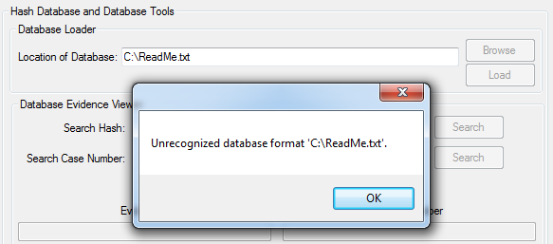

**No 43 -** The value inputted into the textbox allowed a successful population of the correct data







**No 44 -** The value inputted into the textbox allowed a successful population of the correct data







**No 45 -** The Postmortem application deleted the record when the SQL statement was invoked

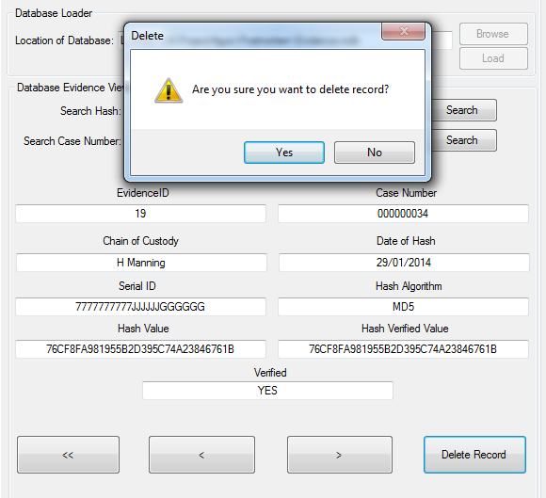



**No 46 -** The variable HashAlgorithm was equalled to 1

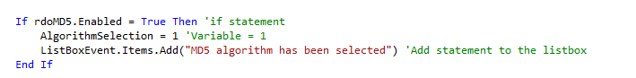

**No 47 -** The variable HashAlgorithm was equalled to 2

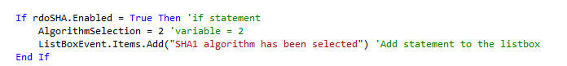

**No 48 -** The variable HashAlgorithm was equalled to 3

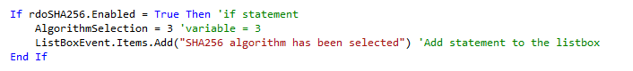

**No 49 -** The variable HashAlgorithm was equalled to 4

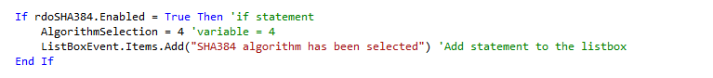

**No 50 -** When the HashAlgorithm was 1 it started the MD5 hashing process

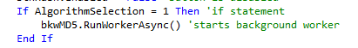

**No 51 -** When the HashAlgorithm was 2 it started the SHA hashing process

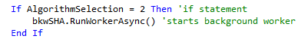

**No 52 -** When the HashAlgorithm was 3 it started the SHA256 hashing process

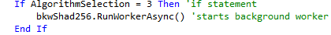

**No 53 -** When the HashAlgorithm was 4 it started the SHA384 hashing process

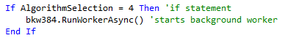

**No 54 –** When the AlgorithmSelection was 1 it started the MD5 verification hashing process

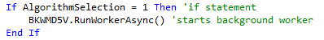

**No 55 -** When the AlgorithmSelection was 2 it started the SHA verification hashing process

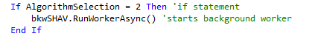

**No 56 -** When the AlgorithmSelection was 3 it started the SHA256 verification hashing process

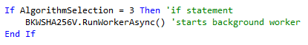

**No 57 -** When the AlgorithmSelection was 4 it started the SHA384 verification hashing process

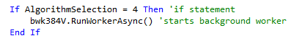

**No 58 -** When the function compared two sets of values, it successfully compared the two to decide if it was verified or not.

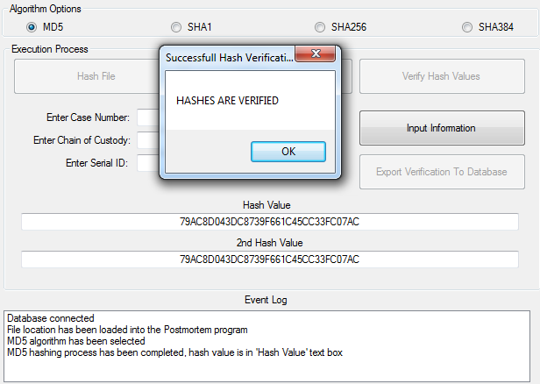

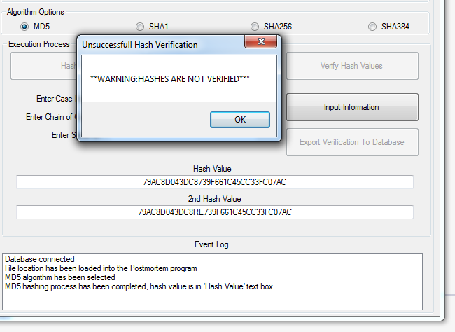

**No 59 -** When entering the wrong password into the textbox, when the submit button was pressed, a messagebox appeared stating that it was shutting down the program

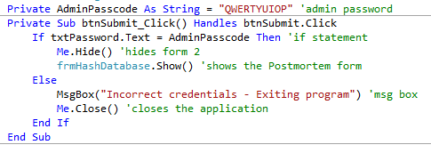

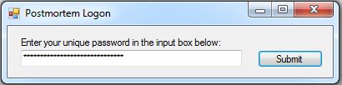

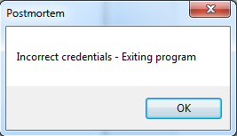

**Appendix 13 –**

**Deployment**

|  |  |  |
| --- | --- | --- |
| Project Identification | | |
| Postmortem | 1 | Date Created 25/10/13 |
|  |  |  |
| Program Manager – Henry Manning | Project Manager – Henry Manning | |
|  |  | |
| Completed by – 04/04/14 | | |
|  | | |

|  |  |  |  |
| --- | --- | --- | --- |
| Deployment Overview | | | |
| Number of Sites or Release Recipients | | **Target Deployments** | **Target Group** | Scheduled Dates |
| The first site of the installation will be the Metropolitan Police Service High Tec Crime Unit and the Avon and Somerset HTU | | 04/04/14 | MPS High Tec Crime Unit | 04/04/14 |
| 04/04/14 | Avon and Somerset TCU | 04/04/14 |
| Deployment Approach | | | | |
| Description | | | | |
| The deployment approach of the Postmortem application will be using a direct installation method. This will entail of installing the program off of an external hard drive such as a USB stick. The Postmortem program install files will be on the USB stick where it can be portable and easy to install on each system where it will be required. | | | | |
| Benefits (Tangible and Intangible) and Risks | | | | |
| By using a direct installation approach to the Postmortem installation, it will be far easier to install the program where as using a wave approach by taking so many computer systems a day and installing them that way. However, there can be a risk of installing the Postmortem application via a USB stick. The USB stick must be forensically wiped so there are no viruses or potential threats to pass onto the target installation systems. | | | | |
| Assumptions and Risks | | | | |
| Assumptions | | | | |
| The computers being the target of the installation must be forensic analyst computers and that they are prepared with Windows architecture. | | | | |
| Risks | | | | |
| USB stick infected with potential virus. | | | | |

|  |  |  |
| --- | --- | --- |
| Deployment Schedule and Resources | | |
| **Target Deployment and Sequence** | | Scheduled Release Dates | Resource Requirements |
| Deployment of installation USB Sticks | | 04/04/2014 | All installation technicians |
| Installation technicians installing the Postmortem program | | 04/04/2014 | The correct computer systems |
| Installation testing | | 04/04/2014 | Installation of the Postmortem application, required test checks passed |
| Postmortem Release | | 04/04/2014 | Satisfactory installation of the Postmortem application |

|  |  |  |
| --- | --- | --- |
| Technology, Infrastructure, and Support Considerations | | |
| Target | **Technology/Infrastructure Requirements** | **Support Requirements** |
| Metropolitan Police Service High Tec Unit | Fully installed Windows operating system and a forensic standard computer system | <Identify any support requirements for the target site/recipients> |
| Avon and Somerset High Tec Unit | <Identify any technology or infrastructure requirements for the site/recipients> | <Identify any support requirements for the target site/recipients> |

|  |  |  |  |
| --- | --- | --- | --- |
| Training Requirements | | | |
| Training Site/Recipients | Scheduled Dates | Trainer | Materials |
| Metropolitan Police Service HTU | 05/04/14 | Henry Manning | Postmortem User Manual |
| Avon and Somerset HTU | 05/04/14 | Henry Manning | Postmortem User Manual |

**Appendix 14 –**

**Maintenance**

When the Postmortem program has been fully implemented into the targets computer systems, it needs to have a maintenance plan. A maintenance plan is needed for the Postmortem application to stay secure, working and to have updates installed into the program so that they can rectify bugs or glitches.

The first in program functionality to deter program crashes and bugs is the Try Catch Method. This is a method of catching errors and then displaying the error in a messagebox. With this method, instead of the program crashing, it will display a simple messagebox, an example of this in action is the following image:

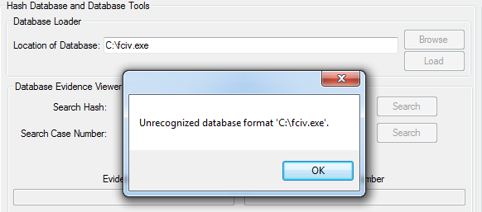

Instead of the program crashing due an incorrect database format, it will simply throw out an error message preventing the program hanging.

|  |  |  |  |  |
| --- | --- | --- | --- | --- |
| **Maintenance Plan** | | | | |
| **Maintainer:** Henry Manning | | | **Date Commenced of Maintaining:** 01/05/2014 | |
| **Time Scale:** | Monthly, starting from 01/05/2014 until 01/08/2014 | | | |
| **Areas of Maintaining:** | |  | | |
|  | |  | | |
| **Area 1 -** | | The first area of maintaining is the login form. The login credentials will be updated to suit the client’s needs such as adding more passwords to the private variables of the Postmortem application. | | |
| **Area 2 -** | | The second area of maintaining is the front end of the Postmortem application. The look of the application will be updated whenever there are new features added to the program such as more algorithms and or more features to the Postmortem program. | | |
| **Area 3 -** | | The third area of maintaining is the back end of the Postmortem application. The source code of the Postmortem application will be updated and maintained to increase:   1. Performance 2. Security   The code will also be updated through the means of new features and algorithms when they have been fully tested before adding them to the program. | | |
| **Area 4 -** | | The fourth area of maintaining the Postmortem application is evaluating the program against the original specification and client requirements. The Postmortem program will be reviewed against all future updates to make sure that it is matching the client’s requirements and the specification. | | |
|  | |  | | |
| **Date of Maintenance:** 01/05/2014 | | | | **Signed By Client:** |
| **Date of Maintenance:** 01/06/2014 | | | | **Signed By Client:** |
| **Date of Maintenance:** 01/07/2014 | | | | **Signed By Client:** |
| **Date of Maintenance:** 01/08/2014 | | | | **Signed By Client:** |
|  | | | |  |
| **Maintenance Log for:** 01/05/2014 | | | | |
| **Log:** | | | | |
| **Maintenance Log for:** 01/06/2014 | | | | |
| **Log:** | | | | |
| **Maintenance Log for:** 01/07/2014 | | | | |
| **Log:** | | | | |
| **Maintenance Log for:** 01/08/2014 | | | | |
| **Log:** | | | | |

After each maintenance day has been completed, the maintenance plan above would be signed off by the client to confirm that maintenance has taken place and it meets the requirements set by the client. It is important for a maintenance plan to be signed off by the client since it is their system being updated.

However, there is a constraint by maintaining the Postmortem application across the two sites where it has been installed, which is a time constraint. The systems being updated already have a copy of the previous version of Postmortem already installed on their systems, this would take an un-installing and reinstalling approach to the whole spectrum of systems. This would also affect the two locations of London and Bristol because it takes time to travel between these two locations and install the new Postmortem package.

In a later build of Postmortem, a viable option to counter this would be to install an update procedure where a new version of the Postmortem application can be downloaded and installed right over the internet, or a update protocol within the Postmortem program where it automatically downloads the new version without the need to search for it on the internet.

There will also be an emergency contact number. This emergency contact number can be found on the contact page of the user manual.

**Appendix 15 –**

**Specification Analysis**

The Postmortem application was designed and created with the client’s specification in mind. The specification is derived from the requirements set by the client because the specification is written with the needs of the client in mind.

The first part of the Postmortem specification is the algorithms. The algorithms stated in the specification being implemented into the Postmortem application were:

1. MD5
2. SHA
3. AES

Both MD5 and SHA algorithms we successfully implemented into the Postmortem application however AES algorithm was not implemented. Instead of implementing the AES algorithm, two other algorithms were installed into the Postmortem software:

1. SHA256
2. SHA384

Instead of having three algorithms in the specification, they were replaced with 4 algorithms altogether being:

1. MD5
2. SHA1
3. SHA256
4. SHA384

There was four algorithms implemented into the Postmortem application than the original stated three, this is an advantage compared to there being only three.



This is due to the analyst’s discretion and they can decide which algorithm option they can use in the hashing protocol in the Postmortem application. This is also a time factor in the generation of hash values because some algorithms take longer to produce than algorithms such as MD5. Overall, the implementation of the four algorithms is a suitable replacement instead of the three original hash functions.

The second part of the Postmortem specification is the area of database functionality in the application. The specification stated many functions with the use of a database in the Postmortem application. A Microsoft Access database has been fully implemented into the Postmortem application via the use of the specification content.

The connection string stated in the specification used to connect to a database file in Access is the same string being used in the Postmortem application.

The navigation of the Postmortem application is done by three buttons in the form and all of them following the same code stated in the specification. Each button is related to the code by either moving forward one record at a time or backwards once at a time. The code stated in the speciation for going forward a record at a time is the following:

If inc <> MaxRows - 1 Then

inc = inc + 1

NavigateRecords()

Else

MsgBox("No More Rows")

End If

The code stated in the specification for going backwards once at a time is the following:

If inc > 0 Then

inc = inc - 1

NavigateRecords()

Else

MsgBox("First Record")

End If

Both sets of code are implemented in the program to allow the functionality of the database be utilised in full effect for the computer analyst.

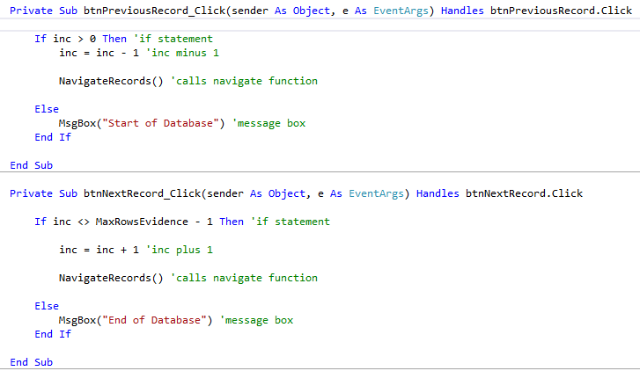

The database area of the specification is followed exactly, and is implemented fully into the program. This area of the Postmortem application follows the specification to where it matches correctly.

The third part of the Postmortem specification is the area of message overloading in the Postmortem application. Message box overloading is used in two areas of the Postmortem program, hash verification. The message box specification was well written because it allowed a full implementation of the messagebox overloading function in the Postmortem application. The specification code of messagebox overloading is the same used in implementing the function:

Dim BoxMsg As DialogResult

Dim Message1 As String = "HASHES ARE VERIFIED"

Dim MsgBoxTitle2 = "Successful Hash Verification"

BoxMsg = MessageBox.Show(Message1, MsgBoxTitle2)

The code being used in the Postmortem application is the following code snippet:

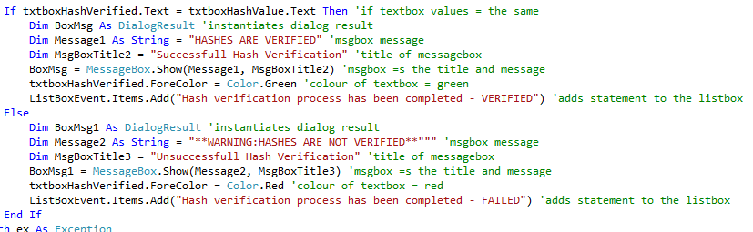

This area of the Postmortem specification was also well written because it covered the basics of messagebox overloading. It also laid out a template for implementing an overloaded messagebox.

The fourth part of the Postmortem specification is the variables being used in the Postmortem application. This part of the specification should have been more detailed in explaining variables and how they can interact with the program. They are also very important in creating the application because they are very important to the success of the program. Without variables in the application, this project would be very much in jeopardy.

Although the variable part of the specification is vague, the variables stated were used in the Postmortem application so they did have use. The variable types used were Strings, Integers, Bytes and many others. These were implemented into the Postmortem application, the code being used is the following snippet:

Dim HashByte As Byte()

Dim MD5String As String

Public AlgorithmSelection As Integer

The variable section of the specification could be revamped to include much more detailed explanations and provide more diagrams into how variables interact with the program.

The fifth and last section of the Postmortem specification is the imports being implemented into the Postmortem application. The imports part of the specification is used to show what import libraries will be used and what is included in them.

There were four stated import libraries stated in the specification, however there were nine total import namespace libraries. Those namespaces included into the Postmortem program are:

* Imports
  + - System.Cryptography
    - System.Text
    - System.IO
    - System.Environment
    - System.Diagnostics
    - System.Threading
    - System.Data.Oledb
    - System.Windows.Forms.DialogResult
    - System.Drawing

The specification described the first namespace of the Postmortem application and was technically well described. However, the specification did not write about the other three namespaces stated in the original specification.

The area of imports in the specification described the System.Cryptography to a sufficient standard but not the other three. This can cause confusion to the client when they see this and they could possibly ask what they are. This part of the specification needs to be re written with descriptions of the other namespaces.

Overall, the specification is well written except for a few areas, those areas being:

1. Variables
2. Imports

These two areas need to be rewritten so that the client can understand them more and in much further detail. The Postmortem application matches the specification in its entirety. Content regarding database functionality is fully implemented into the Postmortem application and so is message box overloading. The first part of the specification states three algorithms is matched in the Postmortem with not three algorithms but four algorithms all together which exceeds the specification. The specification fully matches the Postmortem application.

**Appendix 16 –**

**User Requirements Analysis**

When first approached by the Metropolitan Police Service, they required a program which can match their needs. They created a number of requirements they wish the Postmortem program to achieve. These requirements are:

1. Connects to a database file or SQL server
2. Simple to use
3. Multiple Text Fields
   1. Case Number
   2. Chain of Custody
   3. Date of Hash
   4. Serial ID
   5. Hash Algorithm
   6. Hash Value
   7. Hash Verified Value
   8. Hash Verified (Y/N)
4. Able to hash the file within the program
5. Search features
   1. Search Hash
   2. Search Case Number
6. Load and save features
7. Easy to use the hashing process

The first requirement set by the client is to have the Postmortem application connect to either a database file or an SQL server. This requirement has been met and successfully implemented into the Postmortem application. Within the Postmortem program, by pressing the “Browse” button, this allows the user to browse for the database file:

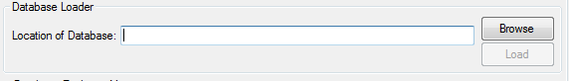

By having a database requirement set by the client, it is a very important aspect of the Postmortem application because this allows the users of the program to store the information generated by hashing and database information. It is also crucial to have a database file for the purpose of chain of custody.

The second requirement set by the client is for the Postmortem application simple to operate. The Postmortem program needs to be simple so that the computer analysts can use it without potentially ruining a case. The layout of the Postmortem was created in mind to make it simple to operate. The layout of the Postmortem application is the following image:

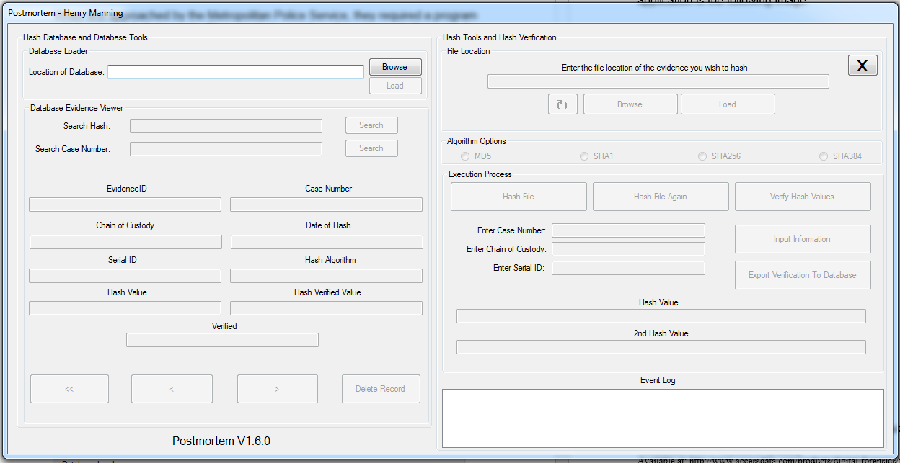

The layout is in a specific order. This makes sure that the operator of the Postmortem program does not do anything which can affect the information created. This requirement set by the client of being a simple program has also been successfully designed. The design of the application allows buttons and controls to be simple and easy to follow when either using the database section or hashing a file. This requirement has been met for the Postmortem application.

The third requirement set by the client is that the Postmortem application must have multiple text fields. These text fields which must be included are:

* 1. Case Number
  2. Chain of Custody
  3. Date of Hash
  4. Serial ID
  5. Hash Algorithm
  6. Hash Value
  7. Hash Verified Value
  8. Hash Verified (Y/N)

Each text field is required for fully completing a hash from the program. Each text field is related to the case by whether it being a case number, date of the hashing process or the hash value. This information created by the program can be viewed in the Postmortem application, the following image shows the multiple text fields in action:

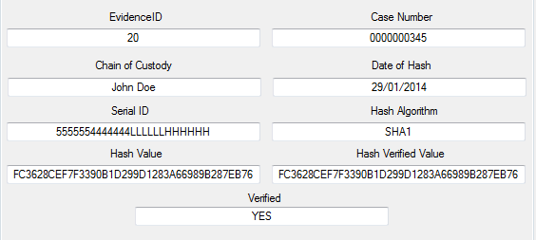

The information in the fields are very important when dealing with a case in a court of law. This information is required to make sure that the evidence being hashed is reliable in court and can’t be accused of being tampered. This requirement set by the client has been successfully implemented.

The fourth requirement set by the client for the Postmortem application is to be able to hash a file within the program. This is the most important requirement set by the client because of its severity. The hash value created by the program must be held and verified to another hash value. The requirement of having an in program hashing is also a good feature since it allows the analyst to control the ways of hashing can be done. An external possibility of hashing a file outside the Postmortem program could be done via an already built program called “FCIV.exe”. This is a Microsoft built program which creates a hash value without the need of a certain created program. However it is much more difficult to handle than Postmortem program. The hashing of an evidence file can be done in the Postmortem program. There are also four hashing algorithms:

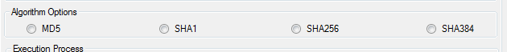

The amount of hashing algorithms exceeds the original number of three by one. These four hashing algorithms in the program are fully functional:

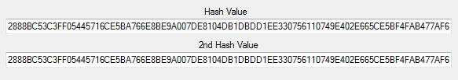

The requirement of having an inbuilt hashing functionality by the Postmortem application was a success and passes the test of being correct and tested.

The fifth requirement set by the client is to have two search features in the Postmortem application. The two features used are:

1. Search Hash
2. Search Case Number

These two features are required by the client to make the navigation of the Postmortem application far easier to use. The search features have been successfully implemented into the Postmortem application via the use of SQL statements:

Search Hash: SELECT * FROM tblEvidence WHERE [Hash_Value] LIKE '%" & txtboxHSearch.Text & "%' ;

Search Case Number: SELECT * FROM tblEvidence WHERE [Case_Number] LIKE '%" & txtboxCSearch.Text & "%' ;

The results of the Search Hash function populate the multiple text fields:

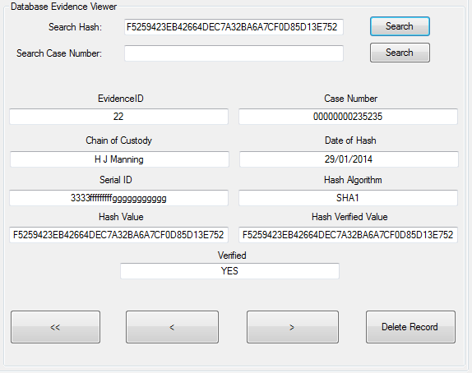

The results of the Search Case Number function populate the multiple text fields:

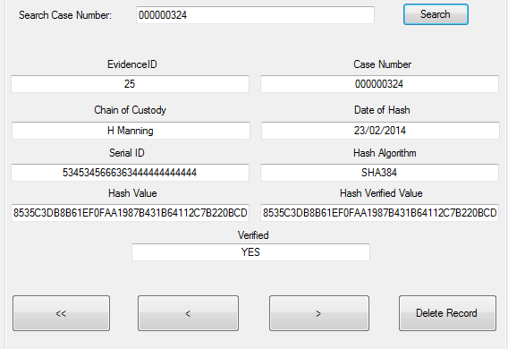

The implementation of both search functions have been a success and have met the requirement set by the client. It is a very important feature as it saves time of manually searching a database as there can be hundreds if not thousands of cases and hashing inside it.

The sixth requirement set by the client for the Postmortem application is to have a load and a save feature. This is another very important feature to have as it completes the chain of custody when hashing a file. The load requirement set by the client has been semi implemented into the program. The program in a way does not load into the program but is automatically populated by the data in the database to the text fields.

However, the requirement of a save feature has been fully implemented into the Postmortem application successfully. The save feature is done at the end of the hashing process. When the steps have been followed of hashing a file, the exporting of the information is the save function built into the Postmortem application:

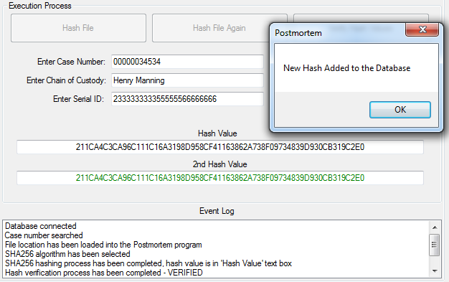

When the Export button has been selected, the information from the evidence file would be saved into the database. The exported information can be seen in the database section of the Postmortem application:

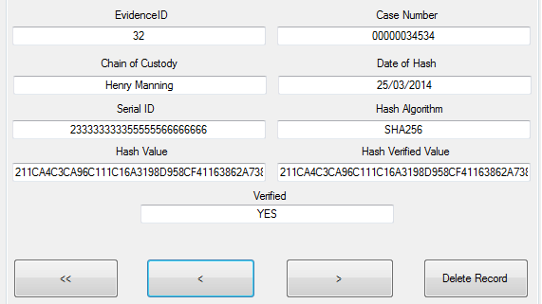

The requirement of having load and save features in the Postmortem has been met. It has an aspect of loading information as it populates the textboxes with information from the database. It also has the save requirement where it saves and exports the information from a hashed file into the database file. This requirement has been successfully implemented into the program.

The seventh and last requirement set by the client is for the Postmortem hashing process to be easy to use. The process of hashing a file in the Postmortem application is very simple.

There is also extra code to the buttons where they will get disabled when they have been pressed once, this is to ensure that nothing has been done twice as this can affect the final result. Each button will become disabled and once the final button has been pressed; “Export” the application can then be reset with using the following button:



When this button is pressed, it resets all the variables and buttons to their original state. This allows a logical order of doing the hashing process which makes it easier to understand as well as more convenient. It is convenient of having a reset button for one reason; does not require the program to be restarted after each hash. If there was no reset button, the computer analyst would need to restart the program to clear the variables and reset the button states.

This requirement set by the client has been met and it is a successful implementation of said requirement.

Overall, all of the requirements set by the client have been successfully implemented into the Postmortem application. There is also an extra feature in the Postmortem application which were not required by them. This extra feature is:

1. Authentication Form:

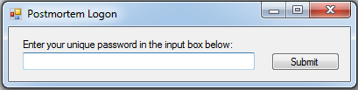

The authentication form adds a layer of security for people using the program. The password is set by using a private variable in the form load of the form.

The requirements have all been successfully implemented with an extra feature of an authentication form. This will increase the usability of the program and keep it more secure.

**Appendix 17 –**

**Presentation**

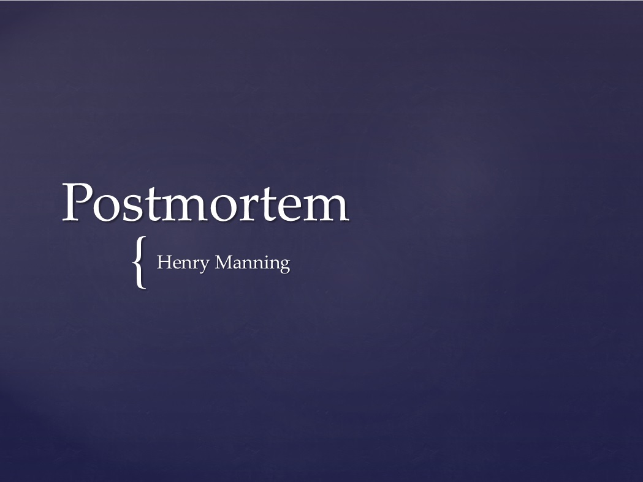



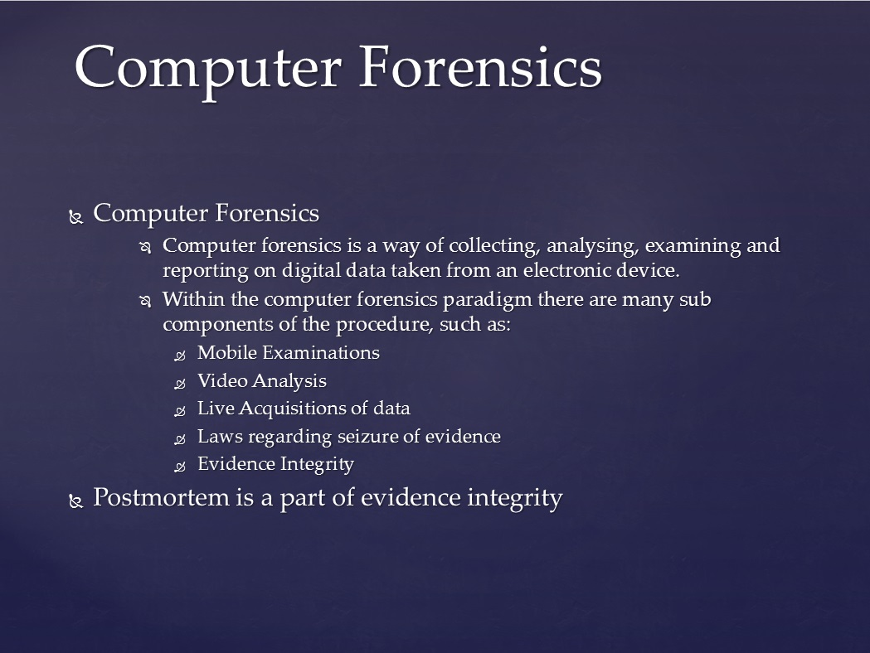

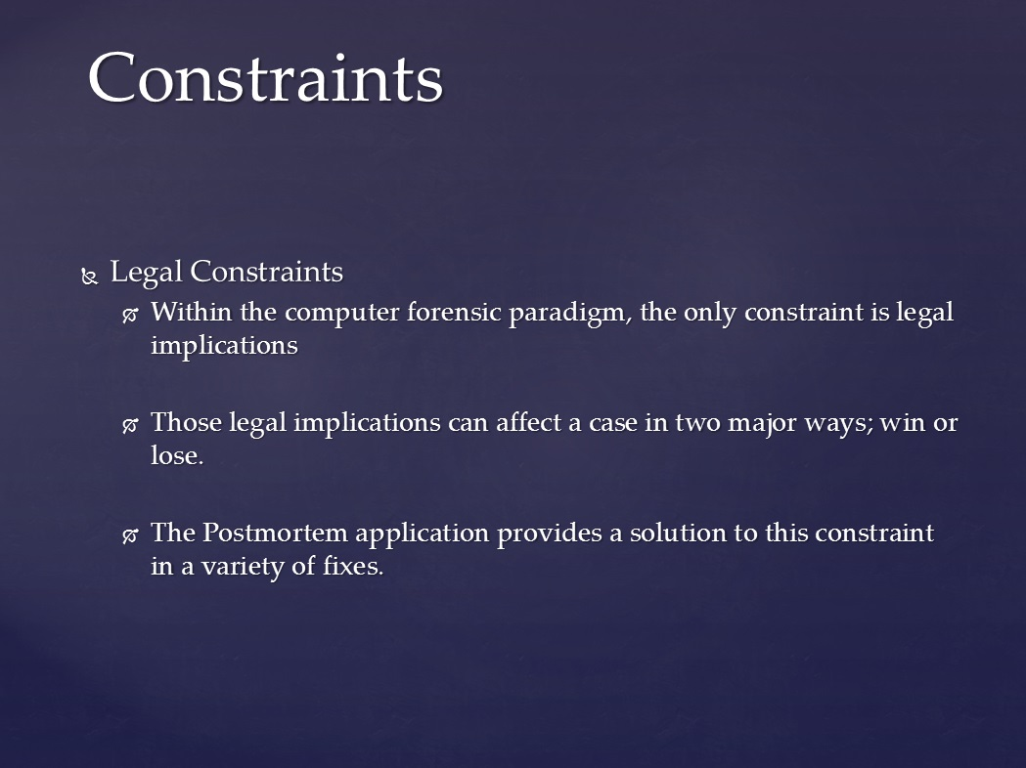

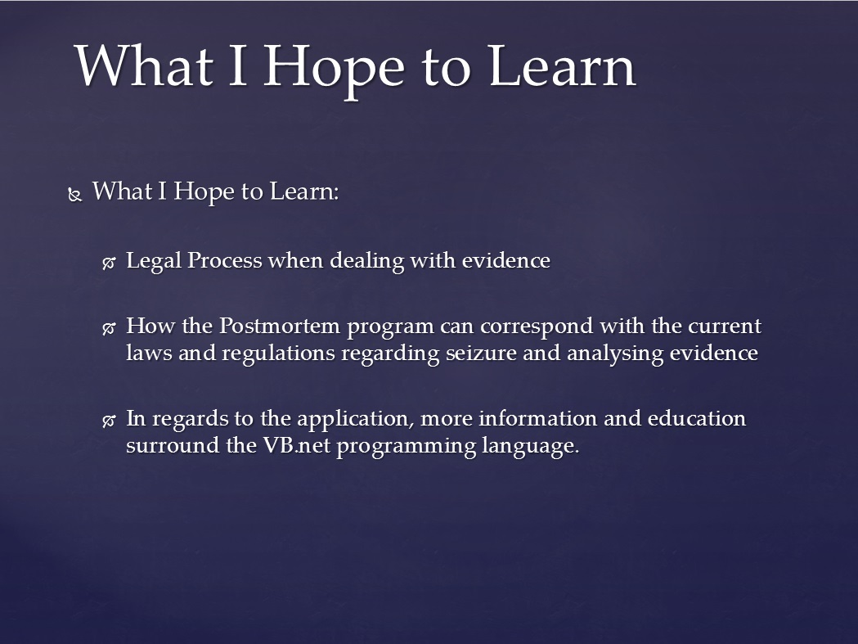

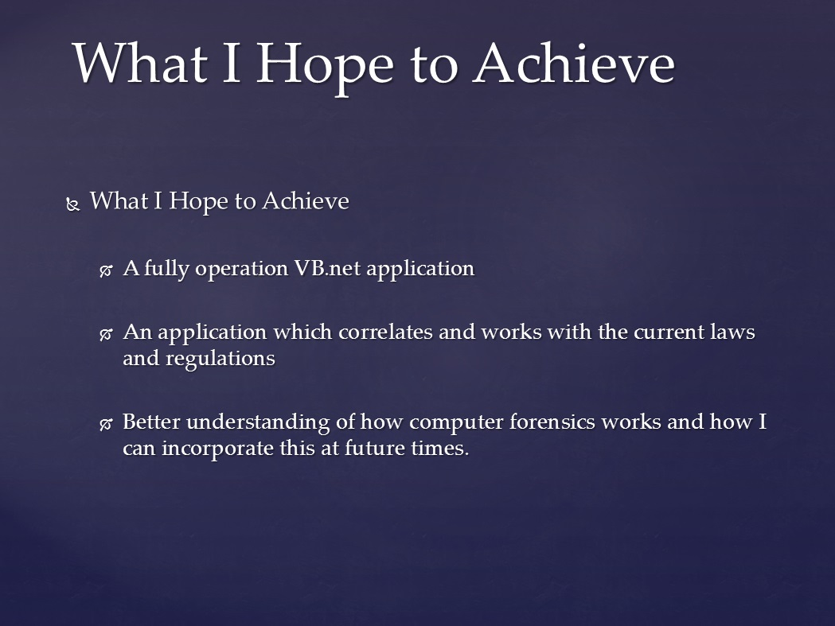

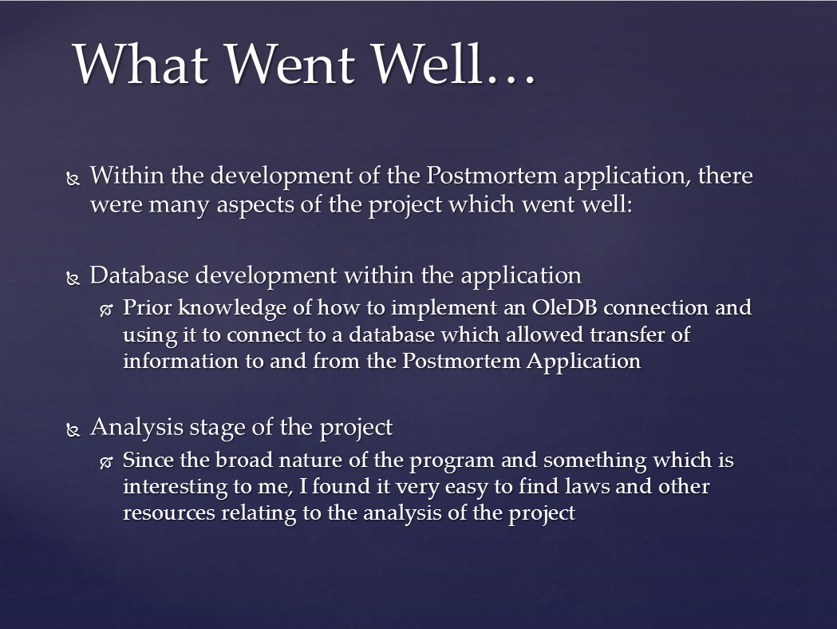

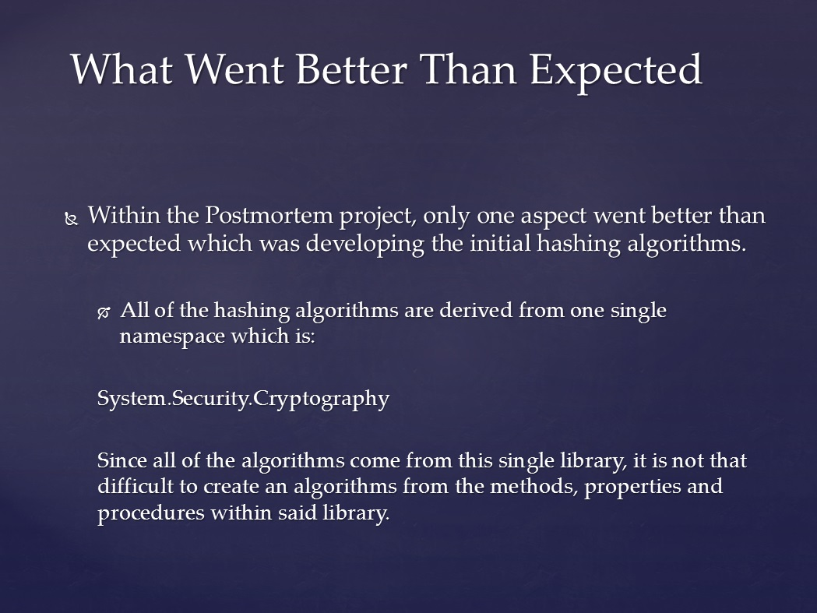

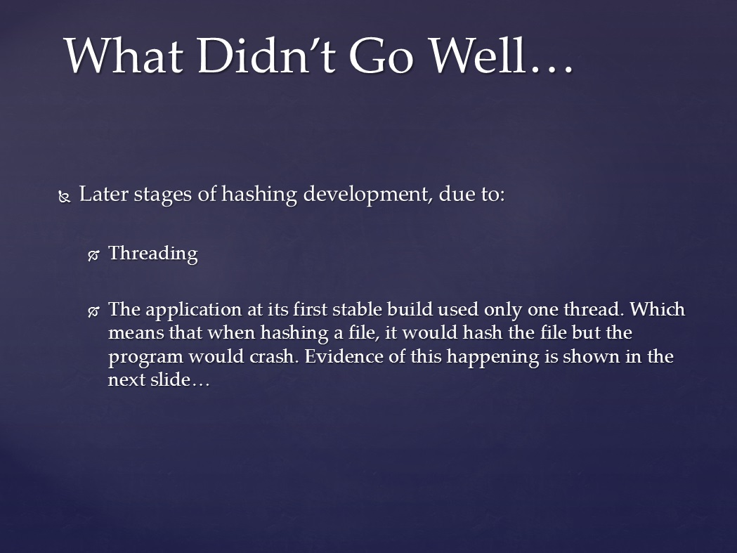

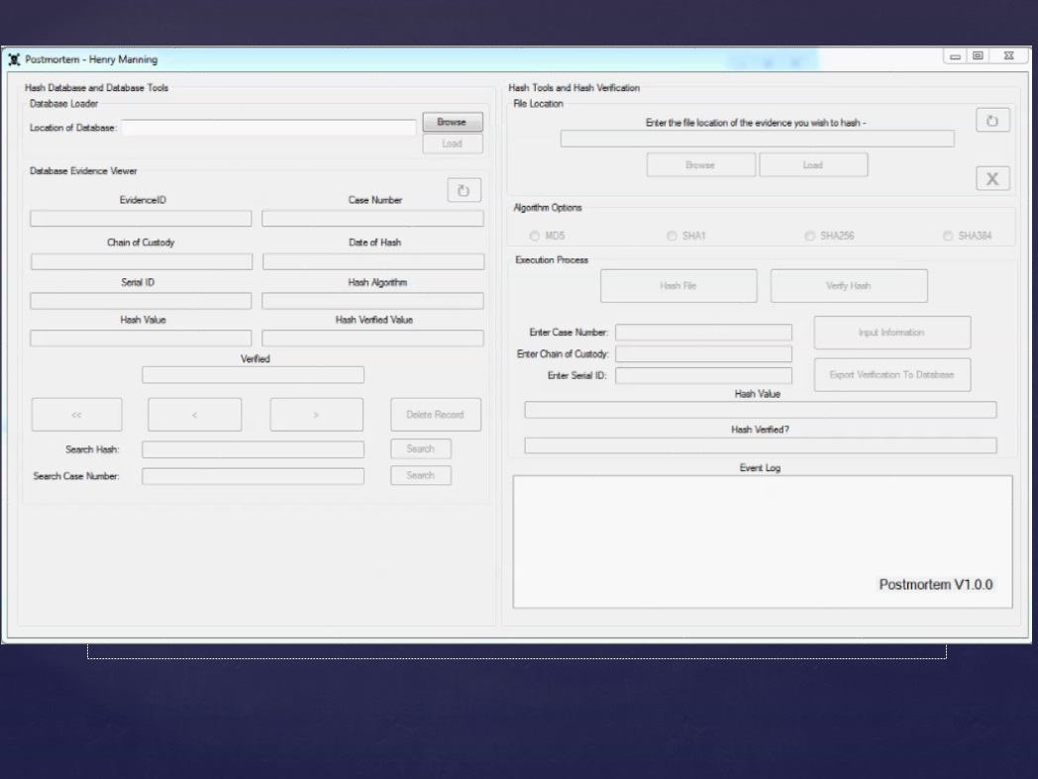

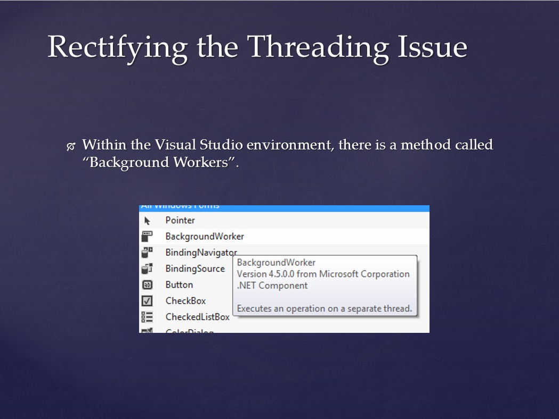

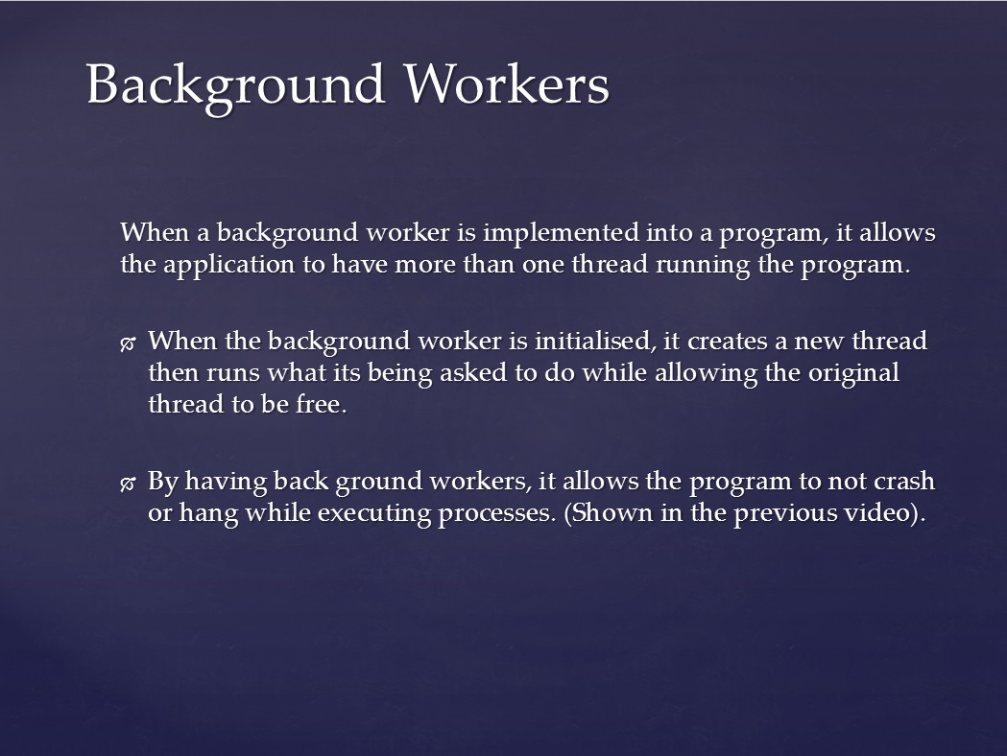

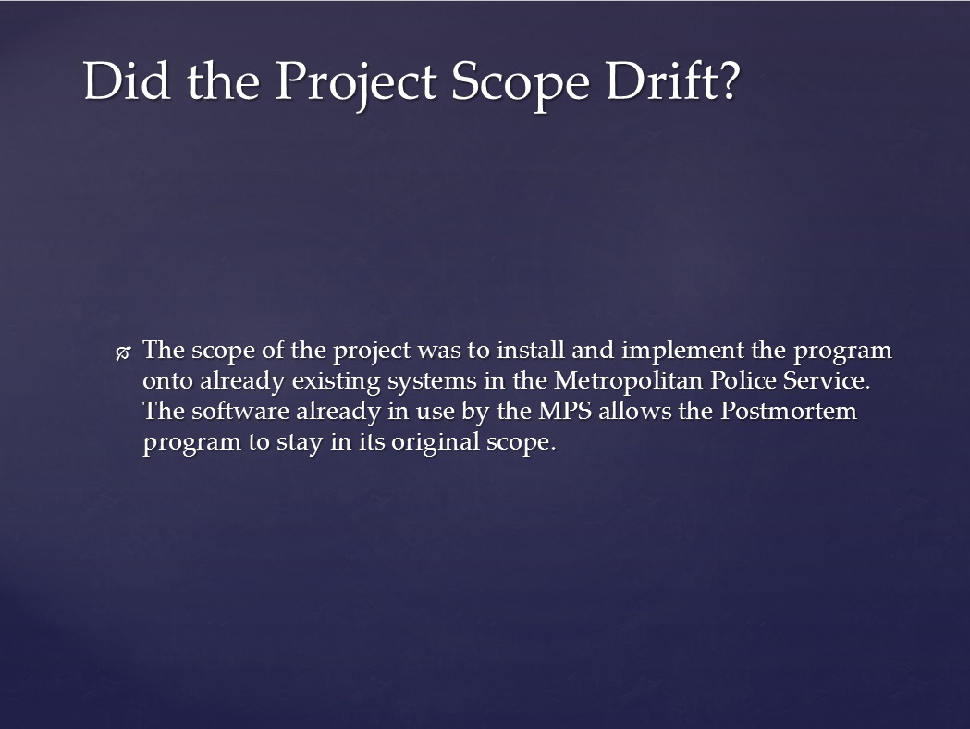



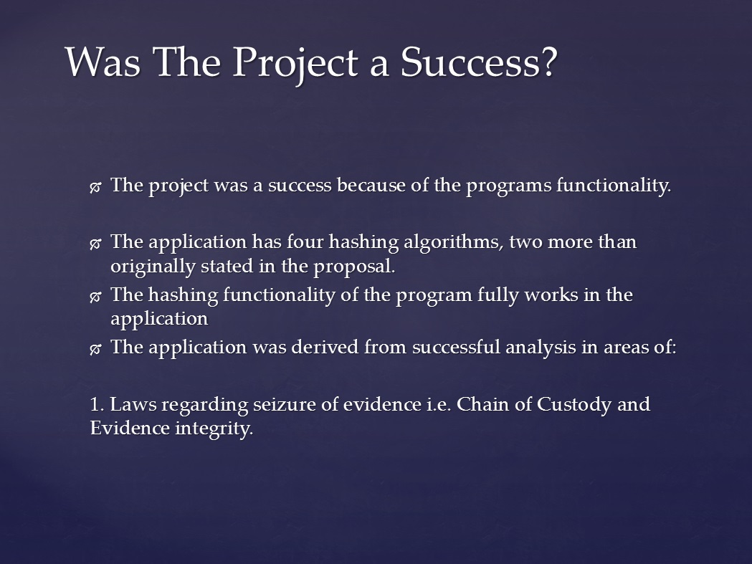

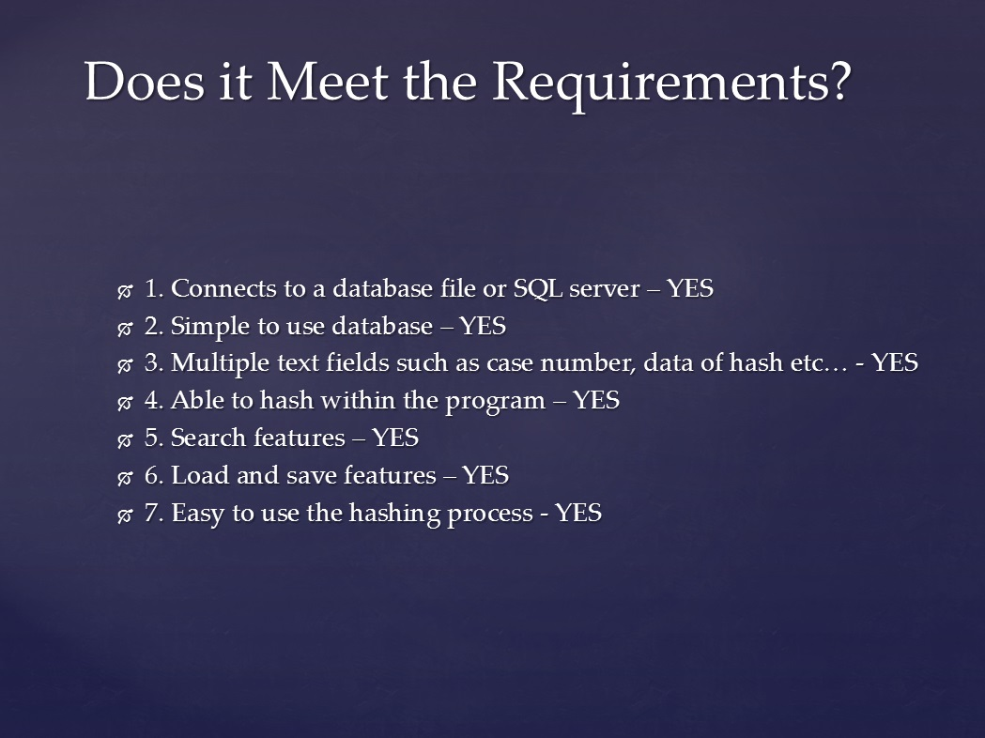

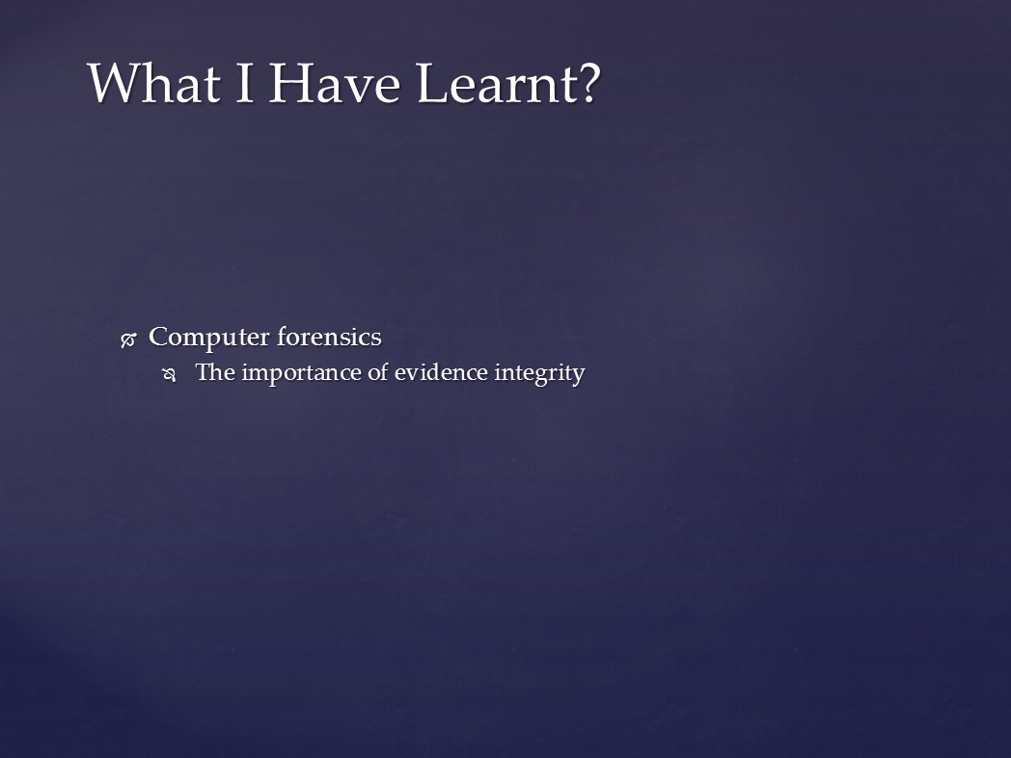

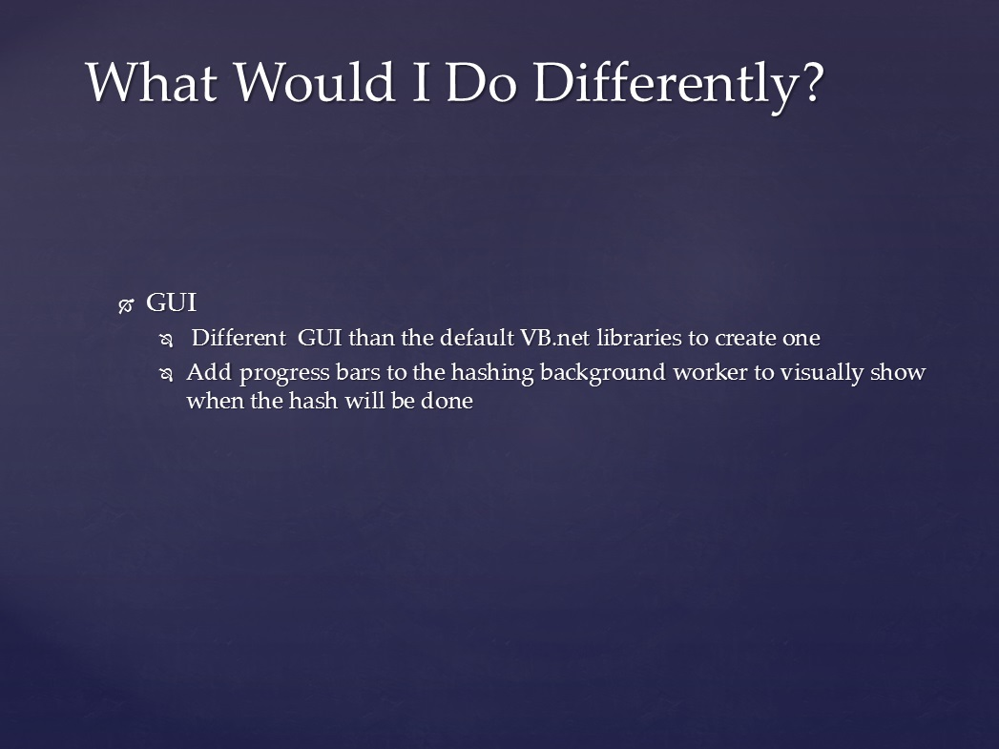



**Review Forms**

## Unit 4 Project Design, Implementation and Evaluation

## Review 1

|  |  |  |  |  |  |
| --- | --- | --- | --- | --- | --- |
| **Review Date:** | **04/12/2013** | | | | |
| **Student Name:** | **Henry Manning** | | | | |
| **Project Title:** | **Postmortem** | | | | |
| **Project Supervisor:** | Chris Sharkey | | **Internal Verifier:** | | Matt Lyons |
|  |  | | |  |  |
| **Project Progress** | | | | | |
| **Initial Plan:** | Complete | **Comment:** | | Outline plan only | |
| **Problem Analysis:** | Complete | **Comment:** | | Ongoing | |
| **Feasibility Study:** | Complete | **Comment:** | | Ongoing | |
| **Requirements:** | Complete | **Comment:** | | Currently being defined | |
| **Specification:** | Complete | **Comment:** | | No derived | |
| **Quality Assurance:** | Complete | **Comment:** | | Not started | |
| **Proposed Solutions:** | Complete | **Comment:** | | Not started | |
| **Chosen Solution:** | Complete | **Comment:** | | Not started | |
|  |  |  | |  | |
| **Is the Project on Schedule:** | Yes  No | **Comment:** | | Outline plan only | |
|  |  |  | |  | |
| **Action Points** | | | | | |
| **Action** | **Due** | **Completed** | | **Supervisor Sign Off** | |
| **Complete Initial Plan** | 11/12/2013 | Click here to enter a date. | | Click here to enter text. | |
| **Analysis Stage Complete** | 22/01/2014 | Click here to enter a date. | | Click here to enter text. | |
| **Analysis Stage Written-up** | 22/01/2014 | Click here to enter a date. | | Click here to enter text. | |
| **Designs Commenced** | 22/01/2014 | Click here to enter a date. | | Click here to enter text. | |
| Click here to enter text. | Click here to enter a date. | Click here to enter a date. | | Click here to enter text. | |
|  |  |  | |  | |
| **Review Sign Off** | | | | | |
|  | | | | | |
| **Student Signature:** |  | | |  | |
|  |  | | |  | |
| **Project Supervisor Signature:** |  | | |  | |
|  |  | | |  | |

## Unit 4 Project Design, Implementation and Evaluation

## Review 2

|  |  |  |  |  |  |
| --- | --- | --- | --- | --- | --- |
| **Review Date:** | **22/01/2014** | | | | |
| **Student Name:** | **Henry Manning** | | | | |
| **Project Title:** | **Postmortem** | | | | |
| **Project Supervisor:** | Chris Sharkey | | **Internal Verifier:** | | Matt Lyons |
|  |  | | |  |  |
| **Review 1 Actions Complete:** | Yes  No | **Comment:** | | All complete | |
| **Project Progress** | | | | | |
| The initial analysis stage of the project has now been completed and designs are now underway, although a recommendation has been made for the requirements to be catalogued using MoSCoW. In addition, a recommendation has been made to use a professional wireframe design tool such as MockFlow, MockingBird or Gliffy. Designs need to be completed and finalised as soon as possible, so that the project can progress to the implementation stage. Both designs and a large percentage of the implementation stage will need to be completed prior to the next formal review. A revised project plan should be completed to reflect any changes in deadlines. | | | | | |
| **Is the Project on Schedule:** | Yes  No | **Comment:** | | 2 Weeks behind schedule. | |
|  |  |  | |  | |
| **Action Points** | | | | | |
| **Action** | **Due** | **Completed** | | **Supervisor Sign Off** | |
| **Complete revised project plan** | 29/01/2014 | Click here to enter a date. | | Click here to enter text. | |
| **Complete recommendation** | 29/01/2014 | Click here to enter a date. | | Click here to enter text. | |
| **Design stage complete** | 05/03/2014 | Click here to enter a date. | | Click here to enter text. | |
| **Implementation complete** | 05/03/2014 | Click here to enter a date. | | Click here to enter text. | |
| Click here to enter text. | Click here to enter a date. | Click here to enter a date. | | Click here to enter text. | |
|  |  |  | |  | |
| **Review Sign Off** | | | | | |
|  | | | | | |
| **Student Signature:** |  | | |  | |
|  |  | | |  | |
| **Project Supervisor Signature:** |  | | |  | |
|  |  | | |  | |

## Unit 4 Project Design, Implementation and Evaluation

## Review 3

|  |  |  |  |  |  |
| --- | --- | --- | --- | --- | --- |
| **Review Date:** | **07/03/2014** | | | | |
| **Student Name:** | **Henry Manning** | | | | |
| **Project Title:** | **Postmortem** | | | | |
| **Project Supervisor:** | Chris Sharkey | | **Internal Verifier:** | | Matt Lyons |
|  |  | | |  |  |
| **Review 2 Actions Complete:** | Yes  No | **Comment:** | | All Complete | |
| **Project Progress** | | | | | |
| The project is progressing well, designs have been completed and the project has been implemented. The artefact can now be demonstrated during the presentation, scheduled for two weeks’ time. Following this the write-up needs to be concluded, proof read, printed and professionally bound prior to the project deadline. | | | | | |
| **Is the Project on Schedule:** | Yes  No | **Comment:** | | On schedule | |
|  |  |  | |  | |
| **Action Points** | | | | | |
| **Action** | **Due** | **Completed** | | **Supervisor Sign Off** | |
| **Produce and deliver project presentation** | 19/03/2014 | Click here to enter a date. | | Click here to enter text. | |
| **Submit the final project write-up** | 04/04/2014 | Click here to enter a date. | | Click here to enter text. | |
| Click here to enter text. | Click here to enter a date. | Click here to enter a date. | | Click here to enter text. | |
| Click here to enter text. | Click here to enter a date. | Click here to enter a date. | | Click here to enter text. | |
|  |  |  | |  | |
| **Review Sign Off** | | | | | |
|  | | | | | |
| **Student Signature:** |  | | |  | |
|  |  | | |  | |
| **Project Supervisor Signature:** |  | | |  | |
|  |  | | |  | |

Unit 4 HND Computing Project

Peer Presentation Evaluation Form

**Student Name: Henry Manning (Postmortem)**

|  |  |
| --- | --- |
| **Method** (what is the chosen method of presentation and is it applicable to the particular type of project): | |
| PowerPoint Presentation, with a pre-recorded screencast demonstration of the project. This included showing the problems which were encountered and how these were overcome. A life demonstration of the project was also included. | |
| **Organisation** (is the presentation well organised and tailored to the particular type of project)**:** | |
| Well organised with a good introduction into the background of the project and what he hoped to achieve. Sound artefact demonstration which demonstrated a significant amount of effort had gone into the project. | |
| **Structure** (is the presentation well structured, in a manner that is suited to the particular type of project)**:** | |
| Structured around the outcomes of the project. Good evidence of reflection in what went well / less well. However, some reference to the chosen development methodology would have been beneficial. | |
| **Delivery** (is the delivery well-paced, suited to the audience and the particular type of project): | |
| Well organised and a good paced delivery. Kept to time relatively well although the program could have been loaded up prior, in the background. To be fair, you did though acknowledged this during the delivery. Overall though a professionally presented presentation. | |
| **General Comments:** | |
| A well organised and well presentation on a sound artefact which meets the user’s requirements. However there are some minor areas which still require improvement. | |
| **Feedback Provided By: Chris Sharkey** | **Date: 19/03/2014** |

Unit 4 HND Computing Project

Peer Presentation Evaluation Form

**Student Name:_HenrManning_________________________**

|  |  |
| --- | --- |
| **Method** (what is the chosen method of presentation and is it applicable to the particular type of project): | |
| Chosen method of presentation was a PowerPoint presentation with a recorded demonstration, it was well suited to the type of project developed. | |
| **Organisation** (is the presentation well organised and tailored to the particular type of project)**:** | |
| Presentation was well organised, in a manner suited to the type of project developed, however there was no discussion of the methodology used within the presentation itself. | |
| **Structure** (is the presentation well structured, in a manner that is suited to the particular type of project)**:** | |
| Presentation was well structured, in a manner suited to the type of project developed. | |
| **Delivery** (is the delivery well-paced, suited to the audience and the particular type of project): | |
| Delivery was well paced, in a manner suited to the audience type of project developed. | |
| **General Comments:** | |
| **Excellent program, good use of multi-threading and very well presented** | |
| **Feedback Provided By: John Bergqvist** | **Date: 19/03/2014** |

Unit 4 HND Computing Project

Peer Presentation Evaluation Form

**Student Name: Henry Manning**

|  |  |
| --- | --- |
| **Method** (what is the chosen method of presentation and is it applicable to the particular type of project): | |
| The presentation was in a PowerPoint presentation format and fit the method of presenting. He also provided a good background on the project and client | |
| **Organisation** (is the presentation well organised and tailored to the particular type of project)**:** | |
| The presentation was well organised, however the demonstration of the project could have been loaded earlier or while presenting to save time during the presentation | |
| **Structure** (is the presentation well structured, in a manner that is suited to the particular type of project)**:** | |
| The presentation was well structured, he provided video evidence of some of the issues that occurred during the development, giving a better understanding of what went wrong | |
| **Delivery** (is the delivery well-paced, suited to the audience and the particular type of project): | |
| Good delivery, informed audience about any unknown or unfamiliar concepts within the application or presentation | |
| **General Comments:** | |
| Overall a well-structured presentation, only issue was the waiting time for the project to load. Should have had the application preloaded. | |
| **Feedback Provided By: Chris Wilson** | **Date: 19/03/14** |